**REACT JS**

Contents

1. Introduction to React.js (5 pages) 8

History and Evolution of React 8

Key Features and Benefits 9

Differences between React and other frameworks (Angular, Vue, etc.) 9

2. Setting Up React Environment (5 pages) 10

Node.js and npm basics 10

Installing and configuring create-react-app 10

Exploring the folder structure 10

Basic React App setup 11

3. JSX: JavaScript Syntax Extension (5 pages) 11

4. React Components (10 pages) 12

Functional vs. Class Components 12

Component Lifecycle (with examples) 14

5. Props in Detail (5 pages) 17

6. State and State Management (10 pages) 20

7. React Hooks (10 pages) 24

Overview of Hooks 24

useState (state hook) 24

useEffect (effect hook) 27

useReducer (state hook) 30

useRef (ref hooks) 33

useLayoutEffect (effect hook) 35

useMemo (callback Hook) 36

useContext (context hooks) 38

Custom Hooks and their Use Cases 41

8. Handling Events (5 pages) 46

React Event System 46

Binding Events in Class Components 48

Handling Events in Functional Components 50

Event Pooling and Performance Considerations 50

9. Conditional Rendering (5 pages) 50

Using if Statements and Ternary Operators 50

Short-circuit Evaluation 51

Rendering Null and False 51

Conditional Rendering with Elements 51

10. Lists and Keys (5 pages) 51

Rendering Lists of Data 51

Importance of Keys in React 51

Optimizing Lists with Unique Keys 51

Dynamic List Rendering Examples 51

11. Forms in React (5 pages) 51

Controlled vs. Uncontrolled Components 51

Handling Form Data and Input Fields 51

Form Validation Techniques 51

Working with 3rd Party Form Libraries (e.g., Formik) 51

12. Context API (5 pages) 51

What is the Context API? 51

Creating and Consuming Context 51

Using Context for Theme and Language Management 51

Context API vs. Props Drilling 51

13. React Router (5 pages) 51

Introduction to Client-Side Routing 51

Setting Up React Router 51

Route Parameters and Nested Routes 51

Programmatic Navigation 51

14. Performance Optimization (5 pages) 51

React’s Reconciliation Algorithm and Virtual DOM 51

Using React.memo, useMemo, and useCallback 51

Lazy Loading with React.lazy and Suspense 51

Optimizing Re-renders 51

15. Error Boundaries (5 pages) 52

What are Error Boundaries? 52

Creating an Error Boundary 52

Catching Errors in Components 52

Best Practices for Error Handling 52

16. Testing React Applications (5 pages) 52

Introduction to Unit and Integration Testing 52

Using Jest and React Testing Library 52

Snapshot Testing 52

Mocking API Requests in Tests 52

17. Working with APIs (5 pages) 52

Fetching Data with fetch and axios 52

Handling Asynchronous Requests 52

Displaying Data in Components 52

Error Handling in API Calls 52

18. React and Redux (10 pages) 52

Introduction to State Management with Redux 52

Setting Up Redux in a React App 52

Actions, Reducers, and the Store 52

Connecting Redux to React Components 52

Redux Toolkit Overview 52

19. Advanced Redux (5 pages) 52

Middleware in Redux (e.g., Thunk, Saga) 52

Handling Side Effects with Redux Thunk 52

Redux Persist for Storing State 52

Combining Multiple Reducers 52

20. Server-Side Rendering (5 pages) 52

Why Server-Side Rendering (SSR)? 52

Next.js: An SSR Framework for React 52

Implementing SSR in a React App 53

SEO and Performance Benefits of SSR 53

21. React Native Overview (5 pages) 53

What is React Native? 53

Differences Between React and React Native 53

Writing Cross-Platform Mobile Apps with React 53

Examples and Use Cases 53

22. Deploying React Applications (5 pages) 53

Building the App for Production 53

Deploying to Static Hosting (Netlify, Vercel, GitHub Pages) 53

Deploying to Cloud Platforms (AWS, GCP) 53

Best Practices for Deployment 53

23. React Ecosystem and Tools (5 pages) 53

Popular React Libraries (React Router, Redux, etc.) 53

Developer Tools and Extensions 53

Code Splitting and Bundle Optimization 53

Styled Components and CSS-in-JS Libraries 53

24. React Best Practices (5 pages) 53

Code Organization and File Structure 53

Component Composition and Reusability 53

Best Practices for State and Props Management 53

Avoiding Common Pitfalls in React Development 53

Typescript Interview Questions 55

Basic TypeScript interview questions and answers 55

1.Explain TypeScript and its use? 55

2.Can you tell the names of some of the built-in types in TypeScript? 55

3.Give an example of generics in TypeScript? 55

4. Tell me about Modules in TypeScript. 56

5.Why can TypeScript be chosen over JavaScript? 56

6.Do TypeScript files need compilation? 56

7.List some benefits of TypeScript? 56

8.In TypeScript, can we call the base class constructor from the child class ? 57

9.What is the difference between TypeScript and a statically typed language? 58

10.Is string interpolation possible in TypeScript? 58

11.How do the extensions .ts and .tsx differ in TypeScript? 58

12.Differentiate between Classes and Interfaces in TypeScript? 59

13.Explain the Interface in TypeScript? 59

14.Explain Decorators in TypeScript. 59

15.When should you use interfaces or classes in TypeScript? 59

16.How can you use class constants in TypeScript? 60

17.In TypeScript, what can you do to check null and undefined? 60

18.Are all object-oriented principles supported by TypeScript? 60

19.Also, tell me some OOP terms supported by TypeScript. 60

20.Explain Getters/Setters in TypeScript. 61

21.Can TypeScript be used on the back-end and how? 61

22.Explain TypeScript Map file? 61

23.Can you explain the difference between String and string in TypeScript? 61

24.Explain Type Erasure in TypeScript? 62

25.How can you create an enum with string values? 62

26.List some features of TypeScript. 63

27.Tell me the Components of TypeScript? 63

28.How will you install TypeScript? 64

29.List the steps you will use to compile TypeScript files? 64

30.Explain Variables in TypeScript and how to create them? 65

31.List the ways you can declare a variable? 65

32.Can we compile .ts automatically with real-time changes in the .ts file? 66

33.List the access modifiers that TypeScript supports. 66

Intermediate TypeScript interview questions and answers 66

1.Why do we say that TypeScript is an optionally statically typed language? 66

2.Explain modules in TypeScript? 67

3.Differentiate between the internal module and the external module? 67

4.Explain namespace in TypeScript and its declaration 68

5.Is function overloading supported in TypeScript? 68

6.Explain Mixins? 68

8.Explain the Scope variable? 69

9.Explain to me the debugging process for a TypeScript file. 70

10.Explain TypeScript Definition Manager and its use. 70

11.Tell me the steps to include a Type Definition File. 70

12.Explain TypeScript Declare Keyword? 71

13.Explain tsconfig.json file? 71

14.Tell me about Generics in TypeScript? 71

15.Differentiate between interface and type statements? 71

16.Tell me about JSX in TypeScript. 72

17.List some JSX modes in TypeScript? 72

18.Explain Ambients in TypeScripts and their use? 73

19.Explain Type assertions in TypeScript? 73

20.Explain Rest parameters? 73

21.List the rules to follow for declaring Rest parameters? Give an example 74

22.Explain “as” syntax in TypeScript. 74

23.What do you know about Enum in TypeScript? 74

24.Differentiate between Relative and Non-relative module imports. 75

25.Explain the anonymous function? 75

26.Explain the method overriding in TypeScript? 75

27.Explain Lambda/Arrow function? 75

28.Explain conditional types in TypeScript. 76

29.How can you make read-only Arrays in TypeScript? 76

30.Explain Nullish Coalescing operator? 76

31.Explain assertion functions? 77

32.Explain Triple-Slash Directives. List some of the triple-slash directives. 77

33.Explain the Omit type ? 77

34.How can you compile TypeScript through Visual Studio Code? 78

35.Can TypeScript files be supported from Node Modules? If yes, then how? 78

36.Explain Recursive Type Aliases? 79

37.Explain “any” in TypeScript? 79

Advanced TypeScript interview questions and answers 80

1. Tell me about the ‘tsconfig.json’ file? 80

2.Tell me about “never” in TypeScript? 81

3.What are design patterns? 82

4.What is the Singleton Design Pattern? 82

5.Explain Facade Design Pattern? 83

6.Explain “promise” in TypeScript. 83

7.Explain how you can manage default parameters in a function in TypeScript? 83

8.Explain the distributive conditional type in TypeScript and its usage? 84

9.Explain the "type" keyword in TypeScript and its usage? 84

10.Explain the "import type" statement in TypeScript? 85

11.List some disadvantages of TypeScript. 85

12.What rules to follow when declaring a variable in TypeScript? 86

13.When is an unknown type used? 87

14.Explain noImplicitAny? 87

15.Differentiate union and intersection types? 87

16.Differentiate between extends and implements in TypeScript? 88

17.Explain how optional chaining works in TypeScript. 90

18.What are abstract classes? 90

19.What are the two syntaxes for type assertions in TypeScript? 91

20.Differentiate between type inference and contextual typing? 92

21.Tell me about the process to declare a constant in TypeScript? 92

22.How do you implement Mixins in TypeScript? 92

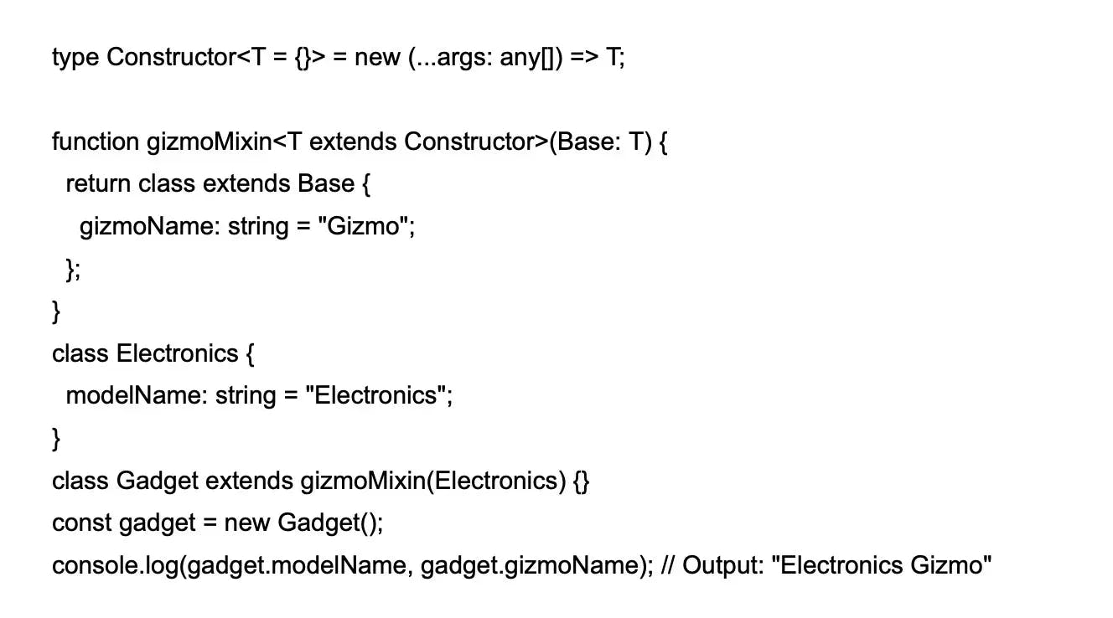 93

24.How can you use mapped types in TypeScript? 93

25.What is the keyof type operator in TypeScript? 94

26.How to use accessors (getters and setters) in TypeScript? 94

27.How can you create a custom decorator in TypeScript? 95

28.How can you handle enums in TypeScript? 95

29.How can you use mapped types with conditional types in TypeScript? 96

# 1. Introduction to React.js (5 pages)

## History and Evolution of React

**1. The Beginning: React’s Origins (2011)**

React's story began at **Facebook** in 2011 when Jordan Walke, a software engineer at Facebook, was working on improving the performance and maintainability of Facebook's web applications. At that time, Facebook engineers were struggling with slow, complex, and inefficient UI rendering. The existing frameworks and approaches (e.g., Backbone.js, jQuery) were not capable of efficiently handling highly dynamic user interfaces.

Walke created an early prototype, initially called **FaxJS**, which aimed to solve this problem by enabling a more declarative and efficient way to build UIs. The goal was to simplify how the UI changes in response to data changes, by introducing a **Virtual DOM** to optimize updates and render the minimal number of changes to the real DOM. This prototype would later evolve into what we know as React.

**2. Initial Release and Open Sourcing (2013)**

In **May 2013**, React was officially open-sourced at the **JSConf US** by Facebook. This was a significant turning point for the technology as it was the first time the public got to interact with React.

At this stage, the key concepts that made React unique were:

* **Component-based architecture**: The idea of breaking the UI into self-contained, reusable components.
* **One-way data flow**: React components could only receive data through **props** from their parent component.
* **Virtual DOM**: A lightweight, in-memory representation of the actual DOM that would allow React to efficiently apply changes by batching updates, leading to improved performance.

While React’s component model was widely praised, developers were initially skeptical of **JSX** (JavaScript XML), a syntax extension that allows developers to write HTML-like code in JavaScript. JSX combined JavaScript and HTML, which violated the popular “separation of concerns” convention at the time. Despite the initial backlash, developers soon recognized JSX’s advantages, as it allowed for greater control and maintainability of components.

**3. React’s Adoption by Facebook and Instagram (2014)**

After its open-source release, React began gaining popularity within the developer community. In **2014**, **Instagram**, a subsidiary of Facebook, adopted React for their web app. This was a critical moment that showcased React's ability to build large, complex applications. Facebook itself also transitioned many of its major parts of the website to React.

Instagram’s use of React became a success story and a proof of concept for many developers, leading to broader adoption across various startups and enterprises.

**4. React 0.14: React Native and Component Refactor (2015)**

In **2015**, React underwent a major refactor with the release of **React 0.14**. Key changes in this release included:

* **Separation of React and ReactDOM**: React itself became responsible only for defining the components, while the actual rendering to the DOM was moved to a separate package called **ReactDOM**. This modular approach made React more flexible, as it could now be rendered on platforms beyond the browser, such as mobile devices and even server environments.
* **React Native**: The most significant outcome of this modularization was the creation of **React Native**, which allowed developers to use React's declarative, component-based model to build mobile applications for iOS and Android. React Native became a huge success in the mobile development world, as it enabled developers to write JavaScript that could render native mobile interfaces.

**5. React 15 and the Fiber Project (2016)**

In **2016**, React 15 was released, but more importantly, the team began working on a massive internal rewrite called **React Fiber**. Fiber was designed to address some of the performance limitations in the existing React core. The primary goal was to improve React’s ability to handle animations, gestures, and incremental rendering.

React Fiber introduced the idea of **asynchronous rendering**, which allowed React to break up rendering work into chunks and prioritize updates. This was a major improvement for performance, especially for complex applications, as it could prevent the UI from freezing when large amounts of work were being processed.

**6. React 16: The Introduction of Fiber (2017)**

In **September 2017**, React 16 (codenamed Fiber) was released, marking a major milestone in React's evolution. It included several major improvements:

* **Error boundaries**: Components that could catch JavaScript errors anywhere in their child component tree and display fallback UIs instead of crashing the whole app.
* **Portals**: A way to render children into a DOM node that exists outside the DOM hierarchy of the parent component.
* **Better server-side rendering**: Improved support for rendering React apps on the server for SEO and performance purposes.

With Fiber, React could now handle asynchronous rendering, significantly improving its performance in dealing with complex user interfaces.

**7. React Hooks: A Game Changer (2019)**

The release of **React 16.8** in **February 2019** introduced **Hooks**, which revolutionized how developers wrote React components. Hooks provided a way to use state and other React features in **functional components**, eliminating the need for class components in many cases.

Popular hooks included:

* **useState**: For managing state in functional components.
* **useEffect**: For handling side effects like API calls, subscriptions, and DOM manipulations.
* **useContext**: For accessing the Context API in functional components.

Hooks addressed a major limitation of React’s previous API, which made it difficult to reuse stateful logic between components. With Hooks, logic could be encapsulated into reusable functions, making React development more modular and functional.

**8. React Today (2020 - 2024)**

React continues to evolve at a rapid pace, with more emphasis on performance, scalability, and ease of use. Key milestones in recent years include:

* **Concurrent Mode (Experimental)**: Allows React to interrupt rendering to handle higher-priority updates, improving responsiveness.
* **React Suspense**: Provides a way to handle asynchronous rendering more gracefully, particularly for data fetching and lazy loading.
* **Server Components**: A new experimental feature that allows React components to be rendered on the server and sent directly to the client.

React remains one of the most widely-used JavaScript libraries, powering massive ecosystems and popular projects like Facebook, Instagram, Netflix, Airbnb, and more.

## Key Features and Benefits

## Differences between React and other frameworks (Angular, Vue, etc.)

1. **Core Philosophy and Approach**

* **React**: React is a **library** focused on building user interfaces, specifically the view layer. It follows a **declarative** approach where developers describe the desired state of the UI, and React updates the DOM to match this state. React is **component-based**, encouraging UI reuse. It also promotes **unidirectional data flow**, ensuring predictable UI changes.
* **Angular**: Angular is a **full-fledged framework** that provides everything needed for development, including routing, forms, and more. It uses **two-way data binding**, where the UI and model reflect each other automatically. Angular is also **opinionated**, with a structured way to build applications.
* **Vue**: Vue is described as a **progressive framework**, allowing incremental adoption. It supports **two-way data binding** but implements it efficiently. Like React, Vue is **component-based**, and it offers flexibility and ease of use, especially for smaller or medium-sized projects.

1. **Learning Curve**

* **React**: It has a **moderate learning curve**. The core of React is simple, but developers need to learn additional tools (e.g., React Router, Redux) to build a full application, requiring a bit more effort to master.
* **Angular**: Angular has a **steep learning curve** due to its full framework approach. Developers need to learn concepts like dependency injection, RxJS, and TypeScript, which can be overwhelming for beginners.
* **Vue**: Vue is known for being **easy to learn**, with a **gentle learning curve**. Its API is simple, and developers can adopt Vue incrementally, making it a popular choice for beginners.

1. **Flexibility vs. Built-In Features**

* **React**: React provides **high flexibility**. Since it's only the view layer, developers can choose their own tools for routing, state management, and more. This requires more decisions and third-party library integration.
* **Angular**: Angular offers a **complete solution** with built-in tools for routing, forms, HTTP requests, etc., reducing the need for third-party libraries but limiting flexibility in choosing other tools.
* **Vue**: Vue provides a balance between flexibility and built-in features. It comes with built-in options like Vue Router and Vuex but allows more flexibility than Angular.

1. **Performance**

* **React**: React uses a **Virtual DOM** to optimize rendering. It updates and re-renders only the components that change, improving performance. However, developers may need to optimize performance manually in some cases.
* **Angular**: Angular’s **two-way data binding** can sometimes slow down performance, especially in large applications, but features like **AOT (Ahead-of-Time) compilation** and **Change Detection** help mitigate these issues.
* **Vue**: Vue also uses a **Virtual DOM**, offering efficient rendering and performance, especially for small to medium-sized applications. Its reactivity system makes it highly performant by default.

1. **Popularity and Community Support**

* **React**: React, backed by **Facebook**, has the **largest community** among the three. It's widely used in the industry, and the ecosystem includes many libraries and frameworks (e.g., Next.js) that enhance development.
* **Angular**: Angular, developed by **Google**, has strong enterprise adoption. It has a large community but is more popular in enterprise environments rather than with smaller projects or independent developers.
* **Vue**: Vue, despite being community-driven, has gained rapid popularity, especially in Asia. It has a smaller community than React or Angular but is known for being approachable and well-documented.

1. **State Management**

* **React**: React uses libraries like **Redux** or **MobX** for complex state management. It also provides the built-in **Context API**, useful for smaller applications or specific state management cases.
* **Angular**: Angular uses built-in services and **NgRx** for state management. This is often more structured but may require more setup than React's approach.
* **Vue**: Vue has its built-in state management library, **Vuex**, which integrates well with the framework and offers a simpler state management solution compared to Redux.

1. **TypeScript Support**

* **React**: React does not use **TypeScript** by default but supports it well. Many developers use **React + TypeScript** for better type safety.
* **Angular**: Angular is built using **TypeScript** and has first-class TypeScript support, making it ideal for developers looking for type safety.
* **Vue**: Vue 3 has improved **TypeScript** support significantly, making it comparable to React in terms of TypeScript integration.

1. **Use Cases**

* **React**: Best for building **single-page applications** (SPAs) and dynamic user interfaces. It’s also a top choice for mobile app development via **React Native**.
* **Angular**: Angular is well-suited for **large-scale enterprise applications**, offering a complete toolkit for developing complex apps.
* **Vue**: Vue is ideal for **small to medium-sized projects**, but it can scale well for larger apps too. It’s a popular choice for projects that need a flexible, lightweight framework.

# 2. Setting Up React Environment (5 pages)

## Node.js and npm basics

## Installing and configuring create-react-app

## Exploring the folder structure

my-react-app/

├── public/

│ ├── index.html

│ └── assets/

│ ├── images/

│ ├── fonts/

│ └── favicon.ico

├── src/

│ ├── components/

│ │ ├── common/

│ │ │ └── Button.js

│ │ ├── layout/

│ │ │ └── Header.js

│ │ │ └── Footer.js

│ │ └── App.js

│ ├── pages/

│ │ ├── HomePage.js

│ │ └── AboutPage.js

│ ├── services/

│ │ └── api.js

│ ├── hooks/

│ │ └── useAuth.js

│ ├── store/

│ │ └── index.js

│ ├── styles/

│ │ └── global.css

│ ├── utils/

│ │ └── helpers.js

│ └── index.js

├── package.json

├── .env

├── .gitignore

└── README.md

## Basic React App setup

# 3. JSX: JavaScript Syntax Extension (5 pages)

**JSX** is a syntax extension for JavaScript, used in React to describe the UI structure. It allows developers to write HTML-like code within JavaScript, making it easier to define React components and the layout they render. While JSX looks like HTML, it's ultimately transformed into pure JavaScript behind the scenes.

**Key Features of JSX:**

1. **Looks Like HTML**: JSX allows you to write HTML-like syntax inside your JavaScript code, making it easier to create UI components.

const element = <h1>Hello, World!</h1>;

This looks like HTML, but it’s actually JSX, which React uses to render the h1 element.

1. **JavaScript in JSX**: You can include any valid JavaScript expression within curly braces {} inside JSX.

const name = 'John';

const element = <h1>Hello, {name}!</h1>;

In this case, the value of the name variable (John) is inserted into the JSX template.

1. **JSX Must Return One Element**: JSX requires that components return a single element. If you need to return multiple elements, you should wrap them in a single parent element like a <div>, or use the React Fragment shorthand (<>...</>).

**return (**

**<div>**

**<h1>Hello!</h1>**

**<p>Welcome to React.</p>**

**</div>**

**);**

Or using React Fragment:

**return (**

**<>**

**<h1>Hello!</h1>**

**<p>Welcome to React.</p>**

**</>**

**);**

1. **Attributes in JSX**: In JSX, attributes are written similarly to HTML, but some names are different due to JavaScript naming conventions. For example:
   * class becomes className
   * for becomes htmlFor

**const element = <button className="btn-primary">Click Me</button>;**

1. **Self-Closing Tags**: Like in HTML, some elements don't need a closing tag in JSX (e.g., <img />, <input />). These can be written as self-closing tags.

**const element = <img src="logo.png" alt="Logo" />;**

1. **JSX Compiles to JavaScript**: JSX isn't directly understood by browsers. Before rendering, JSX is compiled into standard JavaScript using tools like Babel. For example:

**const element = <h1>Hello, world!</h1>;**

Compiles to:

**const element = React.createElement('h1', null, 'Hello, world!');**

1. **Conditional Rendering**: You can conditionally render components or elements in JSX using JavaScript expressions.

**const isLoggedIn = true;**

**return (**

**<div>**

**{isLoggedIn ? <h1>Welcome Back!</h1> : <h1>Please Sign In</h1>}**

**</div>**

**);**

1. **Inline Styles**: You can apply inline styles in JSX using a JavaScript object, where the keys are camelCased versions of the CSS properties.

**const style = { color: 'blue', fontSize: '20px' };**

**return <h1 style={style}>Hello, World!</h1>;**

**Advantages of JSX:**

* **Simplicity**: JSX makes it easier to visualize and create UI components by writing HTML-like syntax directly within JavaScript.
* **Integration with JavaScript**: JSX enables seamless integration of JavaScript expressions, making it more powerful and flexible for dynamic content.
* **Declarative Syntax**: It promotes a declarative style of UI development, where you describe how the UI should look in a given state, and React handles the updates when the state changes.

**Example of a Basic JSX Component:**

**import React from 'react';**

**function Welcome() {**

**const name = 'Alice';**

**return (**

**<div>**

**<h1>Hello, {name}!</h1>**

**<p>Welcome to React with JSX.</p>**

**</div>**

**);**

**}**

**export default Welcome;**

In this example, the Welcome component uses JSX to return an h1 element and a p element. The value of name is dynamically injected using curly braces.

# 4. React Components (10 pages)

## Functional vs. Class Components

In React, components are the building blocks of a user interface. There are two main types of components: **Functional Components** and **Class Components**. While both serve the same purpose, there are important differences in how they are written and how they handle features like state and lifecycle methods.

**1. Functional Components**

Functional components are simpler, typically written as JavaScript functions. Initially, they were stateless, but with the introduction of **React Hooks** in React 16.8, functional components can now manage state and lifecycle methods, making them more powerful and versatile.

**Key Features of Functional Components:**

* Written as JavaScript functions.
* Accept props (properties) as an argument and return JSX to render the UI.
* Stateless before hooks, but now can use state and side effects with **React Hooks** (useState, useEffect, etc.).
* Easier to read, write, and test.
* Typically have no this keyword.

**Example of a Functional Component:**

import React, { useState } from 'react';

function Counter() {

const [count, setCount] = useState(0);

return (

<div>

<p>You clicked {count} times</p>

<button onClick={() => setCount(count + 1)}>Click me</button>

</div>

);

}

export default Counter;

In this example:

* The Counter component uses the useState hook to manage a state variable called count.
* The component renders a button and updates the state when clicked.

**Advantages of Functional Components:**

* **Simpler syntax**: Functional components are more concise and easier to understand.
* **Hooks**: With hooks, functional components can manage state and side effects, making them as powerful as class components.
* **No this keyword**: Since functional components don’t have this, they avoid common pitfalls related to the this keyword in JavaScript.
* **Performance**: Functional components are often considered more performant because they require fewer resources (especially when used without state or lifecycle methods).

**2. Class Components**

Class components were the only way to manage state and lifecycle methods before hooks were introduced. They are written as ES6 classes and extend from React.Component.

**Key Features of Class Components:**

* Written as ES6 classes.
* Must extend React.Component and implement a render() method that returns JSX.
* Use this.state to manage state and this.setState() to update it.
* Use this.props to access props passed from parent components.
* Lifecycle methods like componentDidMount(), componentDidUpdate(), and componentWillUnmount() can be used to handle various phases of the component's lifecycle.

**Example of a Class Component:**

import React, { Component } from 'react';

class Counter extends Component {

constructor(props) {

super(props);

this.state = { count: 0 };

}

incrementCount = () => {

this.setState({ count: this.state.count + 1 });

};

render() {

return (

<div>

<p>You clicked {this.state.count} times</p>

<button onClick={this.incrementCount}>Click me</button>

</div>

);

}

}

export default Counter;

In this example:

* The Counter class component manages its state using this.state and updates it using this.setState().
* The incrementCount method is an arrow function to bind this properly inside the class component.

**Advantages of Class Components:**

* **Lifecycle methods**: Class components offer built-in lifecycle methods (componentDidMount, componentDidUpdate, etc.) to manage side effects like data fetching, DOM manipulation, or subscriptions.
* **Readable for OOP developers**: If you're coming from an object-oriented programming background, class components may feel more familiar.

**Key Differences Between Functional and Class Components**

| **Feature** | **Functional Components** | **Class Components** |
| --- | --- | --- |
| **Definition** | Functions that return JSX | ES6 Classes that extend React.Component |
| **State Management** | Uses **React Hooks** (useState, useEffect) | Manages state with this.state and updates with this.setState() |
| **Lifecycle Methods** | Handled with **Hooks** (useEffect, etc.) | Built-in lifecycle methods (componentDidMount, componentDidUpdate, etc.) |
| **this Keyword** | No this keyword required | Must use this to access state, props, and methods |
| **Simplicity** | Simple and easy to write | More verbose and complex |
| **Performance** | Potentially more performant (lighter weight) | Slightly more resource-intensive |
| **React Hooks** | Fully supported | Hooks cannot be used in class components |
| **Use Case** | Commonly used in modern React apps | Often used in older React apps or where lifecycle methods are needed |

**Lifecycle Methods vs. Hooks:**

In class components, lifecycle methods like componentDidMount() are used to perform actions at different phases of the component lifecycle. With functional components and hooks, these lifecycle phases can be mimicked with hooks like useEffect().

**Example (Class Component with Lifecycle Methods):**

class MyComponent extends React.Component {

componentDidMount() {

console.log('Component mounted');

}

render() {

return <div>Hello, World!</div>;

}

}

**Equivalent in Functional Component with Hooks:**

import React, { useEffect } from 'react';

function MyComponent() {

useEffect(() => {

console.log('Component mounted');

}, []); // Empty array ensures it runs only once (on mount)

return <div>Hello, World!</div>;

}

**When to Use Functional vs. Class Components:**

* **Modern React** favors functional components because they are simpler and can handle state and side effects using hooks.
* Class components are still valid, but many React developers prefer using functional components due to the introduction of hooks.
* For new projects, it’s recommended to use functional components with hooks unless there’s a specific reason to use class components (e.g., legacy code, familiarity with lifecycle methods).

**Conclusion:**

* **Functional Components** are the modern and simpler way to write components, especially with hooks enabling state management and side effects.
* **Class Components** offer a more object-oriented approach with built-in lifecycle methods, but they are less favored in modern React due to their verbosity and the complexities around this.

## Component Lifecycle (with examples)

The **component lifecycle** in React refers to the sequence of events or stages that a React component goes through during its existence. These stages provide hooks (methods) where you can run custom logic when the component is created, updated, or destroyed. React's component lifecycle is divided into three main phases:

1. **Mounting**: When the component is being created and inserted into the DOM.
2. **Updating**: When the component is being re-rendered as a result of changes to props or state.
3. **Unmounting**: When the component is being removed from the DOM.

Let’s break down each phase with examples.

**1. Mounting Phase**

The mounting phase occurs when a component is created and added to the DOM. React provides the following lifecycle methods (in class components) during this phase:

* **constructor()**: Called when the component is being initialized.
* **render()**: Responsible for rendering the JSX to the DOM.
* **componentDidMount()**: Invoked after the component is mounted and rendered into the DOM. It's often used for things like API calls or subscriptions.

**Example of the Mounting Phase:**

**import React, { Component } from 'react';**

**class MyComponent extends Component {**

**constructor(props) {**

**super(props);**

**this.state = { data: null };**

**console.log('Constructor: Component is initialized');**

**}**

**componentDidMount() {**

**console.log('ComponentDidMount: Component is mounted');**

**// Simulate an API call**

**setTimeout(() => {**

**this.setState({ data: 'Fetched data' });**

**}, 1000);**

**}**

**render() {**

**console.log('Render: Component is rendering');**

**return (**

**<div>**

**<h1>Component Lifecycle</h1>**

**<p>{this.state.data ? this.state.data : 'Loading...'}</p>**

**</div>**

**);**

**}**

**}**

**export default MyComponent;**

**Key points**:

* The constructor is called first, initializing the state and props.
* render() is called to display the UI.
* componentDidMount() is called after the component is rendered, where we typically make API calls or perform side effects. In this example, it fetches data and updates the state.

**2. Updating Phase**

The updating phase occurs when a component's state or props change, triggering a re-render. The following lifecycle methods are used:

* **shouldComponentUpdate()**: Determines whether the component should re-render or not (used for performance optimizations).
* **render()**: Re-renders the component with the new state or props.
* **componentDidUpdate()**: Called after the component's updates are flushed to the DOM. This is where you can interact with the DOM or trigger more side effects.

**Example of the Updating Phase:**

import React, { Component } from 'react';

class Counter extends Component {

constructor(props) {

super(props);

this.state = { count: 0 };

}

shouldComponentUpdate(nextProps, nextState) {

// Only update if count is different

return nextState.count !== this.state.count;

}

componentDidUpdate(prevProps, prevState) {

console.log('ComponentDidUpdate: Component updated');

}

increment = () => {

this.setState({ count: this.state.count + 1 });

};

render() {

return (

<div>

<h1>Count: {this.state.count}</h1>

<button onClick={this.increment}>Increment</button>

</div>

);

}

}

export default Counter;

**Key points**:

* shouldComponentUpdate() determines whether the component should update (in this case, it only updates if the count changes).
* componentDidUpdate() is called after the DOM has been updated, which can be useful for interacting with the updated DOM or making network requests.

**3. Unmounting Phase**

The unmounting phase occurs when a component is being removed from the DOM. The only lifecycle method in this phase is:

* **componentWillUnmount()**: Called just before the component is unmounted and destroyed. This is where you can clean up resources like timers, network requests, or event listeners.

**Example of the Unmounting Phase:**

**import React, { Component } from 'react';**

**class Timer extends Component {**

**constructor(props) {**

**super(props);**

**this.state = { time: 0 };**

**}**

**componentDidMount() {**

**this.interval = setInterval(() => {**

**this.setState({ time: this.state.time + 1 });**

**}, 1000);**

**}**

**componentWillUnmount() {**

**console.log('ComponentWillUnmount: Cleaning up');**

**clearInterval(this.interval); // Clear the interval to prevent memory leaks**

**}**

**render() {**

**return (**

**<div>**

**<h1>Timer: {this.state.time} seconds</h1>**

**</div>**

**);**

**}**

**}**

**export default Timer;**

**Key points**:

* componentWillUnmount() is used to clean up side effects like clearing timers or unsubscribing from events when the component is about to be destroyed.

**Lifecycle Methods in Functional Components (using Hooks)**

With the introduction of **Hooks** in React 16.8, the same lifecycle behavior can be achieved in functional components using the useEffect() hook. The useEffect() hook combines functionality from componentDidMount(), componentDidUpdate(), and componentWillUnmount().

**Example Using useEffect in Functional Components:**

**import React, { useState, useEffect } from 'react';**

**function Timer() {**

**const [time, setTime] = useState(0);**

**useEffect(() => {**

**const interval = setInterval(() => {**

**setTime(prevTime => prevTime + 1);**

**}, 1000);**

**// Cleanup function to clear the interval on unmount**

**return () => {**

**clearInterval(interval);**

**console.log('Component unmounted, interval cleared');**

**};**

**}, []); // Empty array ensures it runs once (on mount)**

**return (**

**<div>**

**<h1>Timer: {time} seconds</h1>**

**</div>**

**);**

**}**

**export default Timer;**

In this example:

* useEffect() is called when the component is mounted (equivalent to componentDidMount()).
* The cleanup function inside useEffect() is called when the component is unmounted (equivalent to componentWillUnmount()).

**Summary of Lifecycle Methods:**

1. **Mounting**:
   * constructor()
   * render()
   * componentDidMount()
2. **Updating**:
   * shouldComponentUpdate()
   * render()
   * componentDidUpdate()
3. **Unmounting**:
   * componentWillUnmount()

**Conclusion:**

Understanding the component lifecycle is crucial for effectively managing side effects, performance optimizations, and resource cleanup in React components. Class components use lifecycle methods to manage these stages, while functional components achieve the same behavior using the useEffect hook.

# 5. Props in Detail (5 pages)

In React, **props** (short for "properties") are used to pass data from a parent component to a child component. Props allow components to be dynamic and reusable by receiving input values that determine how the component behaves or what it displays. They are read-only and cannot be modified by the child component that receives them.

**How to Pass Props**

Props are passed to a child component the same way attributes are passed to HTML elements. The parent component passes props by adding attributes to the child component's JSX tag, and the child component can access these props using props.

**Basic Example of Passing Props**

**import React from 'react';**

**// Child Component**

**function Welcome(props) {**

**return <h1>Hello, {props.name}!</h1>;**

**}**

**// Parent Component**

**function App() {**

**return (**

**<div>**

**<Welcome name="Alice" />**

**<Welcome name="Bob" />**

**</div>**

**);**

**}**

**export default App;**

In this example:

* The App component is the parent, and it passes a name prop to the Welcome child component.
* Inside Welcome, props.name is used to display the passed name dynamically.

**Destructuring Props**

Instead of accessing props using props.name, you can **destructure** the props directly in the function parameters for cleaner code.

**function Welcome({ name }) {**

**return <h1>Hello, {name}!</h1>;**

**}**

This simplifies the syntax and makes the code more readable.

**Passing Multiple Props**

You can pass multiple props to a child component by including multiple attributes in the JSX tag.

**function UserInfo({ name, age }) {**

**return (**

**<div>**

**<h2>Name: {name}</h2>**

**<p>Age: {age}</p>**

**</div>**

**);**

**}**

**function App() {**

**return (**

**<div>**

**<UserInfo name="Alice" age={25} />**

**<UserInfo name="Bob" age={30} />**

**</div>**

**);**

**}**

In this case, the UserInfo component receives two props, name and age, and renders them in the UI.

**Props in Class Components**

If you're using class components, props are accessed through this.props.

**import React, { Component } from 'react';**

**class Welcome extends Component {**

**render() {**

**return <h1>Hello, {this.props.name}!</h1>;**

**}**

**}**

**class App extends Component {**

**render() {**

**return (**

**<div>**

**<Welcome name="Alice" />**

**<Welcome name="Bob" />**

**</div>**

**);**

**}**

**}**

**export default App;**

Here, this.props.name is used to access the name prop in the class-based component.

**Default Props**

You can set **default props** for a component in case no prop is passed from the parent component. This is useful for ensuring that your component has some default behavior.

**Example with Default Props**

**function Welcome({ name }) {**

**return <h1>Hello, {name}!</h1>;**

**}**

**Welcome.defaultProps = {**

**name: 'Guest'**

**};**

**function App() {**

**return (**

**<div>**

**<Welcome />**

**<Welcome name="Alice" />**

**</div>**

**);**

**}**

In this example:

* The first Welcome component doesn’t receive a name prop, so it uses the default value "Guest".
* The second Welcome receives "Alice", which overrides the default.

**Prop Types Validation**

To ensure that components receive the correct prop types, React provides **prop-types** validation. This allows you to specify the types and required status of the props.

First, you need to install the prop-types library:

npm install prop-types

Then, use it in your component:

**import PropTypes from 'prop-types';**

**function Welcome({ name, age }) {**

**return (**

**<div>**

**<h1>Hello, {name}!</h1>**

**<p>Age: {age}</p>**

**</div>**

**);**

**}**

**Welcome.propTypes = {**

**name: PropTypes.string.isRequired,**

**age: PropTypes.number**

**};**

**Welcome.defaultProps = {**

**age: 18**

**};**

**function App() {**

**return (**

**<div>**

**<Welcome name="Alice" age={25} />**

**<Welcome name="Bob" />**

**</div>**

**);**

**}**

**export default App;**

* The propTypes object defines that name should be a string and is required, while age should be a number (not required).
* If no age is passed, the default value of 18 will be used.

**Passing Functions as Props**

You can also pass **functions** as props, which is useful when a child component needs to trigger a function defined in the parent component.

**function Button({ handleClick }) {**

**return <button onClick={handleClick}>Click Me</button>;**

**}**

**function App() {**

**const handleClick = () => {**

**alert('Button was clicked!');**

**};**

**return (**

**<div>**

**<Button handleClick={handleClick} />**

**</div>**

**);**

**}**

**export default App;**

In this example:

* The App component defines the handleClick function and passes it as a prop to the Button component.
* The Button component triggers the handleClick function when the button is clicked.

**Children Props**

React has a special prop called children. The children prop allows you to pass elements or components between the opening and closing tags of a component.

**function Wrapper({ children }) {**

**return <div className="wrapper">{children}</div>;**

**}**

**function App() {**

**return (**

**<Wrapper>**

**<h1>Hello, World!</h1>**

**<p>This is wrapped content.</p>**

**</Wrapper>**

**);**

**}**

In this case, children contains the h1 and p elements that are passed to the Wrapper component.

**Conclusion**

* Props are essential in React for making components reusable and dynamic.
* They are passed from parent to child components and are immutable in the child component.
* Props can be any data type, including strings, numbers, objects, arrays, or even functions.
* Functional components receive props as arguments, while class components access them through this.props.
* You can define default props and validate prop types to make your components more robust.

# 6. State and State Management (10 pages)

**State** in React refers to a component's internal data that can change over time. Unlike props, which are passed to components from the outside and are immutable, state is managed within the component and can be updated. When the state changes, React re-renders the component, updating the UI to reflect the new state.

**Key Concepts of State in React**

* **State is private**: Each component manages its own state.
* **State can change**: Components can update their state over time, usually in response to user actions or events.
* **State triggers re-rendering**: When state is updated, the component re-renders automatically to reflect the new state in the UI.

**Managing State in Functional Components**

In modern React, state is typically managed using the **useState** hook within functional components.

**Basic Example with useState**

**import React, { useState } from 'react';**

**function Counter() {**

**// Declare a state variable 'count', and a function 'setCount' to update it**

**const [count, setCount] = useState(0);**

**return (**

**<div>**

**<h1>Count: {count}</h1>**

**<button onClick={() => setCount(count + 1)}>Increment</button>**

**</div>**

**);**

**}**

**export default Counter;**

In this example:

* **useState(0)** initializes the count state variable to 0.
* **setCount(count + 1)** updates the state, and the component re-renders with the new value.

**Managing State in Class Components**

In class components, state is managed using the this.state object, and the this.setState() method is used to update it.

**Basic Example in Class Component**

**import React, { Component } from 'react';**

**class Counter extends Component {**

**constructor(props) {**

**super(props);**

**// Initialize state**

**this.state = {**

**count: 0**

**};**

**}**

**// Method to update state**

**increment = () => {**

**this.setState({ count: this.state.count + 1 });**

**}**

**render() {**

**return (**

**<div>**

**<h1>Count: {this.state.count}</h1>**

**<button onClick={this.increment}>Increment</button>**

**</div>**

**);**

**}**

**}**

**export default Counter;**

Here:

* The state is initialized in the **constructor()** method.
* **this.setState()** is used to update the state and trigger a re-render.

**Updating State**

1. **Direct State Updates (Bad Practice)**: Directly modifying state using this.state.value = newValue is a bad practice because React won’t know that the state has changed, and it won’t trigger a re-render.
2. **Using setState or useState (Good Practice)**: Always use this.setState() in class components or setState() in functional components to update state, which will cause React to re-render the component.

**Example: Updating State in Functional Components**

**function Counter() {**

**const [count, setCount] = useState(0);**

**const increment = () => {**

**setCount(prevCount => prevCount + 1); // Updating state based on the previous state**

**};**

**return (**

**<div>**

**<h1>Count: {count}</h1>**

**<button onClick={increment}>Increment</button>**

**</div>**

**);**

**}**

Here, **prevCount** is used to ensure the correct value is set based on the previous state.

**Handling Complex State**

State can also hold more complex data, like objects or arrays. The pattern for updating these values remains the same: you must return a new version of the state, rather than mutating it directly.

**Example: Complex State (Object)**

**function UserProfile() {**

**const [user, setUser] = useState({ name: "John", age: 30 });**

**const updateAge = () => {**

**setUser(prevUser => ({**

**...prevUser, // Spread the previous state to preserve other properties**

**age: prevUser.age + 1**

**}));**

**};**

**return (**

**<div>**

**<h1>{user.name}</h1>**

**<p>Age: {user.age}</p>**

**<button onClick={updateAge}>Increase Age</button>**

**</div>**

**);**

**}**

Here:

* **prevUser** is spread into the new state to preserve properties like name, while only updating age.

**State in Class Components: Merging with setState**

In class components, calling this.setState() merges the new state with the existing state (shallow merge), meaning you don't need to explicitly spread the previous state.

**Example: Merging State in Class Components**

**class UserProfile extends Component {**

**constructor(props) {**

**super(props);**

**this.state = {**

**name: 'John',**

**age: 30**

**};**

**}**

**updateAge = () => {**

**this.setState({**

**age: this.state.age + 1**

**});**

**}**

**render() {**

**return (**

**<div>**

**<h1>{this.state.name}</h1>**

**<p>Age: {this.state.age}</p>**

**<button onClick={this.updateAge}>Increase Age</button>**

**</div>**

**);**

**}**

**}**

this.setState() merges the age update with the current state automatically.

**State Management Patterns**

As React apps grow, managing state in a component can become complex. There are several patterns and libraries to help with state management.

**1. Lifting State Up**

When multiple components need to share state, it's common to **lift the state up** to the nearest common ancestor. This allows the parent component to manage the state and pass it down to child components via props.

**Example: Lifting State Up**

**function Parent() {**

**const [message, setMessage] = useState("");**

**return (**

**<div>**

**<ChildA setMessage={setMessage} />**

**<ChildB message={message} />**

**</div>**

**);**

**}**

**function ChildA({ setMessage }) {**

**return <button onClick={() => setMessage("Hello from Child A")}>Send Message</button>;**

**}**

**function ChildB({ message }) {**

**return <p>Message: {message}</p>;**

**}**

Here, the message state is lifted to the Parent component, which passes it down to ChildA and ChildB.

**2. Context API**

The **Context API** is used for global state management. It allows you to create a context that can be shared across multiple components, avoiding the need to pass props down through multiple levels.

**Example with Context API**

**import React, { useState, createContext, useContext } from 'react';**

**const MessageContext = createContext();**

**function Parent() {**

**const [message, setMessage] = useState("");**

**return (**

**<MessageContext.Provider value={{ message, setMessage }}>**

**<ChildA />**

**<ChildB />**

**</MessageContext.Provider>**

**);**

**}**

**function ChildA() {**

**const { setMessage } = useContext(MessageContext);**

**return <button onClick={() => setMessage("Hello from Child A")}>Send Message</button>;**

**}**

**function ChildB() {**

**const { message } = useContext(MessageContext);**

**return <p>Message: {message}</p>;**

**}**

Here, MessageContext allows ChildA and ChildB to share the message state without needing to lift it up.

**3. State Management Libraries**

For larger applications, using a state management library like **Redux**, **MobX**, or **Zustand** can simplify managing global state across many components.

**Conclusion**

* **State** is a core concept in React, enabling components to manage dynamic data.
* Functional components use the useState hook, while class components manage state with this.state and this.setState().
* React re-renders components when state changes, ensuring the UI stays in sync with the data.
* For complex applications, patterns like lifting state up, using the Context API, or integrating state management libraries can help manage state effectively.

# 7. React Hooks (10 pages)

## Overview of Hooks

In React, **hooks** are special functions that allow you to use state and other React features in **functional components** (as opposed to class components). Introduced in React 16.8, hooks provide a way to manage component state, handle side effects, and utilize other React capabilities in a cleaner and more reusable way without needing to convert to a class-based structure.

**Why were Hooks introduced?**

Before hooks, if you needed state or lifecycle methods in your components, you had to use class components. This led to more complex and less reusable code. Hooks allow you to:

* **Reuse logic** across multiple components (using custom hooks).
* Simplify the structure of your components by avoiding class-based components.
* Improve readability and manage side effects, state, and context in a more structured way.

**Types of Hooks**

There are several built-in hooks in React:

1. **useState**: Lets you add state to a functional component.
2. **useEffect**: Handles side effects like fetching data, setting up subscriptions, and manually updating the DOM.
3. **useContext**: Allows a component to subscribe to React context without needing a Context.Consumer.
4. **useReducer**: A more powerful hook for handling complex state logic, similar to Redux.
5. **useMemo** and **useCallback**: Performance optimization hooks that help you avoid unnecessary re-renders or recomputations.
6. **useRef**: Provides access to DOM elements or stores values that persist across renders without causing re-renders.
7. **useLayoutEffect**: Similar to useEffect, but it fires synchronously after all DOM mutations.

**Benefits of Hooks:**

* **Cleaner and more concise**: Hooks simplify code, especially when compared to class components.
* **Reusable logic**: You can create custom hooks to extract and reuse stateful logic across components.
* **Better lifecycle management**: Hooks like useEffect allow you to handle component lifecycle events in a more declarative way.

## useState (state hook)

The useState hook is used to add state management to functional components in React. It allows you to declare a state variable and a function to update that state, which will trigger a re-render when the state changes. useState replaces the need for using class-based components to handle state.

const [state, setState] = useState(initialValue);

* **state**: The current state value.
* **setState**: The function to update the state.
* **initialValue**: The initial value of the state, which can be a number, string, array, object, or function.

**import React, { useState } from 'react';**

**function Counter() {**

**// Declaring a state variable 'count' with an initial value of 0**

**const [count, setCount] = useState(0);**

**return (**

**<div>**

**<p>Current Count: {count}</p>**

**<button onClick={() => setCount(count + 1)}>Increment</button>**

**<button onClick={() => setCount(count - 1)}>Decrement</button>**

**</div>**

**);**

**}**

**export default Counter;**

In this example:

* useState(0) initializes the state count to 0.
* setCount(count + 1) updates the state, triggering a re-render of the component.
* React automatically re-renders the component when the state changes, updating the displayed count.

**Key Points:**

1. **Initial State**: The state is initialized when the component first renders.
2. **Updating State**: Calling the updater function (e.g., setCount) with a new value updates the state and re-renders the component.
3. **Multiple State Variables**: You can use useState multiple times within the same component to manage different pieces of state.

**Advanced Example with Objects:**

**import React, { useState } from 'react';**

**function Profile() {**

**const [user, setUser] = useState({**

**name: 'Alice',**

**age: 25,**

**location: 'New York'**

**});**

**const updateLocation = () => {**

**setUser({**

**...user, // Spread the existing user state**

**location: 'San Francisco' // Update only the location**

**});**

**};**

**return (**

**<div>**

**<p>Name: {user.name}</p>**

**<p>Age: {user.age}</p>**

**<p>Location: {user.location}</p>**

**<button onClick={updateLocation}>Move to San Francisco</button>**

**</div>**

**);**

**}**

**export default Profile;**

In this example, setUser is used to update a specific part of the user object without affecting the rest of the state.

**Interview Questions on useState**

1. **What is the useState hook in React?**
   * useState is a hook that allows you to add state to a functional component. It returns an array with the current state value and a function to update that state.
2. **How does useState differ from state in class components?**
   * In class components, state is managed using this.state and updated using this.setState(). In functional components, useState provides a simpler API, making the code more readable and eliminating the need for this.
3. **Can you update the state directly with useState? Why or why not?**
   * No, you cannot update the state directly. State must be updated using the setter function returned by useState (e.g., setState). React schedules a re-render when this function is called, ensuring the component reflects the updated state.
4. **What happens if you call the setState function with the current state value?**
   * If you call the setter function with the current state value (e.g., setCount(count) where count is unchanged), React will not re-render the component as there is no change in the state.
5. **Can you have multiple useState hooks in a single component?**
   * Yes, you can have multiple useState hooks to manage different state variables independently within the same component.
6. **How do you update a specific field in a state object using useState?**
   * You should use the spread operator to copy the existing state and only update the specific field. For example:

setState({ ...state, fieldToUpdate: newValue });

1. **What are the common pitfalls when using useState with objects or arrays?**
   * One common mistake is not copying the previous state when updating an object or array. Failing to do this can lead to loss of other state properties. Always use the spread operator (...) or another method to maintain immutability.
2. **What is lazy initialization in useState?**
   * Lazy initialization allows you to pass a function to useState, which will only run to compute the initial state the first time the component renders, helping optimize performance. For example:

const [count, setCount] = useState(() => computeInitialCount());

1. **Why does useState not merge state like setState in class components?**
   * useState does not merge state because it’s designed to replace the previous state entirely. This encourages better control over state changes and aligns with the principle of immutability.
2. **How does the batching of state updates work in useState?**
   * React batches multiple state updates within the same event handler to avoid unnecessary re-renders. If you call setState multiple times in a row, React will only trigger one re-render after all the state updates have been processed.

**Advanced useState Interview Questions**

1. **What happens if you update state multiple times in a single render cycle? How does React handle batching in functional components with useState?**
   * React **batches** state updates in functional components. If you call setState multiple times inside the same event handler or lifecycle, React batches these calls together and re-renders the component only once at the end. This optimizes performance by reducing unnecessary re-renders.

const handleClick = () => {

setCount(count + 1);

setCount(count + 1);

};

In this case, count will only increase by 1 instead of 2. This is because the count variable is not updated immediately between the two calls.

1. **How can you ensure that the state is updated based on the previous state in useState?**
   * If you need to update the state based on the previous state, you should pass a **function** to setState. This function receives the previous state as an argument and allows you to safely compute the new state.

setCount(prevCount => prevCount + 1);

This ensures that you are always working with the most up-to-date state, even when multiple state updates happen in quick succession.

1. **What are the performance implications of using useState with large objects or arrays, and how can you optimize it?**
   * When using useState with large objects or arrays, updating the state can be expensive because React creates a new state object every time you update it. One way to optimize is to use **lazy state initialization** or minimize state updates by carefully checking if an update is necessary (e.g., only updating when data has truly changed).

**Optimization Example:**

const [list, setList] = useState(() => generateLargeList()); // Lazy initialization

1. **Explain how closures can lead to stale state issues when working with useState.**
   * When working with asynchronous functions (e.g., setTimeout, Promises, or event listeners), closures can capture "stale" values of the state. This happens because the state value inside the closure is "frozen" at the time the function is created.

**const [count, setCount] = useState(0);**

**useEffect(() => {**

**const timer = setTimeout(() => {**

**console.log(count); // May log a stale value**

**}, 1000);**

**return () => clearTimeout(timer);**

**}, []);**

To prevent stale closures, you can use the functional form of setState or include count in the effect’s dependency array:

**useEffect(() => {**

**const timer = setTimeout(() => {**

**setCount(prevCount => prevCount + 1);**

**}, 1000);**

**}, [count]);**

1. **What are the differences between passing a function vs. a value directly to useState?**
   * Passing a function to useState during initialization (useState(() => someFunction())) allows **lazy initialization**. This means the function will only be executed once (during the initial render) and not on subsequent re-renders. On the other hand, if you pass a value directly, it will be evaluated on every render.

**Lazy Initialization Example:**

const [expensiveValue, setExpensiveValue] = useState(() => computeExpensiveValue());

1. **Can you explain why useState does not work like this.setState in class components, especially with object merging?**
   * In class components, this.setState merges the new state with the existing state automatically. However, useState does **not merge** state objects—it replaces the entire state with a new object. To update only part of an object, you need to manually merge the previous state using techniques like the spread operator (...).

**Example:**

const [user, setUser] = useState({ name: 'Alice', age: 25 });

// Updating only the 'age' field

setUser(prevState => ({ ...prevState, age: 26 }));

1. **When would you use useReducer instead of useState?**
   * useState is perfect for managing simple state transitions, but when the state logic becomes more complex, involving multiple related state variables or complex state transitions, useReducer is a better option. It is useful for:
     + **Complex state logic** (e.g., toggling between many states, nested objects).
     + When multiple actions affect different parts of the state.

**Example of useReducer:**

const [state, dispatch] = useReducer(reducer, { count: 0 });

function reducer(state, action) {

switch (action.type) {

case 'increment':

return { count: state.count + 1 };

case 'decrement':

return { count: state.count - 1 };

default:

return state;

}

}

1. **How would you optimize performance in a component with multiple useState hooks that depend on each other?**
   * If you have multiple state variables that are closely related, managing them with separate useState calls may introduce unnecessary re-renders. In such cases, you can:
     + Combine related state variables into a single object.
     + Use useReducer for better control over state transitions.
     + Use **memoization hooks** like useMemo and useCallback to optimize performance by preventing unnecessary re-rendering of child components.

## useEffect (effect hook)

The useEffect hook is used in React functional components to handle **side effects**, such as fetching data from an API, manipulating the DOM, setting up timers, or subscriptions. It serves a similar purpose to lifecycle methods like componentDidMount, componentDidUpdate, and componentWillUnmount in class components.

**Syntax:**

useEffect(() => {

// Side effect logic here

return () => {

// Optional cleanup function

};

}, [dependencies]);

* **Effect function**: This function contains the side-effect logic that runs after the component renders or updates.
* **Cleanup function**: This optional function runs when the component is unmounted or before the effect is re-run (useful for cleaning up subscriptions, event listeners, or timers).
* **Dependency array**: This array controls when the effect runs. If any value in the array changes, the effect will re-run.

**Basic Example:**

**import React, { useState, useEffect } from 'react';**

**function Timer() {**

**const [count, setCount] = useState(0);**

**useEffect(() => {**

**const timer = setInterval(() => {**

**setCount(count => count + 1);**

**}, 1000);**

**// Cleanup function**

**return () => clearInterval(timer);**

**}, []); // Empty dependency array means the effect runs only once (like componentDidMount)**

**return <div>Count: {count}</div>;**

**}**

**export default Timer;**

In this example:

* The effect sets up an interval that increments the count every second.
* The cleanup function clears the interval when the component is unmounted, preventing memory leaks.

**Key Features of useEffect:**

1. **Runs after render**: The effect runs after the component renders or updates.
2. **Optional cleanup**: A cleanup function can be returned from the effect to handle teardown, such as unsubscribing or clearing timers.
3. **Dependency array**: Controls when the effect runs:
   * If empty ([]), the effect runs only once (after the first render).
   * If specific values are included (e.g., [count]), the effect runs every time one of these values changes.

**Detailed Use Cases of useEffect**

1. **Component Mounting (Similar to componentDidMount)**: Use an empty dependency array ([]) to run the effect only when the component is first rendered.

useEffect(() => {

console.log('Component mounted');

return () => {

console.log('Component unmounted');

};

}, []);

1. **Component Updating (Similar to componentDidUpdate)**: If the effect depends on a variable (like count), it will re-run every time that variable changes.

useEffect(() => {

console.log(`Count updated to: ${count}`);

}, [count]); // Effect will re-run every time 'count' changes

1. **Component Unmounting (Similar to componentWillUnmount)**: To clean up side effects, like removing event listeners or clearing intervals, return a cleanup function from useEffect.

useEffect(() => {

window.addEventListener('resize', handleResize);

return () => {

window.removeEventListener('resize', handleResize); // Cleanup on unmount

};

}, []);

1. **Fetching Data with useEffect**: useEffect is commonly used to fetch data from APIs when a component is first rendered.

useEffect(() => {

async function fetchData() {

const response = await fetch('https://api.example.com/data');

const result = await response.json();

setData(result);

}

fetchData();

}, []); // Fetches data once when the component mounts

**Interview Questions on useEffect**

**Basic Questions:**

1. **What is the useEffect hook used for in React?**
   * useEffect is used to handle side effects in functional components, such as data fetching, setting up subscriptions, and interacting with the DOM.
2. **When does the useEffect hook run?**
   * By default, useEffect runs after every render. However, you can control when it runs by providing a dependency array.
3. **What is the purpose of the dependency array in useEffect?**
   * The dependency array allows you to control when the effect runs. If it's empty, the effect runs only once (after the initial render). If specific variables are listed, the effect will re-run when any of those variables change.
4. **How do you clean up side effects in useEffect?**
   * You can return a cleanup function from the useEffect callback. This function is called when the component is unmounted or before the effect is re-run. Cleanup is useful for things like clearing intervals or removing event listeners.

**Advanced Questions:**

1. **What happens if you omit the dependency array in useEffect?**
   * If you omit the dependency array, the effect will run after every render, which can lead to performance issues, especially if it involves heavy computations or API calls. This behavior is often unintended and should be avoided unless necessary.
2. **How can stale closures cause problems in useEffect and how can you fix them?**
   * Stale closures happen when useEffect references an outdated version of a variable (e.g., state). To avoid this, you can pass a function to setState that uses the previous state or include the necessary variables in the dependency array.

useEffect(() => {

const interval = setInterval(() => {

setCount(prevCount => prevCount + 1); // Using previous state to avoid stale closure

}, 1000);

return () => clearInterval(interval);

}, []);

1. **Why should you avoid including non-primitive values (like objects or arrays) in the dependency array of useEffect?**
   * Non-primitive values (objects, arrays, functions) are compared by reference. Even if the object’s contents haven’t changed, a new reference will trigger the effect. This can cause unnecessary re-renders and side effects to run repeatedly.

**Solution:** Use useMemo or useCallback to memoize functions or objects:

const memoizedValue = useMemo(() => computeExpensiveValue(), [dependency]);

1. **How does useEffect differ from lifecycle methods in class components?**
   * In class components, side effects are handled by specific lifecycle methods (componentDidMount, componentDidUpdate, componentWillUnmount). With useEffect, all of these concerns are combined into a single hook, and the timing of when the effect runs is controlled by the dependency array.
2. **What is the difference between useEffect and useLayoutEffect?**
   * useEffect runs after the DOM has been painted, making it suitable for side effects that do not affect the layout (e.g., data fetching, logging). In contrast, useLayoutEffect runs synchronously after the DOM updates but before the browser paints the screen, which is useful for layout-related calculations, like measuring elements or manipulating the DOM before it's rendered to the user.
3. **Can you trigger an effect conditionally without using the dependency array?**
   * You should use conditional logic inside the useEffect itself, rather than relying on the dependency array for conditional behavior.

useEffect(() => {

if (isActive) {

console.log('Effect triggered because isActive is true');

}

}, [isActive]);

1. **How can you optimize useEffect to avoid unnecessary re-renders or side effects?**
   * To optimize useEffect, ensure that:
     + The dependency array is correctly specified.
     + Expensive calculations are memoized using useMemo or useCallback.
     + Non-primitive values (e.g., objects or arrays) are handled carefully to avoid unwanted re-runs due to new references.

## useReducer (state hook)

The useReducer hook is an alternative to useState for managing state, particularly when the state logic is more complex and involves multiple state variables or state transitions. It is inspired by the **Redux pattern** and is useful for handling state updates in a predictable way by defining a reducer function.

const [state, dispatch] = useReducer(reducer, initialState);

* **state**: The current state managed by the reducer.
* **dispatch**: A function that allows you to dispatch actions that the reducer processes to update the state.
* **reducer**: A function that takes the current state and an action as arguments, and returns a new state.
* **initialState**: The initial value of the state.

import React, { useReducer } from 'react';

const initialState = { count: 0 };

function reducer(state, action) {

switch (action.type) {

case 'increment':

return { count: state.count + 1 };

case 'decrement':

return { count: state.count - 1 };

default:

return state;

}

}

function Counter() {

const [state, dispatch] = useReducer(reducer, initialState);

return (

<div>

<p>Count: {state.count}</p>

<button onClick={() => dispatch({ type: 'increment' })}>Increment</button>

<button onClick={() => dispatch({ type: 'decrement' })}>Decrement</button>

</div>

);

}

export default Counter;

In this example:

* The state is an object with a count property.
* The dispatch function triggers state updates by sending action objects to the reducer.
* The reducer function determines how the state should change based on the action type.

**Key Features of useReducer:**

1. **Predictable state transitions**: The state is updated in a predictable way based on the reducer function.
2. **Action-driven state updates**: State updates are driven by dispatching actions with specific types.
3. **Great for complex state logic**: Works well when the state transitions are more complex than simple variable updates.

**Detailed Use Cases of useReducer**

1. **Complex State Management**: When multiple pieces of state are interdependent or when actions modify the state in more complex ways, useReducer provides a clear structure.

const initialState = { count: 0, step: 1 };

function reducer(state, action) {

switch (action.type) {

case 'increment':

return { ...state, count: state.count + state.step };

case 'decrement':

return { ...state, count: state.count - state.step };

case 'setStep':

return { ...state, step: action.step };

default:

return state;

}

}

const CounterWithStep = () => {

const [state, dispatch] = useReducer(reducer, initialState);

return (

<div>

<p>Count: {state.count}</p>

<input

type="number"

value={state.step}

onChange={(e) => dispatch({ type: 'setStep', step: Number(e.target.value) })}

/>

<button onClick={() => dispatch({ type: 'increment' })}>Increment</button>

<button onClick={() => dispatch({ type: 'decrement' })}>Decrement</button>

</div>

);

};

In this case, we manage two pieces of state (count and step) and allow users to adjust the increment/decrement step dynamically.

1. **Using useReducer with API Calls**: useReducer is also useful for managing asynchronous actions like fetching data.

const initialState = { data: null, loading: true, error: null };

function reducer(state, action) {

switch (action.type) {

case 'fetch_success':

return { ...state, loading: false, data: action.payload };

case 'fetch_error':

return { ...state, loading: false, error: action.error };

default:

return state;

}

}

function FetchDataComponent() {

const [state, dispatch] = useReducer(reducer, initialState);

useEffect(() => {

fetch('https://api.example.com/data')

.then((response) => response.json())

.then((data) => dispatch({ type: 'fetch_success', payload: data }))

.catch((error) => dispatch({ type: 'fetch_error', error: error.message }));

}, []);

if (state.loading) return <p>Loading...</p>;

if (state.error) return <p>Error: {state.error}</p>;

return <div>Data: {JSON.stringify(state.data)}</div>;

}

Here, useReducer handles different states: loading, success, and error, making the state transitions clear and predictable.

**Interview Questions on useReducer**

**Basic Questions:**

1. **What is the useReducer hook used for in React?**
   * useReducer is used to manage state that involves more complex logic, typically when you need to handle multiple related state variables or more structured state transitions. It is useful when useState becomes cumbersome.
2. **What is the difference between useState and useReducer?**
   * useState is simpler and more suitable for managing simple state updates. useReducer is better when the state logic is complex or when multiple pieces of state need to be updated based on specific actions.
3. **What is the role of the reducer function in useReducer?**
   * The reducer function determines how the state should change based on the action passed to it. It takes the current state and the action, and returns a new state.
4. **When should you choose useReducer over useState?**
   * You should choose useReducer when:
     + The state logic is complex or involves multiple state variables.
     + State transitions depend on specific actions (e.g., a switch-case pattern).
     + The state updates need to be predictable and easy to test.
5. **How does the dispatch function work in useReducer?**
   * The dispatch function is used to trigger state updates. You pass an action object to dispatch, which is then passed to the reducer function to determine the new state.

**Advanced Questions:**

1. **What are the benefits of useReducer compared to external state management libraries like Redux?**
   * While useReducer provides a simplified way to manage complex state within a single component, Redux is more powerful and is used for managing global state across multiple components. useReducer is more lightweight, doesn't require middleware, and is great for local component state management, while Redux is better suited for large-scale applications.
2. **How can you manage asynchronous actions like API calls with useReducer?**
   * You can handle asynchronous actions by dispatching different actions at various stages of the request (e.g., loading, success, error). These actions can then update the state accordingly, as shown in the previous API example.
3. **How can you optimize performance when using useReducer?**
   * To optimize performance:
     + Memoize the dispatch function to avoid unnecessary re-renders.
     + Keep the reducer function pure (i.e., avoid side effects inside the reducer).
     + Use useMemo or useCallback to memoize expensive calculations or handlers.
4. **What is the significance of action types in the useReducer pattern?**
   * Action types (e.g., 'increment', 'decrement') are important because they define the behavior that should occur when an action is dispatched. By using consistent action types, you can ensure predictable state transitions and easily manage complex state logic.
5. **How do you handle multiple dispatches in useReducer to avoid race conditions?**
   * Race conditions can occur when multiple asynchronous actions are dispatched simultaneously and affect the same state. To avoid this:
     + Ensure actions are independent, or
     + Use useEffect and useReducer together carefully, handling dispatches in sequence to avoid overlapping state updates.
6. **What are the pros and cons of using useReducer for state management?**
   * **Pros:**
     + Predictable state management through action-driven updates.
     + Clear separation of state transitions using a reducer function.
     + Easier to manage complex state than useState.
   * **Cons:**
     + More boilerplate code compared to useState for simple state updates.
     + Can be less intuitive for beginners.
     + For very complex applications, external libraries like Redux may be more scalable.
7. **How can you combine useReducer with other hooks like useContext for global state management?**
   * You can combine useReducer with useContext to create a simple global state management solution. Here's an example:

const GlobalStateContext = React.createContext();

function globalReducer(state, action) {

// Reducer logic for global state

}

function GlobalStateProvider({ children }) {

const [state, dispatch] = useReducer(globalReducer, initialState);

return (

<GlobalStateContext.Provider value={{ state, dispatch }}>

{children}

</GlobalStateContext.Provider>

);

}

function SomeComponent() {

const { state, dispatch } = React.useContext(GlobalStateContext);

return (

<div>

<p>Global count: {state.count}</p>

<button onClick={() => dispatch({ type: 'increment' })}>Increment</button>

</div>

);

}

## useRef (ref hooks)

The useRef hook in React provides a way to store and persist values across renders without causing a re-render. It is commonly used for accessing DOM elements directly, but it can also hold any mutable value that persists between renders.

const refContainer = useRef(initialValue);

* initialValue: The initial value for the reference, which can be null, an object, or any data type.
* refContainer: A mutable object with a single property .current, which holds the value.

**Key Features:**

1. **Accessing DOM Elements**: useRef is often used to directly access and manipulate DOM elements without re-rendering the component.
2. **Persistent Values**: It can store values that don’t trigger re-renders when updated. This is useful for storing timers, previous values, or any other mutable data.
3. **Doesn’t Cause Re-Renders**: Updating the .current property of a useRef object does not cause the component to re-render, making it different from state.
4. **Initial Value**: The value stored in .current persists across re-renders, and the initial value is set only once, when the component mounts.

**Example 1: Using useRef to Access DOM Elements**

import React, { useRef } from 'react';

function InputFocusComponent() {

const inputRef = useRef(null);

const handleClick = () => {

// Directly access the DOM element and set focus

inputRef.current.focus();

};

return (

<div>

<input ref={inputRef} type="text" />

<button onClick={handleClick}>Focus Input</button>

</div>

);

}

In this example, useRef is used to store a reference to the input field, and calling inputRef.current.focus() allows direct interaction with the DOM element.

**Example 2: Storing a Mutable Value**

import React, { useState, useRef } from 'react';

function TimerComponent() {

const [count, setCount] = useState(0);

const countRef = useRef(0); // Count value stored in a ref

let intervalRef = useRef(); // Reference to the interval

const startTimer = () => {

intervalRef.current = setInterval(() => {

countRef.current += 1;

setCount(countRef.current); // Update state to trigger re-render

}, 1000);

};

const stopTimer = () => {

clearInterval(intervalRef.current);

};

return (

<div>

<p>Count: {count}</p>

<button onClick={startTimer}>Start</button>

<button onClick={stopTimer}>Stop</button>

</div>

);

}

In this example, useRef is used to store a mutable counter (countRef) and the reference to an interval (intervalRef). The countRef persists across renders without causing unnecessary re-renders.

**Key Differences Between useState and useRef:**

* **useState**: Re-renders the component when the state changes.
* **useRef**: Does not re-render the component when the reference is updated.

**Basic Interview Questions on useRef:**

1. **What is the purpose of useRef in React?**
   * Answer: useRef provides a way to store a persistent value that doesn't trigger re-renders when updated. It's commonly used for directly accessing DOM elements or storing mutable values across renders.
2. **Can useRef cause a re-render in a React component?**
   * Answer: No, updating the .current property of useRef does not cause a re-render. It holds a mutable value that can persist across renders without affecting the rendering cycle.
3. **What is the difference between useRef and useState?**
   * Answer: useState triggers a re-render when the state is updated, while useRef allows you to store values that persist across renders without causing a re-render.
4. **How would you use useRef to focus an input element?**
   * Answer: You can create a ref using useRef(null) and attach it to the ref attribute of the input element. Then, you can call inputRef.current.focus() to programmatically set focus on the input.

**Advanced Interview Questions on useRef:**

1. **Explain a scenario where you would prefer useRef over useState.**
   * Answer: You would prefer useRef when you need to store a value that persists across renders but doesn’t need to trigger a re-render. For example, when storing a mutable timer ID for an interval or storing the previous value of a prop without affecting the rendering of the component.
2. **How does useRef handle reactivity and persistence in React?**
   * Answer: useRef creates a reference object that persists across renders. The .current property of the ref is mutable and can be updated without triggering React's reconciliation process. The initial value is set on the first render, and React doesn’t reset or modify this value on subsequent renders unless manually changed.
3. **Describe how you would store previous props or state using useRef.**
   * Answer: You can use useRef to store the previous value of props or state by updating the ref’s .current property inside a useEffect hook. Here’s an example:

**import React, { useEffect, useRef } from 'react';**

**function PreviousValueComponent({ value }) {**

**const prevValueRef = useRef();**

**useEffect(() => {**

**prevValueRef.current = value; // Store the previous value**

**}, [value]);**

**return (**

**<div>**

**<p>Current value: {value}</p>**

**<p>Previous value: {prevValueRef.current}</p>**

**</div>**

**);**

**}**

In this example, the previous value of value is stored using useRef.

1. **Can useRef be used to maintain a value between renders without causing memory leaks? If so, how?**
   * Answer: Yes, useRef can be used to persist a value across renders, and it does not typically cause memory leaks. However, it is important to clean up any resources it holds (e.g., event listeners or intervals). This can be done by clearing references or stopping timers in the useEffect cleanup function.
2. **When would you need to use useRef in combination with useEffect?**
   * Answer: useRef is often used in combination with useEffect to manage side effects that need to access mutable values (such as DOM nodes or timers) or to capture previous prop values. Since useEffect runs after renders, it can be used to store or update useRef values based on the component lifecycle.

By understanding when and how to use useRef, you can efficiently manage DOM manipulations, timers, and other mutable values without unnecessarily re-rendering your components.

## useLayoutEffect (effect hook)

useLayoutEffect is a hook in React that runs synchronously **after all DOM mutations** but **before the browser paints** the screen. It is similar to useEffect, but it fires earlier in the render lifecycle, allowing you to perform operations that need to happen after the DOM is updated but before the user sees the final render.

useLayoutEffect(() => {

// Your code here

}, [dependencies]);

* **Effect function**: A function that will execute after the DOM updates but before the paint.
* **Dependency array**: An array of values that the effect depends on. The effect will only re-run when ne of these values changes.

**Key Features of useLayoutEffect:**

1. **Synchronous Execution**: useLayoutEffect runs **synchronously** after DOM updates. This means React waits for useLayoutEffect to complete before updating the browser, making it useful for operations that affect layout (e.g., measuring dimensions or synchronizing UI changes with DOM updates).
2. **DOM Mutations Before Paint**: It allows you to make DOM manipulations or calculations (e.g., positioning elements) right after the DOM has been updated but before the browser has a chance to paint it. This ensures that the changes are reflected immediately without visual "flicker."
3. **Blocking**: Unlike useEffect, which runs after the browser has painted the UI, useLayoutEffect blocks the painting process until the effect has been executed.

**Key Differences Between useEffect and useLayoutEffect:**

* **useEffect**: Runs **after** the render and the browser paints the UI. It does not block the visual updates.
* **useLayoutEffect**: Runs **after the DOM updates** but **before the browser paints**, blocking the visual updates until it completes. It is generally used when DOM measurements or immediate side effects are needed.

**Example: Measuring the DOM Using useLayoutEffect**

import React, { useLayoutEffect, useRef, useState } from 'react';

function LayoutEffectComponent() {

const divRef = useRef(null);

const [width, setWidth] = useState(0);

useLayoutEffect(() => {

if (divRef.current) {

setWidth(divRef.current.offsetWidth); // Measure width after DOM update

}

}, []); // Empty dependency array to run once after initial render

return (

<div>

<div ref={divRef} style={{ width: '100%', background: 'lightblue' }}>

Resize the window to measure this div's width

</div>

<p>Div Width: {width}px</p>

</div>

);

}

In this example, useLayoutEffect is used to measure the width of a div after it has been rendered. The width is calculated immediately after the DOM has been updated, ensuring that the measurement is accurate before the UI is shown to the user.

**When to Use useLayoutEffect:**

* **DOM Measurements**: When you need to measure or manipulate the DOM right after the component renders but before it is painted (e.g., calculating the position, size, or layout of elements).
* **Synchronous Side Effects**: When you need synchronous behavior that affects layout, such as animations, scrolling, or other layout changes that need to happen immediately.
* **Avoiding Layout Shifts**: If you are making changes to the DOM or UI that would cause layout shifts or flickering when made after the paint.

**When Not to Use useLayoutEffect:**

* **Non-Visual Side Effects**: For side effects that don’t affect the layout, such as data fetching, subscriptions, or logging, useEffect is preferable.
* **Performance Concerns**: Because useLayoutEffect blocks the rendering process, overuse or complex logic inside it can lead to performance issues. Use it only when necessary for layout-related tasks.

**Basic Interview Questions on useLayoutEffect:**

1. **What is the purpose of useLayoutEffect in React?**
   * Answer: useLayoutEffect is used for running effects that need to happen **synchronously** after DOM updates but before the browser paints the screen. It's typically used for layout-related tasks like measuring DOM elements or making changes to the DOM immediately after render.
2. **What is the difference between useEffect and useLayoutEffect?**
   * Answer: useEffect runs asynchronously after the DOM is painted and the browser updates the UI, while useLayoutEffect runs synchronously after the DOM update but before the paint, blocking the visual update until the effect completes.
3. **When would you choose useLayoutEffect over useEffect?**
   * Answer: You would use useLayoutEffect when you need to perform tasks that affect the layout of the page, such as measuring or manipulating the DOM before the user sees the result.

**Advanced Interview Questions on useLayoutEffect:**

1. **Why does useLayoutEffect block the browser’s painting process, and when is that behavior necessary?**
   * Answer: useLayoutEffect blocks the painting process to allow synchronous DOM manipulations before the browser visually updates the screen. This behavior is necessary when you need to ensure that certain DOM changes (like positioning or sizing elements) are applied before the UI is painted to prevent flickering or incorrect layout.
2. **Can you describe a scenario where improper use of useLayoutEffect might cause performance issues?**
   * Answer: Overusing useLayoutEffect for non-layout-related side effects (e.g., data fetching or logging) can lead to performance issues because it delays rendering. This could cause noticeable slowdowns, especially in larger applications, as the painting process is blocked until the effect completes.
3. **Explain how useLayoutEffect interacts with the browser’s event loop and painting process.**
   * Answer: useLayoutEffect runs immediately after the DOM is updated but before the browser has a chance to paint. It halts the browser’s event loop until the effect completes, ensuring that any layout-related updates (e.g., DOM measurements or style adjustments) are applied before the user sees the rendered content.
4. **How can you prevent layout thrashing when using useLayoutEffect?**
   * Answer: To avoid layout thrashing, minimize the number of times you read from and write to the DOM within useLayoutEffect. Perform any necessary reads (e.g., measuring elements) first, then batch all writes (e.g., applying styles or changes). Avoid mixing reads and writes in a way that forces the browser to recalculate layout multiple times.
5. **What are some potential pitfalls when using useLayoutEffect with third-party libraries that modify the DOM?**
   * Answer: When using useLayoutEffect with third-party libraries that manipulate the DOM, there is a risk of conflicting DOM updates that may cause unexpected behavior, especially if the library makes asynchronous changes. It’s important to ensure that your DOM manipulations in useLayoutEffect are coordinated with the library to avoid race conditions or flickering.

## useMemo (callback Hook)

The useMemo hook in React is used to **memoize** the result of a function and prevent unnecessary recalculations. It helps optimize performance by recomputing expensive calculations only when their dependencies change.

const memoizedValue = useMemo(() => computeExpensiveValue(a, b), [a, b]);

* computeExpensiveValue: A function that performs a computation.
* [a, b]: Dependency array. If any value inside this array changes, the memoized function will re-run.

**Key Points:**

1. **Performance Optimization**: It caches the result of a function and only recalculates it when one or more dependencies change.
2. **Common Use Case**: Useful when performing computationally expensive tasks (e.g., filtering, sorting large lists, or complex mathematical calculations).
3. **Avoiding Re-Renders**: Prevents expensive calculations on every render and helps in cases where recalculating values for every render might degrade performance.
4. **Memoization in React**: Only recalculates the value when the values in the dependency array change. Otherwise, it returns the cached result from the previous render.

**Example:**

Consider a component that calculates the sum of a large array:

import React, { useMemo, useState } from 'react';

function ExpensiveCalculationComponent() {

const [count, setCount] = useState(0);

const numbers = [1, 2, 3, 4, 5, /*... more numbers*/];

// Only recalculates when numbers array changes

const expensiveSum = useMemo(() => {

console.log('Calculating sum...');

return numbers.reduce((acc, num) => acc + num, 0);

}, [numbers]);

return (

<div>

<p>Expensive Sum: {expensiveSum}</p>

<p>Count: {count}</p>

<button onClick={() => setCount(count + 1)}>Increment Count</button>

</div>

);

}

In this example, the expensive sum is recalculated only when the numbers array changes, not every time the component re-renders due to state changes.

**Common Mistakes:**

1. **Overusing useMemo**: Not all values need to be memoized. Overusing useMemo can actually reduce performance due to the overhead of storing the memoized value.
2. **Incorrect Dependency Array**: Not listing all dependencies can lead to incorrect calculations or stale values. Ensure all necessary dependencies are included.

**Basic Interview Questions on useMemo:**

1. **What is the purpose of useMemo in React?**
   * Answer: useMemo is used to optimize performance by memoizing the result of a function and only recalculating it when its dependencies change.
2. **How is useMemo different from useCallback?**
   * Answer: useMemo memoizes the result of a computation, while useCallback memoizes a function definition. useCallback is used when you want to ensure that the same function reference is maintained between renders.
3. **What happens if the dependency array is empty in useMemo?**
   * Answer: If the dependency array is empty, the memoized function will only run once when the component mounts and never recalculate again unless the component unmounts and remounts.
4. **What are some common use cases of useMemo?**
   * Answer: useMemo is typically used for:
     + Memoizing expensive computations.
     + Reducing re-renders by memoizing values passed as props to child components.
     + Avoiding unnecessary recalculations in situations like filtering or sorting large data sets.

**Advanced Interview Questions on useMemo:**

1. **When should you avoid using useMemo in a React component?**
   * Answer: useMemo should be avoided when the calculation is not expensive or the component’s render is not frequent. Overuse can lead to unnecessary complexity and performance issues.
2. **Explain a scenario where useMemo could lead to stale values.**
   * Answer: If the dependency array is missing necessary dependencies or the dependencies are incorrectly listed, useMemo could return stale values because it will not re-run the computation when the actual value changes.
3. **How would you debug a performance issue where useMemo is incorrectly used?**
   * Answer: First, ensure that all necessary dependencies are listed in the array. Use React Developer Tools to check re-render patterns and compare performance before and after removing useMemo to see if it improves performance.
4. **Can you explain the memory overhead associated with useMemo?**
   * Answer: useMemo stores the result of computations in memory. If overused or used inappropriately (for non-expensive computations), it can lead to memory overhead as React keeps track of these cached values, increasing the complexity of reconciliation.
5. **How does React internally decide whether to recompute a value using useMemo?**
   * Answer: React compares the current values of the dependencies against the previous values. If any dependency has changed, it reruns the function and stores the new value; otherwise, it returns the cached value from the previous render.

## useContext (context hooks)

**What is useContext?**

In React, the **Context API** enables the creation of a global data layer that can be accessed by any component within the component tree. useContext is a hook that simplifies subscribing to this context, allowing components to access context data without needing to pass props down manually (a process known as **prop-drilling**).

In a typical React application, **data flows down** from parent components to children through props. This can become cumbersome when deeply nested components need access to the same data. The Context API, along with useContext, solves this by creating a **context object** that serves as a central storage for data.

**How useContext Works in the Context API**

1. **Creating a Context**:
   * Using React.createContext(), you create a context object, which comes with two components: a **Provider** and a **Consumer**.
   * **Provider**: Wraps components needing access to the context. It takes a value prop, which contains the data or functions you want to share.
   * **Consumer**: Although not needed with useContext, it’s an older way of accessing context before hooks. useContext provides a simpler approach to consuming the context.

const MyContext = React.createContext();

1. **Providing Context to Components**:
   * The <Provider> component makes data available to all its children, creating a subtree where any component can access the provided data via useContext.
   * Contexts can hold any type of data, from strings and objects to functions, making them versatile for sharing any data globally.

<MyContext.Provider value={/* some value */}>

{/* All components here can access the context */}

</MyContext.Provider>

1. **Consuming Context with useContext**:
   * By calling useContext, any component can directly access the data from the context, making it unnecessary to pass props through each level of the component hierarchy.
   * useContext(MyContext) takes in the context object created by React.createContext and returns the nearest Provider’s value.

const value = useContext(MyContext);

**Benefits of useContext**

* **Eliminates Prop-Drilling**: Instead of passing props through every level of the component tree, useContext allows components to directly access the data they need, simplifying the codebase.
* **Centralized Data Management**: Especially for small-to-medium apps, the Context API (used with useContext) can replace more complex state management libraries like Redux, providing a lightweight and simple global state management solution.
* **Reusable Logic**: When combined with custom hooks, useContext can help build modular, reusable logic that makes code more maintainable.

**Example Use Cases for useContext**

1. **Theme Management**: Switching between light and dark themes across an app without prop-drilling.
2. **User Authentication**: Providing user details and authentication methods across components that need access to them.
3. **Language/Localization**: Switching between languages or locales globally in an app.

**Under-the-Hood Functionality of useContext**

Internally, React monitors any context that a component subscribes to. When the value prop of a context’s Provider changes, React triggers a re-render of all components that use that context. Because context values are shared across a component tree, every component accessing this value will re-render on any change, which can lead to performance concerns in large applications if not handled properly.

**Example with useContext and useReducer**

Using useContext with useReducer is a common pattern for more complex state management.

import React, { createContext, useReducer, useContext } from 'react';

const CounterContext = createContext();

const counterReducer = (state, action) => {

switch (action.type) {

case 'increment':

return state + 1;

case 'decrement':

return state - 1;

default:

return state;

}

};

const CounterProvider = ({ children }) => {

const [count, dispatch] = useReducer(counterReducer, 0);

return (

<CounterContext.Provider value={{ count, dispatch }}>

{children}

</CounterContext.Provider>

);

};

const CounterDisplay = () => {

const { count, dispatch } = useContext(CounterContext);

return (

<div>

<p>Count: {count}</p>

<button onClick={() => dispatch({ type: 'increment' })}>+</button>

<button onClick={() => dispatch({ type: 'decrement' })}>-</button>

</div>

);

};

const App = () => (

<CounterProvider>

<CounterDisplay />

</CounterProvider>

);

export default App;

In this example:

* CounterContext provides state management to handle count logic.
* CounterProvider uses useReducer to manage the state and provides count and dispatch to the CounterDisplay component via context.
* CounterDisplay then consumes the context and updates the count accordingly, without needing direct prop drilling from the top.

Memory updated

The useContext hook in React is a powerful tool for managing state or functions that need to be accessible across multiple components without prop-drilling. Here’s a detailed look at useContext, including examples and interview questions.

**Overview of useContext**

The useContext hook allows a React component to subscribe to a React Context object, which holds data that can be accessed by any component within the component tree. It’s commonly used for global state management or sharing data across multiple levels of components.

const value = useContext(MyContext);

**How It Works**

1. **Create a Context**: Use React.createContext to create a context object. It usually includes a provider that wraps around components that need access to the context.
2. **Provide the Context Value**: Use the <Provider> component to pass down the context value.
3. **Consume the Context**: Any component that needs the context value can use the useContext hook.

**Example: Theme Context**

**Step 1: Create Context and Provider**

import React, { createContext, useState, useContext } from 'react';

const ThemeContext = createContext();

const ThemeProvider = ({ children }) => {

const [theme, setTheme] = useState('light');

const toggleTheme = () => {

setTheme((prevTheme) => (prevTheme === 'light' ? 'dark' : 'light'));

};

return (

<ThemeContext.Provider value={{ theme, toggleTheme }}>

{children}

</ThemeContext.Provider>

);

};

export { ThemeContext, ThemeProvider };

**Step 2: Consuming the Context with useContext**

import React from 'react';

import { ThemeContext } from './ThemeContext';

const ThemeToggleButton = () => {

const { theme, toggleTheme } = useContext(ThemeContext);

return (

<button onClick={toggleTheme}>

Current Theme: {theme}

</button>

);

};

export default ThemeToggleButton;

**Step 3: Using the Provider in the App Component**

import React from 'react';

import { ThemeProvider } from './ThemeContext';

import ThemeToggleButton from './ThemeToggleButton';

const App = () => (

<ThemeProvider>

<ThemeToggleButton />

</ThemeProvider>

);

export default App;

**Intermediate-Level Questions**

1. **What problem does useContext solve?**
   * useContext eliminates the need for prop-drilling by allowing any component in the component tree to access the context's value directly.
2. **How would you handle complex state management with useContext?**
   * For complex state management, useContext can be combined with useReducer. This approach is commonly used for more scalable state management patterns.
3. **Explain how Context works under the hood in React.**
   * Context allows React components to “subscribe” to certain data. When data within the context changes, all subscribed components re-render. This is achieved by React’s internal dependency tracking.

**Advanced-Level Questions**

1. **Describe the difference between Context and Redux. When should you use each?**
   * Context is suitable for global state that doesn’t frequently change and doesn’t need to scale across a complex application. Redux is better for complex state management and supports middleware for handling async actions.
2. **What are some potential pitfalls of using useContext in large applications?**
   * Overusing useContext in large apps can lead to performance bottlenecks since every component subscribed to the context will re-render when the context value changes. This can be mitigated by splitting contexts or using memoization.
3. **How would you avoid unnecessary re-renders when using useContext?**
   * To avoid re-renders, you can:
     + Split the context into multiple contexts.
     + Use memo or React.memo to memoize components.
     + Use useMemo or useCallback to prevent functions or complex objects from being re-created on every render.
4. **How can you implement custom hooks to manage multiple contexts?**
   * Custom hooks can be created to simplify managing and consuming multiple contexts in components. For example, a custom hook can encapsulate logic for managing a theme and language context together, abstracting the details for consuming components.

## Custom Hooks and their Use Cases

Custom hooks in React are functions that allow you to encapsulate reusable logic, making your components cleaner, more modular, and easier to maintain. Custom hooks start with the prefix use and can manage complex logic, integrate with external services, or handle a variety of cross-cutting concerns.

**Why Use Custom Hooks?**

Custom hooks make it easier to:

1. **Share Logic Across Components**: Encapsulate complex or repetitive logic, like fetching data or managing subscriptions, into reusable hooks.
2. **Organize Component Code**: Separate the logic of a component from its presentation, keeping components focused on rendering.
3. **Enhance Reusability and Testing**: Custom hooks promote a modular approach, enabling easier testing and maintenance.

**Examples of Custom Hooks and Their Use Cases**

1. **Data Fetching Hook (useFetch)**
   * **Use Case**: Fetch data from an API, handle loading and error states.
   * **Details**: A useFetch hook can manage data fetching logic and can be customized to support caching, polling, or aborting requests.

import { useState, useEffect } from 'react';

const useFetch = (url) => {

const [data, setData] = useState(null);

const [loading, setLoading] = useState(true);

const [error, setError] = useState(null);

useEffect(() => {

const fetchData = async () => {

try {

const response = await fetch(url);

const result = await response.json();

setData(result);

} catch (error) {

setError(error);

} finally {

setLoading(false);

}

};

fetchData();

}, [url]);

return { data, loading, error };

};

// Usage

const Component = () => {

const { data, loading, error } = useFetch('https://api.example.com/data');

if (loading) return <p>Loading...</p>;

if (error) return <p>Error: {error.message}</p>;

return <div>{data}</div>;

};

1. **Form State Management Hook (useForm)**
   * **Use Case**: Manage form data, handle input changes, and validations.
   * **Details**: A useForm hook centralizes form state, making it easier to manage complex forms with minimal boilerplate.

import { useState } from 'react';

const useForm = (initialValues) => {

const [values, setValues] = useState(initialValues);

const handleChange = (event) => {

const { name, value } = event.target;

setValues({

...values,

[name]: value,

});

};

return [values, handleChange];

};

// Usage

const LoginForm = () => {

const [formValues, handleChange] = useForm({ username: '', password: '' });

const handleSubmit = (e) => {

e.preventDefault();

console.log(formValues);

};

return (

<form onSubmit={handleSubmit}>

<input name="username" onChange={handleChange} value={formValues.username} />

<input name="password" type="password" onChange={handleChange} value={formValues.password} />

<button type="submit">Login</button>

</form>

);

};

1. **Authentication Hook (useAuth)**
   * **Use Case**: Manage authentication state, like logging in and out, storing tokens, and checking if the user is authenticated.
   * **Details**: useAuth can handle token storage (e.g., in localStorage) and provide methods to manage authentication status.

import { useState, useEffect } from 'react';

const useAuth = () => {

const [isAuthenticated, setIsAuthenticated] = useState(false);

const login = (token) => {

localStorage.setItem('authToken', token);

setIsAuthenticated(true);

};

const logout = () => {

localStorage.removeItem('authToken');

setIsAuthenticated(false);

};

useEffect(() => {

if (localStorage.getItem('authToken')) {

setIsAuthenticated(true);

}

}, []);

return { isAuthenticated, login, logout };

};

// Usage

const AuthStatus = () => {

const { isAuthenticated, login, logout } = useAuth();

return isAuthenticated ? (

<button onClick={logout}>Logout</button>

) : (

<button onClick={() => login('sampleToken')}>Login</button>

);

};

1. **Media Query Hook (useMediaQuery)**
   * **Use Case**: Detect screen size changes, useful for responsive design.
   * **Details**: useMediaQuery listens for changes in screen size, enabling components to conditionally render based on device size.

import { useState, useEffect } from 'react';

const useMediaQuery = (query) => {

const [matches, setMatches] = useState(false);

useEffect(() => {

const mediaQuery = window.matchMedia(query);

setMatches(mediaQuery.matches);

const handleChange = () => setMatches(mediaQuery.matches);

mediaQuery.addListener(handleChange);

return () => mediaQuery.removeListener(handleChange);

}, [query]);

return matches;

};

// Usage

const ResponsiveComponent = () => {

const isLargeScreen = useMediaQuery('(min-width: 1024px)');

return (

<div>

{isLargeScreen ? <p>Large screen view</p> : <p>Small screen view</p>}

</div>

);

};

1. **Previous Value Hook (usePrevious)**
   * **Use Case**: Capture the previous value of a prop or state.
   * **Details**: Useful for comparing changes, like detecting if a value has increased or decreased from the previous render.

import { useRef, useEffect } from 'react';

const usePrevious = (value) => {

const ref = useRef();

useEffect(() => {

ref.current = value;

}, [value]);

return ref.current;

};

// Usage

const Component = ({ count }) => {

const prevCount = usePrevious(count);

return (

<div>

<p>Current count: {count}</p>

<p>Previous count: {prevCount}</p>

</div>

);

};

**When to Create a Custom Hook**

Create a custom hook when:

* The same logic needs to be reused across multiple components.
* Your component logic becomes too complex or hard to maintain.
* You need to share state or side effects in a clear and modular way.

**Intermediate-Level Questions**

1. **What is a custom hook, and why would you create one?**
   * *Explanation*: A custom hook is a function that allows you to reuse stateful logic across multiple components. Custom hooks are created when logic is repetitive, complex, or needs to be shared across multiple components, promoting modularity and cleaner code.
2. **Describe the difference between a custom hook and a regular function.**
   * *Explanation*: Custom hooks follow the use naming convention and can call other hooks, enabling them to manage React state and side effects, whereas regular functions cannot invoke hooks and lack access to the React lifecycle.
3. **How do you handle side effects in a custom hook?**
   * *Explanation*: You can use useEffect within custom hooks to manage side effects, such as fetching data or subscribing to events. Proper cleanup should be implemented inside useEffect to prevent memory leaks.
4. **Explain how to create a custom hook that shares state and behavior between multiple components.**
   * *Explanation*: Define a custom hook that returns the state and any associated functions, such as handlers or effect-based behaviors. This hook can then be imported by multiple components, each maintaining independent instances of the state and behavior.
5. **What considerations would you make when passing parameters to a custom hook?**
   * *Explanation*: Parameters passed to a custom hook should specify any initial values, configurations, or dependencies needed within the hook. Properly managing dependencies (especially in useEffect or useMemo) ensures that the hook behaves as expected without causing unnecessary re-renders.
6. **Give an example of a custom hook that uses multiple React hooks inside it.**
   * *Explanation*: An example could be a useFetch hook that combines useState for managing data, useEffect for fetching data, and useRef to track if the component is mounted.

**Advanced-Level Questions**

1. **How does the useEffect dependency array work inside custom hooks, and how can it affect the hook’s behavior?**
   * *Explanation*: The dependency array in useEffect dictates when the hook will re-run its effects. Managing dependencies correctly is critical in custom hooks to avoid unintended re-renders or missed updates. Candidates should discuss handling dependencies like functions, objects, or arrays with useCallback or useMemo.
2. **Explain how to share state between components using custom hooks and the Context API together.**
   * *Explanation*: A custom hook can be used to define logic and state, then combined with a context provider to expose the hook’s data globally. The hook simplifies complex logic, and context makes it accessible throughout the component tree, achieving a modular and shareable state.
3. **How would you implement a custom hook to debounce a value? What considerations would you make?**
   * *Explanation*: A useDebounce hook delays updating a value until a specified amount of time has passed without changes. Considerations include using setTimeout inside useEffect for the delay, clearing the timeout on each render, and handling cleanup to avoid memory leaks.

import { useState, useEffect } from 'react';

const useDebounce = (value, delay) => {

const [debouncedValue, setDebouncedValue] = useState(value);

useEffect(() => {

const handler = setTimeout(() => {

setDebouncedValue(value);

}, delay);

return () => clearTimeout(handler);

}, [value, delay]);

return debouncedValue;

};

1. **What are the performance considerations when creating custom hooks that handle large data or frequent updates?**
   * *Explanation*: For heavy operations, consider using useMemo or useCallback to memoize values or functions to prevent unnecessary calculations. It’s also important to minimize re-renders, possibly by breaking the hook into smaller pieces or deferring updates to improve performance.
2. **How can you implement a custom hook that provides previous state, and what might be a practical use case?**
   * *Explanation*: A usePrevious hook can store the previous state using useRef. This could be useful in animations, tracking changes over time, or comparing current and previous values to trigger specific actions.

import { useRef, useEffect } from 'react';

const usePrevious = (value) => {

const ref = useRef();

useEffect(() => {

ref.current = value;

}, [value]);

return ref.current;

};

1. **What’s the best way to handle asynchronous operations in a custom hook, and how do you prevent memory leaks?**
   * *Explanation*: Use useEffect for asynchronous operations, and handle cleanups with either abortController or a mounted flag (useRef) to cancel pending operations when the component is unmounted. This prevents memory leaks by ensuring the operation stops if the component unmounts before it completes.
2. **How would you create a custom hook that integrates with an external library or service?**
   * *Explanation*: Custom hooks can wrap the logic for interacting with external libraries (e.g., Firebase, Google Maps API) to provide an abstracted, reusable interface. For instance, a hook might manage authentication state with Firebase’s SDK, hiding the library’s specifics while exposing useful methods and data.
3. **How would you approach error handling within custom hooks?**
   * *Explanation*: Implement error handling in a way that makes errors accessible to the component. For example, returning an error state alongside the data in hooks like useFetch enables components to conditionally render error messages.
4. **Can you describe a scenario where a custom hook might use a custom hook within itself?**
   * *Explanation*: A more advanced hook might combine multiple custom hooks for more complex behavior. For example, a useUserProfile hook could use useAuth to verify if the user is logged in and useFetch to load user profile data. This approach promotes modularity and keeps individual hooks focused on a single responsibility.
5. **Discuss the limitations or potential pitfalls of custom hooks and how you would address them.**
   * *Explanation*: Some limitations include dependency management, which can lead to infinite loops if not handled carefully, and performance concerns when hooks are not memoized or split correctly. Proper dependency management, memoization, and following React’s rules of hooks are essential to address these issues.

# 8. Handling Events (5 pages)

## React Event System

The React Event System is a wrapper around the native DOM events that provides consistent cross-browser behavior and enhances performance through a synthetic event system. In React, events are handled similarly to DOM events, but with some key differences in how they’re captured, processed, and propagated.

**Key Features of the React Event System**

1. **Synthetic Events**: React uses its own SyntheticEvent wrapper, which standardizes the event properties and behaviors across different browsers. This means that you can use event properties (like event.target, event.preventDefault(), etc.) consistently, regardless of the browser.
2. **Event Delegation**: Instead of attaching event listeners directly to each DOM node, React uses event delegation, where all events are attached to a single event listener at the root of the DOM tree. This improves performance by reducing the number of event listeners and allowing React to batch updates efficiently.
3. **Cross-Browser Compatibility**: React normalizes events to provide a consistent API across all browsers, which helps avoid quirks and differences between browsers.
4. **Event Pooling**: In earlier versions of React (prior to React 17), synthetic events were "pooled," meaning that React reused event objects for efficiency. However, this is no longer the case in modern React, as it’s been deprecated to reduce confusion and potential memory issues.

**Basic Usage of Events in React**

React events are camel-cased versions of standard DOM events. For example:

* onclick in HTML becomes onClick in React.
* onfocus becomes onFocus.
* onsubmit becomes onSubmit.

Here's a simple example:

import React from 'react';

const ClickButton = () => {

const handleClick = (event) => {

console.log('Button clicked:', event);

event.preventDefault(); // Prevent default behavior if needed

};

return <button onClick={handleClick}>Click Me</button>;

};

export default ClickButton;

**Common React Events and Examples**

1. **Mouse Events**
   * Examples: onClick, onDoubleClick, onMouseEnter, onMouseLeave, onMouseMove.
   * Use Case: Handling user interactions, such as clicks or hover effects.

const handleMouseEnter = () => {

console.log("Mouse entered");

};

return <div onMouseEnter={handleMouseEnter}>Hover over me</div>;

1. **Keyboard Events**
   * Examples: onKeyDown, onKeyUp, onKeyPress.
   * Use Case: Listening for key presses, often in forms or for accessibility.

const handleKeyDown = (event) => {

if (event.key === 'Enter') {

console.log("Enter key pressed");

}

};

return <input onKeyDown={handleKeyDown} />;

1. **Form Events**
   * Examples: onChange, onSubmit, onFocus, onBlur.
   * Use Case: Handling input changes, form submissions, focus, and blur events.

const handleInputChange = (event) => {

console.log("Input value:", event.target.value);

};

return <input onChange={handleInputChange} />;

1. **Clipboard Events**
   * Examples: onCopy, onCut, onPaste.
   * Use Case: Managing user interactions with the clipboard.

const handleCopy = () => {

console.log("Text copied to clipboard");

};

return <input onCopy={handleCopy} />;

1. **Focus Events**
   * Examples: onFocus, onBlur.
   * Use Case: Tracking when an element gains or loses focus, useful for accessibility or user experience.

const handleFocus = () => {

console.log("Input is focused");

};

return <input onFocus={handleFocus} />;

**Advanced Concepts in React Event System**

1. **Event Propagation and Stop Propagation**
   * React supports event propagation, which means events bubble up from child elements to parent elements.
   * You can stop event propagation by using event.stopPropagation().

const parentClick = () => console.log("Parent clicked");

const childClick = (event) => {

event.stopPropagation();

console.log("Child clicked");

};

return (

<div onClick={parentClick}>

<button onClick={childClick}>Click Me</button>

</div>

);

1. **Prevent Default**
   * To prevent the default action of an event (e.g., form submission), use event.preventDefault().

const handleSubmit = (event) => {

event.preventDefault();

console.log("Form submitted");

};

return <form onSubmit={handleSubmit}><button type="submit">Submit</button></form>;

1. **Event Pooling (Deprecated in React 17+)**
   * Previously, React used event pooling to optimize performance by reusing the SyntheticEvent objects across events. As of React 17+, event pooling is removed, and each event gets its own event object.
2. **Passive Event Listeners**
   * React events are non-passive by default, which means you can prevent default behavior within them. However, if you need to use passive events (e.g., for scroll optimization), you may need to add native event listeners manually.
3. **Capture Phase Events**
   * Normally, React event handlers are triggered in the bubbling phase. You can also attach handlers for the capture phase by adding Capture to the event name, like onClickCapture.

const handleClickCapture = () => {

console.log("Captured at capture phase");

};

return <button onClickCapture={handleClickCapture}>Click Me</button>;

**Performance Optimization in the React Event System**

1. **Event Delegation with Root Listener**: React’s event system attaches listeners to the root of the document, which means a single event listener is responsible for multiple elements. This reduces the number of event listeners needed in the DOM.
2. **Binding Event Handlers Efficiently**: Avoid creating new function instances inside render to prevent unnecessary re-renders. Instead, define handlers outside the render method or use useCallback if using hooks.
3. **Handling Frequent or Complex Events**: For high-frequency events (e.g., onMouseMove, onScroll), use techniques like throttling or debouncing to limit the number of event executions.

import { useCallback } from 'react';

const handleScroll = useCallback(() => {

console.log("Scrolling...");

}, []);

return <div onScroll={handleScroll}>Scrollable content</div>;

**React Event System Changes in React 17 and 18**

1. **Improved Event Delegation in React 17**: Event listeners are now attached to the root container instead of document, preventing issues with iframes or portals.
2. **Automatic Event Batching in React 18**: React 18 batches events automatically, so state updates from multiple events are grouped together, reducing re-renders and improving performance.

**Key Differences Between React Events and DOM Events**

1. **Naming Convention**: React event names are camel-cased, while native DOM events are all lowercase.
2. **Event Objects**: React’s Synthetic Events provide cross-browser compatibility, whereas native events might have browser-specific behavior.
3. **Event Delegation**: React uses a single event listener on the root, while native DOM events require separate listeners for each element.

## Binding Events in Class Components

n React class components, binding events refers to ensuring that event handlers have the correct this context when invoked. Unlike function components, which leverage hooks, class components require explicit binding when passing class methods as event handlers.

**Why Bind Event Handlers in Class Components?**

In JavaScript, when a method is called as an event handler, it loses its context (this). This is because this in JavaScript depends on the way a function is called. Without binding, this inside a method would be undefined in strict mode, or would refer to the global window object in non-strict mode. In React, to access this.state or this.props inside an event handler, you need to bind the function to the correct instance.

**Different Ways to Bind Events in Class Components**

Here are several methods for binding events in class components, each with its own pros and cons.

**1. Binding in the Constructor (Most Common)**

The most common way is to bind event handlers in the constructor. This method is efficient as binding only occurs once when the component is created, not on every render.

class MyComponent extends React.Component {

constructor(props) {

super(props);

this.state = {

count: 0,

};

// Binding the method to `this` in the constructor

this.handleClick = this.handleClick.bind(this);

}

handleClick() {

// Now `this` refers to the component instance

this.setState({ count: this.state.count + 1 });

}

render() {

return (

<div>

<button onClick={this.handleClick}>Click Me</button>

<p>Count: {this.state.count}</p>

</div>

);

}

}

**2. Using Arrow Functions in Class Fields (Recommended)**

With ES6 class properties, you can define methods as arrow functions directly within the class body. Arrow functions automatically bind this to the context of the class instance, so you don’t need to explicitly bind them in the constructor. This approach is considered more concise and modern.

class MyComponent extends React.Component {

state = {

count: 0,

};

// Define the handler as an arrow function to automatically bind `this`

handleClick = () => {

this.setState({ count: this.state.count + 1 });

};

render() {

return (

<div>

<button onClick={this.handleClick}>Click Me</button>

<p>Count: {this.state.count}</p>

</div>

);

}

}

**3. Inline Arrow Function in the render Method (Not Recommended)**

You can define an arrow function directly in the render method. However, this approach creates a new function every time the component re-renders, which can negatively impact performance, especially if the component renders frequently or is used in a list of items.

class MyComponent extends React.Component {

state = {

count: 0,

};

handleClick() {

this.setState({ count: this.state.count + 1 });

}

render() {

return (

<div>

<button onClick={() => this.handleClick()}>Click Me</button>

<p>Count: {this.state.count}</p>

</div>

);

}

}

**4. Binding in the render Method (Not Recommended)**

You can also bind methods directly in the render method. However, this approach is similar to inline arrow functions as it binds the function each time the component re-renders, which is inefficient and should generally be avoided.

class MyComponent extends React.Component {

state = {

count: 0,

};

handleClick() {

this.setState({ count: this.state.count + 1 });

}

render() {

return (

<div>

<button onClick={this.handleClick.bind(this)}>Click Me</button>

<p>Count: {this.state.count}</p>

</div>

);

}

}

**Choosing the Best Method**

* **Constructor Binding**: Preferred for compatibility and efficiency.
* **Class Field Arrow Functions**: Preferred in modern React projects as it’s concise and easy to read.
* **Inline Arrow Functions / Binding in render**: Not recommended due to performance concerns, as it results in a new function on every re-render.

**Example: Multiple Event Bindings**

class MultiEventComponent extends React.Component {

constructor(props) {

super(props);

this.state = { value1: 0, value2: 0 };

this.handleIncrease1 = this.handleIncrease1.bind(this);

this.handleIncrease2 = this.handleIncrease2.bind(this);

}

handleIncrease1() {

this.setState({ value1: this.state.value1 + 1 });

}

handleIncrease2() {

this.setState({ value2: this.state.value2 + 1 });

}

render() {

return (

<div>

<button onClick={this.handleIncrease1}>Increase 1</button>

<button onClick={this.handleIncrease2}>Increase 2</button>

<p>Value1: {this.state.value1}</p>

<p>Value2: {this.state.value2}</p>

</div>

);

}

}

In this example, both handleIncrease1 and handleIncrease2 are bound to the correct instance in the constructor, ensuring they maintain the appropriate this context.

**Summary**

* **Binding in the constructor** and **using class field arrow functions** are the most efficient methods.
* **Avoid inline functions in the render method** for better performance.
* Choosing the right approach depends on readability, maintainability, and performance requirements of the component.

## Handling Events in Functional Components

In functional components, handling events is simpler than in class components, thanks to React hooks. Unlike class components, functional components don’t require manual binding for this, so defining and handling events involves only using hooks like useState and useEffect for managing state and side effects.

**Event Handling in Functional Components**

1. **Define event handlers as functions inside the component**.
2. **Directly use the event handler in JSX** by attaching it to an event listener (e.g., onClick, onChange).

Here’s a basic example:

import React, { useState } from 'react';

const ClickButton = () => {

const [count, setCount] = useState(0);

const handleClick = () => {

setCount(count + 1);

};

return (

<div>

<button onClick={handleClick}>Click Me</button>

<p>Count: {count}</p>

</div>

);

};

export default ClickButton;

In this example:

* handleClick is an event handler function.
* onClick is directly attached to the button element, triggering handleClick on click.

**Using Arrow Functions in Event Handlers**

Arrow functions are commonly used for event handlers in functional components, allowing concise function definitions and avoiding issues with this.

const ClickButton = () => {

const [count, setCount] = useState(0);

return (

<div>

<button onClick={() => setCount(count + 1)}>Click Me</button>

<p>Count: {count}</p>

</div>

);

};

However, **this method creates a new function on every render**, which can affect performance in large or frequently rendered components.

To avoid this, define the handler as a regular function or use the useCallback hook.

**Using useCallback for Performance Optimization**

useCallback is a hook that memoizes a function, ensuring it’s not recreated on every render. This can be helpful when you want to optimize performance, especially if you’re passing event handlers as props to child components.

import React, { useState, useCallback } from 'react';

const ClickButton = () => {

const [count, setCount] = useState(0);

const handleClick = useCallback(() => {

setCount((prevCount) => prevCount + 1);

}, []);

return (

<div>

<button onClick={handleClick}>Click Me</button>

<p>Count: {count}</p>

</div>

);

};

In this example:

* useCallback memoizes handleClick, so it doesn’t change unless its dependencies (in this case, none) change.

**Common Event Types in Functional Components**

Functional components support all event types available in React:

1. **Form Events** (onChange, onSubmit, etc.)

const FormComponent = () => {

const [inputValue, setInputValue] = useState('');

const handleChange = (event) => {

setInputValue(event.target.value);

};

const handleSubmit = (event) => {

event.preventDefault();

console.log('Submitted:', inputValue);

};

return (

<form onSubmit={handleSubmit}>

<input type="text" value={inputValue} onChange={handleChange} />

<button type="submit">Submit</button>

</form>

);

};

1. **Keyboard Events** (onKeyDown, onKeyUp, etc.)

const KeyPressComponent = () => {

const handleKeyDown = (event) => {

if (event.key === 'Enter') {

console.log('Enter key pressed');

}

};

return <input type="text" onKeyDown={handleKeyDown} />;

};

1. **Mouse Events** (onClick, onDoubleClick, onMouseEnter, etc.)

const HoverComponent = () => {

const handleMouseEnter = () => {

console.log('Mouse entered');

};

return <div onMouseEnter={handleMouseEnter}>Hover over me</div>;

};

1. **Clipboard Events** (onCopy, onCut, onPaste)

const CopyComponent = () => {

const handleCopy = () => {

console.log('Text copied');

};

return <input type="text" onCopy={handleCopy} />;

};

1. **Focus Events** (onFocus, onBlur)

const FocusComponent = () => {

const handleFocus = () => {

console.log('Input focused');

};

return <input type="text" onFocus={handleFocus} />;

};

**Event Handler Best Practices in Functional Components**

1. **Avoid Inline Arrow Functions if Performance is a Concern**: Inline arrow functions recreate a new function on every render, so avoid them in frequently rendered components or lists. Use useCallback when necessary.
2. **Use Event Parameter**: React events receive an event object, similar to native DOM events. To prevent default behavior, use event.preventDefault().

const handleSubmit = (event) => {

event.preventDefault();

console.log("Form submitted");

};

1. **Conditional Event Handling**: Add conditional logic directly in the handler.

const handleKeyDown = (event) => {

if (event.key === 'Enter') {

console.log('Enter pressed');

}

};

1. **Using State in Event Handlers**: When updating state based on the current state, use the functional form of setState to avoid stale closures.

const handleClick = () => {

setCount((prevCount) => prevCount + 1);

};

**Example: Handling Multiple Events in a Single Component**

Here’s an example combining different types of events:

import React, { useState } from 'react';

const EventComponent = () => {

const [text, setText] = useState('');

const [count, setCount] = useState(0);

const handleInputChange = (event) => {

setText(event.target.value);

};

const handleClick = () => {

setCount((prevCount) => prevCount + 1);

};

const handleSubmit = (event) => {

event.preventDefault();

console.log('Submitted:', text);

};

return (

<div>

<form onSubmit={handleSubmit}>

<input type="text" value={text} onChange={handleInputChange} />

<button type="submit">Submit</button>

</form>

<button onClick={handleClick}>Increment</button>

<p>Text: {text}</p>

<p>Count: {count}</p>

</div>

);

};

export default EventComponent;

In this example:

* handleInputChange updates the text state when typing in the input.
* handleClick increments count when clicking the button.
* handleSubmit prevents the form’s default submission and logs the current input text.

**Summary**

* **Functional components handle events simply by defining functions directly within the component**.
* **useCallback optimizes performance** for event handlers that are passed as props to children or need stability between renders.
* **Event objects provide event-specific data** (like event.target.value), while methods like preventDefault or stopPropagation offer event control.

## Event Pooling and Performance Considerations

In React, **event pooling** was a performance optimization technique that existed in React's Synthetic Event System up until React 17. React synthetic events provide a cross-browser compatible wrapper around native events, ensuring a consistent API across all browsers. Event pooling was part of this system to improve memory efficiency, but changes in React have evolved this approach, particularly with React 17 and beyond.

**What Was Event Pooling?**

Event pooling allowed React to **reuse event objects** across different events, instead of creating a new event object every time an event was fired. Here’s how it worked:

* When an event (like onClick) was triggered, React would create a synthetic event, a SyntheticEvent object.
* After the event handler completed, React would "recycle" that synthetic event object, resetting it to be reused by future events, which saved memory by reducing object creation overhead.

**Why Event Pooling Was Removed**

Starting with **React 17**, event pooling was removed to simplify the event system and reduce confusion:

* **Memory management improvements**: With JavaScript engines becoming more efficient, the memory savings from event pooling were minimal.
* **Common errors and unexpected behavior**: Event pooling often caused bugs, as developers found the event properties reset if accessed asynchronously after the handler execution finished.

With the removal of event pooling, each event now has a distinct synthetic event object that stays accessible even after the handler completes, which makes working with asynchronous functions (like setTimeout and Promises) much simpler and more predictable.

**Accessing Event Properties Asynchronously**

Before React 17, you had to call event.persist() to keep a synthetic event around for asynchronous usage. Now, because each event object is created fresh, you don’t need event.persist() and can safely use events asynchronously without worrying about them being "pooled."

**Example of Asynchronous Access in React 17+:**

import React, { useState } from 'react';

const AsyncEventComponent = () => {

const [message, setMessage] = useState('');

const handleClick = (event) => {

setTimeout(() => {

// Safe to access event properties here

setMessage(`Button clicked at coordinates (${event.clientX}, ${event.clientY})`);

}, 1000);

};

return (

<div>

<button onClick={handleClick}>Click Me</button>

<p>{message}</p>

</div>

);

};

export default AsyncEventComponent;

In this example:

* The event object event remains accessible inside the setTimeout callback, making it easy to work with in asynchronous scenarios.

**Event System Performance Considerations in Modern React**

1. **Avoid Inline Functions for Event Handlers**:
   * Inline arrow functions (like onClick={() => handleClick()}) create new function instances on every render, which can be inefficient if the component renders frequently or is used in a large list.
   * Instead, define functions outside of render or use the useCallback hook for memoization when necessary.
2. **Debounce or Throttle High-Frequency Events**:
   * For high-frequency events like onScroll or onMouseMove, consider debouncing (delaying) or throttling (limiting) function calls to avoid performance bottlenecks.

import { useCallback } from 'react';

import _ from 'lodash';

const handleScroll = useCallback(

_.throttle(() => {

console.log("User scrolled");

}, 200), []

);

return <div onScroll={handleScroll}>Content here</div>;

1. **Event Delegation**:
   * React automatically uses event delegation, attaching a single event listener to the root of the DOM tree instead of each individual element, reducing memory usage and improving event management efficiency.
2. **Automatic Event Batching**:
   * React 18 introduces automatic event batching, which groups multiple state updates triggered by events into a single render to reduce the number of re-renders. This is particularly useful for complex or nested components where multiple events might be triggered in quick succession.
3. **Leveraging useCallback**:
   * Memoizing event handlers with useCallback can be beneficial when passing handlers as props to child components or when re-rendering might lead to unnecessary function re-creations.

import React, { useState, useCallback } from 'react';

const ClickButton = () => {

const [count, setCount] = useState(0);

const handleClick = useCallback(() => {

setCount((prevCount) => prevCount + 1);

}, []);

return (

<div>

<button onClick={handleClick}>Click Me</button>

<p>Count: {count}</p>

</div>

);

};

**Summary**

* **Event pooling** is deprecated in React 17, simplifying event handling and preventing bugs in asynchronous code.
* **Event handlers** should be carefully optimized using useCallback, and high-frequency events should be **throttled or debounced** to improve performance.
* **React’s event delegation** system and **automatic batching** help make the React event system efficient, handling many events effectively with minimal overhead.

# 9. Conditional Rendering (5 pages)

In React, **conditional rendering** allows components to render different content based on certain conditions. It enables creating a dynamic UI that updates based on component state, props, or other application data.

**Ways to Implement Conditional Rendering**

React provides several approaches to implement conditional rendering, depending on the complexity and readability of the code you aim for.

**1. Using if Statements**

For more complex logic, if statements can be used to conditionally return different JSX from a function component. However, if statements can’t be directly used within JSX.

const UserStatus = ({ isLoggedIn }) => {

if (isLoggedIn) {

return <p>Welcome back, user!</p>;

}

return <p>Please log in.</p>;

};

**2. Ternary Operator**

The ternary operator is a concise way to conditionally render elements within JSX. It’s ideal for simple conditions where you need to toggle between two values.

const UserStatus = ({ isLoggedIn }) => (

<p>{isLoggedIn ? 'Welcome back, user!' : 'Please log in.'}</p>

);

**3. Logical && Operator**

The logical && operator is useful when you want to render an element only if a condition is true. If the condition is false, React ignores the expression after &&.

const Notifications = ({ hasNotifications }) => (

<div>

<h2>Dashboard</h2>

{hasNotifications && <p>You have new notifications!</p>}

</div>

);

In this example, <p>You have new notifications!</p> only renders if hasNotifications is true.

**4. Using switch Statements**

For multiple conditions, using a switch statement within a function component can be helpful for clarity and readability.

const StatusMessage = ({ status }) => {

switch (status) {

case 'loading':

return <p>Loading...</p>;

case 'success':

return <p>Data loaded successfully!</p>;

case 'error':

return <p>Error loading data.</p>;

default:

return null;

}

};

**5. Immediate return Statements**

When you need a simple, one-time check, you can use return early in the component. This pattern works well for components with simple conditional exit logic.

const UserProfile = ({ isLoggedIn, user }) => {

if (!isLoggedIn) {

return <p>Please log in to view your profile.</p>;

}

return (

<div>

<h2>Welcome, {user.name}!</h2>

<p>Email: {user.email}</p>

</div>

);

};

**Examples of Conditional Rendering in Real-World Scenarios**

**Example 1: Loading, Success, and Error States**

In applications that fetch data, you might show a loading spinner, display data on success, or show an error message if the request fails.

import React, { useState, useEffect } from 'react';

const DataFetcher = () => {

const [data, setData] = useState(null);

const [loading, setLoading] = useState(true);

const [error, setError] = useState(null);

useEffect(() => {

fetch('https://api.example.com/data')

.then((response) => response.json())

.then((result) => {

setData(result);

setLoading(false);

})

.catch((error) => {

setError(error);

setLoading(false);

});

}, []);

if (loading) return <p>Loading...</p>;

if (error) return <p>Error: {error.message}</p>;

return <div>Data: {JSON.stringify(data)}</div>;

};

**Example 2: Conditional Rendering with Multiple Components**

If different components need to render based on state, using conditionals with multiple JSX elements is useful.

const AuthContainer = ({ isLoggedIn }) => {

return (

<div>

{isLoggedIn ? <UserDashboard /> : <LoginScreen />}

</div>

);

};

**Advanced Tips for Conditional Rendering**

1. **Conditional CSS Styling**: You can use conditional rendering to apply specific classes or inline styles based on a condition.

const StatusBadge = ({ status }) => (

<span className={status === 'online' ? 'badge-online' : 'badge-offline'}>

{status}

</span>

);

1. **Avoid Overusing Ternary Operators**: While ternary operators are concise, chaining multiple ternaries can make code harder to read. For complex conditions, consider using if statements or extracting logic into helper functions.
2. **Use Fragment Shorthand**: React fragments (<> </>) can wrap conditional JSX without adding extra DOM nodes.

const Message = ({ show, message }) => (

<>

{show && <p>{message}</p>}

</>

);

1. **Conditional Rendering with Arrays**: For rendering lists conditionally, filter data or use the map() function conditionally.

const TaskList = ({ tasks }) => (

<ul>

{tasks.length > 0 ? (

tasks.map((task) => <li key={task.id}>{task.name}</li>)

) : (

<p>No tasks available.</p>

)}

</ul>

);

1. **Higher-Order Components (HOCs) for Conditional Rendering**: HOCs can conditionally wrap components to handle authorization, permissions, or specific states.

const withAuth = (Component) => (props) =>

props.isLoggedIn ? <Component {...props} /> : <p>Please log in</p>;

const UserDashboard = withAuth(Dashboard);

**Summary**

* **Conditional rendering** enables dynamic UIs based on conditions in the component state, props, or other logic.
* React supports multiple approaches to conditionally render content, including **if statements**, **ternary operators**, **logical operators**, **switch statements**, and **immediate returns**.
* For optimal readability and performance, select an approach that best suits the complexity of your conditions, and avoid excessive nesting or chaining ternary operators for readability.

## Short-circuit Evaluation

In React, **short-circuit evaluation** leverages JavaScript’s logical operators (&& and ||) to streamline conditional rendering, making code cleaner and more readable. It allows for compact, readable expressions without needing if statements or ternary operators for simple conditions.

**Short-Circuit Operators in JavaScript**

1. **Logical AND (&&)**:
   * If the expression on the left is true, it evaluates and returns the expression on the right.
   * If the expression on the left is false, it stops and returns false immediately.
2. **Logical OR (||)**:
   * If the expression on the left is true, it returns that value immediately without evaluating the right.
   * If the expression on the left is false, it evaluates and returns the expression on the right.

**Short-Circuit Evaluation in React**

In React, short-circuiting is commonly used for **conditional rendering**.

**Using && for Conditional Rendering**

The && operator is frequently used to conditionally render JSX based on whether a condition is true. This is useful when you want to render something only if a condition is met.

const UserProfile = ({ isLoggedIn, user }) => (

<div>

<h2>Welcome to the Dashboard</h2>

{isLoggedIn && <p>Hello, {user.name}!</p>}

</div>

);

* In this example, <p>Hello, {user.name}!</p> only renders if isLoggedIn is true. If isLoggedIn is false, nothing is rendered in that place.

**Using || for Fallback Values**

The || operator is useful for providing default or fallback values, especially if the primary value is null, undefined, or false.

const UserGreeting = ({ username }) => (

<p>Hello, {username || 'Guest'}!</p>

);

* Here, if username is null, undefined, or an empty string, it defaults to "Guest".

**Combining && and || for Conditional Rendering**

For more complex conditions, you can combine && and || operators.

const StatusMessage = ({ isLoading, error }) => (

<div>

{isLoading && <p>Loading...</p>}

{error || <p>No errors, everything is fine!</p>}

</div>

);

* If isLoading is true, the "Loading..." message appears.
* If there’s no error, "No errors, everything is fine!" renders as a fallback message.

**Advantages of Short-Circuit Evaluation in React**

1. **Conciseness**: Short-circuiting reduces the need for extra if statements or complex ternary operators.
2. **Readability**: Simplifies the code by avoiding excessive nesting, especially in JSX.
3. **Performance**: Since it stops evaluation as soon as the condition is met, it minimizes unnecessary code execution, particularly useful for large or complex components.

## Rendering Null and False

In React, you can conditionally render nothing by returning null, false, or an empty string (""). When React encounters these values, it doesn’t render anything in the DOM for that particular element, which is useful for managing conditional rendering cleanly without adding extra DOM elements.

**Rendering null in React**

Using null as a return value in your component or within JSX ensures nothing will be rendered. It’s helpful for bypassing rendering altogether based on certain conditions.

const UserProfile = ({ isLoggedIn, user }) => {

if (!isLoggedIn) {

return null; // Nothing is rendered if the user is not logged in

}

return <p>Welcome, {user.name}!</p>;

};

* Here, if isLoggedIn is false, null is returned, and nothing is rendered.

**Rendering false in JSX**

When false is used within JSX, React skips rendering that value. It’s commonly used with the logical && operator for conditional rendering.

const WelcomeMessage = ({ showWelcome }) => (

<div>

<h1>My App</h1>

{showWelcome && <p>Welcome to the app!</p>}

</div>

);

* If showWelcome is false, the <p>Welcome to the app!</p> element is not rendered. React simply ignores false values within JSX.

**Rendering an Empty String ("")**

An empty string is also ignored by React, so it renders nothing. This is less commonly used than null or false, but it can be helpful for managing fallback values.

const OptionalLabel = ({ label }) => (

<label>{label || ""}</label> // Renders nothing if label is empty

);

**Practical Use Cases**

1. **Conditional Sections in a Component**: You may want to render a section only if a certain condition is met, like user login status or data availability. null and false provide a clean way to prevent unnecessary DOM elements.
2. **Avoiding Inline if Statements**: Using && with false or null can simplify JSX and make code more readable.

**Summary**

* Returning **null** or **false** prevents rendering entirely for that section, keeping the DOM clean.
* **React skips null, false, or empty strings** in the JSX, making them effective for conditional rendering.
* Use these values for improved readability and performance in scenarios where a component or section should conditionally render nothing.

## Conditional Rendering with Elements

**Conditional Rendering with JSX Elements**

Using JSX, React makes it easy to conditionally render elements without adding extra divs or wrapping elements.

**Example: Conditional Display of User Profile**

Let's use an example where the UserProfile component renders a user's details only if they are logged in.

const UserProfile = ({ isLoggedIn, user }) => {

// If user is not logged in, return null to render nothing

if (!isLoggedIn) {

return null;

}

return (

<div>

<h2>Welcome, {user.name}!</h2>

<p>Email: {user.email}</p>

</div>

);

};

In this example:

* When isLoggedIn is false, return null; ensures nothing is rendered for this component.
* When isLoggedIn is true, it renders the user’s name and email.

**Conditional Rendering Inside JSX**

You can also use conditional operators within JSX, such as && for short-circuit evaluation, which can be useful if you only need to display a small element based on a condition.

const NotificationBanner = ({ hasNotification }) => (

<div>

<h2>Dashboard</h2>

{hasNotification && <p>You have new notifications!</p>}

</div>

);

Here:

* The <p>You have new notifications!</p> element only renders if hasNotification is true.
* If hasNotification is false, React skips rendering that <p> element entirely.

**Nested Elements and Multiple Conditions**

For more complex conditions, such as displaying different elements based on a user’s role, you can use if...else statements or switch cases within the component's logic.

const Dashboard = ({ userRole }) => {

if (userRole === 'admin') {

return <AdminPanel />;

} else if (userRole === 'editor') {

return <EditorPanel />;

} else if (userRole === 'viewer') {

return <ViewerPanel />;

} else {

return <p>No access rights</p>;

}

};

In this example:

* The Dashboard component displays different components (AdminPanel, EditorPanel, ViewerPanel) based on the userRole prop.
* If none of the roles match, it displays a fallback message.

Using these conditional rendering techniques helps you dynamically control what appears in your UI based on the data, making your components adaptable to different scenarios in a clean and readable way.

# 10. Lists and Keys (5 pages)

## Rendering Lists of Data

In React, rendering lists of data is common when displaying arrays of items like users, products, or messages. React’s JSX allows you to easily map over arrays and create dynamic lists. Each list item needs a unique key to help React efficiently track items when updating, adding, or removing elements in the DOM.

**Basic List Rendering with map()**

The map() function is commonly used to iterate over an array and render each item in JSX.

const TodoList = ({ todos }) => (

<ul>

{todos.map((todo) => (

<li key={todo.id}>{todo.text}</li>

))}

</ul>

);

* In this example, todos is an array of objects, each with a unique id and text.
* The key prop is essential to ensure each <li> element has a unique identifier for React to track it efficiently.

**Example of List Rendering with an Array of Objects**

Let’s say you have an array of products:

const products = [

{ id: 1, name: 'Laptop', price: 999 },

{ id: 2, name: 'Smartphone', price: 599 },

{ id: 3, name: 'Tablet', price: 399 }

];

You can render this list as follows:

const ProductList = ({ products }) => (

<div>

{products.map((product) => (

<div key={product.id}>

<h3>{product.name}</h3>

<p>Price: ${product.price}</p>

</div>

))}

</div>

);

Here, each product is displayed with its name and price, and each item has a unique key based on product.id.

**Best Practices for List Rendering**

1. **Always Use Unique Keys**: Ensure each item in the list has a unique key (often an id). Using index as a key is discouraged, as it can cause issues with state and animations if items are reordered or removed.

// Correct: Unique IDs as keys

todos.map((todo) => <li key={todo.id}>{todo.text}</li>);

// Less Ideal: Index as keys

todos.map((todo, index) => <li key={index}>{todo.text}</li>);

1. **Avoid Using Fragment without a Key**: If each child needs a unique key, avoid using an unkeyed fragment when wrapping list items.

// Preferred

todos.map((todo) => <React.Fragment key={todo.id}>{/* content */}</React.Fragment>);

// Avoid this if the list needs keys

todos.map((todo) => <>{/* content */}</>);

1. **Conditional Rendering with Lists**: If you want to render only certain items based on conditions, you can filter before mapping or include the condition within the map function.

const ImportantTodos = ({ todos }) => (

<ul>

{todos

.filter((todo) => todo.isImportant)

.map((todo) => (

<li key={todo.id}>{todo.text}</li>

))}

</ul>

);

1. **Nested Lists**: If your data has a nested structure, you can render nested lists by mapping over each level of the structure.

const CategoryList = ({ categories }) => (

<ul>

{categories.map((category) => (

<li key={category.id}>

{category.name}

<ul>

{category.items.map((item) => (

<li key={item.id}>{item.name}</li>

))}

</ul>

</li>

))}

</ul>

);

**Example: Rendering Lists with Conditional Content**

Let’s say we want to render a list of users, but display a special message if a user is an admin.

const UserList = ({ users }) => (

<div>

{users.map((user) => (

<div key={user.id}>

<h3>{user.name}</h3>

<p>{user.isAdmin ? 'Admin User' : 'Regular User'}</p>

</div>

))}

</div>

);

**Summary**

* **Use map()** to render lists of elements dynamically.
* **Assign a unique key** to each list item to ensure efficient re-rendering.
* **Filter or conditionally render** items within the list when needed.
* **Avoid using index as a key** unless the list order is static and won't change, as it can lead to rendering issues in dynamic lists.

## Importance of Keys in React

In React, **keys** are essential for efficiently managing and updating lists of elements. Keys help React identify which items have changed, been added, or been removed, allowing it to optimize the re-rendering process. Without keys, React would have to re-render entire lists even if only a few items have changed, which can negatively impact performance.

**Why Are Keys Important?**

1. **Efficient Reconciliation**:
   * React uses a process called **reconciliation** to update the DOM efficiently. Keys help React recognize which elements have changed, making it easy to reuse existing DOM elements instead of re-rendering the entire list. Without unique keys, React re-renders all elements even if only one has changed.
2. **Minimizing Re-renders**:
   * Keys prevent unnecessary re-renders of unchanged elements, which is especially useful in long or complex lists. This improves performance and makes your app more responsive, as only the items with changed keys are updated in the DOM.
3. **Preventing UI Bugs**:
   * Without proper keys, React may mix up items during updates. For example, in a to-do list, if you remove an item without unique keys, React might end up reusing an old DOM node, leading to bugs where items display incorrect data or state.

**Example of Why Keys Matter**

Consider a list of items with unique keys:

const ToDoList = ({ todos }) => (

<ul>

{todos.map((todo) => (

<li key={todo.id}>{todo.text}</li>

))}

</ul>

);

* Here, each <li> element has a key based on todo.id. If the list changes, React will know which items to update based on these keys, optimizing the re-rendering process.

Now, imagine using the index as a key (e.g., key={index}). If you reorder or remove items, React might render items incorrectly because it associates each item with a specific position rather than a unique identity.

**Key Best Practices**

1. **Always Use Unique and Stable Keys**:
   * The value assigned to key should be unique across the list and should not change over time. Common choices are item ids, UUIDs, or other unique identifiers.
2. **Avoid Using Array Index as Key**:
   * Using the array index as a key can lead to performance and UI issues, especially when items are reordered, added, or removed. React may associate the wrong DOM elements with the wrong data, causing unexpected behavior.
3. **Using Keys in Nested Lists**:
   * In nested lists or complex hierarchical data structures, each level of the hierarchy should have its own unique keys for consistent behavior across re-renders.

**Example with Correct and Incorrect Keys**

* **Correct Key Usage**:

const ItemList = ({ items }) => (

<ul>

{items.map((item) => (

<li key={item.id}>{item.name}</li>

))}

</ul>

);

* **Incorrect Key Usage (Using Index)**:

const ItemList = ({ items }) => (

<ul>

{items.map((item, index) => (

<li key={index}>{item.name}</li>

))}

</ul>

);

In the second example, using index as the key could lead to bugs if items are reordered, added, or removed, because React might incorrectly reuse DOM nodes.

**Summary**

* **Keys provide stability** in lists and help React identify individual elements in a list during re-renders.
* Using **unique keys** ensures efficient updating and prevents bugs.
* **Avoid using indexes as keys** for dynamic lists, as they don’t ensure identity over time.

By using appropriate keys, you ensure that your application performs well, avoids UI bugs, and keeps a consistent user experience.

## Optimizing Lists with Unique Keys

In React, lists with unique keys are critical for ensuring efficient updates and preventing unnecessary re-renders. Optimizing lists with unique keys improves performance, especially when working with large or dynamic datasets, by allowing React to accurately track changes and minimize DOM manipulation.

**How Unique Keys Optimize List Rendering**

1. **Enabling Efficient Reconciliation**:
   * During React’s reconciliation process, unique keys allow React to **identify which elements have changed, been added, or been removed**. This means React only updates the necessary parts of the DOM, avoiding costly operations and improving the overall speed of updates.
2. **Reducing Unnecessary DOM Manipulation**:
   * By providing unique keys, React knows which elements to keep and which to replace, preventing unnecessary mounting and unmounting of elements. This ensures that only modified components are re-rendered, reducing the workload on the virtual DOM and keeping the UI responsive.
3. **Improving Performance in Large Lists**:
   * In lists with hundreds or thousands of items, using unique keys drastically reduces the time React spends comparing old and new lists, as it doesn’t need to re-render elements that haven’t changed. This is particularly effective when only a subset of list items is modified.

**Optimizing Techniques for Lists with Unique Keys**

**1. Use Stable, Unique Identifiers**

Use a unique identifier for each item in the list, such as a database ID or UUID. This identifier should be stable over time and unique across the list.

const ProductList = ({ products }) => (

<ul>

{products.map((product) => (

<li key={product.id}>{product.name}</li>

))}

</ul>

);

In this example, product.id acts as a unique and stable key, which allows React to recognize each <li> item uniquely.

**2. Avoid Using Array Index as Key**

Using the array index as a key can lead to unexpected behavior, especially in dynamic lists where items can be added, removed, or reordered.

// Less optimal key usage - avoid using index

const ProductList = ({ products }) => (

<ul>

{products.map((product, index) => (

<li key={index}>{product.name}</li>

))}

</ul>

);

With index as the key, React may inadvertently re-render or misplace elements, as the index value changes when items are added or removed.

**3. Optimize with memo for Non-Changing Lists**

For lists that rarely change, wrapping the list items with React.memo can help by preventing re-renders when the props of each item remain the same.

const ProductItem = React.memo(({ product }) => (

<li key={product.id}>{product.name}</li>

));

const ProductList = ({ products }) => (

<ul>

{products.map((product) => (

<ProductItem key={product.id} product={product} />

))}

</ul>

);

Using React.memo here ensures that each ProductItem only re-renders if its props change, adding another layer of optimization.

**4. Optimize Large Lists with Virtualization**

If you’re working with a very large list, consider using virtualization libraries like **React Virtualized** or **React Window**. These libraries render only the items currently visible in the viewport, dramatically reducing the number of elements in the DOM.

import { FixedSizeList as List } from 'react-window';

const ProductList = ({ products }) => (

<List

height={500} // Container height

itemCount={products.length} // Number of items

itemSize={35} // Height of each item

>

{({ index, style }) => (

<div style={style} key={products[index].id}>

{products[index].name}

</div>

)}

</List>

);

In this example, react-window only renders a few items in the viewport instead of the full list, enhancing performance for long lists.

**5. Batch Updates for Improved Performance**

When adding, removing, or updating items in a list, batch these updates when possible. This minimizes the number of re-renders, as React can process them all at once. Use useState in a way that batches updates, or use state management libraries like **Redux** or **Zustand** to handle complex batch updates.

**Summary**

* **Use unique and stable keys** (like id) to optimize list rendering.
* **Avoid using array index** as it can lead to unexpected behavior in dynamic lists.
* Use **React.memo for non-changing list items** to prevent re-renders.
* **Virtualize large lists** with libraries like react-window for better performance.
* **Batch updates** for list items to minimize re-renders and enhance responsiveness.

## Dynamic List Rendering Examples

Dynamic list rendering in React allows you to display lists that can change based on user interactions or data fetching. Below are several examples demonstrating different scenarios of dynamic list rendering, including adding, removing, and updating items.

**1. Basic Dynamic List Rendering**

This example demonstrates a simple todo list where users can add items dynamically.

import React, { useState } from 'react';

const TodoList = () => {

const [todos, setTodos] = useState([]);

const [inputValue, setInputValue] = useState('');

const addTodo = () => {

if (inputValue.trim()) {

setTodos([...todos, { id: Date.now(), text: inputValue }]);

setInputValue('');

}

};

return (

<div>

<h1>Todo List</h1>

<input

type="text"

value={inputValue}

onChange={(e) => setInputValue(e.target.value)}

placeholder="Add a new todo"

/>

<button onClick={addTodo}>Add Todo</button>

<ul>

{todos.map((todo) => (

<li key={todo.id}>{todo.text}</li>

))}

</ul>

</div>

);

};

export default TodoList;

**Explanation**

* **State Management**: We use useState to manage the list of todos and the current input value.
* **Adding Todos**: When the button is clicked, the addTodo function is called, which updates the todos array and resets the input field.
* **Dynamic Rendering**: The todos array is mapped to render list items dynamically.

**2. Dynamic List with Removal**

This example adds functionality to remove items from the list.

import React, { useState } from 'react';

const ShoppingList = () => {

const [items, setItems] = useState(['Apples', 'Bananas', 'Carrots']);

const removeItem = (index) => {

setItems(items.filter((_, i) => i !== index));

};

return (

<div>

<h1>Shopping List</h1>

<ul>

{items.map((item, index) => (

<li key={index}>

{item}

<button onClick={() => removeItem(index)}>Remove</button>

</li>

))}

</ul>

</div>

);

};

export default ShoppingList;

**Explanation**

* **Removing Items**: The removeItem function filters out the item at the specified index from the items array.
* **Dynamic Button**: Each list item has a "Remove" button that calls removeItem when clicked.

**3. Editable List Items**

This example allows users to edit items in the list.

import React, { useState } from 'react';

const EditableList = () => {

const [items, setItems] = useState([{ id: 1, text: 'Item 1' }, { id: 2, text: 'Item 2' }]);

const [editIndex, setEditIndex] = useState(-1);

const [inputValue, setInputValue] = useState('');

const handleEdit = (index) => {

setEditIndex(index);

setInputValue(items[index].text);

};

const updateItem = (index) => {

const newItems = [...items];

newItems[index].text = inputValue;

setItems(newItems);

setEditIndex(-1);

setInputValue('');

};

return (

<div>

<h1>Editable List</h1>

<ul>

{items.map((item, index) => (

<li key={item.id}>

{editIndex === index ? (

<>

<input

value={inputValue}

onChange={(e) => setInputValue(e.target.value)}

/>

<button onClick={() => updateItem(index)}>Save</button>

</>

) : (

<>

{item.text}

<button onClick={() => handleEdit(index)}>Edit</button>

</>

)}

</li>

))}

</ul>

</div>

);

};

export default EditableList;

**Explanation**

* **Edit Functionality**: Clicking the "Edit" button allows the user to modify the text of that item.
* **Conditional Rendering**: Depending on whether the item is being edited, different UI elements (input field or text) are rendered.

**4. Fetching and Rendering Data**

This example demonstrates how to fetch data from an API and render it as a dynamic list.

import React, { useEffect, useState } from 'react';

const UserList = () => {

const [users, setUsers] = useState([]);

const [loading, setLoading] = useState(true);

useEffect(() => {

const fetchUsers = async () => {

const response = await fetch('https://jsonplaceholder.typicode.com/users');

const data = await response.json();

setUsers(data);

setLoading(false);

};

fetchUsers();

}, []);

if (loading) return <p>Loading...</p>;

return (

<div>

<h1>User List</h1>

<ul>

{users.map((user) => (

<li key={user.id}>{user.name}</li>

))}

</ul>

</div>

);

};

export default UserList;

**Explanation**

* **Fetching Data**: useEffect is used to fetch user data from a placeholder API when the component mounts.
* **Loading State**: A loading state is managed to display a message while the data is being fetched.
* **Dynamic Rendering**: Once the data is loaded, it dynamically renders the list of user names.

**5. Nested Dynamic Lists**

This example demonstrates how to render nested lists, such as categories with items.

import React, { useState } from 'react';

const CategoryList = () => {

const [categories, setCategories] = useState([

{

id: 1,

name: 'Fruits',

items: ['Apple', 'Banana', 'Orange'],

},

{

id: 2,

name: 'Vegetables',

items: ['Carrot', 'Broccoli', 'Spinach'],

},

]);

return (

<div>

<h1>Category List</h1>

<ul>

{categories.map((category) => (

<li key={category.id}>

{category.name}

<ul>

{category.items.map((item, index) => (

<li key={index}>{item}</li>

))}

</ul>

</li>

))}

</ul>

</div>

);

};

export default CategoryList;

**Explanation**

* **Nested Lists**: Each category can contain multiple items, and both categories and items are rendered dynamically.
* **Keys**: Unique keys ensure React can track the nested items efficiently.

**Summary**

These examples demonstrate various scenarios of dynamic list rendering in React, from simple todo lists to nested structures and fetching data from APIs. By understanding how to manage state and re-render components efficiently, you can create dynamic and interactive applications.

# 11. Forms in React (5 pages)

## Controlled vs. Uncontrolled Components

In React, components can be classified as **controlled** or **uncontrolled** based on how they manage their form data and state. Understanding the differences between these two types of components is crucial for building efficient and maintainable forms.

**Controlled Components**

A controlled component is one where the form data is handled by the component's state. In controlled components, the value of an input field is set by React, and any changes to the input are managed through React state.

**Key Characteristics:**

1. **Single Source of Truth**:
   * The state of the input field is maintained in the React component, making it the single source of truth.
2. **Two-Way Binding**:
   * Changes in the input field are reflected in the component state, and updates to the state automatically update the input value.
3. **Event Handling**:
   * Input changes are handled through event handlers (e.g., onChange), which update the state.

**Example of a Controlled Component**

import React, { useState } from 'react';

const ControlledInput = () => {

const [value, setValue] = useState('');

const handleChange = (event) => {

setValue(event.target.value);

};

const handleSubmit = (event) => {

event.preventDefault();

alert(`Submitted value: ${value}`);

};

return (

<form onSubmit={handleSubmit}>

<input type="text" value={value} onChange={handleChange} />

<button type="submit">Submit</button>

</form>

);

};

export default ControlledInput;

**Explanation**

* The input field's value is controlled by the value state.
* The handleChange function updates the state whenever the input changes, ensuring that the UI reflects the latest state.
* The form submission displays the current input value, demonstrating the controlled behavior.

**Uncontrolled Components**

An uncontrolled component is one where the form data is managed by the DOM itself rather than by the component state. In uncontrolled components, input values are accessed using refs, allowing the DOM to handle the input state.

**Key Characteristics:**

1. **DOM as Source of Truth**:
   * The input value is managed directly by the DOM, and React does not control it.
2. **No Two-Way Binding**:
   * Changes in the input field do not directly update the React state until explicitly retrieved using refs.
3. **Accessing Values**:
   * Values are typically accessed when needed, such as on form submission, using React's ref API.

**Example of an Uncontrolled Component**

import React, { useRef } from 'react';

const UncontrolledInput = () => {

const inputRef = useRef(null);

const handleSubmit = (event) => {

event.preventDefault();

alert(`Submitted value: ${inputRef.current.value}`);

};

return (

<form onSubmit={handleSubmit}>

<input type="text" ref={inputRef} />

<button type="submit">Submit</button>

</form>

);

};

export default UncontrolledInput;

**Explanation**

* The input field's value is not bound to React state; instead, it is managed by the DOM.
* The inputRef allows access to the current value of the input when the form is submitted.
* The form submission directly retrieves the input value from the ref.

**Comparison: Controlled vs. Uncontrolled Components**

| **Feature** | **Controlled Components** | **Uncontrolled Components** |
| --- | --- | --- |
| **Data Source** | Component state (React) | DOM (native input elements) |
| **Value Access** | Directly through state | Using refs |
| **State Management** | Managed by React | Managed by the DOM |
| **Two-Way Binding** | Yes | No |
| **Form Handling** | Events directly modify state | Values accessed on demand |
| **Use Cases** | More predictable and easier to debug | Simpler for simple forms, less code |

**When to Use Each**

* **Controlled Components**:
  + Use controlled components when you need to manage form data, validate inputs, or integrate with external data sources. They are easier to debug and provide better control over the form behavior.
* **Uncontrolled Components**:
  + Use uncontrolled components for simple forms or when integrating with non-React libraries that manipulate the DOM. They can simplify code in certain cases where you do not need to maintain state.

## Handling Form Data and Input Fields

Handling form data and input fields in React involves managing the state of form elements, validating inputs, and responding to user interactions. Below is a comprehensive guide on how to effectively handle form data and input fields in React.

**1. Basic Form Structure**

A typical form in React consists of various input fields (like text fields, checkboxes, and radio buttons) and submit buttons. You will usually want to capture the values from these fields and process them when the form is submitted.

**2. Controlled Components**

In React, controlled components are the recommended way to handle form data. They allow you to manage the state of input fields within the component, ensuring that the displayed value is always in sync with the component state.

**Example of a Controlled Form**

import React, { useState } from 'react';

const SimpleForm = () => {

const [formData, setFormData] = useState({

name: '',

email: '',

password: '',

});

const handleChange = (event) => {

const { name, value } = event.target;

setFormData({

...formData,

[name]: value,

});

};

const handleSubmit = (event) => {

event.preventDefault();

alert(`Submitted: ${JSON.stringify(formData)}`);

};

return (

<form onSubmit={handleSubmit}>

<div>

<label>

Name:

<input

type="text"

name="name"

value={formData.name}

onChange={handleChange}

required

/>

</label>

</div>

<div>

<label>

Email:

<input

type="email"

name="email"

value={formData.email}

onChange={handleChange}

required

/>

</label>

</div>

<div>

<label>

Password:

<input

type="password"

name="password"

value={formData.password}

onChange={handleChange}

required

/>

</label>

</div>

<button type="submit">Submit</button>

</form>

);

};

export default SimpleForm;

**Explanation**

* **State Management**: The formData state holds the values of the input fields.
* **Dynamic Input Handling**: The handleChange function updates the corresponding field in formData using the name attribute of the input elements.
* **Form Submission**: On form submission, the handleSubmit function prevents the default behavior and processes the collected data.

**3. Validating Input Data**

Validation can be implemented during input handling or upon form submission. Here's how to handle simple validation.

**Example with Validation**

javascript

Copy code

const ValidatedForm = () => {

const [formData, setFormData] = useState({

email: '',

password: '',

});

const [errors, setErrors] = useState({});

const handleChange = (event) => {

const { name, value } = event.target;

setFormData({

...formData,

[name]: value,

});

};

const validateForm = () => {

const newErrors = {};

if (!/\S+@\S+\.\S+/.test(formData.email)) {

newErrors.email = 'Email is invalid';

}

if (formData.password.length < 6) {

newErrors.password = 'Password must be at least 6 characters';

}

return newErrors;

};

const handleSubmit = (event) => {

event.preventDefault();

const newErrors = validateForm();

if (Object.keys(newErrors).length > 0) {

setErrors(newErrors);

} else {

alert(`Submitted: ${JSON.stringify(formData)}`);

setErrors({});

}

};

return (

<form onSubmit={handleSubmit}>

<div>

<label>

Email:

<input

type="email"

name="email"

value={formData.email}

onChange={handleChange}

required

/>

</label>

{errors.email && <p style={{ color: 'red' }}>{errors.email}</p>}

</div>

<div>

<label>

Password:

<input

type="password"

name="password"

value={formData.password}

onChange={handleChange}

required

/>

</label>

{errors.password && <p style={{ color: 'red' }}>{errors.password}</p>}

</div>

<button type="submit">Submit</button>

</form>

);

};

**Explanation**

* **Error Handling**: An errors state is used to store validation messages.
* **Validation Logic**: The validateForm function checks the email format and password length.
* **Display Errors**: Validation messages are displayed next to the respective input fields when validation fails.

**4. Handling Multiple Input Types**

You can manage different types of input fields (like checkboxes, radio buttons, and selects) in a similar way.

**Example with Checkboxes and Radio Buttons**

javascript

Copy code

const MultiInputForm = () => {

const [formData, setFormData] = useState({

name: '',

email: '',

isSubscribed: false,

favoriteFruit: '',

});

const handleChange = (event) => {

const { name, type, checked, value } = event.target;

setFormData({

...formData,

[name]: type === 'checkbox' ? checked : value,

});

};

const handleSubmit = (event) => {

event.preventDefault();

alert(`Submitted: ${JSON.stringify(formData)}`);

};

return (

<form onSubmit={handleSubmit}>

<div>

<label>

Name:

<input

type="text"

name="name"

value={formData.name}

onChange={handleChange}

required

/>

</label>

</div>

<div>

<label>

Email:

<input

type="email"

name="email"

value={formData.email}

onChange={handleChange}

required

/>

</label>

</div>

<div>

<label>

Subscribe to newsletter:

<input

type="checkbox"

name="isSubscribed"

checked={formData.isSubscribed}

onChange={handleChange}

/>

</label>

</div>

<div>

<label>Favorite Fruit:</label>

<select name="favoriteFruit" value={formData.favoriteFruit} onChange={handleChange}>

<option value="">Select...</option>

<option value="apple">Apple</option>

<option value="banana">Banana</option>

<option value="orange">Orange</option>

</select>

</div>

<button type="submit">Submit</button>

</form>

);

};

export default MultiInputForm;

**Explanation**

* **Checkbox Handling**: The handleChange function checks if the input type is a checkbox and updates the state accordingly.
* **Select Handling**: The select element also updates the state with the selected value.

**5. Submitting Form Data**

When the form is submitted, you can handle the data as needed—sending it to a server, displaying it, or processing it further.

**Example: Sending Form Data to an API**

javascript

Copy code

const ApiForm = () => {

const [formData, setFormData] = useState({

name: '',

email: '',

});

const handleChange = (event) => {

const { name, value } = event.target;

setFormData({

...formData,

[name]: value,

});

};

const handleSubmit = async (event) => {

event.preventDefault();

try {

const response = await fetch('https://api.example.com/submit', {

method: 'POST',

headers: {

'Content-Type': 'application/json',

},

body: JSON.stringify(formData),

});

if (response.ok) {

alert('Form submitted successfully!');

} else {

alert('Error submitting form');

}

} catch (error) {

alert('Error: ' + error.message);

}

};

return (

<form onSubmit={handleSubmit}>

<div>

<label>

Name:

<input

type="text"

name="name"

value={formData.name}

onChange={handleChange}

required

/>

</label>

</div>

<div>

<label>

Email:

<input

type="email"

name="email"

value={formData.email}

onChange={handleChange}

required

/>

</label>

</div>

<button type="submit">Submit</button>

</form>

);

};

export default ApiForm;

**Explanation**

* **Async Submission**: The handleSubmit function is asynchronous, allowing for the submission of data to an external API.
* **Error Handling**: Basic error handling is implemented to provide user feedback on the submission process.

**Summary**

Handling form data and input fields in React involves:

* Using **controlled components** to manage input values with state.
* Implementing **validation** for user input.
* Handling different input types, including text, checkboxes, radio buttons, and selects.
* Processing and submitting the form data to a server or API.

## Form Validation Techniques

Form validation is an essential aspect of handling user input in React applications. It ensures that the data entered by users meets specific criteria before being processed or submitted. Various techniques can be employed to validate form data in React, ranging from simple built-in HTML validation to more complex solutions using libraries. Below is an overview of several techniques for form validation in React, along with examples.

**1. HTML5 Built-in Validation**

HTML5 provides built-in validation features for form elements, which can be utilized without additional libraries. You can use attributes like required, pattern, minLength, and maxLength to enforce basic validation rules.

**Example**

javascript

Copy code

const Html5ValidationForm = () => {

const handleSubmit = (event) => {

event.preventDefault();

alert('Form submitted successfully!');

};

return (

<form onSubmit={handleSubmit}>

<div>

<label>

Email:

<input type="email" required />

</label>

</div>

<div>

<label>

Password:

<input type="password" minLength={6} required />

</label>

</div>

<button type="submit">Submit</button>

</form>

);

};

**Explanation**

* The required attribute ensures the field must be filled.
* The minLength attribute specifies that the password must be at least six characters long.
* The browser handles the validation, and error messages are displayed automatically.

**2. Custom Validation with State**

You can implement custom validation logic by managing input state and displaying error messages manually.

**Example**

javascript

Copy code

import React, { useState } from 'react';

const CustomValidationForm = () => {

const [email, setEmail] = useState('');

const [password, setPassword] = useState('');

const [errors, setErrors] = useState({});

const validate = () => {

const newErrors = {};

const emailPattern = /\S+@\S+\.\S+/;

if (!email) {

newErrors.email = 'Email is required';

} else if (!emailPattern.test(email)) {

newErrors.email = 'Email is invalid';

}

if (!password) {

newErrors.password = 'Password is required';

} else if (password.length < 6) {

newErrors.password = 'Password must be at least 6 characters';

}

return newErrors;

};

const handleSubmit = (event) => {

event.preventDefault();

const validationErrors = validate();

if (Object.keys(validationErrors).length > 0) {

setErrors(validationErrors);

} else {

alert('Form submitted successfully!');

setErrors({});

}

};

return (

<form onSubmit={handleSubmit}>

<div>

<label>

Email:

<input

type="email"

value={email}

onChange={(e) => setEmail(e.target.value)}

/>

</label>

{errors.email && <p style={{ color: 'red' }}>{errors.email}</p>}

</div>

<div>

<label>

Password:

<input

type="password"

value={password}

onChange={(e) => setPassword(e.target.value)}

/>

</label>

{errors.password && <p style={{ color: 'red' }}>{errors.password}</p>}

</div>

<button type="submit">Submit</button>

</form>

);

};

export default CustomValidationForm;

**Explanation**

* **Custom Validation Logic**: The validate function checks the email format and password length.
* **Error State**: The errors state stores validation messages, which are displayed conditionally.
* **Form Submission**: On submission, validation errors are checked and displayed if present.

**3. Form Libraries**

Using third-party libraries can simplify form validation, especially for complex forms. Popular libraries include **Formik** and **React Hook Form**.

**Example with Formik**

Formik is a popular library that helps manage form state, validation, and submission.

bash

Copy code

npm install formik

javascript

Copy code

import React from 'react';

import { Formik, Field, Form, ErrorMessage } from 'formik';

import * as Yup from 'yup';

const FormikValidationForm = () => {

const validationSchema = Yup.object().shape({

email: Yup.string().email('Invalid email').required('Required'),

password: Yup.string().min(6, 'Must be at least 6 characters').required('Required'),

});

return (

<Formik

initialValues={{ email: '', password: '' }}

validationSchema={validationSchema}

onSubmit={(values) => {

alert(JSON.stringify(values, null, 2));

}}

>

{() => (

<Form>

<div>

<label>Email:</label>

<Field name="email" type="email" />

<ErrorMessage name="email" component="div" style={{ color: 'red' }} />

</div>

<div>

<label>Password:</label>

<Field name="password" type="password" />

<ErrorMessage name="password" component="div" style={{ color: 'red' }} />

</div>

<button type="submit">Submit</button>

</Form>

)}

</Formik>

);

};

export default FormikValidationForm;

**Explanation**

* **Yup Validation Schema**: Yup is used to define validation rules in a schema format.
* **Formik Components**: Field and ErrorMessage components manage input fields and error messages automatically.
* **Submission Handling**: On submission, Formik handles the data processing seamlessly.

**Example with React Hook Form**

React Hook Form is another library that focuses on minimizing re-renders and optimizing performance.

bash

Copy code

npm install react-hook-form

javascript

Copy code

import React from 'react';

import { useForm } from 'react-hook-form';

const HookFormValidation = () => {

const { register, handleSubmit, formState: { errors } } = useForm();

const onSubmit = (data) => {

alert(JSON.stringify(data, null, 2));

};

return (

<form onSubmit={handleSubmit(onSubmit)}>

<div>

<label>Email:</label>

<input

type="email"

{...register('email', { required: 'Email is required', pattern: { value: /\S+@\S+\.\S+/, message: 'Invalid email' } })}

/>

{errors.email && <p style={{ color: 'red' }}>{errors.email.message}</p>}

</div>

<div>

<label>Password:</label>

<input

type="password"

{...register('password', { required: 'Password is required', minLength: { value: 6, message: 'Must be at least 6 characters' } })}

/>

{errors.password && <p style={{ color: 'red' }}>{errors.password.message}</p>}

</div>

<button type="submit">Submit</button>

</form>

);

};

export default HookFormValidation;

**Explanation**

* **useForm Hook**: This hook provides methods for managing form state and validation.
* **Dynamic Registration**: The register function links input fields to the form management system, allowing for automatic validation.
* **Error Handling**: Errors are managed with the errors object and displayed as needed.

**4. Asynchronous Validation**

In some cases, you may need to validate inputs against an external source (like checking if an email is already in use). You can implement asynchronous validation using a library or manually.

**Example with Asynchronous Validation**

javascript

Copy code

const AsyncValidationForm = () => {

const [email, setEmail] = useState('');

const [emailError, setEmailError] = useState('');

const validateEmail = async (email) => {

// Simulate an API call

const existingEmails = ['test@example.com', 'user@example.com'];

return new Promise((resolve) => {

setTimeout(() => {

if (existingEmails.includes(email)) {

resolve('Email is already in use');

} else {

resolve('');

}

}, 1000);

});

};

const handleSubmit = async (event) => {

event.preventDefault();

const error = await validateEmail(email);

if (error) {

setEmailError(error);

} else {

alert('Form submitted successfully!');

setEmailError('');

}

};

return (

<form onSubmit={handleSubmit}>

<div>

<label>

Email:

<input

type="email"

value={email}

onChange={(e) => setEmail(e.target.value)}

required

/>

</label>

{emailError && <p style={{ color: 'red' }}>{emailError}</p>}

</div>

<button type="submit">Submit</button>

</form>

);

};

export default AsyncValidationForm;

**Explanation**

* **Simulated API Call**: The validateEmail function simulates checking an email against a list.
* **Asynchronous Handling**: The handleSubmit function waits for the validation to complete before proceeding with submission.

# 12. Context API (5 pages)

## What is the Context API?

The Context API is a powerful feature in React that enables you to share data across components without having to explicitly pass props through every level of the component tree. It helps in managing global state, making it easier to access and manage data that is needed by multiple components, especially in larger applications.

**Key Concepts of the Context API**

1. **Context Creation**: You create a context using the React.createContext() method. This method returns a Context object that contains both a Provider and a Consumer.

javascript

Copy code

import React from 'react';

const MyContext = React.createContext();

1. **Provider**: The Provider component is used to wrap a part of your component tree. It takes a value prop, which is the data you want to make available to all components within its tree.

javascript

Copy code

const MyProvider = ({ children }) => {

const value = { name: 'John', age: 30 };

return (

<MyContext.Provider value={value}>

{children}

</MyContext.Provider>

);

};

1. **Consumer**: The Consumer component allows components to access the context value. It uses a render prop pattern, meaning you provide a function as a child, which receives the current context value.

javascript

Copy code

const MyComponent = () => {

return (

<MyContext.Consumer>

{({ name, age }) => (

<div>

<p>Name: {name}</p>

<p>Age: {age}</p>

</div>

)}

</MyContext.Consumer>

);

};

1. **useContext Hook**: In functional components, you can use the useContext hook to simplify the way you access context values. This hook allows you to consume context without needing to use the Consumer component directly.

javascript

Copy code

import React, { useContext } from 'react';

const MyComponent = () => {

const context = useContext(MyContext);

return (

<div>

<p>Name: {context.name}</p>

<p>Age: {context.age}</p>

</div>

);

};

**When to Use Context API**

The Context API is particularly useful in the following scenarios:

* **Global State Management**: When you have data that needs to be accessed by many components at different nesting levels (e.g., user authentication status, theme settings).
* **Avoiding Prop Drilling**: When passing props through multiple layers of components becomes cumbersome or leads to cluttered component code.
* **Configuration**: For sharing configuration options or settings throughout your application.

**Example Usage**

Here’s a complete example that demonstrates how to use the Context API in a simple React application:

javascript

Copy code

import React, { createContext, useContext, useState } from 'react';

// Create a Context

const ThemeContext = createContext();

// Create a Provider component

const ThemeProvider = ({ children }) => {

const [theme, setTheme] = useState('light');

const toggleTheme = () => {

setTheme((prevTheme) => (prevTheme === 'light' ? 'dark' : 'light'));

};

return (

<ThemeContext.Provider value={{ theme, toggleTheme }}>

{children}

</ThemeContext.Provider>

);

};

// Create a component that consumes the context

const ThemedComponent = () => {

const { theme, toggleTheme } = useContext(ThemeContext);

return (

<div style={{ background: theme === 'light' ? '#fff' : '#333', color: theme === 'light' ? '#000' : '#fff' }}>

<p>The current theme is {theme}</p>

<button onClick={toggleTheme}>Toggle Theme</button>

</div>

);

};

// Use the Provider in your application

const App = () => {

return (

<ThemeProvider>

<ThemedComponent />

</ThemeProvider>

);

};

export default App;

**Explanation of Example**

* **Context Creation**: A ThemeContext is created to manage theme-related data.
* **Provider Component**: ThemeProvider manages the current theme state and provides a toggleTheme function.
* **Consumer Component**: ThemedComponent consumes the context using useContext, allowing it to read the current theme and toggle it when the button is clicked.

## Creating and Consuming Context

Creating and consuming context in React involves several steps. Below is a comprehensive guide that includes code examples demonstrating how to create a context, provide it to components, and consume it in various parts of your application.

**Step 1: Creating Context**

To create a context, you use the React.createContext() method. This creates a context object that includes a Provider and a Consumer.

**Example: Create Context**

javascript

Copy code

import React, { createContext } from 'react';

// Create a Context object

const UserContext = createContext();

export default UserContext;

**Step 2: Creating a Provider Component**

A Provider component allows you to specify the value that will be shared throughout the component tree. This component wraps your application's components that need access to the context.

**Example: Create a Provider Component**

javascript

Copy code

import React, { useState } from 'react';

import UserContext from './UserContext';

const UserProvider = ({ children }) => {

const [user, setUser] = useState({ name: 'Alice', age: 25 });

const updateUser = (newUser) => {

setUser(newUser);

};

return (

<UserContext.Provider value={{ user, updateUser }}>

{children}

</UserContext.Provider>

);

};

export default UserProvider;

**Step 3: Wrapping Components with the Provider**

To make the context available to the components that need it, wrap your component tree with the Provider component.

**Example: Using the Provider in the App**

javascript

Copy code

import React from 'react';

import UserProvider from './UserProvider';

import UserProfile from './UserProfile';

const App = () => {

return (

<UserProvider>

<UserProfile />

</UserProvider>

);

};

export default App;

**Step 4: Consuming the Context**

You can consume the context using either the Context.Consumer component or the useContext hook in functional components.

**Example: Using Context.Consumer**

javascript

Copy code

import React from 'react';

import UserContext from './UserContext';

const UserProfile = () => {

return (

<UserContext.Consumer>

{({ user, updateUser }) => (

<div>

<h1>User Profile</h1>

<p>Name: {user.name}</p>

<p>Age: {user.age}</p>

<button onClick={() => updateUser({ name: 'Bob', age: 30 })}>

Update User

</button>

</div>

)}

</UserContext.Consumer>

);

};

export default UserProfile;

**Example: Using useContext Hook**

Using the useContext hook simplifies consuming context in functional components:

javascript

Copy code

import React, { useContext } from 'react';

import UserContext from './UserContext';

const UserProfile = () => {

const { user, updateUser } = useContext(UserContext);

return (

<div>

<h1>User Profile</h1>

<p>Name: {user.name}</p>

<p>Age: {user.age}</p>

<button onClick={() => updateUser({ name: 'Bob', age: 30 })}>

Update User

</button>

</div>

);

};

export default UserProfile;

**Full Example**

Here's a complete example that combines all the steps:

javascript

Copy code

// UserContext.js

import React, { createContext } from 'react';

const UserContext = createContext();

export default UserContext;

// UserProvider.js

import React, { useState } from 'react';

import UserContext from './UserContext';

const UserProvider = ({ children }) => {

const [user, setUser] = useState({ name: 'Alice', age: 25 });

const updateUser = (newUser) => {

setUser(newUser);

};

return (

<UserContext.Provider value={{ user, updateUser }}>

{children}

</UserContext.Provider>

);

};

export default UserProvider;

// UserProfile.js

import React, { useContext } from 'react';

import UserContext from './UserContext';

const UserProfile = () => {

const { user, updateUser } = useContext(UserContext);

return (

<div>

<h1>User Profile</h1>

<p>Name: {user.name}</p>

<p>Age: {user.age}</p>

<button onClick={() => updateUser({ name: 'Bob', age: 30 })}>

Update User

</button>

</div>

);

};

export default UserProfile;

// App.js

import React from 'react';

import UserProvider from './UserProvider';

import UserProfile from './UserProfile';

const App = () => {

return (

<UserProvider>

<UserProfile />

</UserProvider>

);

};

export default App;

**Explanation of the Example**

1. **Creating Context**: The UserContext is created to hold user data.
2. **Provider Component**: The UserProvider component manages user state and provides it to the components that need it.
3. **Using the Provider**: The UserProvider wraps the UserProfile component, making the context available.
4. **Consuming the Context**: The UserProfile component accesses the context using the useContext hook, displaying user information and allowing updates.

**Benefits of Using Context API**

* **Avoids Prop Drilling**: Prevents the need to pass props through many layers of components.
* **Centralized State Management**: Centralizes state, making it easier to manage and maintain.
* **Improves Readability**: Enhances code readability by reducing the clutter of props.

**Use Cases for Context API**

* **Theme Management**: Managing light/dark themes throughout an application.
* **User Authentication**: Storing user information and authentication status globally.
* **Localization**: Managing language settings and localization data.

## Using Context for Theme and Language Management

Using the Context API for managing themes and languages in a React application is an effective way to provide global settings that can be accessed and modified throughout your component tree. This approach allows you to switch themes (e.g., light and dark) or change languages without needing to pass props down multiple layers of components.

**Example: Theme Management**

In this example, we will create a theme context that allows users to toggle between light and dark themes.

**Step 1: Create the Theme Context**

javascript

Copy code

// ThemeContext.js

import React, { createContext, useState } from 'react';

const ThemeContext = createContext();

export const ThemeProvider = ({ children }) => {

const [theme, setTheme] = useState('light');

const toggleTheme = () => {

setTheme((prevTheme) => (prevTheme === 'light' ? 'dark' : 'light'));

};

return (

<ThemeContext.Provider value={{ theme, toggleTheme }}>

{children}

</ThemeContext.Provider>

);

};

export default ThemeContext;

**Step 2: Create a Themed Component**

Now let's create a component that consumes the theme context and adjusts its style based on the current theme.

javascript

Copy code

// ThemedComponent.js

import React, { useContext } from 'react';

import ThemeContext from './ThemeContext';

const ThemedComponent = () => {

const { theme, toggleTheme } = useContext(ThemeContext);

const styles = {

background: theme === 'light' ? '#fff' : '#333',

color: theme === 'light' ? '#000' : '#fff',

padding: '20px',

borderRadius: '5px',

textAlign: 'center',

};

return (

<div style={styles}>

<h1>{`Current Theme: ${theme}`}</h1>

<button onClick={toggleTheme}>Toggle Theme</button>

</div>

);

};

export default ThemedComponent;

**Step 3: Use the Theme Provider in Your App**

Finally, wrap your application with the ThemeProvider to make the theme context available throughout your component tree.

javascript

Copy code

// App.js

import React from 'react';

import { ThemeProvider } from './ThemeContext';

import ThemedComponent from './ThemedComponent';

const App = () => {

return (

<ThemeProvider>

<ThemedComponent />

</ThemeProvider>

);

};

export default App;

**Complete Example for Theme Management**

Here’s a complete example integrating the previous steps:

javascript

Copy code

// ThemeContext.js

import React, { createContext, useState } from 'react';

const ThemeContext = createContext();

export const ThemeProvider = ({ children }) => {

const [theme, setTheme] = useState('light');

const toggleTheme = () => {

setTheme((prevTheme) => (prevTheme === 'light' ? 'dark' : 'light'));

};

return (

<ThemeContext.Provider value={{ theme, toggleTheme }}>

{children}

</ThemeContext.Provider>

);

};

export default ThemeContext;

// ThemedComponent.js

import React, { useContext } from 'react';

import ThemeContext from './ThemeContext';

const ThemedComponent = () => {

const { theme, toggleTheme } = useContext(ThemeContext);

const styles = {

background: theme === 'light' ? '#fff' : '#333',

color: theme === 'light' ? '#000' : '#fff',

padding: '20px',

borderRadius: '5px',

textAlign: 'center',

};

return (

<div style={styles}>

<h1>{`Current Theme: ${theme}`}</h1>

<button onClick={toggleTheme}>Toggle Theme</button>

</div>

);

};

export default ThemedComponent;

// App.js

import React from 'react';

import { ThemeProvider } from './ThemeContext';

import ThemedComponent from './ThemedComponent';

const App = () => {

return (

<ThemeProvider>

<ThemedComponent />

</ThemeProvider>

);

};

export default App;

**Example: Language Management**

Similarly, you can manage language settings using the Context API. Here’s how you can set up a language context that allows switching between different languages.

**Step 1: Create the Language Context**

javascript

Copy code

// LanguageContext.js

import React, { createContext, useState } from 'react';

const LanguageContext = createContext();

export const LanguageProvider = ({ children }) => {

const [language, setLanguage] = useState('en');

const toggleLanguage = () => {

setLanguage((prevLanguage) => (prevLanguage === 'en' ? 'es' : 'en'));

};

return (

<LanguageContext.Provider value={{ language, toggleLanguage }}>

{children}

</LanguageContext.Provider>

);

};

export default LanguageContext;

**Step 2: Create a Multilingual Component**

This component will display text based on the selected language.

javascript

Copy code

// MultilingualComponent.js

import React, { useContext } from 'react';

import LanguageContext from './LanguageContext';

const MultilingualComponent = () => {

const { language, toggleLanguage } = useContext(LanguageContext);

const messages = {

en: { greeting: 'Hello', farewell: 'Goodbye' },

es: { greeting: 'Hola', farewell: 'Adiós' },

};

return (

<div>

<h1>{messages[language].greeting}</h1>

<button onClick={toggleLanguage}>

Switch to {language === 'en' ? 'Spanish' : 'English'}

</button>

</div>

);

};

export default MultilingualComponent;

**Step 3: Use the Language Provider in Your App**

Wrap your application with the LanguageProvider to provide language context.

javascript

Copy code

// App.js

import React from 'react';

import { ThemeProvider } from './ThemeContext';

import { LanguageProvider } from './LanguageContext';

import ThemedComponent from './ThemedComponent';

import MultilingualComponent from './MultilingualComponent';

const App = () => {

return (

<ThemeProvider>

<LanguageProvider>

<ThemedComponent />

<MultilingualComponent />

</LanguageProvider>

</ThemeProvider>

);

};

export default App;

**Complete Example for Language Management**

Here’s the complete example for managing languages using the Context API:

javascript

Copy code

// LanguageContext.js

import React, { createContext, useState } from 'react';

const LanguageContext = createContext();

export const LanguageProvider = ({ children }) => {

const [language, setLanguage] = useState('en');

const toggleLanguage = () => {

setLanguage((prevLanguage) => (prevLanguage === 'en' ? 'es' : 'en'));

};

return (

<LanguageContext.Provider value={{ language, toggleLanguage }}>

{children}

</LanguageContext.Provider>

);

};

export default LanguageContext;

// MultilingualComponent.js

import React, { useContext } from 'react';

import LanguageContext from './LanguageContext';

const MultilingualComponent = () => {

const { language, toggleLanguage } = useContext(LanguageContext);

const messages = {

en: { greeting: 'Hello', farewell: 'Goodbye' },

es: { greeting: 'Hola', farewell: 'Adiós' },

};

return (

<div>

<h1>{messages[language].greeting}</h1>

<button onClick={toggleLanguage}>

Switch to {language === 'en' ? 'Spanish' : 'English'}

</button>

</div>

);

};

export default MultilingualComponent;

// App.js

import React from 'react';

import { ThemeProvider } from './ThemeContext';

import { LanguageProvider } from './LanguageContext';

import ThemedComponent from './ThemedComponent';

import MultilingualComponent from './MultilingualComponent';

const App = () => {

return (

<ThemeProvider>

<LanguageProvider>

<ThemedComponent />

<MultilingualComponent />

</LanguageProvider>

</ThemeProvider>

);

};

export default App;

**Summary**

Using the Context API for theme and language management in React applications provides a centralized way to manage global settings. This approach:

* **Avoids Prop Drilling**: Allows components to access shared state without needing to pass props down manually.
* **Improves Maintainability**: Makes the code more organized and easier to maintain.
* **Enhances User Experience**: Provides a seamless way to switch themes or languages.

## Context API vs. Props Drilling

The Context API and props drilling are two different approaches to managing and passing data between components in React applications. Each method has its use cases, advantages, and disadvantages. Here’s a detailed comparison:

**Props Drilling**

**Definition**: Props drilling is the process of passing data from a parent component down to child components through props. When a component needs to pass data to a deeply nested child, the parent component must pass the data through each intermediate component.

**Example of Props Drilling**

javascript

Copy code

const App = () => {

const user = { name: 'Alice', age: 30 };

return <Parent user={user} />;

};

const Parent = ({ user }) => {

return <Child user={user} />;

};

const Child = ({ user }) => {

return <Grandchild user={user} />;

};

const Grandchild = ({ user }) => {

return <div>{`Name: ${user.name}, Age: ${user.age}`}</div>;

};

**Pros and Cons of Props Drilling**

**Advantages**

* **Simplicity**: It's straightforward and easy to understand, especially for smaller applications.
* **Explicitness**: The data flow is clear, as you can see which component is responsible for which data.

**Disadvantages**

* **Cumbersome**: As the component tree grows deeper, passing props through many layers becomes cumbersome and cluttered.
* **Performance**: Re-rendering can occur for all intermediate components even if they don't directly use the passed props.
* **Tight Coupling**: Components become tightly coupled to the structure of the props, making it harder to refactor or reuse them independently.

**Context API**

**Definition**: The Context API is a built-in feature in React that allows you to create a global state that can be accessed from any component, regardless of its position in the component tree. It eliminates the need to pass props down through every level of the component hierarchy.

**Example of Using Context API**

javascript

Copy code

import React, { createContext, useContext } from 'react';

const UserContext = createContext();

const App = () => {

const user = { name: 'Alice', age: 30 };

return (

<UserContext.Provider value={user}>

<Parent />

</UserContext.Provider>

);

};

const Parent = () => {

return <Child />;

};

const Child = () => {

return <Grandchild />;

};

const Grandchild = () => {

const user = useContext(UserContext);

return <div>{`Name: ${user.name}, Age: ${user.age}`}</div>;

};

**Pros and Cons of Context API**

**Advantages**

* **Avoids Prop Drilling**: Directly shares data with any nested component without passing through each level.
* **Cleaner Code**: Reduces the clutter of prop-passing in deeply nested component structures.
* **Global State Management**: Makes it easier to manage state that is required in multiple parts of the application (e.g., themes, user authentication).

**Disadvantages**

* **Overhead for Small Apps**: For small applications, using the Context API may introduce unnecessary complexity.
* **Re-rendering**: If not managed properly, changes in context can trigger re-renders of all components that consume the context, even if they don’t need to be updated.
* **Debugging Difficulty**: It can be harder to trace where data is coming from since context values can be set from anywhere in the tree.

**When to Use Each Approach**

* **Use Props Drilling When**:
  + The application is small and the component tree is shallow.
  + You want to keep a clear and explicit data flow.
  + The data is only needed by a few levels of components.
* **Use Context API When**:
  + The application is large, with many nested components needing access to the same data.
  + You want to avoid passing props through multiple layers unnecessarily.
  + You need to manage global state that affects many parts of the application, such as user settings or themes.

**Summary**

| **Feature** | **Props Drilling** | **Context API** |
| --- | --- | --- |
| **Data Flow** | Explicitly passed through each component | Accessed globally without passing through props |
| **Complexity** | Simple for small apps, cumbersome for large ones | Cleaner for large apps, but adds complexity |
| **Performance** | Can cause unnecessary re-renders | Potential for more re-renders if not managed |
| **Use Case** | Suitable for small applications | Suitable for large applications or shared states |

# 13. React Router (5 pages)

## Introduction to Client-Side Routing

Client-side routing in React allows you to create single-page applications (SPAs) where navigation between different views or pages does not require a full page reload. Instead, the browser dynamically updates the displayed content based on the user's interactions, improving the user experience by making navigation faster and more fluid.

**Overview of Client-Side Routing**

In React, client-side routing is typically managed using libraries like **React Router**, which provides components and hooks to handle routing within your application. Here's how client-side routing works:

1. **Single HTML File**: The application loads a single HTML file that contains the root React component.
2. **Dynamic Content**: Based on the URL, React Router dynamically renders the appropriate components without reloading the page.
3. **Browser History**: The library uses the browser's history API to manage navigation and state, enabling features like back and forward navigation.

**Setting Up React Router**

1. **Installation**: First, you need to install React Router in your project:

bash

Copy code

npm install react-router-dom

1. **Basic Setup**: You can set up your routing in the main application file (usually App.js or index.js).

**Example of Client-Side Routing with React Router**

**Step 1: Basic Routing**

Here's a simple example demonstrating basic routing using React Router.

javascript

Copy code

// App.js

import React from 'react';

import { BrowserRouter as Router, Route, Switch, Link } from 'react-router-dom';

// Sample Components

const Home = () => <h2>Home Page</h2>;

const About = () => <h2>About Page</h2>;

const NotFound = () => <h2>404 Not Found</h2>;

const App = () => {

return (

<Router>

<nav>

<ul>

<li>

<Link to="/">Home</Link>

</li>

<li>

<Link to="/about">About</Link>

</li>

</ul>

</nav>

<Switch>

<Route path="/" exact component={Home} />

<Route path="/about" component={About} />

<Route component={NotFound} /> {/* Fallback for unmatched routes */}

</Switch>

</Router>

);

};

export default App;

**Explanation of the Example**

1. **Router**: The BrowserRouter component (Router) wraps the application and provides routing capabilities.
2. **Links**: The Link component is used to create navigational links that update the URL and render the corresponding component without reloading the page.
3. **Route**: The Route component is used to define the mapping between the URL path and the component that should be rendered. The exact prop ensures that the component only matches when the path is exactly /.
4. **Switch**: The Switch component renders the first Route that matches the current URL, ensuring that only one route is displayed at a time.
5. **Fallback Route**: If no routes match, a fallback component (e.g., NotFound) can be displayed.

**Step 2: Nested Routing**

You can also create nested routes by defining routes within other components.

javascript

Copy code

// App.js

import React from 'react';

import { BrowserRouter as Router, Route, Switch, Link } from 'react-router-dom';

const Home = () => <h2>Home Page</h2>;

const About = () => <h2>About Page</h2>;

const Contact = () => <h2>Contact Page</h2>;

const NotFound = () => <h2>404 Not Found</h2>;

const App = () => {

return (

<Router>

<nav>

<ul>

<li>

<Link to="/">Home</Link>

</li>

<li>

<Link to="/about">About</Link>

</li>

<li>

<Link to="/contact">Contact</Link>

</li>

</ul>

</nav>

<Switch>

<Route path="/" exact component={Home} />

<Route path="/about" component={About} />

<Route path="/contact" component={Contact} />

<Route component={NotFound} />

</Switch>

</Router>

);

};

export default App;

**Step 3: Route Parameters**

You can also define routes with parameters, which allows you to pass data via the URL.

javascript

Copy code

// App.js

import React from 'react';

import { BrowserRouter as Router, Route, Switch, Link } from 'react-router-dom';

const UserProfile = ({ match }) => {

return <h2>User ID: {match.params.userId}</h2>;

};

const App = () => {

return (

<Router>

<nav>

<ul>

<li>

<Link to="/user/1">User 1</Link>

</li>

<li>

<Link to="/user/2">User 2</Link>

</li>

</ul>

</nav>

<Switch>

<Route path="/user/:userId" component={UserProfile} />

</Switch>

</Router>

);

};

export default App;

**Explanation of Route Parameters**

* **Dynamic Routing**: In the example above, the route path "/user/:userId" defines a dynamic route, where :userId is a placeholder for the actual user ID.
* **Accessing Parameters**: The match prop provides access to the route parameters, which can be used to render dynamic content based on the URL.

**Step 4: Redirects**

You can redirect users from one route to another using the Redirect component.

javascript

Copy code

// App.js

import React from 'react';

import { BrowserRouter as Router, Route, Switch, Link, Redirect } from 'react-router-dom';

const Home = () => <h2>Home Page</h2>;

const About = () => <h2>About Page</h2>;

const NotFound = () => <h2>404 Not Found</h2>;

const App = () => {

return (

<Router>

<nav>

<ul>

<li>

<Link to="/">Home</Link>

</li>

<li>

<Link to="/about">About</Link>

</li>

</ul>

</nav>

<Switch>

<Route path="/" exact component={Home} />

<Route path="/about" component={About} />

<Redirect from="/old-about" to="/about" /> {/* Redirect from old route to new */}

<Route component={NotFound} />

</Switch>

</Router>

);

};

export default App;

**Explanation of Redirects**

* **Redirect Component**: The Redirect component allows you to programmatically redirect from one route to another.
* **Use Case**: This is useful for handling route changes, like when a route has changed, and you want to redirect users to the new path.

**Conclusion**

Client-side routing in React is an essential feature for building modern web applications that provide a seamless user experience. By utilizing the React Router library, developers can easily set up routing, manage navigation, and render components dynamically based on the URL. This approach improves performance and user experience by allowing for faster navigation without full page reloads.

**Additional Features of React Router**

* **Route Guards**: You can protect routes based on user authentication or permissions.
* **Lazy Loading**: React Router supports code splitting and lazy loading of components to improve performance.
* **Custom Route Matching**: You can create custom route matching logic to handle specific use cases.

## Programmatic Navigation

Programmatic navigation in React Router allows you to navigate to different routes programmatically based on user actions, API responses, or any other events that occur in your application. This is particularly useful when you want to redirect users after submitting a form, based on authentication status, or in response to other events.

**How to Implement Programmatic Navigation**

**Using the useNavigate Hook (React Router v6)**

In React Router v6 and above, you can use the useNavigate hook to programmatically navigate to different routes. Here’s how you can implement it:

1. **Installation**: Ensure you have react-router-dom installed:

bash

Copy code

npm install react-router-dom

1. **Setup Basic Routing**: First, set up a basic routing structure in your app.

**Example of Programmatic Navigation with useNavigate**

javascript

Copy code

import React from 'react';

import { BrowserRouter as Router, Route, Routes, Link, useNavigate } from 'react-router-dom';

const Home = () => <h2>Home Page</h2>;

const About = () => <h2>About Page</h2>;

const NavigateButton = () => {

const navigate = useNavigate();

const handleClick = () => {

// Navigate to the About page programmatically

navigate('/about');

};

return <button onClick={handleClick}>Go to About</button>;

};

const App = () => {

return (

<Router>

<nav>

<ul>

<li>

<Link to="/">Home</Link>

</li>

<li>

<NavigateButton />

</li>

</ul>

</nav>

<Routes>

<Route path="/" element={<Home />} />

<Route path="/about" element={<About />} />

</Routes>

</Router>

);

};

export default App;

**Explanation of the Example**

1. **useNavigate Hook**: The useNavigate hook provides a function that you can call to programmatically navigate to different routes. In the example, the handleClick function uses navigate('/about') to redirect the user to the About page when the button is clicked.
2. **Routes Setup**: The Routes component defines the different routes of your application. The Route component is used to specify the path and the component to render.

**Additional Features of Programmatic Navigation**

1. **Passing State**: You can pass state when navigating to another route using the second argument of the navigate function.

javascript

Copy code

const handleClick = () => {

navigate('/about', { state: { from: 'Home Page' } });

};

In the About component, you can access this state using the useLocation hook.

javascript

Copy code

import { useLocation } from 'react-router-dom';

const About = () => {

const location = useLocation();

return <h2>About Page - Navigated from: {location.state?.from}</h2>;

};

1. **Replacing the History**: You can replace the current entry in the history stack using the { replace: true } option. This is useful when you don’t want the user to navigate back to the previous page after the navigation.

javascript

Copy code

const handleClick = () => {

navigate('/about', { replace: true });

};

1. **Conditional Navigation**: You can use programmatic navigation based on conditions, such as form submissions or authentication checks.

javascript

Copy code

const handleSubmit = () => {

if (isLoggedIn) {

navigate('/dashboard');

} else {

navigate('/login');

}

};

# 14. Performance Optimization (5 pages)

## React’s Reconciliation Algorithm and Virtual DOM

React's reconciliation algorithm and the Virtual DOM are key concepts that significantly enhance the performance and efficiency of React applications. Understanding how they work together helps developers optimize their React apps and grasp why React is fast and efficient.

**What is the Virtual DOM?**

The **Virtual DOM** is an in-memory representation of the actual DOM (Document Object Model). When you make changes to a React component's state or props, React first updates the Virtual DOM instead of the real DOM. This process helps to minimize direct manipulation of the real DOM, which is often slow and performance-intensive.

**Key Characteristics of the Virtual DOM:**

1. **Lightweight**: The Virtual DOM is a lightweight copy of the actual DOM, making it faster to manipulate and update.
2. **Diffing Algorithm**: React uses a diffing algorithm to compare the Virtual DOM with the previous version to identify what has changed.
3. **Batch Updates**: By making multiple changes in the Virtual DOM and then applying them all at once to the real DOM, React minimizes the number of updates, improving performance.

**What is the Reconciliation Algorithm?**

**Reconciliation** is the process through which React determines how to efficiently update the UI to reflect changes in state or props. When a component's state changes, React compares the new Virtual DOM with the previous Virtual DOM to calculate the minimum number of changes needed.

**How the Reconciliation Process Works:**

1. **Render Phase**: When a component updates (due to a state change, prop change, etc.), React creates a new Virtual DOM tree for that component and its children.
2. **Diffing**: React compares the new Virtual DOM tree with the previous Virtual DOM tree. It does this using a diffing algorithm that works under the assumption that components can be classified as either:
   * **Same type**: If the component type (like a function or class component) is the same, React will compare their properties and children.
   * **Different types**: If the component type is different, React will unmount the old component and mount a new one.
3. **Update the Real DOM**: After calculating the differences, React updates only the parts of the actual DOM that have changed, rather than re-rendering the entire DOM. This is done in a process called **"commit phase"**.

**Key Concepts in the Reconciliation Algorithm**

1. **Keys**:
   * Keys help React identify which items in a list have changed, been added, or been removed. When rendering lists of elements, assigning a unique key prop to each element allows React to optimize the rendering process.
   * Without keys, React may mistakenly re-use elements or fail to manage updates properly.

javascript

Copy code

const TodoList = ({ todos }) => {

return (

<ul>

{todos.map(todo => (

<li key={todo.id}>{todo.text}</li>

))}

</ul>

);

};

1. **Element Types**:
   * React treats components differently based on their types. If a component's type changes, React will unmount the old component and mount a new one, instead of attempting to re-use it. This helps prevent errors and optimizes performance.
2. **Component State**:
   * React can optimize rendering based on the component's internal state. If the state hasn’t changed, React can skip re-rendering that component.
3. **Batched Updates**:
   * React can batch multiple state updates into a single re-render. This means if multiple updates are triggered in quick succession, React can consolidate them and update the DOM once instead of multiple times, which boosts performance.

**Example of Reconciliation**

Consider a simple example where you have a list of items and you want to update one of the items.

javascript

Copy code

const List = ({ items }) => (

<ul>

{items.map(item => (

<li key={item.id}>{item.name}</li>

))}

</ul>

);

const App = () => {

const [items, setItems] = React.useState([

{ id: 1, name: 'Item 1' },

{ id: 2, name: 'Item 2' },

]);

const updateItem = () => {

setItems([

{ id: 1, name: 'Updated Item 1' }, // Change this item

{ id: 2, name: 'Item 2' },

]);

};

return (

<div>

<button onClick={updateItem}>Update Item 1</button>

<List items={items} />

</div>

);

};

**What Happens During Reconciliation**

1. When you click the button to update Item 1, React triggers the updateItem function, updating the state.
2. A new Virtual DOM tree is created, representing the updated list.
3. React compares the new Virtual DOM tree with the previous one:
   * It sees that the first item's name has changed but retains its key, so it updates just that item in the real DOM.
4. The result is that only the necessary parts of the DOM are updated, leading to efficient rendering.

**Benefits of React’s Reconciliation Algorithm**

* **Performance**: By minimizing the number of updates to the real DOM and batching updates, React provides better performance compared to traditional methods of direct DOM manipulation.
* **Declarative Syntax**: Developers can focus on describing what the UI should look like, while React handles the complexities of UI updates.
* **Flexibility**: The reconciliation process allows for complex UI interactions while maintaining performance.

## Using React.memo, useMemo, and useCallback

React provides several optimization techniques to improve the performance of applications by reducing unnecessary re-renders and calculations. Three of the most commonly used techniques are React.memo, useMemo, and useCallback. Let's delve into each of these in detail.

**1. React.memo**

**What is React.memo?**

React.memo is a higher-order component (HOC) that optimizes functional components by preventing them from re-rendering unless their props change. This is particularly useful when you have a functional component that accepts props and renders UI based on those props.

**How it Works**

When a component is wrapped with React.memo, React performs a shallow comparison of the previous props and the new props. If the props are the same, React skips rendering the component and uses the last rendered output instead.

**Usage**

**Basic Example**

javascript

Copy code

import React from 'react';

// A functional component

const MyComponent = ({ value }) => {

console.log('Rendering MyComponent');

return <div>{value}</div>;

};

// Wrap the component with React.memo

const MemoizedComponent = React.memo(MyComponent);

const ParentComponent = () => {

const [count, setCount] = React.useState(0);

const [value, setValue] = React.useState('Initial Value');

return (

<div>

<button onClick={() => setCount(count + 1)}>Increment Count</button>

<button onClick={() => setValue('Updated Value')}>Update Value</button>

<MemoizedComponent value={value} />

</div>

);

};

export default ParentComponent;

**Key Points**

* **Shallow Comparison**: React.memo does a shallow comparison of props. If you pass an object or array as a prop, ensure it doesn’t change reference unless its content changes.
* **Custom Comparison Function**: You can also provide a custom comparison function as a second argument to React.memo to determine if a re-render is necessary.

**Example with Custom Comparison**

javascript

Copy code

const areEqual = (prevProps, nextProps) => {

return prevProps.value === nextProps.value; // Only re-render if value changes

};

const MemoizedComponent = React.memo(MyComponent, areEqual);

**2. useMemo**

**What is useMemo?**

The useMemo hook is used to memoize the result of a calculation or an object/array, ensuring that the value is recalculated only when its dependencies change. This is useful for optimizing performance in components that perform expensive calculations or create complex objects.

**How it Works**

When you use useMemo, you provide it with a function that computes a value and an array of dependencies. React will recompute the memoized value only when one of the dependencies changes.

**Usage**

**Basic Example**

javascript

Copy code

import React from 'react';

const ExpensiveCalculationComponent = ({ items }) => {

const total = React.useMemo(() => {

console.log('Calculating total...');

return items.reduce((sum, item) => sum + item, 0);

}, [items]); // Recalculate only when items change

return <div>Total: {total}</div>;

};

const ParentComponent = () => {

const [count, setCount] = React.useState(0);

const [items, setItems] = React.useState([1, 2, 3]);

return (

<div>

<button onClick={() => setCount(count + 1)}>Increment Count</button>

<ExpensiveCalculationComponent items={items} />

</div>

);

};

export default ParentComponent;

**Key Points**

* **Performance Improvement**: Use useMemo for expensive calculations to prevent unnecessary recalculations on every render.
* **Dependency Array**: Always specify a dependency array to ensure the memoized value is updated correctly.

**Example with Complex Objects**

javascript

Copy code

const ParentComponent = () => {

const [count, setCount] = React.useState(0);

const [items, setItems] = React.useState([1, 2, 3]);

// Memoizing an object

const memoizedObject = React.useMemo(() => {

return { items };

}, [items]);

return (

<div>

<button onClick={() => setCount(count + 1)}>Increment Count</button>

<ExpensiveCalculationComponent items={memoizedObject.items} />

</div>

);

};

**3. useCallback**

**What is useCallback?**

The useCallback hook is used to memoize functions, ensuring that the function instance remains the same between renders unless its dependencies change. This is especially useful when passing callback functions to child components that rely on reference equality to determine whether they should re-render.

**How it Works**

When you use useCallback, you provide it with a function and an array of dependencies. React returns a memoized version of the callback that only changes if one of the dependencies has changed.

**Usage**

**Basic Example**

javascript

Copy code

import React from 'react';

const ChildComponent = React.memo(({ onClick, label }) => {

console.log(`Rendering ${label}`);

return <button onClick={onClick}>{label}</button>;

});

const ParentComponent = () => {

const [count, setCount] = React.useState(0);

// Memoizing the callback function

const handleClick = React.useCallback(() => {

console.log('Button clicked!');

}, []); // Empty array means it will not change

return (

<div>

<button onClick={() => setCount(count + 1)}>Increment Count</button>

<ChildComponent onClick={handleClick} label="Click Me!" />

</div>

);

};

export default ParentComponent;

**Key Points**

* **Reference Equality**: useCallback helps maintain the same function reference across renders unless its dependencies change, which is essential for optimizing child components.
* **Dependency Array**: Always specify a dependency array to ensure the memoized function is updated correctly.

**Example with Dependencies**

javascript

Copy code

const ParentComponent = () => {

const [count, setCount] = React.useState(0);

const handleClick = React.useCallback(() => {

console.log('Button clicked!', count);

}, [count]); // Will change when count changes

return (

<div>

<button onClick={() => setCount(count + 1)}>Increment Count</button>

<ChildComponent onClick={handleClick} label="Click Me!" />

</div>

);

};

**Summary of When to Use Each**

* **React.memo**: Use this for wrapping functional components that receive props and you want to prevent unnecessary re-renders when props remain the same.
* **useMemo**: Use this for memoizing expensive calculations or objects that should only be recalculated when specific dependencies change.
* **useCallback**: Use this for memoizing functions that are passed as props to child components to prevent them from re-rendering unless necessary.

**Performance Considerations**

* While these optimizations can enhance performance, they also introduce complexity. Use them judiciously and primarily in scenarios where performance bottlenecks are identified.
* **Profiling**: Utilize React DevTools Profiler to analyze performance and determine where optimizations are beneficial.
* **Overuse**: Avoid overusing these hooks in components that don't need them, as they can complicate code without providing significant benefits.

## Lazy Loading with React.lazy and Suspense

Lazy loading is a technique used in web development to optimize performance by loading components or resources only when they are needed. In React, this can be achieved using React.lazy and Suspense, which help in splitting your application into smaller chunks. This reduces the initial load time and improves the user experience, especially in large applications.

**Overview of React.lazy and Suspense**

**1. React.lazy**

React.lazy is a function that allows you to define a component that is loaded lazily. It takes a function that returns a promise (usually through a dynamic import() statement) and returns a React component that will load the specified component only when it is needed.

**2. Suspense**

Suspense is a component that wraps around lazy-loaded components. It allows you to specify a loading fallback (like a spinner or placeholder) that is displayed while the lazy component is being loaded.

**How to Use React.lazy and Suspense**

Here’s a detailed step-by-step guide on how to implement lazy loading with React.lazy and Suspense.

**Step 1: Create Components**

Let’s create two components: Home and About. The About component will be loaded lazily.

javascript

Copy code

// Home.js

import React from 'react';

const Home = () => {

return <h1>Home Page</h1>;

};

export default Home;

javascript

Copy code

// About.js

import React from 'react';

const About = () => {

return <h1>About Page</h1>;

};

export default About;

**Step 2: Lazy Load the About Component**

In your main component (e.g., App.js), you can use React.lazy to import the About component.

javascript

Copy code

import React, { Suspense, lazy } from 'react';

// Lazy load the About component

const About = lazy(() => import('./About'));

const Home = lazy(() => import('./Home')); // You can also lazy load other components

const App = () => {

return (

<div>

<h1>My Application</h1>

<Suspense fallback={<div>Loading...</div>}>

<Home />

<About />

</Suspense>

</div>

);

};

export default App;

**Explanation of Code**

1. **Lazy Loading**:
   * The About component is loaded using lazy(() => import('./About')). This dynamically imports the About component when it is needed.
   * You can also lazy load the Home component or any other component similarly.
2. **Suspense Component**:
   * The Suspense component wraps the lazy-loaded components.
   * The fallback prop specifies what should be displayed while the lazy component is loading. In this case, it shows a simple "Loading..." message.

**Step 3: Navigation (Optional)**

If you want to load components lazily based on navigation, you can integrate lazy loading with React Router. Here’s an example:

javascript

Copy code

import React, { Suspense, lazy } from 'react';

import { BrowserRouter as Router, Route, Switch, Link } from 'react-router-dom';

const Home = lazy(() => import('./Home'));

const About = lazy(() => import('./About'));

const App = () => {

return (

<Router>

<nav>

<ul>

<li>

<Link to="/">Home</Link>

</li>

<li>

<Link to="/about">About</Link>

</li>

</ul>

</nav>

<Suspense fallback={<div>Loading...</div>}>

<Switch>

<Route path="/about">

<About />

</Route>

<Route path="/">

<Home />

</Route>

</Switch>

</Suspense>

</Router>

);

};

export default App;

**Explanation of Code**

1. **React Router Integration**:
   * The App component includes a navigation bar with links to the Home and About pages.
   * React Router is used to define routes. The About component is lazy-loaded when the user navigates to the /about path.
2. **Switch and Route**:
   * The Switch component renders the first Route that matches the current location.
   * The fallback prop in Suspense will show the loading state while either the Home or About component is being loaded.

**Benefits of Lazy Loading**

1. **Performance Improvement**: Lazy loading helps reduce the initial loading time of the application by splitting code into smaller bundles, loading them on demand.
2. **User Experience**: Users can start interacting with the application faster as they don’t have to wait for all components to load.
3. **Reduced Bandwidth**: It reduces the amount of data transferred to the client, especially for users who may not navigate to all parts of the application.

**Considerations**

* **Error Handling**: Consider implementing error boundaries to catch errors that occur during the loading of lazy-loaded components.
* **Loading State**: Customize the loading state to provide better feedback to users, such as showing a spinner or skeleton screen.

**Example of Error Boundaries**

To handle errors that might occur during the loading of a lazy-loaded component, you can use an error boundary.

javascript

Copy code

import React, { Component, Suspense, lazy } from 'react';

const About = lazy(() => import('./About'));

class ErrorBoundary extends Component {

constructor(props) {

super(props);

this.state = { hasError: false };

}

static getDerivedStateFromError(error) {

return { hasError: true };

}

componentDidCatch(error, info) {

console.log('Error caught:', error);

}

render() {

if (this.state.hasError) {

return <h1>Something went wrong.</h1>;

}

return this.props.children;

}

}

const App = () => {

return (

<div>

<h1>My Application</h1>

<ErrorBoundary>

<Suspense fallback={<div>Loading...</div>}>

<About />

</Suspense>

</ErrorBoundary>

</div>

);

};

export default App;

**Conclusion**

Lazy loading with React.lazy and Suspense is a powerful way to optimize the loading performance of React applications. By breaking the application into smaller chunks and loading components only when necessary, you can significantly enhance user experience while reducing load times and bandwidth usage.

Make sure to consider error handling and customize loading states to provide a polished experience for your users.

## Optimizing Re-renders

Optimizing re-renders in React is essential for enhancing the performance of applications, especially as they scale in complexity. When components re-render unnecessarily, it can lead to performance bottlenecks, slow response times, and a suboptimal user experience. Here’s a detailed overview of techniques and best practices to optimize re-renders in React.

**1. Understanding Re-renders**

Re-renders occur when the state or props of a component change, causing React to re-evaluate and update the virtual DOM. Understanding when and why re-renders happen is the first step in optimization.

**2. Key Techniques for Optimizing Re-renders**

**2.1. Use React.memo**

* **What is it?**: React.memo is a higher-order component that memoizes functional components. It prevents a component from re-rendering if its props have not changed.
* **How to Use**:

javascript

Copy code

import React from 'react';

const MyComponent = React.memo(({ value }) => {

console.log('Rendering MyComponent');

return <div>{value}</div>;

});

const ParentComponent = () => {

const [count, setCount] = React.useState(0);

return (

<div>

<button onClick={() => setCount(count + 1)}>Increment Count</button>

<MyComponent value={count} />

</div>

);

};

**2.2. Use useCallback**

* **What is it?**: useCallback returns a memoized version of a callback function that only changes if one of the dependencies has changed.
* **How to Use**:

javascript

Copy code

import React, { useCallback, useState } from 'react';

const ChildComponent = React.memo(({ onClick }) => {

console.log('ChildComponent re-rendered');

return <button onClick={onClick}>Click Me!</button>;

});

const ParentComponent = () => {

const [count, setCount] = useState(0);

const handleClick = useCallback(() => {

console.log('Button clicked');

}, []); // The function reference remains the same

return (

<div>

<button onClick={() => setCount(count + 1)}>Increment Count</button>

<ChildComponent onClick={handleClick} />

</div>

);

};

**2.3. Use useMemo**

* **What is it?**: useMemo memoizes a value, preventing expensive calculations on every render unless its dependencies change.
* **How to Use**:

javascript

Copy code

import React, { useMemo, useState } from 'react';

const ExpensiveComponent = ({ items }) => {

const total = useMemo(() => {

console.log('Calculating total...');

return items.reduce((sum, item) => sum + item, 0);

}, [items]); // Recalculate only when items change

return <div>Total: {total}</div>;

};

const ParentComponent = () => {

const [count, setCount] = useState(0);

const [items, setItems] = useState([1, 2, 3]);

return (

<div>

<button onClick={() => setCount(count + 1)}>Increment Count</button>

<ExpensiveComponent items={items} />

</div>

);

};

**2.4. Optimize Context Usage**

* **Issue**: Using Context can lead to re-renders of all consumers whenever the context value changes.
* **Solution**: Split contexts or use multiple providers to avoid unnecessary re-renders. Also, use useMemo to memoize context values.

javascript

Copy code

const MyContext = React.createContext();

const MyProvider = ({ children }) => {

const [state, setState] = useState(initialState);

const value = useMemo(() => ({ state, setState }), [state]);

return <MyContext.Provider value={value}>{children}</MyContext.Provider>;

};

**2.5. Avoid Inline Functions in Render**

* **Issue**: Inline functions can create new function instances on every render, leading to unnecessary re-renders of child components.
* **Solution**: Use useCallback for event handlers passed to child components.

javascript

Copy code

const ParentComponent = () => {

const handleClick = useCallback(() => {

console.log('Clicked');

}, []);

return <ChildComponent onClick={handleClick} />;

};

**2.6. Use React DevTools Profiler**

* **What is it?**: The React DevTools Profiler helps identify performance bottlenecks by analyzing component re-renders.
* **How to Use**: Use the Profiler tab to track the time taken for renders and identify components that re-render frequently or take a long time to render.

**3. Other Best Practices**

**3.1. Keep Component State Local**

* Keep state as local as possible to prevent unnecessary re-renders of parent components. Use lifting state up only when necessary.

**3.2. Use Pure Components or Functional Components**

* Use React.PureComponent for class components, which implements shouldComponentUpdate with a shallow prop and state comparison.

**3.3. Batch State Updates**

* React automatically batches state updates in event handlers. However, in asynchronous operations, you can use the functional form of setState to ensure updates are batched:

javascript

Copy code

setCount(prevCount => prevCount + 1);

**3.4. Split Large Components**

* Break down large components into smaller ones. This not only makes your code more manageable but also allows you to optimize the smaller components individually.

**Conclusion**

Optimizing re-renders in React involves a combination of strategies and techniques that focus on reducing unnecessary updates to components. By using tools like React.memo, useCallback, useMemo, and optimizing context usage, developers can significantly improve the performance of their applications. Profiling with React DevTools helps identify performance bottlenecks, enabling targeted optimizations. Implementing these best practices will lead to a more responsive user experience and better resource management in your React applications.

# 15. Error Boundaries (5 pages)

## What are Error Boundaries?

Error boundaries are a powerful feature in React designed to catch and handle errors gracefully in the component tree. They prevent entire applications from crashing due to JavaScript errors in individual components, allowing you to display fallback UIs instead of a broken application. This is crucial for maintaining a smooth user experience, especially in larger applications.

**What are Error Boundaries?**

* **Definition**: An error boundary is a React component that implements error handling methods to catch JavaScript errors in its child component tree.
* **Purpose**: To catch errors during rendering, lifecycle methods, and constructors of child components, allowing developers to show a user-friendly error message instead of the default behavior, which is to unmount the component tree.
* **Limitations**: Error boundaries do not catch errors in:
  + Event handlers (unless wrapped in an error boundary).
  + Asynchronous code (e.g., setTimeout or Promises).
  + Errors thrown in the error boundary itself.
  + Server-side rendering (SSR).

**How to Create an Error Boundary**

To create an error boundary, you need to define a class component that implements either getDerivedStateFromError or componentDidCatch.

**Step 1: Implementing an Error Boundary**

Here’s how you can create a simple error boundary component:

javascript

Copy code

import React, { Component } from 'react';

class ErrorBoundary extends Component {

constructor(props) {

super(props);

this.state = { hasError: false };

}

// This lifecycle method is called when an error is thrown in a descendant component

static getDerivedStateFromError(error) {

// Update state so the next render shows the fallback UI

return { hasError: true };

}

// This lifecycle method logs the error

componentDidCatch(error, errorInfo) {

console.error("Error caught by Error Boundary:", error, errorInfo);

// You can also log the error to an error reporting service

}

render() {

if (this.state.hasError) {

// Fallback UI to display when there's an error

return <h1>Something went wrong.</h1>;

}

return this.props.children; // Render the children components

}

}

export default ErrorBoundary;

**Step 2: Using the Error Boundary**

You can now wrap any component that you want to monitor for errors with the ErrorBoundary component:

javascript

Copy code

import React from 'react';

import ErrorBoundary from './ErrorBoundary'; // Import the ErrorBoundary component

import ComponentThatMayError from './ComponentThatMayError'; // A component that may throw an error

const App = () => {

return (

<div>

<h1>My Application</h1>

<ErrorBoundary>

<ComponentThatMayError />

</ErrorBoundary>

</div>

);

};

export default App;

**Example of a Component that May Throw an Error**

Here’s a simple example of a component that throws an error when a button is clicked:

javascript

Copy code

import React from 'react';

const ComponentThatMayError = () => {

const throwError = () => {

throw new Error("An error occurred!");

};

return (

<div>

<h2>This component may throw an error!</h2>

<button onClick={throwError}>Throw Error</button>

</div>

);

};

export default ComponentThatMayError;

**Key Lifecycle Methods for Error Boundaries**

1. **getDerivedStateFromError**:
   * This static method is called when an error is thrown in a child component. It receives the error as an argument and allows you to update the state to render a fallback UI.
   * **Usage**: Return an object to update state (usually { hasError: true }).
2. **componentDidCatch**:
   * This lifecycle method is called after an error has been thrown. It receives two arguments: the error and an object with information about where the error occurred.
   * **Usage**: Useful for logging errors to an external service for monitoring and debugging.

**Key Points to Remember**

* **Error Boundary is a Class Component**: Only class components can be used as error boundaries. Functional components cannot catch errors with the same mechanisms but can leverage hooks and other strategies for error handling.
* **Granularity**: You can place multiple error boundaries throughout your component tree to catch errors at different levels. This can help in isolating and managing errors more effectively.
* **Fallback UI**: Customize the fallback UI to inform users about the error in a user-friendly manner. Instead of just a generic error message, consider providing options to retry the action or navigate back to a safe area.

**Example of Using Multiple Error Boundaries**

javascript

Copy code

import React from 'react';

import ErrorBoundary from './ErrorBoundary';

import ComponentA from './ComponentA';

import ComponentB from './ComponentB';

const App = () => {

return (

<div>

<h1>My Application</h1>

<ErrorBoundary>

<ComponentA />

</ErrorBoundary>

<ErrorBoundary>

<ComponentB />

</ErrorBoundary>

</div>

);

};

export default App;

**Logging Errors**

To log errors effectively, you can extend the componentDidCatch method to send error details to an error tracking service:

javascript

Copy code

componentDidCatch(error, errorInfo) {

console.error("Error caught by Error Boundary:", error, errorInfo);

// Example of sending error to a logging service

logErrorToMyService(error, errorInfo);

}

**Error Boundaries with Hooks**

As of now, there is no direct way to create error boundaries using React Hooks. However, you can manage errors using hooks within a functional component and display a fallback UI. This method usually requires more manual error handling.

**Conclusion**

Error boundaries are a crucial feature in React that enhance the robustness of applications by providing a way to gracefully handle errors. By implementing error boundaries, you can prevent your entire application from crashing and create a better user experience, making it easier to maintain and debug your React applications.

* **Best Practices**: Use error boundaries judiciously, wrapping components where errors are likely to occur. Customize the fallback UI for better user experience and consider logging errors for monitoring purposes.
* **Testing**: Test your error boundaries by simulating errors to ensure they behave as expected in real scenarios.

## Catching Errors in Components

Catching errors in React components is an essential aspect of building robust applications. By handling errors gracefully, you can enhance the user experience, prevent application crashes, and provide feedback to users when something goes wrong. Here’s a detailed overview of how to catch errors in React components, including using error boundaries and alternative methods.

**1. Understanding the Types of Errors in React**

Errors in React can occur in various contexts, including:

* **Rendering errors**: Issues that arise during the rendering of components (e.g., accessing properties of undefined).
* **Lifecycle method errors**: Errors that occur in lifecycle methods like componentDidMount, componentDidUpdate, and others.
* **Event handler errors**: Errors that occur during event handling (e.g., click events).
* **Asynchronous errors**: Errors that arise from asynchronous operations, such as API calls or promises.

**2. Catching Errors with Error Boundaries**

**What are Error Boundaries?**

Error boundaries are React components that implement the getDerivedStateFromError and componentDidCatch lifecycle methods. They can catch errors in the rendering phase, lifecycle methods, and constructors of their child components.

**How to Implement an Error Boundary**

Here's how you can create an error boundary component:

javascript

Copy code

import React, { Component } from 'react';

class ErrorBoundary extends Component {

constructor(props) {

super(props);

this.state = { hasError: false };

}

// Update state to show the fallback UI

static getDerivedStateFromError(error) {

return { hasError: true };

}

// Log the error information

componentDidCatch(error, errorInfo) {

console.error("Error caught by Error Boundary:", error, errorInfo);

// Optionally send error to an external logging service

}

render() {

if (this.state.hasError) {

// Fallback UI

return <h1>Something went wrong.</h1>;

}

return this.props.children; // Render the child components

}

}

export default ErrorBoundary;

**Using the Error Boundary**

You can wrap components that may throw errors with the ErrorBoundary component:

javascript

Copy code

import React from 'react';

import ErrorBoundary from './ErrorBoundary';

import ComponentThatMayError from './ComponentThatMayError';

const App = () => {

return (

<div>

<h1>My Application</h1>

<ErrorBoundary>

<ComponentThatMayError />

</ErrorBoundary>

</div>

);

};

export default App;

**3. Catching Errors in Event Handlers**

While error boundaries can catch errors in rendering and lifecycle methods, they do not catch errors in event handlers. To handle errors in event handlers, you can use try-catch blocks:

javascript

Copy code

const MyComponent = () => {

const handleClick = () => {

try {

// Code that may throw an error

throw new Error("An error occurred in the event handler!");

} catch (error) {

console.error("Caught error in event handler:", error);

// Handle error (e.g., update state, show a message)

}

};

return <button onClick={handleClick}>Click Me</button>;

};

**4. Catching Errors in Asynchronous Code**

When dealing with asynchronous code (like API calls), you can catch errors using try-catch with async/await syntax or .catch() with Promises.

**Using Async/Await**

javascript

Copy code

const MyComponent = () => {

const fetchData = async () => {

try {

const response = await fetch('https://api.example.com/data');

if (!response.ok) {

throw new Error('Network response was not ok');

}

const data = await response.json();

// Handle the fetched data

} catch (error) {

console.error("Error fetching data:", error);

// Handle error (e.g., update state, show a message)

}

};

React.useEffect(() => {

fetchData();

}, []);

return <div>My Component</div>;

};

**Using Promises**

javascript

Copy code

const MyComponent = () => {

const fetchData = () => {

fetch('https://api.example.com/data')

.then(response => {

if (!response.ok) {

throw new Error('Network response was not ok');

}

return response.json();

})

.then(data => {

// Handle the fetched data

})

.catch(error => {

console.error("Error fetching data:", error);

// Handle error (e.g., update state, show a message)

});

};

React.useEffect(() => {

fetchData();

}, []);

return <div>My Component</div>;

};

**5. Best Practices for Catching Errors**

* **Use Error Boundaries**: Wrap critical components with error boundaries to prevent the entire app from crashing. Customize the fallback UI for better user experience.
* **Handle Errors in Event Handlers**: Use try-catch blocks in event handlers to manage errors and provide feedback to users.
* **Handle Asynchronous Errors**: Always catch errors in asynchronous code to avoid unhandled promise rejections and provide meaningful feedback.
* **Log Errors**: Consider logging errors to a monitoring service for better debugging and error tracking in production environments.
* **Graceful Degradation**: Implement fallback UIs or alternative flows when errors occur, ensuring users can continue to use your application.

## Best Practices for Error Handling

Effective error handling is essential in React applications to ensure a smooth user experience and robust application performance. Here are some best practices for error handling in React:

**1. Use Error Boundaries**

**What Are They?**  
Error boundaries are React components that catch JavaScript errors in their child component tree. They allow you to display a fallback UI instead of crashing the entire application.

**Best Practices:**

* **Wrap Critical Components**: Use error boundaries around components that are likely to fail, such as those fetching data from APIs or handling user input.
* **Customize Fallback UI**: Provide a user-friendly fallback UI that informs users about the error and suggests actions (e.g., retry, go back).
* **Log Errors**: Implement logging in the componentDidCatch lifecycle method to capture error details for debugging.

**Example**:

javascript

Copy code

class ErrorBoundary extends React.Component {

constructor(props) {

super(props);

this.state = { hasError: false };

}

static getDerivedStateFromError(error) {

return { hasError: true };

}

componentDidCatch(error, errorInfo) {

console.error("Error caught by Error Boundary:", error, errorInfo);

// Log error to external service

}

render() {

if (this.state.hasError) {

return <h1>Something went wrong.</h1>;

}

return this.props.children;

}

}

**2. Handle Errors in Event Handlers**

Errors can occur in event handlers and should be managed properly to prevent application crashes.

**Best Practices:**

* **Use Try-Catch**: Wrap potentially error-prone code in try-catch blocks within your event handlers.
* **Provide Feedback**: Inform users about what went wrong and guide them on how to proceed.

**Example**:

javascript

Copy code

const MyComponent = () => {

const handleClick = () => {

try {

// Code that may throw an error

} catch (error) {

console.error("Caught error in event handler:", error);

alert("An error occurred! Please try again.");

}

};

return <button onClick={handleClick}>Click Me</button>;

};

**3. Manage Asynchronous Errors**

Asynchronous operations, such as API calls, can fail and need special handling.

**Best Practices:**

* **Use Try-Catch with Async/Await**: When using async/await syntax, always wrap your await calls in try-catch blocks.
* **Handle Promise Rejections**: For promise-based code, always use .catch() to handle potential errors.

**Example**:

javascript

Copy code

const fetchData = async () => {

try {

const response = await fetch('https://api.example.com/data');

if (!response.ok) throw new Error('Network response was not ok');

const data = await response.json();

// Process the data

} catch (error) {

console.error("Error fetching data:", error);

alert("Failed to load data. Please try again later.");

}

};

**4. Implement Global Error Handling**

For larger applications, you might want to implement a global error handling mechanism.

**Best Practices:**

* **Use a Global Error Boundary**: Wrap your main application component with an error boundary to catch any unhandled errors in the app.
* **Error Logging Service**: Set up a centralized error logging service to track errors in production. Libraries like Sentry or LogRocket can help.

**5. Provide User-Friendly Messages**

Always consider the user experience when handling errors.

**Best Practices:**

* **Be Clear and Concise**: Use simple language to explain what went wrong and what actions users can take.
* **Avoid Technical Jargon**: Avoid displaying raw error messages or stack traces to users.
* **Provide Recovery Options**: Allow users to retry actions or navigate to other parts of the app when errors occur.

**6. Use Custom Hooks for Error Handling**

If you find yourself handling errors in a repetitive manner, consider creating custom hooks to manage error handling logic.

**Example**:

javascript

Copy code

import { useState } from 'react';

const useFetch = (url) => {

const [data, setData] = useState(null);

const [error, setError] = useState(null);

const fetchData = async () => {

try {

const response = await fetch(url);

if (!response.ok) throw new Error('Network response was not ok');

const result = await response.json();

setData(result);

} catch (err) {

setError(err);

console.error("Error fetching data:", err);

}

};

return { data, error, fetchData };

};

// Usage

const MyComponent = () => {

const { data, error, fetchData } = useFetch('https://api.example.com/data');

return (

<div>

<button onClick={fetchData}>Fetch Data</button>

{error && <p>Error: {error.message}</p>}

{data && <div>{/* Render your data */}</div>}

</div>

);

};

**7. Testing Error Handling**

Ensure your error handling logic works as expected by writing tests.

**Best Practices:**

* **Unit Tests**: Write unit tests for components that implement error boundaries to ensure they render the fallback UI when an error occurs.
* **Integration Tests**: Test event handlers and asynchronous operations to confirm they handle errors correctly.

**8. Continuous Improvement**

* **Monitor and Improve**: Regularly review logged errors to identify patterns or areas of your application that may need refactoring to improve reliability.
* **User Feedback**: Gather feedback from users about their experience when errors occur, and adjust your error handling strategies accordingly.

# 16. Testing React Applications (5 pages)

## Introduction to Unit and Integration Testing

Testing is a crucial part of the development process in React applications, as it helps ensure that your application behaves as expected, catches bugs early, and improves code quality. This comprehensive guide will cover the various aspects of testing React applications, including the types of tests, testing libraries, best practices, and examples.

**1. Types of Tests**

Testing React applications typically involves several types of tests:

**a. Unit Tests**

* **Definition**: Focus on testing individual components or functions in isolation.
* **Purpose**: Verify that each part of your application behaves correctly with a variety of inputs.
* **Tools**: Jest is commonly used for unit testing in React applications.

**b. Integration Tests**

* **Definition**: Test the interaction between multiple components or modules.
* **Purpose**: Ensure that components work together as expected and that data flows correctly through the application.
* **Tools**: React Testing Library (RTL) is often used for integration tests, as it encourages testing components in a way that simulates user interactions.

**c. End-to-End (E2E) Tests**

* **Definition**: Test the entire application from the user's perspective.
* **Purpose**: Ensure that the application works as a whole, simulating real user scenarios.
* **Tools**: Cypress and Selenium are popular choices for E2E testing.

**2. Testing Libraries**

**a. Jest**

* **Overview**: A zero-config testing framework that works well with React. It supports mocking, snapshot testing, and code coverage.
* **Key Features**:
  + Fast and parallel test execution.
  + Built-in assertion library.
  + Easy mocking and spying capabilities.

**b. React Testing Library (RTL)**

* **Overview**: A library that helps test React components by focusing on user interactions rather than implementation details.
* **Key Features**:
  + Encourages testing components as a user would interact with them.
  + Provides utilities for querying and asserting on DOM elements.
  + Works seamlessly with Jest.

**c. Cypress**

* **Overview**: A powerful end-to-end testing framework that runs in the browser and provides a rich API for testing web applications.
* **Key Features**:
  + Time travel feature for debugging.
  + Real-time reloads and automatic waiting for commands.
  + Simple API for simulating user interactions.

**3. Setting Up Testing**

To get started with testing in a React application, follow these steps:

1. **Install Dependencies**: If you’re using Create React App, Jest and RTL are already included. Otherwise, you can install them using npm or yarn:

bash

Copy code

npm install --save-dev jest @testing-library/react @testing-library/jest-dom

1. **Create a Test File**: Create a test file with a .test.js or .spec.js extension in the same directory as the component you want to test.

**4. Writing Tests**

**a. Unit Testing with Jest**

Here's a simple example of unit testing a React component using Jest:

javascript

Copy code

// MyComponent.js

import React from 'react';

const MyComponent = ({ title }) => {

return <h1>{title}</h1>;

};

export default MyComponent;

javascript

Copy code

// MyComponent.test.js

import React from 'react';

import { render, screen } from '@testing-library/react';

import MyComponent from './MyComponent';

describe('MyComponent', () => {

test('renders the title', () => {

render(<MyComponent title="Hello, World!" />);

const heading = screen.getByRole('heading', { name: /hello, world!/i });

expect(heading).toBeInTheDocument();

});

});

**b. Integration Testing with React Testing Library**

You can test the interaction between components using React Testing Library:

javascript

Copy code

// ParentComponent.js

import React, { useState } from 'react';

import MyComponent from './MyComponent';

const ParentComponent = () => {

const [title, setTitle] = useState("Initial Title");

return (

<div>

<MyComponent title={title} />

<button onClick={() => setTitle("Updated Title")}>Update Title</button>

</div>

);

};

export default ParentComponent;

javascript

Copy code

// ParentComponent.test.js

import React from 'react';

import { render, screen, fireEvent } from '@testing-library/react';

import ParentComponent from './ParentComponent';

describe('ParentComponent', () => {

test('updates the title when the button is clicked', () => {

render(<ParentComponent />);

const button = screen.getByRole('button', { name: /update title/i });

// Check initial title

expect(screen.getByRole('heading')).toHaveTextContent("Initial Title");

// Click the button to update title

fireEvent.click(button);

// Check updated title

expect(screen.getByRole('heading')).toHaveTextContent("Updated Title");

});

});

**5. End-to-End Testing with Cypress**

To set up Cypress, you need to install it and create a testing folder:

bash

Copy code

npm install --save-dev cypress

Then you can write a simple E2E test:

javascript

Copy code

// cypress/integration/myapp.spec.js

describe('My App', () => {

it('should display the title and update it', () => {

cy.visit('http://localhost:3000'); // Change to your app's URL

cy.contains('Initial Title'); // Check initial title

cy.get('button').click(); // Click the update button

cy.contains('Updated Title'); // Check updated title

});

});

**6. Best Practices for Testing**

1. **Test Behavior, Not Implementation**: Focus on how the user interacts with your components rather than the internal implementation. This makes tests more resilient to changes.
2. **Write Descriptive Test Cases**: Use descriptive names for your test cases to make it clear what each test is verifying.
3. **Keep Tests Isolated**: Each test should be independent and not rely on the state of other tests. This makes it easier to identify failures.
4. **Use Mocks and Spies**: Use Jest’s mocking capabilities to simulate API calls or other dependencies, allowing you to test components in isolation.
5. **Run Tests Regularly**: Integrate your tests into your development workflow. Run tests frequently during development, and consider setting up CI/CD pipelines to run tests automatically.
6. **Monitor Code Coverage**: Use tools like Jest’s built-in code coverage reports to identify untested parts of your codebase. Aim for high coverage, but focus on testing critical paths first.
7. **Continuous Integration**: Use CI tools (like GitHub Actions, CircleCI, or Travis CI) to automatically run tests on pull requests and ensure that the main branch is always stable.

**7. Debugging Tests**

When tests fail, use debugging tools to identify the issues:

* **Console Logging**: Add console.log statements in your tests or components to track the state and flow of data.
* **Jest Watch Mode**: Run tests in watch mode with jest --watch to see live feedback on test results as you make changes.

**8. Conclusion**

Testing is a vital part of the development process in React applications. By utilizing unit tests, integration tests, and end-to-end tests, you can ensure that your application is reliable and user-friendly. Leveraging testing libraries like Jest and React Testing Library makes the process easier and more efficient.

## Snapshot Testing

Snapshot testing is a technique used in React applications to ensure that a component's rendered output remains consistent over time. It captures a "snapshot" of a component's rendered output and compares it to future renders to detect any unintended changes. This technique is particularly useful for detecting UI regressions.

**1. What is Snapshot Testing?**

**Definition**: Snapshot testing involves rendering a React component and saving its output to a file (the snapshot). Later, when tests are run again, the output is compared to the saved snapshot. If the output has changed, the test fails, indicating a potential issue.

**Purpose**:

* To catch changes in the UI that may not be intentional.
* To provide a quick way to verify that a component renders correctly.
* To facilitate testing of complex components with dynamic content.

**2. Setting Up Snapshot Testing**

To get started with snapshot testing in a React application, you'll typically use Jest, which comes with built-in support for this feature.

**Installation**

If you're using Create React App, Jest is already included. Otherwise, install Jest and React Testing Library if you haven't done so:

bash

Copy code

npm install --save-dev jest @testing-library/react @testing-library/jest-dom

**3. Writing a Snapshot Test**

Here's a simple example of how to create and use snapshot tests with a React component.

**Example Component**

javascript

Copy code

// MyComponent.js

import React from 'react';

const MyComponent = ({ title }) => {

return <h1>{title}</h1>;

};

export default MyComponent;

**Snapshot Test**

javascript

Copy code

// MyComponent.test.js

import React from 'react';

import { render } from '@testing-library/react';

import MyComponent from './MyComponent';

test('renders correctly with title', () => {

const { asFragment } = render(<MyComponent title="Hello, World!" />);

expect(asFragment()).toMatchSnapshot();

});

**4. How Snapshot Testing Works**

* **Render the Component**: The render function from React Testing Library is used to render the component in a test environment.
* **Capture the Snapshot**: The asFragment() function captures the rendered output as a Document Fragment.
* **Match the Snapshot**: The toMatchSnapshot() matcher compares the current rendered output to the saved snapshot. If it’s the first time the test is run, Jest creates a new snapshot file (usually located in a __snapshots__ directory next to the test file).

**5. Updating Snapshots**

If you intentionally change the output of a component, you can update the snapshots. Run the tests with the -u flag:

bash

Copy code

npm test -- -u

**6. Best Practices for Snapshot Testing**

1. **Use Sparingly**: While snapshot testing can be a powerful tool, it should not replace all forms of testing. Use it for components where the output is stable and predictable.
2. **Keep Snapshots Meaningful**: Avoid capturing large or complex components as a single snapshot. Instead, focus on simpler, smaller components to make snapshots easier to understand.
3. **Review Snapshot Changes**: When updating snapshots, always review the changes carefully to ensure they are intentional. Treat snapshot updates with the same scrutiny as code changes.
4. **Combine with Other Tests**: Use snapshot testing alongside unit tests and integration tests for comprehensive coverage. This way, you can ensure both the functionality and output of your components are correct.
5. **Use Descriptive Test Names**: Write clear and descriptive test names that explain what the snapshot represents. This helps when reviewing snapshots and understanding their purpose.

**7. Limitations of Snapshot Testing**

* **Overfitting**: Relying too much on snapshots can lead to tests that are overly specific, making them fragile to changes. If the output changes slightly (e.g., whitespace, formatting), the snapshot will fail, requiring an update even if the change is not a bug.
* **Less Granular Testing**: Snapshot tests might not catch specific issues in functionality or behavior, so they should be complemented with other testing strategies.

## Mocking API Requests in Tests

**1. Why Mock API Requests?**

* **Isolation**: Isolating components from the backend allows you to test them without side effects or dependencies.
* **Speed**: Mocking reduces the time spent waiting for network requests, making your tests run faster.
* **Reliability**: Tests become less prone to failure due to network issues, such as server downtime or rate limiting.
* **Flexibility**: You can easily simulate different server responses, including errors, loading states, or specific data structures.

**2. Tools for Mocking API Requests**

Several libraries can help you mock API requests in React tests:

* **Jest**: Comes with built-in mocking capabilities that can be used to mock modules and functions.
* **Axios Mock Adapter**: A library specifically designed to mock Axios requests.
* **MSW (Mock Service Worker)**: An advanced tool that intercepts network requests at the service worker level, allowing for more realistic testing.

**3. Mocking API Requests with Jest**

**Example Using Jest**

Suppose you have a component that fetches user data from an API:

javascript

Copy code

// UserComponent.js

import React, { useEffect, useState } from 'react';

import axios from 'axios';

const UserComponent = () => {

const [user, setUser] = useState(null);

const [loading, setLoading] = useState(true);

useEffect(() => {

const fetchUser = async () => {

const response = await axios.get('https://api.example.com/user');

setUser(response.data);

setLoading(false);

};

fetchUser();

}, []);

if (loading) return <p>Loading...</p>;

return <div>{user.name}</div>;

};

export default UserComponent;

**Mocking with Jest**

You can mock the Axios library using Jest's jest.mock() function:

javascript

Copy code

// UserComponent.test.js

import React from 'react';

import { render, screen, waitFor } from '@testing-library/react';

import axios from 'axios';

import UserComponent from './UserComponent';

jest.mock('axios');

describe('UserComponent', () => {

test('renders user name after fetching', async () => {

// Mocking the API response

const user = { name: 'John Doe' };

axios.get.mockResolvedValue({ data: user });

render(<UserComponent />);

// Check loading state

expect(screen.getByText(/loading/i)).toBeInTheDocument();

// Wait for the user name to appear

await waitFor(() => {

expect(screen.getByText(/john doe/i)).toBeInTheDocument();

});

});

test('handles error correctly', async () => {

// Mocking an error response

axios.get.mockRejectedValue(new Error('Network error'));

render(<UserComponent />);

// Check loading state

expect(screen.getByText(/loading/i)).toBeInTheDocument();

// Wait for the loading to finish

await waitFor(() => {

expect(screen.queryByText(/john doe/i)).toBeNull();

});

});

});

**4. Mocking API Requests with Axios Mock Adapter**

If you're using Axios, the **Axios Mock Adapter** is a great option for mocking requests.

**Installation**

bash

Copy code

npm install --save-dev axios-mock-adapter

**Example Using Axios Mock Adapter**

javascript

Copy code

// UserComponent.test.js

import React from 'react';

import { render, screen, waitFor } from '@testing-library/react';

import axios from 'axios';

import AxiosMockAdapter from 'axios-mock-adapter';

import UserComponent from './UserComponent';

const mock = new AxiosMockAdapter(axios);

describe('UserComponent', () => {

afterEach(() => {

mock.reset(); // Reset the mock after each test

});

test('renders user name after fetching', async () => {

const user = { name: 'John Doe' };

mock.onGet('https://api.example.com/user').reply(200, user);

render(<UserComponent />);

expect(screen.getByText(/loading/i)).toBeInTheDocument();

await waitFor(() => {

expect(screen.getByText(/john doe/i)).toBeInTheDocument();

});

});

test('handles error correctly', async () => {

mock.onGet('https://api.example.com/user').reply(500);

render(<UserComponent />);

expect(screen.getByText(/loading/i)).toBeInTheDocument();

await waitFor(() => {

expect(screen.queryByText(/john doe/i)).toBeNull();

});

});

});

**5. Mocking API Requests with MSW**

**Mock Service Worker (MSW)** provides a more realistic way to handle API mocking by intercepting actual network requests in a way that simulates a real server.

**Installation**

bash

Copy code

npm install msw --save-dev

**Setting Up MSW**

Create a file to configure MSW, typically called setupTests.js:

javascript

Copy code

// src/setupTests.js

import { server } from './mocks/server'; // Adjust the path as needed

beforeAll(() => server.listen());

afterEach(() => server.resetHandlers());

afterAll(() => server.close());

**Mock Handlers**

Define your API handlers in a separate file:

javascript

Copy code

// src/mocks/handlers.js

import { rest } from 'msw';

export const handlers = [

rest.get('https://api.example.com/user', (req, res, ctx) => {

return res(ctx.json({ name: 'John Doe' }));

}),

rest.get('https://api.example.com/user/error', (req, res, ctx) => {

return res(ctx.status(500));

}),

];

**Create a Server**

Set up the MSW server in a new file:

javascript

Copy code

// src/mocks/server.js

import { setupServer } from 'msw/node';

import { handlers } from './handlers';

export const server = setupServer(...handlers);

**Using MSW in Tests**

Now, you can use MSW in your tests:

javascript

Copy code

// UserComponent.test.js

import React from 'react';

import { render, screen, waitFor } from '@testing-library/react';

import UserComponent from './UserComponent';

describe('UserComponent', () => {

test('renders user name after fetching', async () => {

render(<UserComponent />);

expect(screen.getByText(/loading/i)).toBeInTheDocument();

await waitFor(() => {

expect(screen.getByText(/john doe/i)).toBeInTheDocument();

});

});

test('handles error correctly', async () => {

render(<UserComponent />);

// Change the handler for this test

server.use(

rest.get('https://api.example.com/user', (req, res, ctx) => {

return res(ctx.status(500));

})

);

expect(screen.getByText(/loading/i)).toBeInTheDocument();

await waitFor(() => {

expect(screen.queryByText(/john doe/i)).toBeNull();

});

});

});

**6. Best Practices for Mocking API Requests**

1. **Use the Right Tool**: Choose the mocking library that fits your use case best. For simple API mocking, Jest or Axios Mock Adapter is sufficient. For more complex scenarios or when you want to simulate browser-like behavior, consider using MSW.
2. **Keep Tests Independent**: Ensure that your tests do not depend on the state of the server or previous tests. Reset mocks or handlers as needed.
3. **Simulate Different Scenarios**: Mock different API responses (successful, error, empty data) to ensure your components handle all scenarios gracefully.
4. **Document Your Mocks**: Keep clear documentation on how your mocks are set up, especially when using complex setups like MSW. This helps other developers understand your tests better.
5. **Review API Mocking Regularly**: As your API changes, remember to update your mocks accordingly to keep your tests relevant and accurate.

# 17. Working with APIs (5 pages)

## Fetching Data with fetch and axios

**1. Fetching Data with fetch**

The fetch API is native to JavaScript and available in all modern browsers. It’s great for simple requests but requires additional handling for tasks like error checking and data transformation.

**Basic Example with fetch**

javascript

Copy code

// FetchExample.js

import React, { useEffect, useState } from 'react';

const FetchExample = () => {

const [data, setData] = useState([]);

const [error, setError] = useState(null);

const [loading, setLoading] = useState(true);

useEffect(() => {

fetch('https://jsonplaceholder.typicode.com/posts')

.then(response => {

if (!response.ok) {

throw new Error('Network response was not ok');

}

return response.json();

})

.then(data => {

setData(data);

setLoading(false);

})

.catch(error => {

setError(error.message);

setLoading(false);

});

}, []);

if (loading) return <p>Loading...</p>;

if (error) return <p>Error: {error}</p>;

return (

<ul>

{data.map(item => (

<li key={item.id}>{item.title}</li>

))}

</ul>

);

};

export default FetchExample;

In this example:

* **Error Handling**: The .catch() block captures any network or data fetching errors.
* **Loading State**: The loading state provides feedback to the user while waiting for data.

**Sending Data with fetch (POST Request)**

javascript

Copy code

const sendData = () => {

fetch('https://jsonplaceholder.typicode.com/posts', {

method: 'POST',

headers: {

'Content-Type': 'application/json',

},

body: JSON.stringify({

title: 'foo',

body: 'bar',

userId: 1,

}),

})

.then(response => response.json())

.then(data => console.log(data))

.catch(error => console.error('Error:', error));

};

**2. Fetching Data with axios**

axios is a popular library with a straightforward API that simplifies tasks like setting headers, handling timeouts, and intercepting requests. It also supports features like automatic JSON transformation, which makes it a preferred option for complex API interactions.

**Installing axios**

bash

Copy code

npm install axios

**Basic Example with axios**

javascript

Copy code

// AxiosExample.js

import React, { useEffect, useState } from 'react';

import axios from 'axios';

const AxiosExample = () => {

const [data, setData] = useState([]);

const [error, setError] = useState(null);

const [loading, setLoading] = useState(true);

useEffect(() => {

axios

.get('https://jsonplaceholder.typicode.com/posts')

.then(response => {

setData(response.data);

setLoading(false);

})

.catch(error => {

setError(error.message);

setLoading(false);

});

}, []);

if (loading) return <p>Loading...</p>;

if (error) return <p>Error: {error}</p>;

return (

<ul>

{data.map(item => (

<li key={item.id}>{item.title}</li>

))}

</ul>

);

};

export default AxiosExample;

In this example:

* **Error Handling**: axios automatically throws an error if a request fails, so you can use .catch() to handle it.
* **Loading State**: The loading state is toggled to inform the user while the data is fetched.

**Sending Data with axios (POST Request)**

javascript

Copy code

const sendData = () => {

axios

.post('https://jsonplaceholder.typicode.com/posts', {

title: 'foo',

body: 'bar',

userId: 1,

})

.then(response => console.log(response.data))

.catch(error => console.error('Error:', error));

};

**3. Comparison of fetch vs. axios**

| **Feature** | **fetch** | **axios** |
| --- | --- | --- |
| **Built-in** | Yes | No |
| **Automatic JSON Parsing** | No (must call .json()) | Yes (response data is already parsed) |
| **Error Handling** | Basic (need custom handling) | Throws errors on non-200 responses |
| **Timeouts** | Requires additional setup | Supported out-of-the-box |
| **Request Cancellation** | Limited (with AbortController) | Supported via built-in cancellation API |

**Example of Request Cancellation**

With axios, you can easily cancel requests:

javascript

Copy code

useEffect(() => {

const source = axios.CancelToken.source();

axios

.get('https://jsonplaceholder.typicode.com/posts', { cancelToken: source.token })

.then(response => setData(response.data))

.catch(error => {

if (axios.isCancel(error)) {

console.log('Request canceled', error.message);

} else {

setError(error.message);

}

});

return () => {

source.cancel('Operation canceled by the user.');

};

}, []);

In this example, axios.CancelToken.source() creates a token that you can use to cancel the request when the component unmounts or when a user action cancels it.

**4. Best Practices for Data Fetching in React**

1. **Error Handling**: Implement error handling for a better user experience in case of network or API errors.
2. **Loading Indicators**: Use loading indicators (e.g., spinners) to inform the user that data is being loaded.
3. **Dependency Arrays in useEffect**: Be mindful of dependencies in useEffect to prevent unnecessary re-fetching.
4. **Clean Up Requests**: Cancel any ongoing requests if the component unmounts to prevent memory leaks.
5. **Data Transformation**: Transform data if necessary before storing it in state to keep the UI layer independent from the API structure.

## Handling Asynchronous Requests

Handling asynchronous requests in React involves using functions like fetch or libraries like axios inside lifecycle hooks or React’s useEffect hook in functional components. The core challenge is ensuring that the UI updates only after data has been successfully fetched, handling loading and error states, and cleaning up requests to avoid memory leaks when a component unmounts.

Here's an in-depth look at how to handle asynchronous requests in React.

**1. Basic Setup with useEffect**

The useEffect hook is essential for handling side effects like data fetching. By default, it runs after the initial render and any updates to its dependency array, making it a good place to perform data fetching.

**Example of Basic Asynchronous Request**

javascript

Copy code

import React, { useEffect, useState } from 'react';

const AsyncExample = () => {

const [data, setData] = useState(null);

const [loading, setLoading] = useState(true);

const [error, setError] = useState(null);

useEffect(() => {

const fetchData = async () => {

try {

setLoading(true);

const response = await fetch('https://jsonplaceholder.typicode.com/posts');

if (!response.ok) throw new Error('Network response was not ok');

const result = await response.json();

setData(result);

} catch (error) {

setError(error.message);

} finally {

setLoading(false);

}

};

fetchData();

}, []); // Empty dependency array means this runs once on mount

if (loading) return <p>Loading...</p>;

if (error) return <p>Error: {error}</p>;

return (

<ul>

{data.map(item => (

<li key={item.id}>{item.title}</li>

))}

</ul>

);

};

export default AsyncExample;

In this example:

* **Loading State**: setLoading(true) and setLoading(false) help track loading state.
* **Error Handling**: Errors are caught and set using setError.
* **Empty Dependency Array**: The useEffect hook runs once when the component mounts.

**2. Using Axios for Simplified Error Handling and JSON Parsing**

While fetch is native to JavaScript, axios simplifies requests with automatic JSON parsing and better error handling.

**Example with Axios**

javascript

Copy code

import React, { useEffect, useState } from 'react';

import axios from 'axios';

const AxiosExample = () => {

const [data, setData] = useState(null);

const [loading, setLoading] = useState(true);

const [error, setError] = useState(null);

useEffect(() => {

const fetchData = async () => {

try {

setLoading(true);

const response = await axios.get('https://jsonplaceholder.typicode.com/posts');

setData(response.data);

} catch (error) {

setError(error.message);

} finally {

setLoading(false);

}

};

fetchData();

}, []);

if (loading) return <p>Loading...</p>;

if (error) return <p>Error: {error}</p>;

return (

<ul>

{data.map(item => (

<li key={item.id}>{item.title}</li>

))}

</ul>

);

};

export default AxiosExample;

With axios, the response data is already parsed as JSON, and error handling is simplified because axios will throw an error on non-2xx responses.

**3. Handling Clean-Up with AbortController**

When a component unmounts before a request completes, we want to cancel the request to prevent memory leaks or state updates on unmounted components. AbortController is helpful for canceling fetch requests in this scenario.

**Example with AbortController**

javascript

Copy code

useEffect(() => {

const controller = new AbortController();

const fetchData = async () => {

try {

const response = await fetch('https://jsonplaceholder.typicode.com/posts', {

signal: controller.signal

});

const result = await response.json();

setData(result);

} catch (error) {

if (error.name === 'AbortError') {

console.log('Fetch aborted');

} else {

setError(error.message);

}

} finally {

setLoading(false);

}

};

fetchData();

return () => controller.abort();

}, []);

With AbortController, the request can be canceled if the component unmounts.

**4. Custom Hook for Asynchronous Requests**

Creating a custom hook for data fetching allows you to reuse asynchronous logic across components. This hook can handle loading, error, and data states.

**Example of a useFetch Custom Hook**

javascript

Copy code

import { useState, useEffect } from 'react';

import axios from 'axios';

const useFetch = (url) => {

const [data, setData] = useState(null);

const [loading, setLoading] = useState(true);

const [error, setError] = useState(null);

useEffect(() => {

const source = axios.CancelToken.source();

const fetchData = async () => {

try {

setLoading(true);

const response = await axios.get(url, { cancelToken: source.token });

setData(response.data);

} catch (error) {

if (axios.isCancel(error)) {

console.log('Request canceled:', error.message);

} else {

setError(error.message);

}

} finally {

setLoading(false);

}

};

fetchData();

return () => {

source.cancel('Operation canceled by the user.');

};

}, [url]);

return { data, loading, error };

};

export default useFetch;

**Using the Custom Hook**

javascript

Copy code

import React from 'react';

import useFetch from './useFetch';

const DataComponent = () => {

const { data, loading, error } = useFetch('https://jsonplaceholder.typicode.com/posts');

if (loading) return <p>Loading...</p>;

if (error) return <p>Error: {error}</p>;

return (

<ul>

{data.map(item => (

<li key={item.id}>{item.title}</li>

))}

</ul>

);

};

export default DataComponent;

This custom hook simplifies data fetching across different components, centralizing loading, data, and error management.

**5. Optimizations for Handling Async Requests**

1. **Debounce Requests**: Use a debounce mechanism for input-driven requests (e.g., search bars) to avoid excessive API calls.
2. **Avoid Unnecessary Re-fetching**: Use the dependency array in useEffect carefully to prevent excessive re-fetching.
3. **Use Caching**: Consider caching API responses in local state or context to avoid redundant requests.
4. **SSR (Server-Side Rendering)**: Use libraries like Next.js for server-side data fetching to optimize performance and initial page load.
5. **Prefetching**: For apps where future data might be required (like scrolling lists), prefetch data in the background to enhance responsiveness.

## Error Handling in API Calls

Error handling in API calls is crucial in React applications to manage unexpected issues gracefully and provide meaningful feedback to users. Error handling techniques typically involve tracking errors in state, using try...catch blocks, and handling specific HTTP statuses and network issues. Here’s a breakdown of best practices and approaches for effective error handling in React.

**1. Basic Error Handling with try...catch in fetch**

When using the native fetch API, we can use try...catch blocks in asynchronous functions to handle errors. However, because fetch only rejects on network errors (not on HTTP errors like 404 or 500), you’ll need to add custom checks to catch these as well.

**Example with fetch**

javascript

Copy code

import React, { useState, useEffect } from 'react';

const FetchExample = () => {

const [data, setData] = useState(null);

const [loading, setLoading] = useState(true);

const [error, setError] = useState(null);

useEffect(() => {

const fetchData = async () => {

try {

const response = await fetch('https://jsonplaceholder.typicode.com/posts');

if (!response.ok) { // Check for HTTP errors

throw new Error(`HTTP error! Status: ${response.status}`);

}

const result = await response.json();

setData(result);

} catch (error) {

setError(error.message);

} finally {

setLoading(false);

}

};

fetchData();

}, []);

if (loading) return <p>Loading...</p>;

if (error) return <p>Error: {error}</p>;

return (

<ul>

{data.map(item => (

<li key={item.id}>{item.title}</li>

))}

</ul>

);

};

export default FetchExample;

In this example:

* **Custom Error Messages**: The if (!response.ok) check catches non-200 HTTP statuses.
* **Error State**: If an error occurs, it’s stored in error state, which is displayed to the user.

**2. Using Axios for Simplified Error Handling**

With axios, error handling is more straightforward. Axios automatically throws an error for non-200 HTTP statuses, so you only need a catch block to handle all errors.

**Example with Axios**

javascript

Copy code

import React, { useEffect, useState } from 'react';

import axios from 'axios';

const AxiosExample = () => {

const [data, setData] = useState(null);

const [loading, setLoading] = useState(true);

const [error, setError] = useState(null);

useEffect(() => {

const fetchData = async () => {

try {

const response = await axios.get('https://jsonplaceholder.typicode.com/posts');

setData(response.data);

} catch (error) {

setError(error.response ? `Error: ${error.response.status} - ${error.response.statusText}` : error.message);

} finally {

setLoading(false);

}

};

fetchData();

}, []);

if (loading) return <p>Loading...</p>;

if (error) return <p>{error}</p>;

return (

<ul>

{data.map(item => (

<li key={item.id}>{item.title}</li>

))}

</ul>

);

};

export default AxiosExample;

In this example:

* **Error Information**: error.response provides details like HTTP status and status text, which can be displayed for better feedback.
* **Automatic Status Handling**: Axios handles HTTP errors automatically, simplifying error checks.

**3. Categorizing Errors for Better User Feedback**

Handling different types of errors helps to provide more targeted feedback. Typical error categories include:

* **Network Errors**: Errors due to connectivity issues.
* **Server Errors**: HTTP errors like 500 or 404.
* **Client-Side Errors**: Errors from validation issues or incorrect parameters.

**Example of Categorized Error Handling**

javascript

Copy code

const fetchData = async () => {

try {

const response = await axios.get('https://jsonplaceholder.typicode.com/posts');

setData(response.data);

} catch (error) {

if (!error.response) {

setError('Network error - Please check your connection.');

} else if (error.response.status >= 500) {

setError('Server error - Please try again later.');

} else if (error.response.status === 404) {

setError('Resource not found - The requested data is not available.');

} else {

setError(`Error: ${error.response.status}`);

}

} finally {

setLoading(false);

}

};

This example provides specific messages for each error category, making it easier for users to understand what went wrong.

**4. Handling API Errors with Retry Logic**

In cases where requests may occasionally fail due to network issues, adding a retry mechanism can help improve user experience.

**Example of Retry Logic with axios**

javascript

Copy code

const fetchDataWithRetry = async (retryCount = 3) => {

try {

const response = await axios.get('https://jsonplaceholder.typicode.com/posts');

setData(response.data);

} catch (error) {

if (retryCount > 0) {

setTimeout(() => fetchDataWithRetry(retryCount - 1), 1000); // Retry after 1 second

} else {

setError('Failed to fetch data after multiple attempts. Please try again later.');

}

} finally {

setLoading(false);

}

};

In this example, the request will retry up to three times before setting an error message. This is helpful for handling temporary network interruptions.

**5. Implementing Error Boundaries for UI-Level Error Handling**

React error boundaries help catch JavaScript errors in child components, preventing the entire UI from breaking. Error boundaries are only available in class components, so they’re often used at a high level in the app structure.

**Creating an Error Boundary Component**

javascript

Copy code

import React from 'react';

class ErrorBoundary extends React.Component {

constructor(props) {

super(props);

this.state = { hasError: false };

}

static getDerivedStateFromError(error) {

return { hasError: true };

}

componentDidCatch(error, errorInfo) {

console.log('Logging error:', error, errorInfo); // Log error details

}

render() {

if (this.state.hasError) {

return <h2>Something went wrong. Please try again later.</h2>;

}

return this.props.children;

}

}

export default ErrorBoundary;

To use this, wrap any component that might throw errors with ErrorBoundary:

javascript

Copy code

<ErrorBoundary>

<SomeComponent />

</ErrorBoundary>

This approach ensures that errors don’t cause the whole application to crash.

**6. Custom Hooks for Centralized Error Handling**

Creating a custom hook for data fetching and error handling can help centralize logic, making it reusable across components.

**Example of a Custom useFetch Hook with Error Handling**

javascript

Copy code

import { useState, useEffect } from 'react';

import axios from 'axios';

const useFetch = (url) => {

const [data, setData] = useState(null);

const [loading, setLoading] = useState(true);

const [error, setError] = useState(null);

useEffect(() => {

const source = axios.CancelToken.source();

const fetchData = async () => {

try {

setLoading(true);

const response = await axios.get(url, { cancelToken: source.token });

setData(response.data);

} catch (error) {

if (axios.isCancel(error)) {

console.log('Request canceled:', error.message);

} else {

setError(error.message);

}

} finally {

setLoading(false);

}

};

fetchData();

return () => {

source.cancel('Request canceled by the user.');

};

}, [url]);

return { data, loading, error };

};

export default useFetch;

Using this hook allows you to manage loading, data, and error states in a consistent way across multiple components, making error handling more uniform.

**Summary of Error Handling Best Practices**

1. **Use try...catch**: Always wrap async requests in try...catch blocks to handle promise rejections.
2. **Provide User-Friendly Error Messages**: Tailor messages based on the type of error (e.g., network issues, 404 errors).
3. **Implement Retry Logic**: For intermittent failures, retry requests a set number of times before showing an error.
4. **Use Error Boundaries for UI Errors**: Catch JavaScript errors with error boundaries to keep the UI from breaking completely.
5. **Centralize Error Handling with Custom Hooks**: Create reusable hooks to manage loading, error, and data states across components.

# 18. React and Redux (10 pages)

## Introduction to State Management with Redux

State management in React can become challenging as applications grow in complexity. Redux is a popular library that provides a robust solution for managing state across the application. Redux’s predictable, centralized state container enables applications to efficiently manage shared state across components, making it particularly useful in scenarios with multiple components that need to access and update the same data. Here's a detailed look at state management with Redux, covering its core principles, setup, and common patterns.

**1. Why Use Redux?**

Redux is beneficial when:

* Multiple components need access to the same data.
* Application state logic is complex and needs to be shared or persisted.
* The state needs to be manipulated in a predictable, consistent manner across the app.

In Redux, all application state is held in a single JavaScript object called the **store**. Components interact with this store to read state or dispatch actions to update state.

**2. Core Principles of Redux**

Redux is built on three key principles:

* **Single Source of Truth**: The global state of the application is stored in a single, central store. This ensures consistent state across components.
* **State is Read-Only**: The state in Redux cannot be changed directly; it can only be changed by dispatching actions that describe the change.
* **Changes are Made with Pure Functions**: Reducers, which handle state changes, are pure functions. This ensures predictability, making the state changes easy to trace and debug.

**3. Key Concepts in Redux**

Understanding the core parts of Redux is essential:

* **Store**: The store holds the application’s entire state and serves as the single source of truth. You create a store using Redux’s createStore function.
* **Actions**: Actions are JavaScript objects that describe changes to the state. An action has a type property (describing the action’s purpose) and optionally a payload containing data necessary to make the change.

javascript

Copy code

const addItemAction = {

type: 'ADD_ITEM',

payload: {

id: 1,

name: 'New Item'

}

};

* **Reducers**: Reducers are pure functions that take the current state and an action, returning a new state. The function listens for specific action types and updates the state based on the action.

javascript

Copy code

const itemsReducer = (state = [], action) => {

switch (action.type) {

case 'ADD_ITEM':

return [...state, action.payload];

case 'REMOVE_ITEM':

return state.filter(item => item.id !== action.payload.id);

default:

return state;

}

};

* **Dispatch**: The dispatch function sends actions to the Redux store to be processed by the reducers. Components or other parts of the application can call dispatch to update the state.

javascript

Copy code

store.dispatch(addItemAction);

**4. Setting Up Redux**

Redux setup requires a few key steps, including creating actions, reducers, and a store. Here’s a basic example.

**Step 1: Install Redux and React-Redux**

First, install Redux and React-Redux to your project:

bash

Copy code

npm install redux react-redux

**Step 2: Create Actions**

Actions describe the "what" of state changes. Here are two action creators, which are functions that return action objects.

javascript

Copy code

// actions.js

export const addItem = (item) => ({

type: 'ADD_ITEM',

payload: item

});

export const removeItem = (id) => ({

type: 'REMOVE_ITEM',

payload: { id }

});

**Step 3: Create a Reducer**

A reducer is a function that takes the current state and an action, then returns the new state.

javascript

Copy code

// reducer.js

const initialState = {

items: []

};

const itemsReducer = (state = initialState, action) => {

switch (action.type) {

case 'ADD_ITEM':

return { ...state, items: [...state.items, action.payload] };

case 'REMOVE_ITEM':

return { ...state, items: state.items.filter(item => item.id !== action.payload.id) };

default:

return state;

}

};

export default itemsReducer;

**Step 4: Create a Store**

The store is the single source of truth. You can create it by passing in the root reducer.

javascript

Copy code

// store.js

import { createStore } from 'redux';

import itemsReducer from './reducer';

const store = createStore(itemsReducer);

export default store;

**Step 5: Providing the Store to the Application**

React-Redux’s Provider component makes the Redux store available to the entire component tree.

javascript

Copy code

// index.js

import React from 'react';

import ReactDOM from 'react-dom';

import { Provider } from 'react-redux';

import App from './App';

import store from './store';

ReactDOM.render(

<Provider store={store}>

<App />

</Provider>,

document.getElementById('root')

);

**Step 6: Using State and Dispatching Actions**

With useSelector and useDispatch hooks from React-Redux, components can access state and dispatch actions.

javascript

Copy code

import React from 'react';

import { useSelector, useDispatch } from 'react-redux';

import { addItem, removeItem } from './actions';

const ItemList = () => {

const items = useSelector(state => state.items);

const dispatch = useDispatch();

const handleAddItem = () => {

const newItem = { id: Date.now(), name: 'New Item' };

dispatch(addItem(newItem));

};

const handleRemoveItem = (id) => {

dispatch(removeItem(id));

};

return (

<div>

<button onClick={handleAddItem}>Add Item</button>

<ul>

{items.map(item => (

<li key={item.id}>

{item.name}

<button onClick={() => handleRemoveItem(item.id)}>Remove</button>

</li>

))}

</ul>

</div>

);

};

export default ItemList;

**5. Middleware for Asynchronous Actions**

Middleware in Redux intercepts actions before they reach the reducer, enabling functionality like async actions or logging. Commonly, redux-thunk is used to handle asynchronous actions in Redux.

**Using Redux Thunk for Async Actions**

bash

Copy code

npm install redux-thunk

Add redux-thunk as middleware when creating the store.

javascript

Copy code

import { createStore, applyMiddleware } from 'redux';

import thunk from 'redux-thunk';

import itemsReducer from './reducer';

const store = createStore(itemsReducer, applyMiddleware(thunk));

**Example of an Async Action Creator**

An async action creator fetches data from an API and then dispatches actions based on the response.

javascript

Copy code

// asyncActions.js

import axios from 'axios';

export const fetchItems = () => {

return async (dispatch) => {

dispatch({ type: 'FETCH_ITEMS_REQUEST' });

try {

const response = await axios.get('/api/items');

dispatch({ type: 'FETCH_ITEMS_SUCCESS', payload: response.data });

} catch (error) {

dispatch({ type: 'FETCH_ITEMS_FAILURE', error });

}

};

};

Reducer handling the async states:

javascript

Copy code

const itemsReducer = (state = { items: [], loading: false, error: null }, action) => {

switch (action.type) {

case 'FETCH_ITEMS_REQUEST':

return { ...state, loading: true, error: null };

case 'FETCH_ITEMS_SUCCESS':

return { ...state, loading: false, items: action.payload };

case 'FETCH_ITEMS_FAILURE':

return { ...state, loading: false, error: action.error };

default:

return state;

}

};

**6. Redux Toolkit: Simplified Redux**

Redux Toolkit is the official toolset recommended by Redux for efficient setup. It includes utilities like createSlice for reducers, configureStore for store creation, and integrated support for async actions, which simplifies much of the boilerplate code.

**7. Benefits and Best Practices**

* **Modular Structure**: Keep actions, reducers, and components organized by function.
* **Single Responsibility Principle**: Each action and reducer should handle a specific function or state update.
* **Selector Functions**: Use selectors to access and transform state to keep components clean.
* **Middleware**: Use middleware for async actions and logging.

**Summary**

Redux is a powerful tool for managing complex state logic in large applications. By using a centralized store, actions, and reducers, Redux promotes a predictable and structured approach to state management. Redux Toolkit further simplifies setup, making it easier to integrate and maintain. Whether used with plain Redux or Toolkit, effective state management with Redux enables scalable and maintainable React applications.

## Setting Up Redux in a React App

Setting up Redux in a React app involves installing necessary packages, creating actions and reducers, configuring the Redux store, and connecting Redux to React components. Using Redux Toolkit, the official toolset for Redux, simplifies much of this setup.

**Step 1: Install Redux and React-Redux**

Start by installing @reduxjs/toolkit and react-redux:

bash

Copy code

npm install @reduxjs/toolkit react-redux

* **@reduxjs/toolkit** provides tools for creating Redux logic in a simplified way.
* **react-redux** connects the Redux store with React components.

**Step 2: Set Up the Redux Store**

Create a store.js file in the src directory.

javascript

Copy code

// src/store.js

import { configureStore } from '@reduxjs/toolkit';

const store = configureStore({

reducer: {

// Add reducers here

}

});

export default store;

configureStore from Redux Toolkit simplifies store creation and automatically sets up good defaults, such as adding middleware for async actions.

**Step 3: Create a Slice (Actions and Reducer Combined)**

Redux Toolkit uses **slices**, which combine actions and reducers into a single file. A slice typically manages one part of the app's state, such as authentication, users, or products.

Create a features folder inside src and add a slice, for example, counterSlice.js:

javascript

Copy code

// src/features/counterSlice.js

import { createSlice } from '@reduxjs/toolkit';

const counterSlice = createSlice({

name: 'counter',

initialState: 0,

reducers: {

increment: (state) => state + 1,

decrement: (state) => state - 1,

incrementByAmount: (state, action) => state + action.payload

}

});

export const { increment, decrement, incrementByAmount } = counterSlice.actions;

export default counterSlice.reducer;

* **createSlice** generates actions and a reducer automatically based on the reducers field.
* Actions like increment, decrement, and incrementByAmount are created, and they’ll be available in components for dispatching.

**Step 4: Add Slice Reducers to the Store**

Open store.js and import the slice’s reducer, then add it to the reducer property in configureStore:

javascript

Copy code

// src/store.js

import { configureStore } from '@reduxjs/toolkit';

import counterReducer from './features/counterSlice';

const store = configureStore({

reducer: {

counter: counterReducer

}

});

export default store;

**Step 5: Provide the Store to the React App**

Use the Provider component from react-redux to make the store available to all components in your app.

javascript

Copy code

// src/index.js

import React from 'react';

import ReactDOM from 'react-dom';

import { Provider } from 'react-redux';

import store from './store';

import App from './App';

ReactDOM.render(

<Provider store={store}>

<App />

</Provider>,

document.getElementById('root')

);

**Step 6: Accessing and Updating State in Components**

Redux state and actions are accessed in components using the useSelector and useDispatch hooks from react-redux.

**Example Component Using Redux State and Actions**

javascript

Copy code

// src/Counter.js

import React from 'react';

import { useSelector, useDispatch } from 'react-redux';

import { increment, decrement, incrementByAmount } from './features/counterSlice';

const Counter = () => {

const count = useSelector((state) => state.counter);

const dispatch = useDispatch();

return (

<div>

<h1>{count}</h1>

<button onClick={() => dispatch(increment())}>Increment</button>

<button onClick={() => dispatch(decrement())}>Decrement</button>

<button onClick={() => dispatch(incrementByAmount(5))}>Increment by 5</button>

</div>

);

};

export default Counter;

* **useSelector** retrieves the current state value.
* **useDispatch** sends actions to the Redux store, updating state.

**Summary**

1. **Install** Redux Toolkit and React-Redux.
2. **Configure the Store** using configureStore in store.js.
3. **Create Slices** for each part of your state (e.g., counterSlice).
4. **Add Reducers** to the store.
5. **Wrap the App** with Provider to make the store accessible to components.
6. **Access State and Dispatch Actions** using useSelector and useDispatch in components.

## Actions, Reducers, and the Store

In Redux, **Actions**, **Reducers**, and the **Store** are the three core components that work together to manage and update the application’s state in a predictable and maintainable way.

**1. Actions**

**Actions** are plain JavaScript objects that describe an event or change in the application. They represent the "what happened" part of a state update. Each action has a type property and, optionally, a payload property containing the data needed to perform the update.

**Example of an Action**

javascript

Copy code

const addItemAction = {

type: 'ADD_ITEM',

payload: { id: 1, name: 'New Item' }

};

In Redux, **Action Creators** are functions that return actions. They help streamline the process of creating actions.

**Example of an Action Creator**

javascript

Copy code

const addItem = (item) => ({

type: 'ADD_ITEM',

payload: item

});

Action creators make the code more readable and help avoid repeating the action structure throughout the code.

**2. Reducers**

**Reducers** are pure functions that take the current state and an action as arguments, and return a new state based on the action type. They specify how the application’s state should change in response to each action, without mutating the original state. A reducer function should:

* Accept the current state and an action as parameters.
* Use the action type to decide how to update the state.
* Return the new state without mutating the original state.

**Example of a Reducer**

javascript

Copy code

const initialState = {

items: []

};

const itemsReducer = (state = initialState, action) => {

switch (action.type) {

case 'ADD_ITEM':

return { ...state, items: [...state.items, action.payload] };

case 'REMOVE_ITEM':

return { ...state, items: state.items.filter(item => item.id !== action.payload.id) };

default:

return state;

}

};

In the example, the reducer:

* Adds an item to the items array when it receives an ADD_ITEM action.
* Removes an item when it receives a REMOVE_ITEM action.

Reducers must be pure functions, meaning they cannot have side effects (e.g., making API calls or modifying external variables). This purity ensures that state changes are predictable and testable.

**3. The Store**

The **Store** is the central repository that holds the entire application’s state in Redux. It also provides methods to access state, dispatch actions, and register listeners for state changes.

The store is created by combining all reducers and initializing the state. In Redux, you create the store using the createStore function or, if using Redux Toolkit, the configureStore function, which simplifies the setup and automatically applies good defaults.

**Creating the Store (with Redux Toolkit)**

javascript

Copy code

import { configureStore } from '@reduxjs/toolkit';

import itemsReducer from './features/itemsSlice';

const store = configureStore({

reducer: {

items: itemsReducer

}

});

export default store;

In this example:

* configureStore combines all reducers and configures the store.
* It also allows adding middleware or enabling Redux DevTools with minimal configuration.

**Summary of Each Part's Role**

1. **Actions** describe "what happened" as events that change the state.
2. **Reducers** handle these actions by defining how each action should update the state.
3. **The Store** centralizes the state, manages actions, and updates the state by delegating to reducers.

## Connecting Redux to React Components

Connecting Redux to React components allows components to read from and update the Redux store. Using **React-Redux**'s Provider, useSelector, and useDispatch hooks simplifies this connection, especially with function components.

**Step 1: Provide the Redux Store to the Application**

To connect Redux to React, wrap the root component (App) with the Provider component from react-redux, passing the Redux store as a prop. This makes the store available to every component within the app.

javascript

Copy code

// src/index.js

import React from 'react';

import ReactDOM from 'react-dom';

import { Provider } from 'react-redux';

import App from './App';

import store from './store'; // Import your configured store

ReactDOM.render(

<Provider store={store}>

<App />

</Provider>,

document.getElementById('root')

);

**Step 2: Accessing State with useSelector**

The useSelector hook allows components to read or "select" data from the Redux store's state. It takes a selector function as an argument, which defines what part of the state the component needs.

**Example Component Using useSelector**

javascript

Copy code

// src/components/Counter.js

import React from 'react';

import { useSelector } from 'react-redux';

const Counter = () => {

const count = useSelector((state) => state.counter.value); // Assuming a counter slice in the store

return <h1>Counter: {count}</h1>;

};

export default Counter;

In this example:

* useSelector is used to access state.counter.value, which holds the counter’s current value.
* state refers to the entire Redux store, so you access the specific part of the state using dot notation.

**Step 3: Updating State with useDispatch**

To update the Redux store, components use the useDispatch hook. This hook provides the dispatch function, which sends actions to the Redux store.

**Example Component Using useDispatch**

In this example, we add buttons to increment and decrement the counter:

javascript

Copy code

// src/components/Counter.js

import React from 'react';

import { useSelector, useDispatch } from 'react-redux';

import { increment, decrement } from '../features/counterSlice';

const Counter = () => {

const count = useSelector((state) => state.counter.value);

const dispatch = useDispatch();

return (

<div>

<h1>Counter: {count}</h1>

<button onClick={() => dispatch(increment())}>Increment</button>

<button onClick={() => dispatch(decrement())}>Decrement</button>

</div>

);

};

export default Counter;

* **useDispatch** returns the dispatch function. When you call dispatch(increment()), it sends the increment action to the Redux store.
* **increment and decrement** are action creators from counterSlice.js, which automatically handle creating actions with type properties.

**Step 4: Example of Full Redux Flow in React Component**

Here’s how the Redux flow works in this example:

1. **Action**: Clicking "Increment" dispatches an increment action.
2. **Reducer**: Redux intercepts the action and routes it to the reducer(s).
3. **State Update**: The reducer updates the state.
4. **Re-render**: useSelector detects the updated state and triggers a re-render in the component.

**Summary**

1. **Wrap** your root component with Provider to make the store accessible.
2. Use **useSelector** to access data from the store within components.
3. Use **useDispatch** to dispatch actions to update the store.

## Redux Toolkit Overview

Redux Toolkit (RTK) is the official, recommended way to use Redux. It simplifies Redux setup, provides sensible defaults, and includes tools to help manage state, handle side effects, and write cleaner, more maintainable Redux code. RTK addresses common issues in Redux, like boilerplate code, complex configurations, and middleware setup, making it easier to implement best practices out of the box.

**Key Features of Redux Toolkit**

1. **configureStore**: Sets up the Redux store with good defaults, integrates DevTools, and includes middleware for handling asynchronous actions.
2. **createSlice**: Combines actions and reducers in a single file, creating "slices" of the Redux state to reduce boilerplate and enhance readability.
3. **createAsyncThunk**: Simplifies asynchronous actions (e.g., API calls) by providing a consistent approach for handling pending, fulfilled, and rejected states.
4. **Built-in Middleware**: Includes redux-thunk by default for handling async actions and automatically configures middleware for detecting potential state mutations.
5. **createSelector**: Optimizes state selection and allows for creating memoized selectors to reduce re-renders.

**Core Concepts and API in Redux Toolkit**

**1. configureStore**

configureStore is a function that sets up a Redux store with helpful default configurations:

* Automatically adds middleware like redux-thunk.
* Integrates Redux DevTools for easier debugging.
* Helps to avoid common mistakes by applying immutable and serializable checks to the state.

**Example Setup with configureStore:**

javascript

Copy code

import { configureStore } from '@reduxjs/toolkit';

import counterReducer from './features/counterSlice';

const store = configureStore({

reducer: {

counter: counterReducer,

},

});

export default store;

In this example, the counterReducer is assigned to manage the counter state slice.

**2. createSlice**

createSlice simplifies the creation of a Redux slice by combining actions and a reducer in a single function. This function automatically generates action creators and types based on the reducers you define.

**Example Using createSlice:**

javascript

Copy code

import { createSlice } from '@reduxjs/toolkit';

const counterSlice = createSlice({

name: 'counter',

initialState: { value: 0 },

reducers: {

increment: (state) => { state.value += 1; },

decrement: (state) => { state.value -= 1; },

incrementByAmount: (state, action) => { state.value += action.payload; },

},

});

export const { increment, decrement, incrementByAmount } = counterSlice.actions;

export default counterSlice.reducer;

Here:

* **name**: Defines the slice name (used in action type generation).
* **initialState**: Sets the initial state for the slice.
* **reducers**: Defines action handlers and modifies the state directly (Redux Toolkit uses Immer to handle immutability).

**3. createAsyncThunk**

createAsyncThunk is used to handle asynchronous actions like API requests. It automatically generates actions for the pending, fulfilled, and rejected states of the async process.

**Example with createAsyncThunk:**

javascript

Copy code

import { createSlice, createAsyncThunk } from '@reduxjs/toolkit';

import api from '../api';

export const fetchUser = createAsyncThunk('user/fetchUser', async (userId) => {

const response = await api.getUser(userId);

return response.data;

});

const userSlice = createSlice({

name: 'user',

initialState: { user: null, status: 'idle', error: null },

reducers: {},

extraReducers: (builder) => {

builder

.addCase(fetchUser.pending, (state) => {

state.status = 'loading';

})

.addCase(fetchUser.fulfilled, (state, action) => {

state.status = 'succeeded';

state.user = action.payload;

})

.addCase(fetchUser.rejected, (state, action) => {

state.status = 'failed';

state.error = action.error.message;

});

},

});

export default userSlice.reducer;

In this example:

* **fetchUser**: Asynchronous function that makes an API call.
* **extraReducers**: Listens for fetchUser states (pending, fulfilled, rejected) and updates the state accordingly.

**4. Built-in Middleware**

With configureStore, Redux Toolkit automatically includes:

* redux-thunk for handling async logic.
* Middleware that checks for immutability and serializability issues, preventing common Redux bugs.

**5. createSelector**

createSelector from the reselect library (integrated with Redux Toolkit) allows creating memoized selectors, optimizing performance by avoiding unnecessary recalculations and re-renders.

**Example with createSelector:**

javascript

Copy code

import { createSelector } from '@reduxjs/toolkit';

const selectItems = (state) => state.items;

const selectTotalPrice = createSelector(

selectItems,

(items) => items.reduce((total, item) => total + item.price, 0)

);

Here, selectTotalPrice recalculates only when items changes, saving resources.

**Advantages of Using Redux Toolkit**

* **Reduced Boilerplate**: Combines action creators and reducers into slices, reducing code duplication.
* **Clearer Async Handling**: With createAsyncThunk, async logic becomes more organized and follows a consistent pattern.
* **Built-in Best Practices**: configureStore adds sensible defaults, and automatic middleware reduces potential mistakes.
* **Enhanced Readability**: createSlice centralizes state logic, making state handling and updates easier to follow.

**Summary**

Redux Toolkit streamlines the setup and usage of Redux by providing intuitive APIs like configureStore and createSlice, offering powerful async handling with createAsyncThunk, and optimizing performance with built-in middleware and createSelector. This toolkit is ideal for reducing complexity and encouraging best practices in Redux development.

# 19. Advanced Redux (5 pages)

## Middleware in Redux (e.g., Thunk, Saga)

Middleware in Redux is a powerful concept that allows you to intercept actions dispatched to the store, enabling you to perform additional logic before the action reaches the reducer. This can be useful for handling asynchronous actions, logging, error handling, or modifying actions before they reach the reducer. Middleware essentially acts as a bridge between the action dispatching and the reducer, providing a way to enhance or extend Redux's capabilities.

**Key Concepts of Middleware**

1. **Enhancers**: Middleware can be considered as a specific type of store enhancer that wraps the store's dispatch function. They can modify the behavior of the store.
2. **Composition**: Middleware can be composed together, allowing you to apply multiple middleware functions to the store.
3. **Interception**: Middleware can intercept actions, enabling the possibility to modify, delay, or even cancel them based on certain conditions.

**Common Use Cases for Middleware**

1. **Asynchronous Actions**: Handling side effects such as API calls, which need to be executed outside the synchronous action flow.
2. **Logging**: Logging every action dispatched and the state changes, which is especially useful for debugging.
3. **Crash Reporting**: Catching errors in action dispatching or reducer execution and sending error reports.
4. **Routing**: Intercepting navigation actions to manage routing more effectively.

**Creating Custom Middleware**

Creating custom middleware involves defining a function that takes the Redux store’s API (dispatch and getState) and returns a function that takes the next middleware function. This is a higher-order function structure.

**Basic Middleware Structure**

javascript

Copy code

const customMiddleware = (store) => (next) => (action) => {

// Custom logic before the action is dispatched

console.log('Dispatching:', action);

// Pass the action to the next middleware or reducer

const result = next(action);

// Custom logic after the action is dispatched

console.log('Next state:', store.getState());

return result;

};

**Applying Middleware**

When setting up a Redux store using configureStore from Redux Toolkit, you can apply middleware easily. By default, Redux Toolkit includes redux-thunk for handling asynchronous actions, but you can add your custom middleware as well.

**Example of Applying Middleware**

javascript

Copy code

import { configureStore } from '@reduxjs/toolkit';

import { createSlice } from '@reduxjs/toolkit';

// Example slice

const counterSlice = createSlice({

name: 'counter',

initialState: { value: 0 },

reducers: {

increment: (state) => {

state.value += 1;

},

decrement: (state) => {

state.value -= 1;

},

},

});

const store = configureStore({

reducer: {

counter: counterSlice.reducer,

},

middleware: (getDefaultMiddleware) =>

getDefaultMiddleware().concat(customMiddleware), // Adding custom middleware

});

export default store;

**Using Redux Thunk for Asynchronous Actions**

Redux Thunk is the most common middleware used for handling asynchronous logic in Redux. It allows you to write action creators that return a function instead of an action. This function can perform asynchronous operations and dispatch actions based on the results.

**Example of Redux Thunk**

javascript

Copy code

import { createSlice, createAsyncThunk } from '@reduxjs/toolkit';

import axios from 'axios';

// Async thunk for fetching data

export const fetchData = createAsyncThunk('data/fetchData', async (endpoint) => {

const response = await axios.get(endpoint);

return response.data; // This will be the action payload

});

// Slice definition

const dataSlice = createSlice({

name: 'data',

initialState: { items: [], loading: false, error: null },

reducers: {},

extraReducers: (builder) => {

builder

.addCase(fetchData.pending, (state) => {

state.loading = true;

})

.addCase(fetchData.fulfilled, (state, action) => {

state.loading = false;

state.items = action.payload; // Update state with fetched data

})

.addCase(fetchData.rejected, (state, action) => {

state.loading = false;

state.error = action.error.message; // Handle errors

});

},

});

export const { actions, reducer } = dataSlice;

export default reducer;

**Example: Logging Middleware**

Here’s a simple logging middleware that logs actions and the new state after each action is dispatched:

javascript

Copy code

const loggerMiddleware = (store) => (next) => (action) => {

console.log('Dispatching action:', action);

const result = next(action); // Dispatch the action to the next middleware/reducer

console.log('New state:', store.getState());

return result;

};

// Applying the logging middleware

const store = configureStore({

reducer: {

counter: counterSlice.reducer,

},

middleware: (getDefaultMiddleware) => getDefaultMiddleware().concat(loggerMiddleware),

});

**Summary**

* **Middleware** provides a way to enhance the Redux store’s functionality by intercepting actions and performing additional logic before they reach the reducer.
* **Common use cases** include handling asynchronous operations, logging, and crash reporting.
* **Custom middleware** can be created by following a specific structure and can be applied when configuring the Redux store.
* **Redux Thunk** is a widely used middleware for managing asynchronous actions in Redux, allowing for more complex action creators.

## Handling Side Effects with Redux Thunk

Redux Saga is a middleware library for managing side effects in Redux applications. It provides a more powerful way to handle asynchronous actions, such as data fetching, while keeping the Redux store logic clean and testable. Redux Saga is based on ES6 generators, allowing you to write asynchronous code that looks synchronous, making it easier to reason about and maintain.

**Key Concepts of Redux Saga**

1. **Sagas**: Sagas are generator functions that yield effects, which are plain JavaScript objects describing the side effects. These effects are then interpreted by the middleware to perform tasks like making API calls or dispatching actions.
2. **Effects**: Redux Saga provides a set of built-in effects that you can yield from your sagas, including:
   * call: Call a function (often used for async functions).
   * put: Dispatch an action to the Redux store.
   * take: Wait for a specific action to be dispatched.
   * takeEvery: Listen for all instances of a specific action and run a saga in response.
   * takeLatest: Similar to takeEvery, but only runs the latest saga and cancels any previous ones.
3. **Blocking and Non-blocking Sagas**: Sagas can block the execution of code until a certain condition is met (e.g., waiting for an action) or run concurrently without blocking.
4. **Testing**: Since sagas are generator functions, they can be tested easily by iterating over their yielded effects without needing to run the entire middleware.

**Setting Up Redux Saga**

To set up Redux Saga in your Redux application, follow these steps:

1. **Install Redux Saga**:

bash

Copy code

npm install redux-saga

1. **Create a Saga Middleware**:

You need to create the saga middleware and apply it to the Redux store.

javascript

Copy code

import { createStore, applyMiddleware } from 'redux';

import createSagaMiddleware from 'redux-saga';

import rootReducer from './reducers'; // Import your root reducer

import rootSaga from './sagas'; // Import your root saga

const sagaMiddleware = createSagaMiddleware();

const store = createStore(

rootReducer,

applyMiddleware(sagaMiddleware)

);

// Run the root saga

sagaMiddleware.run(rootSaga);

**Creating Sagas**

Here’s an example of how to create and use sagas to handle asynchronous actions:

1. **Define Sagas**:

Create a file for your sagas (e.g., sagas.js).

javascript

Copy code

import { call, put, takeLatest } from 'redux-saga/effects';

import axios from 'axios';

import { fetchUsersSuccess, fetchUsersFailure } from './actions';

// Saga to fetch users

function* fetchUsers() {

try {

const response = yield call(axios.get, 'https://api.example.com/users');

yield put(fetchUsersSuccess(response.data)); // Dispatch success action

} catch (error) {

yield put(fetchUsersFailure(error.message)); // Dispatch failure action

}

}

// Watcher saga

function* watchFetchUsers() {

yield takeLatest('FETCH_USERS_REQUEST', fetchUsers); // Listen for the request action

}

// Root saga

export default function* rootSaga() {

yield watchFetchUsers(); // Run the watcher saga

}

In this example:

* + **fetchUsers**: A generator function that fetches data using axios and dispatches success or failure actions based on the response.
  + **watchFetchUsers**: A watcher saga that listens for the FETCH_USERS_REQUEST action and triggers the fetchUsers saga.
  + **rootSaga**: Combines all watcher sagas.

**Actions and Reducers**

Define the action creators and reducers to handle the states associated with fetching users:

javascript

Copy code

// actions.js

export const fetchUsersRequest = () => ({ type: 'FETCH_USERS_REQUEST' });

export const fetchUsersSuccess = (users) => ({

type: 'FETCH_USERS_SUCCESS',

payload: users,

});

export const fetchUsersFailure = (error) => ({

type: 'FETCH_USERS_FAILURE',

payload: error,

});

javascript

Copy code

// reducer.js

const initialState = {

users: [],

loading: false,

error: null,

};

const userReducer = (state = initialState, action) => {

switch (action.type) {

case 'FETCH_USERS_REQUEST':

return { ...state, loading: true, error: null };

case 'FETCH_USERS_SUCCESS':

return { ...state, loading: false, users: action.payload };

case 'FETCH_USERS_FAILURE':

return { ...state, loading: false, error: action.payload };

default:

return state;

}

};

export default userReducer;

**Dispatching Actions**

You can dispatch the FETCH_USERS_REQUEST action to start the process:

javascript

Copy code

import React from 'react';

import { useDispatch, useSelector } from 'react-redux';

import { fetchUsersRequest } from './actions';

const Users = () => {

const dispatch = useDispatch();

const { users, loading, error } = useSelector((state) => state.users);

const handleFetchUsers = () => {

dispatch(fetchUsersRequest());

};

return (

<div>

<h1>Users</h1>

<button onClick={handleFetchUsers}>Fetch Users</button>

{loading && <p>Loading...</p>}

{error && <p>Error: {error}</p>}

<ul>

{users.map((user) => (

<li key={user.id}>{user.name}</li>

))}

</ul>

</div>

);

};

export default Users;

**Advantages of Redux Saga**

* **Declarative Effects**: Using generator functions allows you to express asynchronous flows in a more readable and maintainable way.
* **Easier Testing**: Sagas can be tested independently of the middleware by running the generator and asserting the yielded effects.
* **Complex Async Flows**: Redux Saga can handle complex asynchronous flows (like debouncing, throttling, and managing concurrent requests) with ease.
* **Cancellation**: It provides powerful cancellation features to manage running tasks effectively.

**Summary**

* **Redux Saga** is a middleware library for managing side effects in Redux applications, using ES6 generator functions to handle asynchronous logic.
* Sagas yield effects that are interpreted by the middleware, allowing for clean handling of side effects, such as API calls.
* Redux Saga is especially useful for complex asynchronous flows, making it easier to manage, test, and maintain asynchronous logic in a Redux application.

## Redux Persist for Storing State

**Redux Persist** is a library that enables state persistence in Redux applications. It allows you to save the Redux state in storage (like localStorage or sessionStorage) and rehydrate it when the app is reloaded. This means that users can maintain their state even after refreshing the page or closing the browser. Redux Persist is particularly useful for scenarios where you want to retain user preferences, forms, or other data across sessions.

**Key Features of Redux Persist**

1. **State Persistence**: Automatically saves the Redux state in storage, ensuring data is retained across page reloads or app restarts.
2. **Configurable Storage**: You can choose different storage engines, such as localStorage, sessionStorage, or even custom storage solutions.
3. **Selective Persistence**: You can configure which parts of your Redux state to persist and which to ignore, allowing for finer control over what is stored.
4. **Automatic Rehydration**: Automatically rehydrates the state from storage when the app starts, ensuring the UI is in sync with the persisted state.
5. **Versioning and Migration**: Support for state versioning and migration allows you to manage changes in your state structure over time.

**Setting Up Redux Persist**

To get started with Redux Persist, follow these steps:

1. **Install Redux Persist**:

You can install Redux Persist using npm or yarn:

bash

Copy code

npm install redux-persist

1. **Basic Configuration**:

Here's how to configure Redux Persist with a basic Redux setup.

javascript

Copy code

import { createStore } from 'redux';

import { persistStore, persistReducer } from 'redux-persist';

import storage from 'redux-persist/lib/storage'; // defaults to localStorage

import rootReducer from './reducers'; // Import your root reducer

// Redux Persist configuration

const persistConfig = {

key: 'root', // key to be used in storage

storage, // storage engine (localStorage, sessionStorage, etc.)

};

// Creating a persisted reducer

const persistedReducer = persistReducer(persistConfig, rootReducer);

// Create Redux store

const store = createStore(persistedReducer);

// Create a persistor

const persistor = persistStore(store);

export { store, persistor };

**Using Redux Persist with React**

To integrate Redux Persist with a React application, you need to wrap your main app component with the PersistGate component provided by Redux Persist. This component delays the rendering of your app's UI until the persisted state has been retrieved and saved to Redux.

1. **Integrate Redux Persist in your React App**:

javascript

Copy code

import React from 'react';

import ReactDOM from 'react-dom';

import { Provider } from 'react-redux';

import { PersistGate } from 'redux-persist/integration/react';

import { store, persistor } from './store'; // Import store and persistor

import App from './App';

ReactDOM.render(

<Provider store={store}>

<PersistGate loading={null} persistor={persistor}>

<App />

</PersistGate>

</Provider>,

document.getElementById('root')

);

**Selective Persistence**

You can choose which parts of your Redux state to persist by using the whitelist or blacklist options in the persistConfig.

* **Whitelist**: Only the specified reducers will be persisted.
* **Blacklist**: The specified reducers will not be persisted.

**Example**:

javascript

Copy code

const persistConfig = {

key: 'root',

storage,

whitelist: ['user'], // Only persist the 'user' reducer

// blacklist: ['temporary'] // Uncomment to not persist the 'temporary' reducer

};

**Migrating State**

If you need to handle changes to your Redux state structure over time, you can use migrations. This allows you to update the state when the version changes.

**Example of Migrations**:

javascript

Copy code

const persistConfig = {

key: 'root',

storage,

version: 1, // Current version

migrate: (state) => {

// Perform migration logic here

return Promise.resolve(state);

},

};

**Example of a Redux Slice**

Here’s a simple example of a Redux slice and how to set it up with Redux Persist.

javascript

Copy code

import { createSlice } from '@reduxjs/toolkit';

const userSlice = createSlice({

name: 'user',

initialState: { name: '', email: '' },

reducers: {

setUser: (state, action) => {

state.name = action.payload.name;

state.email = action.payload.email;

},

clearUser: (state) => {

state.name = '';

state.email = '';

},

},

});

export const { setUser, clearUser } = userSlice.actions;

export default userSlice.reducer;

**Example of Root Reducer**

In your root reducer, you can combine your slices like this:

javascript

Copy code

import { combineReducers } from 'redux';

import userReducer from './userSlice';

const rootReducer = combineReducers({

user: userReducer,

// Add other reducers here

});

export default rootReducer;

**Summary**

* **Redux Persist** allows you to persist and rehydrate your Redux state, enabling a seamless experience for users.
* **Setup** involves installing the library, configuring storage, and wrapping your app with the PersistGate.
* **Selective persistence** and **migration** features allow you to manage state complexity effectively.
* By integrating Redux Persist, you can improve the user experience by retaining application state across sessions.

## Combining Multiple Reducers

In Redux, you can manage a complex application state by splitting it into smaller, manageable pieces called **reducers**. Each reducer handles a specific part of the state and is responsible for responding to specific actions. When you have multiple reducers, you can combine them into a single root reducer using the combineReducers function provided by Redux. This allows you to maintain a structured and organized state management system.

**Why Combine Reducers?**

1. **Modularity**: Breaking down the state management into multiple reducers makes your code more modular and easier to maintain.
2. **Separation of Concerns**: Each reducer can focus on a specific slice of the state, making it easier to understand and reason about.
3. **Scalability**: As your application grows, you can easily add more reducers to manage new features without affecting existing ones.

**Setting Up Combined Reducers**

Here’s how to combine multiple reducers in a Redux application:

1. **Define Your Reducers**:

First, define the individual reducers that manage different parts of your state. For example, let's create two reducers: one for managing user information and another for managing products.

javascript

Copy code

// userReducer.js

const initialState = {

name: '',

email: '',

};

const userReducer = (state = initialState, action) => {

switch (action.type) {

case 'SET_USER':

return { ...state, ...action.payload };

case 'CLEAR_USER':

return initialState;

default:

return state;

}

};

export default userReducer;

javascript

Copy code

// productReducer.js

const initialProductsState = {

items: [],

loading: false,

error: null,

};

const productReducer = (state = initialProductsState, action) => {

switch (action.type) {

case 'FETCH_PRODUCTS_REQUEST':

return { ...state, loading: true };

case 'FETCH_PRODUCTS_SUCCESS':

return { ...state, loading: false, items: action.payload };

case 'FETCH_PRODUCTS_FAILURE':

return { ...state, loading: false, error: action.payload };

default:

return state;

}

};

export default productReducer;

1. **Combine the Reducers**:

Use the combineReducers function from Redux to combine the reducers into a single root reducer.

javascript

Copy code

// rootReducer.js

import { combineReducers } from 'redux';

import userReducer from './userReducer';

import productReducer from './productReducer';

const rootReducer = combineReducers({

user: userReducer,

products: productReducer,

});

export default rootReducer;

1. **Create the Redux Store**:

Now, you can create the Redux store using the combined root reducer.

javascript

Copy code

// store.js

import { createStore } from 'redux';

import rootReducer from './rootReducer';

const store = createStore(rootReducer);

export default store;

**Accessing State in Components**

When accessing the state in your React components, you can retrieve the specific slice of the state managed by each reducer using useSelector from react-redux.

javascript

Copy code

import React from 'react';

import { useSelector, useDispatch } from 'react-redux';

import { setUser } from './userActions'; // Assume we have a userActions file

const UserProfile = () => {

const user = useSelector((state) => state.user);

const dispatch = useDispatch();

const handleSetUser = () => {

dispatch(setUser({ name: 'John Doe', email: 'john@example.com' }));

};

return (

<div>

<h1>User Profile</h1>

<p>Name: {user.name}</p>

<p>Email: {user.email}</p>

<button onClick={handleSetUser}>Set User</button>

</div>

);

};

export default UserProfile;

**Benefits of Combining Reducers**

1. **Clear Structure**: Your state shape mirrors your application's structure, making it easier to navigate and understand.
2. **Easier Testing**: Each reducer can be tested independently, simplifying the testing process.
3. **Maintainability**: Changes to one part of the state do not affect unrelated parts, reducing the chances of introducing bugs.

**Summary**

* **Combining multiple reducers** allows you to manage a more complex state in a structured manner.
* Each reducer can focus on a specific slice of the state, leading to better organization and maintainability.
* You can access the combined state in your components using useSelector and dispatch actions to specific reducers using useDispatch.
* Using combineReducers is essential for scalable Redux applications, making your codebase cleaner and easier to work with.

# 20. Server-Side Rendering (5 pages)

## Why Server-Side Rendering (SSR)?

**Server-Side Rendering (SSR)** is a technique used in web development where HTML pages are generated on the server instead of the client (browser). This approach contrasts with client-side rendering (CSR), where JavaScript frameworks generate HTML in the browser. SSR has several advantages, particularly for performance, SEO, and user experience. Here’s a detailed look at why you might choose to implement SSR in your applications:

**1. Improved Performance**

* **Faster Initial Load Time**: SSR can significantly reduce the time to first paint (TTFP) by delivering a fully rendered page to the browser. Users see content more quickly since they do not have to wait for JavaScript to download and execute.
* **Reduced Client-Side Processing**: Since the server handles the rendering, the client devices (especially mobile or low-power devices) do not have to perform heavy computations. This can lead to better performance for users with less powerful devices.

**2. Enhanced SEO**

* **Search Engine Crawling**: Search engines have traditionally had difficulty crawling JavaScript-heavy applications, leading to poor indexing. With SSR, search engines can easily read the pre-rendered HTML, improving the likelihood of indexing and ranking your pages better.
* **Better Social Media Sharing**: When a link is shared on social media, the platform often scrapes metadata (like titles and descriptions) from the HTML. SSR ensures that the necessary information is readily available for scraping, leading to better previews in social media shares.

**3. Improved User Experience**

* **Content Availability**: Users can see the content immediately without waiting for JavaScript to render the page. This is especially important for users with slower internet connections.
* **Consistent Performance Across Devices**: By shifting the rendering load to the server, SSR can provide a more consistent experience across various devices and browsers, particularly for those that may struggle with JavaScript-heavy applications.

**4. Simplified State Management**

* **Data Fetching**: SSR can streamline data fetching processes. Since the server can fetch data and render it before sending it to the client, the client-side application receives a fully hydrated page, which can lead to simplified state management.
* **Initial State Setup**: When using frameworks like Next.js, you can set up initial state data on the server, allowing the client to use that data without additional API calls.

**5. Accessibility**

* **Better Accessibility Support**: SSR can enhance accessibility by ensuring that content is available in the initial HTML payload, making it more accessible for users relying on screen readers or other assistive technologies.

**6. Framework Support**

* **Frameworks Built for SSR**: Many popular frameworks (like Next.js for React and Nuxt.js for Vue) provide built-in support for SSR, making it easier to implement and manage SSR without having to build everything from scratch.

**7. Reduced Time to Interactivity**

* **Quickly Interactive Pages**: SSR can allow pages to be interactive more quickly than CSR, as the server sends fully rendered HTML. This means that users can start interacting with the page (e.g., clicking links, filling out forms) sooner, leading to a better overall experience.

**8. Cacheability**

* **Server-Side Caching**: SSR allows for the caching of rendered pages at the server level, reducing the load on backend services and improving response times for frequently accessed pages. This caching can significantly speed up load times for users revisiting the page.

**Considerations**

While SSR has many advantages, it also comes with challenges:

* **Increased Server Load**: Rendering pages on the server can increase the load on your server, which may require more powerful infrastructure.
* **Complexity in Development**: Implementing SSR can introduce complexity to your application, particularly in managing routing and state between server and client.
* **Longer Time to First Byte (TTFB)**: In some cases, SSR can lead to longer TTFB if the server takes time to process requests and render pages, especially under heavy loads.

**Conclusion**

Server-Side Rendering offers numerous benefits that can lead to improved performance, SEO, and user experience. While there are challenges associated with it, the advantages often outweigh the drawbacks, making SSR a compelling choice for modern web applications, particularly those requiring strong SEO or aiming to deliver fast, interactive experiences to users. By leveraging frameworks that support SSR, developers can streamline the implementation process and enjoy the benefits of this powerful rendering technique.

## Next.js: An SSR Framework for React

**Next.js** is a powerful React framework designed for building server-rendered applications. It simplifies the development of React applications by providing features such as server-side rendering (SSR), static site generation (SSG), and API routes, all out of the box. This makes it an ideal choice for developers looking to build performant, SEO-friendly, and scalable applications.

**Key Features of Next.js**

1. **Server-Side Rendering (SSR)**:
   * Next.js enables SSR by default, allowing pages to be rendered on the server. This leads to faster initial loading times and better SEO performance since search engines can easily crawl and index the content.
2. **Static Site Generation (SSG)**:
   * Next.js supports SSG, which pre-renders pages at build time. This is ideal for content that doesn't change frequently, as it allows for extremely fast load times and reduced server load.
3. **Dynamic Routing**:
   * Next.js provides a file-based routing system, making it easy to create dynamic routes. The folder structure within the pages directory automatically maps to routes in the application.
4. **API Routes**:
   * You can create API endpoints directly within your Next.js application. This allows you to handle backend functionality (like form submissions or data fetching) without needing a separate server.
5. **Automatic Code Splitting**:
   * Next.js automatically splits your code by page, ensuring that only the necessary JavaScript is loaded for each page. This helps improve load times and performance.
6. **Fast Refresh**:
   * Next.js features fast refresh for a better development experience. Changes in your components are reflected in real time without losing the component's state.
7. **Image Optimization**:
   * Built-in image optimization ensures that images are served in the most efficient format and size for different devices, enhancing performance and user experience.
8. **Internationalization (i18n)**:
   * Next.js has built-in support for internationalization, making it easier to develop multi-language applications.
9. **Typescript Support**:
   * Next.js has first-class support for TypeScript, allowing you to build type-safe applications easily.

**Basic Setup and Usage**

**1. Creating a New Next.js Application**

To create a new Next.js application, you can use the following command:

bash

Copy code

npx create-next-app@latest my-next-app

This command sets up a new Next.js project with all the necessary configuration and dependencies.

**2. Project Structure**

A typical Next.js project structure looks like this:

java

Copy code

my-next-app/

├── node_modules/

├── pages/

│ ├── api/

│ ├── index.js

│ ├── about.js

├── public/

├── styles/

├── package.json

* **pages/**: Contains the application pages. Each .js file corresponds to a route.
* **api/**: Contains API routes.
* **public/**: Holds static assets like images and fonts.
* **styles/**: Contains global styles and CSS modules.

**3. Creating Pages**

Creating a new page in Next.js is as simple as adding a new file to the pages directory.

javascript

Copy code

// pages/about.js

import React from 'react';

const About = () => {

return <h1>About Us</h1>;

};

export default About;

This creates an /about route in your application.

**4. Server-Side Rendering Example**

To use SSR in Next.js, you can export an async function called getServerSideProps from your page component.

javascript

Copy code

// pages/users.js

import React from 'react';

const Users = ({ users }) => {

return (

<div>

<h1>Users List</h1>

<ul>

{users.map(user => (

<li key={user.id}>{user.name}</li>

))}

</ul>

</div>

);

};

export async function getServerSideProps() {

const res = await fetch('https://jsonplaceholder.typicode.com/users');

const users = await res.json();

return {

props: {

users,

},

};

}

export default Users;

In this example, when a user visits the /users page, the server fetches the list of users, and the component is rendered with the fetched data.

**5. Static Site Generation Example**

For static site generation, you can use getStaticProps.

javascript

Copy code

// pages/posts.js

import React from 'react';

const Posts = ({ posts }) => {

return (

<div>

<h1>Posts List</h1>

<ul>

{posts.map(post => (

<li key={post.id}>{post.title}</li>

))}

</ul>

</div>

);

};

export async function getStaticProps() {

const res = await fetch('https://jsonplaceholder.typicode.com/posts');

const posts = await res.json();

return {

props: {

posts,

},

};

}

export default Posts;

In this case, when you build the application, the posts will be fetched and pre-rendered as static HTML.

**Benefits of Using Next.js**

1. **Performance**: Next.js optimizes performance out of the box, thanks to SSR, SSG, and automatic code splitting.
2. **SEO Friendly**: Pre-rendered pages are more accessible to search engines, improving SEO.
3. **Developer Experience**: Next.js simplifies routing and API management, making it easier for developers to focus on building features.
4. **Scalability**: The ability to easily switch between SSR and SSG allows for flexible architecture as your application grows.

**Conclusion**

Next.js is a powerful framework that enhances the React development experience by providing built-in support for server-side rendering, static site generation, and a host of other features that streamline the development process. Its performance benefits and SEO advantages make it an excellent choice for building modern web applications. Whether you’re developing a simple static website or a complex web application, Next.js provides the tools and capabilities you need to create high-quality web experiences.

## Implementing SSR in a React App

Implementing Server-Side Rendering (SSR) in a React app enhances performance, SEO, and user experience. While frameworks like **Next.js** simplify this process, you can set up SSR manually using **Node.js** and **Express**. Below is a detailed guide on how to implement SSR in a React application.

**Step-by-Step Guide to Implementing SSR in a React App**

**1. Set Up Your React Application**

First, create a new React application. You can use Create React App for this purpose.

bash

Copy code

npx create-react-app my-ssr-app

cd my-ssr-app

**2. Install Required Dependencies**

Install express, react-dom, and @babel/register to set up your server.

bash

Copy code

npm install express react-dom @babel/register

**3. Create a Basic Project Structure**

Your project structure should look like this:

arduino

Copy code

my-ssr-app/

├── public/

├── src/

│ ├── components/

│ ├── App.js

│ ├── index.js

├── server.js

├── babel.config.js

├── package.json

**4. Configure Babel**

Create a file named babel.config.js to allow the server to understand JSX syntax.

javascript

Copy code

// babel.config.js

module.exports = {

presets: [

'@babel/preset-env',

'@babel/preset-react'

]

};

**5. Create a Basic Express Server**

Create a file named server.js in the root of your project. This file will set up your Express server and handle rendering React components.

javascript

Copy code

// server.js

require('@babel/register')({

presets: ['@babel/preset-env', '@babel/preset-react']

});

import express from 'express';

import fs from 'fs';

import path from 'path';

import React from 'react';

import { renderToString } from 'react-dom/server';

import App from './src/App';

const PORT = process.env.PORT || 3000;

const app = express();

// Serve static files from the React app

app.use(express.static(path.join(__dirname, 'build')));

// Handle requests with React

app.get('*', (req, res) => {

const appString = renderToString(<App />);

const indexFile = path.join(__dirname, 'build', 'index.html');

fs.readFile(indexFile, 'utf8', (err, data) => {

if (err) {

console.error(err);

return res.status(500).send('Some error happened');

}

// Inject the rendered app string into the HTML

return res.send(

data.replace(

'<div id="root"></div>',

`<div id="root">${appString}</div>`

)

);

});

});

// Start the server

app.listen(PORT, () => {

console.log(`Server is listening on port ${PORT}`);

});

**6. Create Your React Components**

Create a simple React component that will be rendered. For instance, modify the src/App.js file as follows:

javascript

Copy code

// src/App.js

import React from 'react';

const App = () => {

return (

<div>

<h1>Hello, Server-Side Rendering!</h1>

<p>This page was rendered on the server!</p>

</div>

);

};

export default App;

**7. Build Your React App**

Build the React application to create a production-ready build.

bash

Copy code

npm run build

**8. Run the Server**

You can now start the server using Node.js.

bash

Copy code

node server.js

The server should now be running, and you can navigate to http://localhost:3000 to see your server-rendered React app.

**Handling Data Fetching**

To fetch data during server-side rendering, you need to modify the setup to allow your components to receive data. Here’s how to do that:

1. **Modify Your App Component to Accept Props**:

Update the src/App.js to accept props for data.

javascript

Copy code

// src/App.js

import React from 'react';

const App = ({ data }) => {

return (

<div>

<h1>Hello, Server-Side Rendering!</h1>

<p>This page was rendered on the server!</p>

<h2>Fetched Data:</h2>

<pre>{JSON.stringify(data, null, 2)}</pre>

</div>

);

};

export default App;

1. **Fetch Data in Your Server Route**:

Modify the Express route to fetch data before rendering the component.

javascript

Copy code

// server.js

import fetch from 'node-fetch';

app.get('*', async (req, res) => {

const response = await fetch('https://jsonplaceholder.typicode.com/posts');

const data = await response.json();

const appString = renderToString(<App data={data} />);

const indexFile = path.join(__dirname, 'build', 'index.html');

fs.readFile(indexFile, 'utf8', (err, data) => {

if (err) {

console.error(err);

return res.status(500).send('Some error happened');

}

return res.send(

data.replace(

'<div id="root"></div>',

`<div id="root">${appString}</div>`

)

);

});

});

**Benefits of Implementing SSR**

1. **SEO**: Pre-rendered HTML is more easily indexed by search engines, improving SEO performance.
2. **Performance**: Users receive a fully rendered page from the server, reducing the time to first contentful paint.
3. **User Experience**: Immediate content availability leads to a better experience, especially on slower connections.

**Conclusion**

Implementing Server-Side Rendering in a React app can significantly enhance its performance, SEO, and overall user experience. This guide has shown you how to set up a basic SSR application using Express and React, allowing for data fetching and rendering components on the server. While using frameworks like Next.js simplifies this process, building your own SSR solution gives you more control and flexibility.

## SEO and Performance Benefits of SSR

Server-Side Rendering (SSR) is a powerful technique in web development, particularly for React applications, that offers several benefits, especially in terms of **SEO** and **performance**. Here’s a detailed overview of how SSR enhances these aspects:

**SEO Benefits of SSR**

1. **Improved Indexing by Search Engines**:
   * **Pre-rendered Content**: SSR delivers fully rendered HTML pages to the client. This means search engine crawlers can access and index the content immediately without needing to execute JavaScript. This is especially important for search engines that may struggle to index JavaScript-heavy applications effectively.
   * **Enhanced Crawlability**: Since the content is delivered directly in HTML format, it ensures that all important content is visible to search engines, improving the chances of ranking higher in search results.
2. **Faster Time to Content**:
   * **Quick Loading**: SSR can reduce the time it takes for users to see content on the page, which is a factor in user experience and search ranking. Search engines like Google consider page loading speed as a ranking factor.
   * **Better First Contentful Paint (FCP)**: Users can see the initial content quickly, improving the perception of performance and engagement. A faster FCP often leads to lower bounce rates, which can positively influence SEO rankings.
3. **Improved User Engagement**:
   * **Lower Bounce Rates**: If users see content quickly, they are less likely to leave the site, which can lead to improved metrics like average session duration and engagement. Search engines often take these metrics into account when determining search rankings.
   * **Better User Experience**: A well-rendered site with relevant content encourages users to explore further, increasing the chances of conversion or achieving other goals.
4. **Dynamic Metadata**:
   * **Customizable Head Tags**: SSR allows you to set dynamic metadata (title, description, etc.) based on the content being rendered. This is essential for SEO as it helps search engines understand the context of your pages, potentially improving click-through rates from search results.

**Performance Benefits of SSR**

1. **Faster Initial Load**:
   * **Reduced Client-Side Workload**: With SSR, the server does most of the heavy lifting in terms of rendering the components. This reduces the workload on the client-side, allowing users to interact with the page sooner.
   * **Fewer Resources Used by the Client**: Since the initial HTML is rendered on the server, the client browser does not have to process and render the JavaScript before seeing the content, leading to a faster perceived loading time.
2. **Optimized Resource Loading**:
   * **Asynchronous Data Fetching**: SSR can optimize resource loading by fetching data on the server before rendering the page. This means that when the client receives the HTML, it can display the fully populated page rather than fetching data after the page load.
   * **Reduced Time to Interactive (TTI)**: With SSR, the page becomes interactive faster since the server sends a fully rendered page, allowing users to start interacting with it before all JavaScript files have been downloaded and executed.
3. **Enhanced Performance on Mobile Devices**:
   * **Lower Device Load**: Mobile devices often have limited processing power compared to desktops. By offloading rendering to the server, SSR provides a smoother experience for mobile users, resulting in better performance on less powerful devices.
4. **Improved Caching Strategies**:
   * **Static Rendering with Caching**: SSR can be combined with caching strategies to serve pre-rendered pages quickly. This allows for quick responses without hitting the server every time a request is made, reducing load on the server and improving response times for users.
   * **Edge Caching**: With SSR, it’s possible to implement edge caching, where pre-rendered pages are stored closer to the user. This minimizes latency and improves loading speeds.

**Conclusion**

Implementing Server-Side Rendering in a React application offers significant SEO and performance benefits. By providing pre-rendered content, faster load times, and improved user engagement, SSR enhances the overall user experience and can lead to better search engine rankings. As web development continues to evolve, adopting SSR can be a strategic advantage for improving the visibility and performance of web applications.

# 21. React Native Overview (5 pages)

## What is React Native?

**Introduction**

React Native is a powerful framework developed by Facebook for building mobile applications using JavaScript and React. Launched in 2015, it allows developers to create native mobile apps for iOS and Android using a single codebase. This approach reduces development time and resources while ensuring a seamless user experience across platforms. React Native combines the best parts of native development with React, enabling developers to build high-quality mobile applications with ease.

**Key Features of React Native**

1. **Cross-Platform Development**:
   * React Native allows developers to write a single codebase that can run on both iOS and Android platforms. This cross-platform capability significantly reduces the time and effort required to build and maintain applications for multiple operating systems.
2. **Native Performance**:
   * Unlike traditional hybrid frameworks that rely on WebViews, React Native renders components using native APIs. This results in performance that is closer to native applications, offering a smooth and responsive user experience.
3. **Reusable Components**:
   * React Native promotes the creation of reusable UI components. Developers can build encapsulated components that manage their own state and can be combined to create complex user interfaces, enhancing code reusability and maintainability.
4. **Hot Reloading**:
   * One of the standout features of React Native is hot reloading, which allows developers to see the changes made in the code without needing to recompile the entire application. This feature accelerates the development process and improves productivity.
5. **Rich Ecosystem and Community Support**:
   * React Native has a vast ecosystem of libraries and tools that simplify development. Additionally, a strong community of developers contributes to ongoing improvements and support, making it easier to find solutions to common challenges.

**Architecture of React Native**

React Native follows a unique architecture that combines JavaScript and native code. Its architecture can be broken down into three main layers:

1. **JavaScript Layer**:
   * This layer contains the application's logic written in JavaScript. It includes components, state management, and business logic. React Native uses the React library to manage the UI components and their state.
2. **Bridge**:
   * The bridge is a crucial component of React Native's architecture, facilitating communication between the JavaScript layer and the native layer. It allows the JavaScript code to invoke native modules and vice versa, enabling a seamless interaction between the two.
3. **Native Layer**:
   * This layer consists of native APIs and components specific to each platform (iOS and Android). React Native provides a set of built-in components that map to native UI components, ensuring that the application maintains a native look and feel.

**Setting Up a React Native Environment**

To start building applications with React Native, developers need to set up their development environment. Here are the key steps to get started:

1. **Prerequisites**:
   * Install Node.js, which includes npm (Node Package Manager) for managing packages.
   * Ensure that you have the required tools for Android or iOS development:
     + For Android: Android Studio, Android SDK, and Java Development Kit (JDK).
     + For iOS: Xcode (macOS only).
2. **Install React Native CLI**:
   * Use npm to install the React Native command-line interface globally:

bash

Copy code

npm install -g react-native-cli

1. **Create a New Project**:
   * To create a new React Native project, use the following command:

bash

Copy code

npx react-native init MyProject

This command sets up a new React Native project with the necessary files and dependencies.

1. **Run the Application**:
   * Navigate to the project directory and run the application on your desired platform:

For iOS:

bash

Copy code

cd MyProject

npx react-native run-ios

For Android:

bash

Copy code

cd MyProject

npx react-native run-android

**Building a Simple React Native Application**

To demonstrate the capabilities of React Native, let’s create a simple application that displays a list of items. Here’s a step-by-step breakdown:

1. **Create a New Component**: Create a new file named ItemList.js in the src folder and define a simple functional component.

javascript

Copy code

// src/ItemList.js

import React from 'react';

import { View, Text, FlatList, StyleSheet } from 'react-native';

const DATA = [

{ id: '1', title: 'Item 1' },

{ id: '2', title: 'Item 2' },

{ id: '3', title: 'Item 3' },

];

const ItemList = () => {

return (

<View style={styles.container}>

<FlatList

data={DATA}

keyExtractor={item => item.id}

renderItem={({ item }) => <Text style={styles.item}>{item.title}</Text>}

/>

</View>

);

};

const styles = StyleSheet.create({

container: {

flex: 1,

padding: 20,

},

item: {

padding: 15,

backgroundColor: '#f9c2ff',

marginVertical: 8,

marginHorizontal: 16,

},

});

export default ItemList;

1. **Integrate the Component in the App**: Modify the App.js file to include the ItemList component.

javascript

Copy code

// App.js

import React from 'react';

import { SafeAreaView } from 'react-native';

import ItemList from './src/ItemList';

const App = () => {

return (

<SafeAreaView style={{ flex: 1 }}>

<ItemList />

</SafeAreaView>

);

};

export default App;

1. **Run the Application**: Run the application on your preferred platform. You should see a simple list of items displayed on the screen.

**Debugging and Testing in React Native**

1. **Debugging**: React Native provides several tools for debugging, including:
   * **React Developer Tools**: Inspect component hierarchies and state in real time.
   * **Console Logging**: Use console.log to debug your application effectively.
2. **Testing**:
   * **Unit Testing**: Use Jest, which comes bundled with React Native, for unit testing your components.
   * **Integration Testing**: Tools like React Native Testing Library help with testing the UI components and their interactions.

**Best Practices in React Native Development**

1. **Code Reusability**:
   * Create reusable components to reduce redundancy and improve maintainability.
2. **State Management**:
   * Utilize libraries like Redux or MobX for complex state management needs, especially in larger applications.
3. **Performance Optimization**:
   * Optimize rendering performance by using React.memo and the FlatList component for handling large lists efficiently.
4. **Responsive Design**:
   * Use percentage-based dimensions and Flexbox for layouts to ensure a responsive design across various device sizes.
5. **Regular Updates**:
   * Keep your dependencies, React Native version, and libraries up to date to benefit from the latest features and security patches.

**Conclusion**

React Native has revolutionized mobile app development by providing a framework that combines the best aspects of native and web development. With its cross-platform capabilities, native performance, and rich ecosystem, React Native empowers developers to build high-quality mobile applications quickly and efficiently. As the framework continues to evolve, it remains a popular choice for developers seeking to create engaging user experiences across multiple platforms.

## Differences Between React and React Native

React and React Native are two powerful technologies developed by Facebook, but they serve different purposes and have distinct characteristics. Here’s a detailed comparison highlighting their key differences:

**1. Purpose**

* **React**:
  + React is a JavaScript library used for building user interfaces, primarily for web applications. It allows developers to create reusable UI components that can manage their own state and render efficiently.
* **React Native**:
  + React Native is a framework designed for building mobile applications using JavaScript and React. It enables developers to create native mobile apps for iOS and Android using a single codebase.

**2. Target Platforms**

* **React**:
  + Targeted at web browsers. React applications run in a web environment and are optimized for desktop and mobile web interfaces.
* **React Native**:
  + Targeted at mobile platforms. React Native applications run on iOS and Android devices and are optimized for mobile environments.

**3. Rendering Method**

* **React**:
  + Uses the **Virtual DOM** to efficiently update and render components in the browser. When the state of a component changes, React creates a new Virtual DOM representation and compares it with the previous one to determine the minimal number of changes required to update the real DOM.
* **React Native**:
  + Does not use a Virtual DOM. Instead, it renders components using **native APIs**, meaning React Native communicates directly with the native UI components of the mobile platform. This approach offers better performance for mobile applications.

**4. UI Components**

* **React**:
  + Utilizes standard HTML elements like <div>, <span>, <h1>, etc., to build the UI. Styling is often done using CSS or libraries like styled-components.
* **React Native**:
  + Uses custom components such as <View>, <Text>, <Image>, etc., that map directly to native components. There’s no HTML or CSS; instead, styles are defined using JavaScript objects, and layout is handled with Flexbox.

**5. Styling**

* **React**:
  + Styles are applied using traditional CSS, CSS-in-JS libraries, or pre-processors like SASS or LESS. Developers have full access to the web styling capabilities.
* **React Native**:
  + Uses a different styling approach, relying on JavaScript objects for styles. It does not support all CSS properties, and some web-specific styles (like pseudo-classes) are not available.

**6. Navigation**

* **React**:
  + Uses libraries like **React Router** to manage navigation and routing in web applications. Routing is typically handled through URL changes and browser history.
* **React Native**:
  + Uses libraries like **React Navigation** or **React Native Navigation** to manage navigation in mobile applications. Navigation is usually stack-based, and it supports gestures and animations typical of mobile experiences.

**7. Performance**

* **React**:
  + Performance is optimized for web applications with the Virtual DOM, which minimizes DOM manipulation and enhances rendering speed.
* **React Native**:
  + Performance is optimized for mobile applications by leveraging native components and APIs, resulting in a more responsive user interface that feels like a native app.

**8. Development Tools**

* **React**:
  + Utilizes web development tools, including Chrome DevTools, React Developer Tools, and various web debugging tools.
* **React Native**:
  + Provides tools specifically for mobile development, such as the React Native Debugger, Flipper, and integrated device emulators for testing.

**9. Ecosystem and Libraries**

* **React**:
  + A rich ecosystem of libraries and tools for state management (like Redux or MobX), routing (like React Router), and styling (like styled-components or Emotion).
* **React Native**:
  + An ecosystem that includes libraries for native features (like react-native-gesture-handler for gestures, react-native-reanimated for animations), and access to device APIs (like camera, location, etc.) through native modules.

**10. Community and Support**

* **React**:
  + Has a large community and a wealth of resources, tutorials, and third-party libraries, making it easier for developers to find support and solutions.
* **React Native**:
  + Also boasts a large community, with specific resources, libraries, and forums dedicated to mobile development challenges and best practices.

**Conclusion**

In summary, while React and React Native share a common foundation in JavaScript and the React paradigm, they are tailored for different environments—React for web development and React Native for mobile app development. Understanding these differences is crucial for developers looking to leverage these technologies effectively in their projects. Whether building a web application or a mobile app, both frameworks provide robust tools and a strong ecosystem that enhances the development experience.

## Writing Cross-Platform Mobile Apps with React

Writing cross-platform mobile applications using React, particularly through React Native, allows developers to create high-quality mobile apps for both iOS and Android platforms from a single codebase. This not only saves time and resources but also enhances maintainability and scalability. Here's a detailed guide on how to approach writing cross-platform mobile apps with React Native, including best practices, tools, and techniques.

**1. Introduction to Cross-Platform Development**

Cross-platform development refers to the practice of building applications that can run on multiple operating systems, allowing developers to write code once and deploy it across different platforms. React Native facilitates this by providing a framework that enables the development of native mobile applications using JavaScript and React.

**2. Setting Up the Development Environment**

Before you start building a cross-platform mobile app with React Native, you need to set up your development environment:

**Prerequisites**

* **Node.js**: Ensure that you have Node.js installed on your machine, as it comes with npm (Node Package Manager) which is used for managing packages.
* **Watchman**: Recommended for macOS users to watch changes in the filesystem.
* **React Native CLI**: Install the CLI globally using npm:

bash

Copy code

npm install -g react-native-cli

* **Development Tools**:
  + For **iOS**: Install Xcode from the Mac App Store.
  + For **Android**: Install Android Studio, which includes the Android SDK and emulator.

**Creating a New Project**

To create a new React Native project, you can use the following command:

bash

Copy code

npx react-native init MyCrossPlatformApp

This command initializes a new React Native project with the name MyCrossPlatformApp.

**3. Building a Basic Application**

Let’s walk through building a simple cross-platform mobile application that displays a list of items.

**Project Structure**

The basic structure of a React Native project includes:

* App.js: The main entry point of the application.
* android/: Contains Android-specific files.
* ios/: Contains iOS-specific files.
* node_modules/: Contains all the dependencies.

**Creating the ItemList Component**

1. **Create a new file** called ItemList.js in the components folder (create the folder if it doesn't exist):

javascript

Copy code

// components/ItemList.js

import React from 'react';

import { View, Text, FlatList, StyleSheet } from 'react-native';

const DATA = [

{ id: '1', title: 'Item 1' },

{ id: '2', title: 'Item 2' },

{ id: '3', title: 'Item 3' },

];

const ItemList = () => {

return (

<View style={styles.container}>

<FlatList

data={DATA}

keyExtractor={item => item.id}

renderItem={({ item }) => <Text style={styles.item}>{item.title}</Text>}

/>

</View>

);

};

const styles = StyleSheet.create({

container: {

flex: 1,

padding: 20,

},

item: {

padding: 15,

backgroundColor: '#f9c2ff',

marginVertical: 8,

marginHorizontal: 16,

},

});

export default ItemList;

1. **Update App.js** to use the ItemList component:

javascript

Copy code

// App.js

import React from 'react';

import { SafeAreaView } from 'react-native';

import ItemList from './components/ItemList';

const App = () => {

return (

<SafeAreaView style={{ flex: 1 }}>

<ItemList />

</SafeAreaView>

);

};

export default App;

1. **Run the Application**:

For iOS:

bash

Copy code

npx react-native run-ios

For Android:

bash

Copy code

npx react-native run-android

You should see the list of items displayed on the screen in both iOS and Android emulators.

**4. Handling Platform-Specific Code**

While React Native allows for a shared codebase, there may be instances where you need to implement platform-specific code. Here’s how you can handle this:

* **Platform Module**: Use the Platform module to detect the platform at runtime and apply platform-specific logic:

javascript

Copy code

import { Platform } from 'react-native';

const isIOS = Platform.OS === 'ios';

const isAndroid = Platform.OS === 'android';

const styles = StyleSheet.create({

container: {

flex: 1,

backgroundColor: isIOS ? 'lightblue' : 'lightgreen',

},

});

* **File Naming Convention**: You can create platform-specific files by suffixing them with .ios.js or .android.js. For example:
  + MyComponent.ios.js
  + MyComponent.android.js

React Native will automatically use the correct file based on the platform.

**5. Navigation in React Native**

For navigation between screens in your app, you can use libraries like **React Navigation**:

1. **Install React Navigation**:

bash

Copy code

npm install @react-navigation/native

npm install react-native-gesture-handler react-native-reanimated react-native-screens react-native-safe-area-context @react-native-community/masked-view

1. **Wrap Your App in Navigation Container**:

Update your App.js to include a navigation container:

javascript

Copy code

import React from 'react';

import { NavigationContainer } from '@react-navigation/native';

import { createStackNavigator } from '@react-navigation/stack';

import ItemList from './components/ItemList';

const Stack = createStackNavigator();

const App = () => {

return (

<NavigationContainer>

<Stack.Navigator>

<Stack.Screen name="Item List" component={ItemList} />

</Stack.Navigator>

</NavigationContainer>

);

};

export default App;

**6. Accessing Native Features**

React Native allows access to device features like camera, GPS, and notifications through various libraries:

* **React Native Camera**: For accessing the camera.
* **React Native Location**: For GPS functionalities.
* **React Native Push Notifications**: For handling notifications.

**7. Testing and Debugging**

Testing and debugging are crucial for delivering a robust application:

* **Debugging**: Use Chrome DevTools or React Native Debugger for debugging your application. You can enable remote debugging by shaking your device (or emulator) and selecting "Debug" from the menu.
* **Unit Testing**: Use Jest, which is integrated with React Native, for unit testing your components.
* **Integration Testing**: Use testing libraries like React Native Testing Library to simulate user interactions.

**8. Best Practices for Cross-Platform Development**

* **Consistent Design**: Maintain a consistent design language across platforms. Use responsive design techniques to ensure a good user experience on both iOS and Android.
* **Use Platform-Specific Code Wisely**: While it’s essential to share code, only implement platform-specific code when necessary to keep the codebase clean.
* **Optimize Performance**: Minimize the use of heavy computations in rendering. Utilize React.memo and useCallback to optimize rendering performance.
* **Regular Updates**: Keep libraries and dependencies updated to take advantage of the latest features and security improvements.

**Conclusion**

Writing cross-platform mobile applications with React Native enables developers to leverage the power of JavaScript and React to create high-quality, native-like mobile experiences for both iOS and Android. By following best practices and utilizing the tools and libraries available in the React Native ecosystem, developers can build efficient, maintainable applications that run smoothly across platforms. This approach not only saves time and resources but also enhances the overall development experience.

## Examples and Use Cases

React Native has become a popular framework for building mobile applications due to its ability to create high-performance apps for both iOS and Android using a single codebase. Below are several examples and use cases that illustrate how React Native can be applied effectively across different domains.

**Examples of React Native Applications**

1. **Social Media Apps**
   * **Example**: Facebook
     + **Use Case**: Facebook originally developed React Native for its mobile app, allowing the company to leverage its existing web development expertise. The app includes various features such as news feeds, notifications, and messaging, all built using React Native.
2. **E-commerce Applications**
   * **Example**: Shopify
     + **Use Case**: Shopify uses React Native for its mobile app, enabling merchants to manage their stores on-the-go. The app includes functionalities for product management, order tracking, and customer communication, all optimized for mobile devices.
3. **Finance and Banking Apps**
   * **Example**: Bloomberg
     + **Use Case**: The Bloomberg app provides real-time financial news and market data. It utilizes React Native to create a smooth and responsive user interface that allows users to navigate news articles and financial information easily.
4. **Travel and Booking Apps**
   * **Example**: Airbnb
     + **Use Case**: Airbnb leverages React Native to provide a seamless experience for users booking accommodations and experiences. The app features a responsive layout that allows users to view listings, read reviews, and make reservations easily.
5. **Health and Fitness Apps**
   * **Example**: Instagram
     + **Use Case**: Instagram uses React Native for parts of its app, particularly in features like the "New Posts" screen and notifications. This allows the team to iterate quickly and push updates seamlessly.
6. **Entertainment and Streaming Apps**
   * **Example**: Discord
     + **Use Case**: Discord uses React Native for its mobile app to provide a real-time chat and communication platform for gamers and communities. The app integrates voice channels, video calls, and messaging in a user-friendly interface.

**Use Cases for React Native**

1. **Cross-Platform Development**
   * **Scenario**: A startup wants to launch a mobile app for both iOS and Android simultaneously.
   * **Solution**: Using React Native, the startup can write most of its code once, saving time and resources while reaching a broader audience.
2. **Rapid Prototyping**
   * **Scenario**: A company wants to test a new mobile app idea quickly.
   * **Solution**: React Native allows developers to prototype the app in a short amount of time, making it easier to gather feedback from users and iterate on the design.
3. **Real-time Applications**
   * **Scenario**: An organization needs to build a messaging app with real-time features.
   * **Solution**: React Native supports WebSockets and libraries like Socket.io, enabling the development of real-time applications such as chat and collaboration tools.
4. **Integrating Native Features**
   * **Scenario**: A developer needs access to device features such as the camera, GPS, or push notifications.
   * **Solution**: React Native provides access to native APIs through libraries (e.g., react-native-camera, react-native-maps), allowing developers to integrate these features seamlessly.
5. **Large Applications with Complex UIs**
   * **Scenario**: A media application requires a rich user interface with complex animations and transitions.
   * **Solution**: React Native supports complex UIs and animations with libraries like react-native-reanimated and react-navigation, making it suitable for media-heavy applications.
6. **Enterprise Applications**
   * **Scenario**: A company needs a mobile app for internal processes such as employee management or inventory tracking.
   * **Solution**: React Native's modular architecture allows for easy updates and maintenance, making it ideal for enterprise-level applications that require frequent changes.

**Code Examples**

**1. Simple To-Do List App**

Here’s a simple example of a To-Do List app built with React Native:

javascript

Copy code

// App.js

import React, { useState } from 'react';

import { View, Text, TextInput, Button, FlatList, StyleSheet } from 'react-native';

const App = () => {

const [task, setTask] = useState('');

const [tasks, setTasks] = useState([]);

const addTask = () => {

if (task) {

setTasks([...tasks, { key: task }]);

setTask('');

}

};

return (

<View style={styles.container}>

<TextInput

style={styles.input}

placeholder="Add a new task"

value={task}

onChangeText={setTask}

/>

<Button title="Add Task" onPress={addTask} />

<FlatList

data={tasks}

renderItem={({ item }) => <Text style={styles.task}>{item.key}</Text>}

/>

</View>

);

};

const styles = StyleSheet.create({

container: {

flex: 1,

padding: 20,

backgroundColor: '#fff',

},

input: {

height: 40,

borderColor: 'gray',

borderWidth: 1,

marginBottom: 10,

padding: 10,

},

task: {

padding: 15,

borderBottomWidth: 1,

borderBottomColor: '#ccc',

},

});

export default App;

**2. Fetching Data from an API**

Here's how you can fetch and display data from an API using React Native:

javascript

Copy code

// App.js

import React, { useEffect, useState } from 'react';

import { View, Text, FlatList, ActivityIndicator, StyleSheet } from 'react-native';

const App = () => {

const [data, setData] = useState([]);

const [loading, setLoading] = useState(true);

useEffect(() => {

fetch('https://jsonplaceholder.typicode.com/posts')

.then((response) => response.json())

.then((json) => {

setData(json);

setLoading(false);

})

.catch((error) => console.error(error));

}, []);

if (loading) {

return <ActivityIndicator size="large" color="#0000ff" />;

}

return (

<View style={styles.container}>

<FlatList

data={data}

keyExtractor={(item) => item.id.toString()}

renderItem={({ item }) => (

<View style={styles.item}>

<Text style={styles.title}>{item.title}</Text>

<Text>{item.body}</Text>

</View>

)}

/>

</View>

);

};

const styles = StyleSheet.create({

container: {

flex: 1,

padding: 20,

},

item: {

marginBottom: 20,

padding: 15,

backgroundColor: '#f9f9f9',

borderRadius: 5,

borderColor: '#ddd',

borderWidth: 1,

},

title: {

fontWeight: 'bold',

},

});

export default App;

**Conclusion**

React Native is a versatile framework that enables developers to create cross-platform mobile applications efficiently. With its ability to share code between platforms and access native device features, it’s suitable for a wide range of applications, from social media and e-commerce to real-time communication and enterprise solutions. By leveraging its ecosystem and best practices, developers can build robust, high-quality mobile apps that provide a seamless user experience on both iOS and Android.

# 22. Deploying React Applications (5 pages)

## Building the App for Production

**Steps to Build a React Native App for Production**

**1. Prepare Your App for Production**

Before you build your app, make sure to prepare it adequately:

* **Optimize Assets**: Ensure that images and other assets are optimized for performance. You can use tools like ImageOptim or TinyPNG to compress images without losing quality.
* **Environment Variables**: Use environment variables to manage different settings for development and production. Libraries like react-native-dotenv or react-native-config can help you set this up.
* **Clean Code**: Remove any console logs, unused code, or debugging tools that you used during development. This reduces clutter and can improve performance.

**2. Test Your Application**

* **Unit Tests**: Write and run unit tests to ensure that your components function as expected. You can use Jest, which is integrated with React Native.
* **End-to-End Tests**: Consider using testing libraries like Detox or Appium for end-to-end testing, especially for critical user flows.
* **Manual Testing**: Perform thorough manual testing on both iOS and Android devices/emulators to identify any issues or inconsistencies.

**3. Configure Production Settings**

* **Performance Optimization**:
  + Enable **minification** and **dead code elimination** in your build process to reduce the size of your app. React Native does this by default in production builds.
  + Use **lazy loading** for components that are not immediately needed.
* **Disable Debugging Tools**: Ensure that development-only tools (like React DevTools) are disabled in the production build.
* **Production-Ready Libraries**: Ensure that any third-party libraries you’re using are optimized for production.

**4. Build the Application**

**For iOS:**

1. Open the project in Xcode by navigating to the ios directory:

bash

Copy code

cd ios

open YourProject.xcworkspace

1. In Xcode, select your project in the project navigator.
2. Select the target (your app) and go to the **Build Settings** tab. Make sure the build configuration is set to **Release**.
3. Archive the app:
   * Choose **Product > Archive**.
   * Once the archive is created, you can distribute it through the **Organizer** window.
4. **Distribute the App**: You can publish your app to the App Store using Xcode.

**For Android:**

1. Generate a signed APK or App Bundle using the following command:

bash

Copy code

cd android

./gradlew assembleRelease

This will create a release APK in android/app/build/outputs/apk/release/app-release.apk.

1. **Signing the App**:
   * Create a **keystore** to sign your app if you haven’t done so already. Use the following command:

bash

Copy code

keytool -genkey -v -keystore my-release-key.keystore -alias my-key-alias -keyalg RSA -keysize 2048 -validity 10000

* + Configure the signing in your android/app/build.gradle file:

groovy

Copy code

android {

...

signingConfigs {

release {

storeFile file('my-release-key.keystore')

storePassword 'your-store-password'

keyAlias 'my-key-alias'

keyPassword 'your-key-password'

}

}

buildTypes {

release {

signingConfig signingConfigs.release

...

}

}

}

1. **Distribute the App**: You can publish your APK to the Google Play Console or distribute it through other means.

**5. Monitor and Maintain the App**

* **Error Monitoring**: Use tools like Sentry, Bugsnag, or Firebase Crashlytics to monitor errors and crashes in your production app.
* **Analytics**: Integrate analytics tools like Google Analytics or Mixpanel to track user behavior and app performance.
* **Updates**: Regularly update your app to fix bugs, improve performance, and add new features. Use Over-the-Air (OTA) updates with tools like CodePush to deploy minor updates without going through the app store review process.

## Deploying to Static Hosting (Netlify, Vercel, GitHub Pages)

Deploying a React app to static hosting services like Netlify, Vercel, and GitHub Pages is straightforward and can be done in a few steps. Below, I’ll guide you through the deployment process for each of these platforms.

**1. Deploying to Netlify**

**Netlify** is a popular platform for hosting static sites and offers continuous deployment from your Git repository.

**Steps:**

1. **Build Your React App**: Make sure you have your app built for production. Run:

bash

Copy code

npm run build

This creates a build directory containing your static files.

1. **Sign Up / Log In to Netlify**: Go to [Netlify](https://www.netlify.com/) and create an account or log in.
2. **Create a New Site**:
   * Click on "New site from Git."
   * Connect your Git provider (GitHub, GitLab, Bitbucket).
3. **Select Your Repository**: Choose the repository that contains your React app.
4. **Configure the Build Settings**:
   * **Branch to deploy**: Usually main or master.
   * **Build command**: npm run build
   * **Publish directory**: build
5. **Deploy Site**: Click on "Deploy site." Your site will be built and deployed. Once the deployment is complete, you’ll be given a URL for your live site.
6. **Custom Domain (Optional)**: You can set up a custom domain if desired through the site settings.

**2. Deploying to Vercel**

**Vercel** is another excellent platform for deploying React apps with features like serverless functions and automatic scaling.

**Steps:**

1. **Build Your React App**: Similar to Netlify, ensure your app is built for production:

bash

Copy code

npm run build

1. **Sign Up / Log In to Vercel**: Go to [Vercel](https://vercel.com/) and create an account or log in.
2. **Import Project**:
   * Click on "New Project."
   * Import your project from your Git repository (GitHub, GitLab, Bitbucket).
3. **Configure Project Settings**:
   * Vercel will automatically detect that it’s a React app and set the necessary configurations. Ensure that:
     + **Framework Preset**: Should be set to "Create React App."
     + **Build Command**: npm run build
     + **Output Directory**: build
4. **Deploy**: Click on "Deploy." Your app will be built and deployed automatically. After deployment, you’ll receive a live URL.
5. **Custom Domain (Optional)**: You can also add a custom domain through the Vercel dashboard.

**3. Deploying to GitHub Pages**

**GitHub Pages** allows you to host static websites directly from a GitHub repository.

**Steps:**

1. **Install GitHub Pages Package**: First, you need to install the gh-pages package in your React app:

bash

Copy code

npm install gh-pages --save-dev

1. **Update package.json**: Add a homepage field to your package.json. Set it to your GitHub repository URL:

json

Copy code

"homepage": "https://<username>.github.io/<repository-name>"

1. **Add Deployment Scripts**: Modify your package.json to add predeploy and deploy scripts:

json

Copy code

"scripts": {

...

"predeploy": "npm run build",

"deploy": "gh-pages -d build"

}

1. **Build and Deploy**: Run the following command to build and deploy your app to GitHub Pages:

bash

Copy code

npm run deploy

1. **Access Your App**: Your app will be deployed to https://<username>.github.io/<repository-name>.
2. **Custom Domain (Optional)**: You can set up a custom domain in the repository settings under "Pages."

**Summary**

Each of these static hosting services provides a simple and effective way to deploy your React application. Here’s a quick recap of the steps:

* **Netlify**: Connect your Git repository, configure build settings, and deploy.
* **Vercel**: Import your project, adjust settings if needed, and deploy.
* **GitHub Pages**: Set up a homepage, add deployment scripts, and use gh-pages to deploy.

## Deploying to Cloud Platforms (AWS, GCP)

**Deploying a React App to AWS**

**Option 1: AWS S3 and CloudFront**

**Amazon S3** (Simple Storage Service) is a scalable storage service for hosting static websites, while **CloudFront** is a content delivery network (CDN) that can be used to deliver your application globally with low latency.

**Steps:**

1. **Build Your React App**: Run the following command to build your application for production:

bash

Copy code

npm run build

1. **Create an S3 Bucket**:
   * Log in to the [AWS Management Console](https://aws.amazon.com/console/).
   * Navigate to **S3** and click on **Create bucket**.
   * Choose a unique bucket name and select your preferred region.
   * Under **Block Public Access settings for this bucket**, uncheck "Block all public access" and acknowledge the warning (you need this for public access).
2. **Upload Build Files**:
   * Click on your newly created bucket.
   * Click on **Upload**, and upload all the files from the build folder.
3. **Configure Bucket for Static Hosting**:
   * Go to the **Properties** tab of your bucket.
   * Scroll down to **Static website hosting** and select **Enable**.
   * Set the **Index document** to index.html and the **Error document** to index.html (this helps with routing).
4. **Set Permissions**:
   * Go to the **Permissions** tab of your bucket.
   * Under **Bucket policy**, add a policy to allow public access:

json

Copy code

{

"Version": "2012-10-17",

"Statement": [

{

"Sid": "PublicReadGetObject",

"Effect": "Allow",

"Principal": "*",

"Action": "s3:GetObject",

"Resource": "arn:aws:s3:::your-bucket-name/*"

}

]

}

1. **Optional: Set Up CloudFront**:
   * Navigate to **CloudFront** and create a new distribution.
   * For **Origin Domain Name**, select your S3 bucket.
   * Choose Redirect HTTP to HTTPS for the Viewer Protocol Policy.
   * After the distribution is created, it may take some time to propagate. Your app will be available at the CloudFront URL provided.

**Option 2: AWS Amplify**

AWS Amplify is a powerful platform for deploying full-stack applications with CI/CD capabilities.

**Steps:**

1. **Log In to AWS Amplify**: Go to the [AWS Amplify Console](https://aws.amazon.com/amplify/).
2. **Connect Your Repository**:
   * Click on **Get Started** under Deploy.
   * Choose your Git provider (e.g., GitHub, GitLab, Bitbucket).
   * Authorize Amplify to access your repository and select the repository and branch you want to deploy.
3. **Configure Build Settings**: Amplify automatically detects your build settings. You can customize them if necessary. The default build command should be:

bash

Copy code

npm install && npm run build

1. **Deploy the App**: Click **Save and Deploy**. Amplify will build and deploy your app. After deployment, you’ll receive a live URL for your app.
2. **Custom Domain (Optional)**: You can set up a custom domain through the Amplify dashboard.

**Deploying a React App to Google Cloud Platform (GCP)**

**Option 1: Google Cloud Storage and Firebase Hosting**

**Google Cloud Storage** can be used to host static websites, while **Firebase Hosting** is a dedicated service for deploying web apps.

**Steps for Google Cloud Storage:**

1. **Build Your React App**: Build your React app using:

bash

Copy code

npm run build

1. **Set Up Google Cloud Storage**:
   * Go to the Google Cloud Console.
   * Create a new project or select an existing one.
   * Navigate to **Storage** and create a new bucket. Choose a unique name and select a region.
2. **Upload Build Files**:
   * Click on your bucket, then click **Upload Files**.
   * Upload all files from the build directory.
3. **Make Your Bucket Public**:
   * Go to the **Permissions** tab.
   * Add a new **Public Access** and grant the role of **Storage Object Viewer**.
4. **Configure Static Website Hosting**:
   * Go to the **Settings** tab of your bucket.
   * Enable **Static website hosting** and set the main page to index.html and the 404 page to index.html.
5. **Access Your App**: Your app will be accessible via the public URL of the bucket.

**Steps for Firebase Hosting:**

1. **Install Firebase CLI**: If you haven't already, install the Firebase CLI:

bash

Copy code

npm install -g firebase-tools

1. **Log In to Firebase**: Run the following command and follow the prompts to log in:

bash

Copy code

firebase login

1. **Initialize Firebase**: Navigate to your project folder and run:

bash

Copy code

firebase init

* + Select **Hosting**.
  + Choose an existing project or create a new one.
  + Set the public directory to build.
  + Configure it as a single-page app (rewrite all URLs to index.html).

1. **Deploy Your App**: Build your app if you haven’t already:

bash

Copy code

npm run build

Deploy your app with:

bash

Copy code

firebase deploy

After deployment, you’ll receive a hosting URL for your application.

**Summary**

Both AWS and GCP provide reliable and scalable options for deploying your React application. Here’s a quick recap:

* **AWS**: You can use S3 + CloudFront for static hosting or AWS Amplify for a streamlined CI/CD approach.
* **GCP**: Use Google Cloud Storage for static hosting or Firebase Hosting for a more feature-rich deployment option.

## Best Practices for Deployment

Deploying a React app involves more than just getting your code on a server. Following best practices can ensure your application is reliable, performant, secure, and maintainable. Here are some key best practices for deploying a React app:

**1. Optimize Your Build**

* **Production Build**: Always create a production build of your app using npm run build. This ensures that your app is minified, optimized, and ready for deployment.
* **Tree Shaking**: Use tools that support tree shaking to remove unused code. This reduces the final bundle size and improves load times.
* **Code Splitting**: Implement code splitting with React’s lazy loading and dynamic imports to load only the components required for the initial render, which helps decrease initial load times.

**2. Improve Performance**

* **Image Optimization**: Use appropriately sized images and formats (like WebP) to minimize load times. Consider using a tool like ImageOptim or Cloudinary for image optimization.
* **Caching Strategies**: Utilize caching to improve performance. Implement strategies like HTTP caching and service workers for progressive web apps (PWAs) to cache static assets.
* **Content Delivery Network (CDN)**: Use a CDN to distribute your app's static files globally, reducing latency and improving load times for users across different geographical locations.

**3. Security Considerations**

* **HTTPS**: Always serve your application over HTTPS to protect user data and improve SEO. Most hosting platforms like Netlify and Vercel offer free HTTPS by default.
* **Environment Variables**: Use environment variables to store sensitive information (like API keys) and avoid hardcoding them in your code. Tools like dotenv can help manage these variables locally.
* **Content Security Policy (CSP)**: Implement CSP to prevent cross-site scripting (XSS) attacks. A well-defined CSP can limit the sources of content that browsers can load.

**4. Monitoring and Logging**

* **Error Monitoring**: Use tools like Sentry or Rollbar to monitor and log errors in your application. This helps you catch and fix issues before they affect a large number of users.
* **Performance Monitoring**: Utilize tools like Google Analytics or Lighthouse to analyze performance metrics. This allows you to identify bottlenecks and optimize accordingly.

**5. CI/CD Integration**

* **Continuous Integration/Continuous Deployment (CI/CD)**: Set up a CI/CD pipeline using services like GitHub Actions, CircleCI, or Travis CI. This automates testing, building, and deploying your app, ensuring that only code that passes tests is deployed.
* **Automated Tests**: Write unit, integration, and end-to-end tests to ensure your application functions correctly before deployment. Use tools like Jest, React Testing Library, and Cypress.

**6. Version Control and Rollback**

* **Versioning**: Use semantic versioning to manage your application versions. This helps keep track of changes and makes it easier to manage releases.
* **Rollback Strategies**: Have a rollback strategy in place in case of deployment failures. Most CI/CD tools offer rollback capabilities that allow you to revert to a previous stable version quickly.

**7. Documentation**

* **Deployment Documentation**: Maintain clear documentation on how to deploy your application, including environment setup, dependencies, and any specific commands.
* **Code Documentation**: Ensure your code is well-documented so that team members (or your future self) can understand the codebase quickly.

**8. SEO Considerations**

* **Meta Tags**: Use appropriate meta tags for SEO and social media sharing. Libraries like react-helmet can help manage your document head effectively.
* **Server-Side Rendering (SSR)**: Consider implementing SSR or pre-rendering for better SEO, especially if your app relies on search engines for traffic. Frameworks like Next.js can help with this.

# 23. React Ecosystem and Tools (5 pages)

## Popular React Libraries (React Router, Redux, etc.)

## Developer Tools and Extensions

When developing React applications, various developer tools and browser extensions can significantly enhance productivity, debugging, and performance optimization. Here’s a comprehensive overview of essential tools and extensions for React development:

**1. React Developer Tools**

**React Developer Tools** is an official browser extension for Chrome and Firefox that allows you to inspect and debug React components in your application.

* **Features**:
  + View the component hierarchy and props/state of each component.
  + Edit component props and state on-the-fly to see real-time changes.
  + Monitor component performance and identify unnecessary re-renders.
  + Use the Profiler tab to analyze performance bottlenecks in your React app.

**Installation**:

* Chrome Extension
* [Firefox Add-on](https://addons.mozilla.org/en-US/firefox/addon/react-devtools/)

**2. Redux DevTools**

If you’re using Redux for state management, **Redux DevTools** is an invaluable tool for monitoring state changes.

* **Features**:
  + Time-travel debugging: Go back and forth through state changes.
  + Inspect actions and state changes in real-time.
  + Supports custom actions and middleware.

**Installation**:

* Redux DevTools Extension for Chrome
* [Redux DevTools Extension for Firefox](https://addons.mozilla.org/en-US/firefox/addon/reduxdevtools/)

**3. React Router DevTools**

If your application uses **React Router** for navigation, the **React Router DevTools** can help you understand routing and navigation states.

* **Features**:
  + Inspect the current route and navigation history.
  + View dynamic route parameters.
  + Monitor the transitions between routes.

**Installation**:

* React Router DevTools

**4. Performance Monitoring Tools**

* **Lighthouse**: A built-in tool in Chrome DevTools that provides audits for performance, accessibility, and SEO. It gives insights into your app's performance metrics and suggests optimizations.
* **WebPageTest**: A website that allows you to test your web applications' performance from different locations and under various conditions.

**5. Linting and Formatting Tools**

* **ESLint**: A static code analysis tool to identify problematic patterns in your JavaScript code. It can be configured to work with React using the eslint-plugin-react package.
* **Prettier**: An opinionated code formatter that helps maintain a consistent style in your codebase. It can be integrated with ESLint for seamless formatting.

**6. Testing Tools**

* **Jest**: A delightful JavaScript testing framework, often used with React for unit and integration tests. It comes with built-in test runners and assertions.
* **React Testing Library**: A library for testing React components that encourages testing through the user’s perspective.

**7. API Testing Tools**

* **Postman**: A popular tool for testing APIs. You can send requests to your backend and check responses without needing to use your frontend.
* **Insomnia**: An alternative to Postman, it provides a clean interface for API testing with features like environment variables and response visualization.

**8. Code Quality and Collaboration Tools**

* **SonarQube**: An open-source tool that helps you continuously inspect the code quality and security vulnerabilities in your React application.
* **GitHub Actions**: Automate your build, test, and deployment workflows with GitHub Actions. You can set up CI/CD pipelines to ensure code quality and streamline deployments.

**9. Design Tools**

* **Storybook**: An open-source tool for developing UI components in isolation. It allows you to create and document components, making it easier to manage UI libraries.
* **Figma**: A collaborative interface design tool that can help in prototyping and designing user interfaces. Figma plugins can also help generate code snippets for React components.

**10. Additional Browser Extensions**

* **React Perf**: A performance measurement tool to identify and diagnose performance issues in React applications.
* **WhatFont**: A handy tool to identify fonts used on web pages, which can be useful for ensuring consistency in design.

## Code Splitting and Bundle Optimization

Code splitting and bundle optimization are crucial techniques in React applications to improve performance, load times, and overall user experience. By breaking your code into smaller chunks and optimizing the loading process, you can ensure that your app loads faster and is more efficient. Here’s a detailed overview of these concepts, including strategies, examples, and tools.

**What is Code Splitting?**

**Code splitting** is a feature supported by bundlers like Webpack that allows you to split your code into smaller bundles which can then be loaded on demand. This means that instead of sending the entire application code in one large bundle, you can load only the parts of the application that are needed for the initial render, which significantly reduces the amount of JavaScript that needs to be downloaded and parsed initially.

**Benefits of Code Splitting**

1. **Improved Load Time**: By loading only the necessary code, the initial load time is reduced, improving user experience.
2. **Lazy Loading**: Non-critical resources can be loaded only when required, such as when a user navigates to a specific part of the application.
3. **Better Performance**: Reduces the overall size of JavaScript files that the browser has to download and execute.

**How to Implement Code Splitting in React**

1. **Dynamic Imports**: The simplest way to implement code splitting in a React application is by using dynamic imports with the import() function.

javascript

Copy code

import React, { Suspense, lazy } from 'react';

const LazyComponent = lazy(() => import('./LazyComponent'));

function App() {

return (

<div>

<h1>My App</h1>

<Suspense fallback={<div>Loading...</div>}>

<LazyComponent />

</Suspense>

</div>

);

}

In this example:

* + The LazyComponent is only loaded when it is rendered.
  + The Suspense component allows you to show a fallback (like a loading spinner) while the lazy component is loading.

1. **React Router Code Splitting**: You can also implement code splitting with React Router to load route components on demand.

javascript

Copy code

import { BrowserRouter as Router, Route, Switch } from 'react-router-dom';

import React, { Suspense, lazy } from 'react';

const Home = lazy(() => import('./Home'));

const About = lazy(() => import('./About'));

function App() {

return (

<Router>

<Suspense fallback={<div>Loading...</div>}>

<Switch>

<Route path="/about" component={About} />

<Route path="/" component={Home} />

</Switch>

</Suspense>

</Router>

);

}

**Bundle Optimization Techniques**

In addition to code splitting, there are several strategies for optimizing bundles in a React application:

1. **Minification**: Minify your JavaScript files using tools like Terser or UglifyJS to remove unnecessary whitespace and comments, and to shorten variable names.
2. **Tree Shaking**: Use tree shaking to eliminate dead code from your bundles. This works by statically analyzing the code to remove any parts that aren’t actually used.
3. **Using Production Builds**: Always create a production build of your React app using npm run build or yarn build. This ensures that optimizations like minification and dead code elimination are applied.
4. **Bundle Analyzer**: Use tools like webpack-bundle-analyzer to visualize the size of your output files. This helps you identify which modules are contributing most to the bundle size.

bash

Copy code

npm install --save-dev webpack-bundle-analyzer

Then add it to your Webpack configuration:

javascript

Copy code

const { BundleAnalyzerPlugin } = require('webpack-bundle-analyzer');

module.exports = {

// Other configurations...

plugins: [

new BundleAnalyzerPlugin(),

],

};

1. **Code Splitting with Webpack**: Use Webpack’s built-in support for code splitting by defining optimization.splitChunks in your Webpack configuration:

javascript

Copy code

optimization: {

splitChunks: {

chunks: 'all',

minSize: 20000,

maxSize: 0,

minChunks: 1,

maxAsyncRequests: 30,

maxInitialRequests: 30,

automaticNameDelimiter: '~',

automaticNameMaxLength: 30,

name: true,

cacheGroups: {

vendor: {

test: /[\\/]node_modules[\\/]/,

name: 'vendors',

chunks: 'all',

},

},

},

}

1. **Using CDNs**: For large libraries or assets that don’t change frequently, consider loading them from a CDN. This can reduce the size of your initial bundle and leverage browser caching.

**Conclusion**

Implementing code splitting and bundle optimization in your React application can lead to significant improvements in load time and performance. By loading only the necessary code on demand and optimizing the overall bundle size, you enhance the user experience and ensure your application is efficient. Tools like Webpack, React Router, and various plugins can help facilitate these processes, making them easier to implement in your workflow.

## Styled Components and CSS-in-JS Libraries

Styled Components and other CSS-in-JS libraries have gained popularity in the React ecosystem for managing styles in a more modular, scalable, and dynamic way. These libraries allow developers to write CSS directly within their JavaScript components, which can lead to cleaner and more maintainable code. Below is a detailed overview of Styled Components, CSS-in-JS libraries, and their benefits and use cases.

**What are Styled Components?**

**Styled Components** is a popular library for styling React applications using tagged template literals. It enables you to write CSS directly within your JavaScript files, encapsulating styles at the component level.

**Key Features of Styled Components**

1. **Scoped Styles**: Styles are scoped to the component, preventing conflicts with other components or styles in the application.
2. **Dynamic Styling**: You can create dynamic styles based on component props, making it easier to create responsive and conditional styles.
3. **Theming**: Styled Components support theming, allowing you to define a theme for your application and easily switch between themes.
4. **Automatic Vendor Prefixing**: Styled Components automatically adds vendor prefixes to your styles, ensuring compatibility across different browsers.
5. **Server-Side Rendering**: It supports server-side rendering (SSR) out of the box, which is beneficial for performance and SEO.

**Basic Usage of Styled Components**

Here’s a simple example of how to use Styled Components in a React application:

1. **Installation**:

First, install Styled Components:

bash

Copy code

npm install styled-components

1. **Creating a Styled Component**:

javascript

Copy code

import styled from 'styled-components';

const Button = styled.button`

background-color: ${(props) => props.primary ? 'blue' : 'gray'};

color: white;

padding: 10px 20px;

border: none;

border-radius: 5px;

cursor: pointer;

&:hover {

opacity: 0.8;

}

`;

1. **Using the Styled Component**:

javascript

Copy code

function App() {

return (

<div>

<Button primary>Primary Button</Button>

<Button>Secondary Button</Button>

</div>

);

}

**Benefits of Using Styled Components**

1. **Component-Centric**: Styles are tightly coupled with components, making it easier to manage and understand styles as part of the component logic.
2. **No Class Name Collisions**: Styled Components generate unique class names, eliminating the risk of style collisions and ensuring that styles apply only to the intended components.
3. **Theming Support**: Easily implement themes using the ThemeProvider to manage global styles across the application.
4. **Enhanced Readability**: Keeping styles within components can improve readability, as you don’t have to switch between multiple files to understand how a component is styled.
5. **Dynamic Styling**: Conditional styling based on props makes it simple to create variations of components without duplicating CSS rules.

**Other CSS-in-JS Libraries**

In addition to Styled Components, several other CSS-in-JS libraries are popular in the React ecosystem:

1. **Emotion**:
   * A flexible and performant CSS-in-JS library.
   * Supports both string and object styles.
   * Features a styled API similar to Styled Components.

javascript

Copy code

/** @jsxImportSource @emotion/react */

import { css } from '@emotion/react';

const buttonStyle = css`

background-color: blue;

color: white;

`;

function Button() {

return <button css={buttonStyle}>Click Me</button>;

}

1. **JSS**:
   * A popular library for writing CSS styles with JavaScript.
   * Offers a powerful theming system and plugins for features like vendor prefixing.

javascript

Copy code

import { createUseStyles } from 'react-jss';

const useStyles = createUseStyles({

button: {

backgroundColor: 'blue',

color: 'white',

},

});

function Button() {

const classes = useStyles();

return <button className={classes.button}>Click Me</button>;

}

1. **Styled System**:
   * A library for building design systems with a focus on responsive, theme-based styles.
   * Integrates well with Styled Components and Emotion.
2. **Linaria**:
   * A zero-runtime CSS-in-JS library that generates CSS at build time.
   * Provides a styled-components-like API while avoiding runtime overhead.

**Best Practices for Using CSS-in-JS**

1. **Organize Styles**: Keep styles organized by component and avoid excessive nesting in styled components to maintain readability.
2. **Use Theme Providers**: Take advantage of theming capabilities to ensure consistent styling across your application.
3. **Avoid Inline Styles**: Prefer using styled components or CSS-in-JS syntax over inline styles for better performance and styling capabilities.
4. **Limit Dynamic Styles**: While dynamic styles are powerful, overusing them can lead to performance issues. Use them judiciously.
5. **Monitor Bundle Size**: Keep an eye on your bundle size, as CSS-in-JS libraries can increase the size of your JavaScript bundles. Use tools like Webpack Bundle Analyzer to check.

# 24. React Best Practices (5 pages)

## Code Organization and File Structure

Organizing your code and file structure effectively in a React application is crucial for maintainability, scalability, and collaboration. A well-thought-out structure can enhance the development experience and make it easier for teams to navigate the codebase. Below is a detailed overview of best practices for code organization and file structure in React applications.

**1. Project Structure Overview**

The structure of your React application can vary based on the project's complexity, size, and team preferences. However, some common practices can help you create a clean and maintainable architecture.

**Common Directory Structure**

Here’s a typical directory structure for a React application:

perl

Copy code

my-app/

├── public/

│ ├── index.html

│ ├── favicon.ico

│ └── assets/ # Static assets (images, fonts, etc.)

├── src/

│ ├── components/ # Reusable components

│ ├── pages/ # Page components (used in routing)

│ ├── hooks/ # Custom hooks

│ ├── context/ # Context API providers

│ ├── styles/ # Global styles and theme files

│ ├── utils/ # Utility functions

│ ├── services/ # API services or business logic

│ ├── tests/ # Test files (unit, integration, etc.)

│ ├── App.js # Main application component

│ ├── index.js # Entry point of the application

│ └── routes.js # Route definitions (if applicable)

├── package.json

└── README.md

**2. Directory Breakdown**

**a. public/ Directory**

* **Purpose**: Contains static files that can be served directly, such as the HTML file and images.
* **Typical Files**:
  + index.html: The main HTML file for your app.
  + favicon.ico: The app's favicon.
  + assets/: Folder for storing images, fonts, and other static resources.

**b. src/ Directory**

This is where most of your application logic resides.

* **components/**:
  + **Purpose**: Contains reusable components that can be used across different parts of your application.
  + **Structure**:
    - Organize by feature or type.
    - Each component can have its own folder with its styles, tests, and subcomponents.

Example:

mathematica

Copy code

components/

├── Button/

│ ├── Button.js

│ ├── Button.test.js

│ └── Button.styles.js

├── Modal/

│ ├── Modal.js

│ └── Modal.test.js

* **pages/**:
  + **Purpose**: Contains components that represent pages or views in your application, typically associated with routes.

Example:

Copy code

pages/

├── Home.js

├── About.js

└── Contact.js

* **hooks/**:
  + **Purpose**: Contains custom hooks for encapsulating reusable logic.

Example:

Copy code

hooks/

├── useFetch.js

├── useForm.js

└── useLocalStorage.js

* **context/**:
  + **Purpose**: Contains Context API providers and related hooks.

Example:

Copy code

context/

├── AuthContext.js

├── ThemeContext.js

* **styles/**:
  + **Purpose**: Contains global styles, theme definitions, or CSS-in-JS files.

Example:

Copy code

styles/

├── globalStyles.js

└── theme.js

* **utils/**:
  + **Purpose**: Contains utility functions and helpers that can be used across components.

Example:

Copy code

utils/

├── api.js

├── formatDate.js

* **services/**:
  + **Purpose**: Contains functions for API calls or business logic.

Example:

Copy code

services/

├── userService.js

└── productService.js

* **tests/**:
  + **Purpose**: Contains test files corresponding to components, hooks, or utilities.

Example:

Copy code

tests/

├── App.test.js

└── utils.test.js

* **App.js**:
  + **Purpose**: The main application component that sets up routes, context providers, and global layouts.
* **index.js**:
  + **Purpose**: The entry point of the application, where the root component is rendered.
* **routes.js**:
  + **Purpose**: (Optional) Contains route definitions if you're using React Router for navigation.

**3. Best Practices for Code Organization**

1. **Keep Components Small and Focused**: Aim for single-responsibility components that are easier to test and reuse.
2. **Use Descriptive Names**: Choose meaningful names for your directories and files to convey their purpose.
3. **Group Related Files**: Organize files by feature rather than type (e.g., keep component, styles, and tests together).
4. **Maintain Consistency**: Use a consistent naming convention for files and folders, such as camelCase or kebab-case.
5. **Separate Concerns**: Keep business logic, styles, and components separate to improve maintainability.
6. **Document Your Structure**: Consider adding a README file in your src/ directory to describe the project structure and conventions for new developers.
7. **Monitor Component Complexity**: If a component grows too large, consider breaking it down into smaller subcomponents.
8. **Leverage TypeScript**: If using TypeScript, include type definitions alongside your components for better type safety and documentation.

## Component Composition and Reusability

Composition and Reusability react

**ChatGPT said:**

ChatGPT

Component composition and reusability are foundational concepts in React that allow developers to build flexible, maintainable, and scalable applications. Understanding how to effectively compose and reuse components can significantly improve code quality and reduce duplication. Below is a detailed overview of component composition and reusability in React, along with practical examples and best practices.

**1. Understanding Component Composition**

**Component composition** refers to the ability to combine multiple components to create a more complex user interface. In React, components can be composed in various ways, allowing developers to build applications with a modular architecture.

**Key Principles of Composition**

* **Container/Presentational Pattern**: Separate components into two categories: container components (which manage state and logic) and presentational components (which focus solely on rendering UI).
* **Higher-Order Components (HOCs)**: A function that takes a component and returns a new component with additional functionality.
* **Render Props**: A technique where a component accepts a function as a prop to control what to render.
* **Children Prop**: The special children prop allows components to pass child elements to their render method, enabling flexible compositions.

**2. Example of Component Composition**

**Basic Example**

Let’s consider a simple example where we compose a button and a card component:

javascript

Copy code

// Button.js

import React from 'react';

const Button = ({ onClick, children }) => {

return (

<button onClick={onClick} style={{ padding: '10px', margin: '5px' }}>

{children}

</button>

);

};

export default Button;

// Card.js

import React from 'react';

const Card = ({ title, children }) => {

return (

<div style={{ border: '1px solid #ccc', padding: '20px', borderRadius: '5px' }}>

<h2>{title}</h2>

<div>{children}</div>

</div>

);

};

export default Card;

// App.js

import React from 'react';

import Button from './Button';

import Card from './Card';

const App = () => {

return (

<div>

<Card title="My Card">

<p>This is some content inside the card.</p>

<Button onClick={() => alert('Button clicked!')}>Click Me</Button>

</Card>

</div>

);

};

export default App;

In this example, we have a Button and a Card component. The Card component composes the Button by using the children prop, allowing us to nest the button inside the card seamlessly.

**3. Reusability of Components**

**Component reusability** is the practice of creating components that can be reused throughout the application without modification. This reduces duplication and makes it easier to maintain code.

**Guidelines for Creating Reusable Components**

1. **Make Components Generic**: Avoid hardcoding values. Use props to pass data and behaviors into your components.
2. **Use Prop Types**: Define prop types to document the expected data types for your components, which can also help with type safety.
3. **Utilize Default Props**: Provide default values for props to ensure that your components can render correctly even if certain props are not provided.
4. **Avoid Side Effects**: Components should not have side effects, meaning they should not modify external state or rely on global variables.
5. **Keep Styles Modular**: If using CSS, ensure styles are scoped to the component to avoid conflicts.

**4. Advanced Composition Techniques**

**a. Higher-Order Components (HOCs)**

HOCs are functions that take a component and return a new component, enhancing it with additional functionality:

javascript

Copy code

const withLoading = (WrappedComponent) => {

return ({ isLoading, ...props }) => {

if (isLoading) {

return <div>Loading...</div>;

}

return <WrappedComponent {...props} />;

};

};

// Usage

const DataDisplay = ({ data }) => <div>{data}</div>;

const EnhancedDataDisplay = withLoading(DataDisplay);

// In your App component

<EnhancedDataDisplay isLoading={true} data="Some Data" />

**b. Render Props**

Using the render props pattern allows components to share code by passing a function that returns a React element:

javascript

Copy code

const MouseTracker = ({ render }) => {

const [position, setPosition] = React.useState({ x: 0, y: 0 });

const handleMouseMove = (event) => {

setPosition({ x: event.clientX, y: event.clientY });

};

return (

<div style={{ height: '100vh' }} onMouseMove={handleMouseMove}>

{render(position)}

</div>

);

};

// Usage

const App = () => (

<MouseTracker render={({ x, y }) => (

<h1>Mouse position: {x}, {y}</h1>

)} />

);

**5. Best Practices for Component Composition and Reusability**

1. **Design for Reuse**: Always consider how a component might be reused in the future when designing its API.
2. **Limit Component Responsibilities**: Aim for components that do one thing well. If a component has too many responsibilities, consider splitting it.
3. **Use Composition over Inheritance**: Favor composition over inheritance to enhance flexibility and maintainability in your components.
4. **Document Components**: Provide clear documentation on how to use your components, including examples and prop descriptions.
5. **Test Reusable Components**: Ensure that your components are thoroughly tested to verify that they behave as expected when reused.

## Best Practices for State and Props Management

Managing state and props effectively is crucial for building scalable and maintainable React applications. By following best practices for state and props management, developers can ensure a smooth data flow and component communication, ultimately leading to a better user experience. Below are detailed best practices along with examples.

**1. Understanding State and Props**

* **State**: State is a local data storage that is mutable and is managed within the component. When state changes, the component re-renders to reflect those changes. State should be used for data that the component itself manages and may change over time.
* **Props**: Props (short for properties) are immutable and are used to pass data and event handlers from parent components to child components. Props facilitate communication between components and allow for component reuse.

**2. Best Practices for Managing State**

**a. Lift State Up**

When multiple components need to share state, lift the state up to the nearest common ancestor. This approach ensures a single source of truth and helps prevent issues related to data inconsistency.

**Example**:

javascript

Copy code

const ParentComponent = () => {

const [value, setValue] = useState("");

return (

<div>

<ChildComponentA value={value} />

<ChildComponentB setValue={setValue} />

</div>

);

};

const ChildComponentA = ({ value }) => <input value={value} readOnly />;

const ChildComponentB = ({ setValue }) => (

<button onClick={() => setValue("New Value")}>Change Value</button>

);

**b. Use Local State for Component-specific Data**

For data that is only relevant to a single component and does not need to be shared, use local state. This keeps your components self-contained and easier to manage.

**Example**:

javascript

Copy code

const Counter = () => {

const [count, setCount] = useState(0);

return (

<div>

<p>{count}</p>

<button onClick={() => setCount(count + 1)}>Increment</button>

</div>

);

};

**c. Use Context for Global State Management**

When you have global state that needs to be accessible by many components, consider using React's Context API. This avoids the need to pass props down through many layers of components.

**Example**:

javascript

Copy code

const ThemeContext = createContext();

const App = () => {

const [theme, setTheme] = useState("light");

return (

<ThemeContext.Provider value={{ theme, setTheme }}>

<ChildComponent />

</ThemeContext.Provider>

);

};

const ChildComponent = () => {

const { theme, setTheme } = useContext(ThemeContext);

return (

<div style={{ background: theme === "light" ? "#fff" : "#333" }}>

<button onClick={() => setTheme(theme === "light" ? "dark" : "light")}>

Toggle Theme

</button>

</div>

);

};

**d. Avoid Overusing State**

Keep your component state as simple as possible. Avoid storing derived or unnecessary state, as this can lead to confusion and bugs. If a value can be computed from props or other state, it should not be stored in state.

**Example**:

Instead of this:

javascript

Copy code

const [isVisible, setIsVisible] = useState(true);

You can derive it from props:

javascript

Copy code

const isVisible = props.show;

**3. Best Practices for Managing Props**

**a. Use Destructuring for Props**

Destructure props in your functional components for cleaner and more readable code.

**Example**:

javascript

Copy code

const Greeting = ({ name, age }) => {

return <h1>Hello, {name}. You are {age} years old.</h1>;

};

**b. Use Prop Types or TypeScript for Type Checking**

Define prop types using PropTypes or use TypeScript for type checking. This helps catch errors early and improves code documentation.

**Example using PropTypes**:

javascript

Copy code

import PropTypes from 'prop-types';

const Greeting = ({ name, age }) => {

return <h1>Hello, {name}. You are {age} years old.</h1>;

};

Greeting.propTypes = {

name: PropTypes.string.isRequired,

age: PropTypes.number.isRequired,

};

**c. Default Props for Optional Props**

Provide default values for optional props using defaultProps or TypeScript to ensure that components can render even when certain props are not provided.

**Example**:

javascript

Copy code

Greeting.defaultProps = {

age: 18, // Default age

};

**d. Avoid Prop Drilling**

If a prop needs to be passed down through many layers of components, consider using Context API to avoid prop drilling. Prop drilling can lead to complicated and hard-to-maintain code.

**4. Best Practices for Performance Optimization**

**a. Memoization with React.memo and useMemo**

Use React.memo to prevent unnecessary re-renders of functional components and useMemo to memoize expensive calculations.

**Example with React.memo**:

javascript

Copy code

const MemoizedComponent = React.memo(({ data }) => {

return <div>{data}</div>;

});

**Example with useMemo**:

javascript

Copy code

const MyComponent = ({ items }) => {

const processedItems = useMemo(() => {

return items.map(item => expensiveCalculation(item));

}, [items]);

return <div>{processedItems}</div>;

};

**b. Batching State Updates**

React batches state updates in event handlers, so multiple updates within the same handler will only trigger a single re-render. However, updates in asynchronous functions (like setTimeout or Promise) may not be batched. To ensure performance, try to group state updates together.

**Example**:

javascript

Copy code

const handleClick = () => {

setCount(prevCount => prevCount + 1);

setValue("Updated");

};

**5. Best Practices for Code Organization**

* **Keep Related State and Props Together**: Group related state and props in the same component to keep your code organized.
* **Document State and Prop Types**: Provide comments and documentation for your state and props to help other developers understand their purpose.
* **Use Naming Conventions**: Use clear and descriptive names for state variables and props to improve readability.

## Avoiding Common Pitfalls in React Development

Avoiding common pitfalls in React development is essential for creating robust, maintainable, and high-performance applications. Below are some of the most common pitfalls, along with best practices and strategies to avoid them.

**1. State Management Issues**

**a. Direct State Mutation**

**Pitfall**: Mutating state directly can lead to unexpected behavior and bugs because React relies on immutability to determine when to re-render components.

**Solution**: Always use the setter function from useState or setState to update state.

**Example**:

javascript

Copy code

// Bad: Direct mutation

this.state.items.push(newItem);

// Good: Using setState

this.setState(prevState => ({

items: [...prevState.items, newItem]

}));

**b. Overusing State**

**Pitfall**: Storing derived state (state that can be calculated from other state or props) can lead to inconsistencies and make debugging difficult.

**Solution**: Compute values as needed instead of storing them in state.

**Example**:

javascript

Copy code

// Bad: Derived state

const [total, setTotal] = useState(calculateTotal(items));

// Good: Compute on render

const total = calculateTotal(items);

**2. Props Mismanagement**

**a. Prop Drilling**

**Pitfall**: Passing props through many layers of components can lead to complex and hard-to-maintain code.

**Solution**: Use React Context or state management libraries (like Redux) to avoid prop drilling.

**Example**:

javascript

Copy code

// Using Context to avoid prop drilling

const ThemeContext = React.createContext();

const App = () => {

const theme = "dark";

return (

<ThemeContext.Provider value={theme}>

<NestedComponent />

</ThemeContext.Provider>

);

};

**b. Ignoring PropTypes**

**Pitfall**: Not using PropTypes or TypeScript can lead to runtime errors that could have been caught during development.

**Solution**: Use PropTypes to define the expected types of props or leverage TypeScript for type safety.

**Example**:

javascript

Copy code

import PropTypes from 'prop-types';

const Button = ({ label }) => <button>{label}</button>;

Button.propTypes = {

label: PropTypes.string.isRequired,

};

**3. Performance Issues**

**a. Unnecessary Re-renders**

**Pitfall**: Components re-render unnecessarily, causing performance bottlenecks, especially in large applications.

**Solution**: Use React.memo, useMemo, and useCallback to optimize component rendering.

**Example**:

javascript

Copy code

const MemoizedComponent = React.memo(({ value }) => {

return <div>{value}</div>;

});

**b. Not Leveraging Code Splitting**

**Pitfall**: Large bundles can slow down initial load times.

**Solution**: Implement code splitting using dynamic imports with React.lazy and Suspense.

**Example**:

javascript

Copy code

const LazyComponent = React.lazy(() => import('./LazyComponent'));

const App = () => (

<Suspense fallback={<div>Loading...</div>}>

<LazyComponent />

</Suspense>

);

**4. Inefficient Event Handling**

**a. Binding Event Handlers**

**Pitfall**: Not binding event handlers in class components can lead to issues where this is undefined.

**Solution**: Use arrow functions or bind the method in the constructor.

**Example**:

javascript

Copy code

// Using arrow function

handleClick = () => {

console.log(this);

};

// Binding in constructor

constructor(props) {

super(props);

this.handleClick = this.handleClick.bind(this);

}

**b. Using Inline Functions in Render**

**Pitfall**: Creating functions inline within the render method can lead to performance issues due to new function instances being created on each render.

**Solution**: Define functions outside of the render method or use useCallback.

**Example**:

javascript

Copy code

const handleClick = useCallback(() => {

console.log('Button clicked');

}, []);

**5. Ineffective Error Handling**

**a. Not Using Error Boundaries**

**Pitfall**: Failing to implement error boundaries can result in the entire app crashing due to rendering errors in child components.

**Solution**: Implement error boundaries using the componentDidCatch lifecycle method or the getDerivedStateFromError static method.

**Example**:

javascript

Copy code

class ErrorBoundary extends React.Component {

constructor(props) {

super(props);

this.state = { hasError: false };

}

static getDerivedStateFromError(error) {

return { hasError: true };

}

componentDidCatch(error, info) {

console.error("Error caught: ", error);

}

render() {

if (this.state.hasError) {

return <h1>Something went wrong.</h1>;

}

return this.props.children;

}

}

**6. Ignoring Accessibility**

**a. Neglecting ARIA Attributes**

**Pitfall**: Failing to provide proper ARIA attributes can lead to accessibility issues for users with disabilities.

**Solution**: Ensure that all interactive elements have the necessary ARIA attributes and roles.

**Example**:

javascript

Copy code

<button aria-label="Close" onClick={handleClose}>

X

</button>

**7. Poor Component Structure**

**a. Monolithic Components**

**Pitfall**: Creating large, monolithic components that handle too many responsibilities can make the codebase difficult to manage.

**Solution**: Break components into smaller, reusable, and focused components.

**Example**: Instead of:

javascript

Copy code

const UserProfile = () => {

// Handles rendering, state management, and API calls

};

Break it down into:

javascript

Copy code

const UserProfile = () => <UserInfo />;

const UserInfo = () => {/* Render user info */};

# Typescript Interview Questions

## Basic TypeScript interview questions and answers

### 1.Explain TypeScript and its use?

TypeScript is an open-source programming language developed and maintained by Microsoft, which acts as a statically-typed [superset of JavaScript](https://www.turing.com/kb/migrate-javascript-to-typescript). By extending JavaScript with type annotations and interfaces, it enables developers to catch errors during the compilation process rather than at runtime, thus ensuring safer and more efficient code.

TypeScript is also highly scalable, allowing for the development of large applications with features like namespaces, decorators, and abstract classes. One of its most significant strengths is its seamless integration with the JavaScript ecosystem and modern frameworks like Angular, React, or Vue.js, making it an invaluable tool for any developer looking to create maintainable and robust web applications.

### 2.Can you tell the names of some of the built-in types in TypeScript?

In TypeScript, there are several built-in types available for developers to ensure safer, more accurate code. Some of the most common built-in types include:

any: Represents any type of value and allows a variable to store multiple types.

boolean: Represents a boolean value, which can be either true or false.

number: Represents any numeric value, including integers and floating-point numbers.

string: Represents a sequence of characters, commonly used for storing textual data.

null: Represents the absence of a value intentionally assigned to a variable.

undefined: Represents a variable that has not yet been assigned a value.

void: Represents the lack of a type, commonly used as the return type for functions that do not return a value.

### 3.Give an example of generics in TypeScript?

Generics in TypeScript allow for creating reusable and flexible components without compromising on type safety. They enable you to create functions, classes, or interfaces that can work with different types while still providing the benefits of static typing. Here's an example using generics in a TypeScript function:

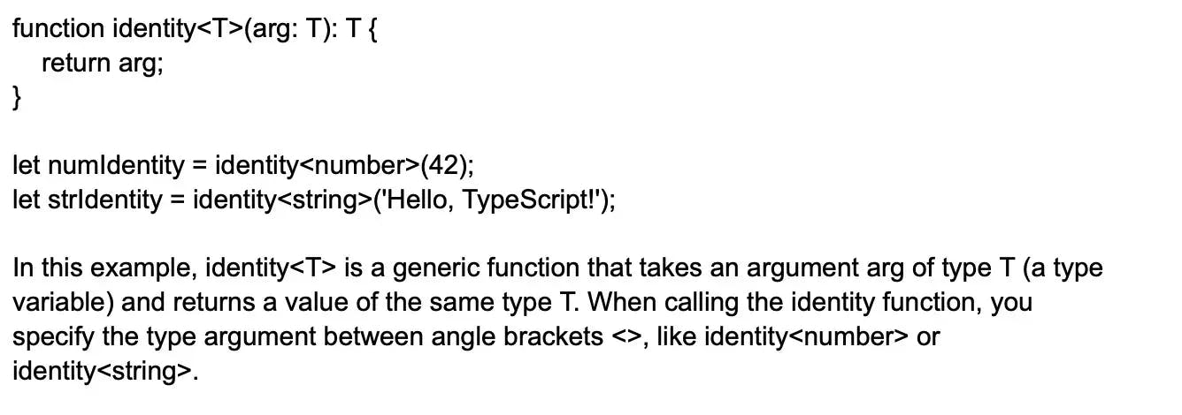

The generic function identity allows you to work with different types without losing type information. In this case, numIdentity will have the type number, and strIdentity will have the type string.

### 4. Tell me about Modules in TypeScript.

Modules in TypeScript provide a way to organize and encapsulate code, making it easier to develop, maintain, and test large applications. They allow you to split your code into separate files, keeping each file focused on a specific set of functionality or a single responsibility. Modules are designed to manage dependencies and avoid naming conflicts by using distinct namespaces and imports/exports.

There are two main types of modules in TypeScript:

External modules: Also known as "file modules," they are one module per source file. When you create a new TypeScript file and work with the import and export keywords, you are automatically creating an external module. These are the most commonly used TypeScript modules.

Ambient modules: These are used to provide type information for third-party libraries or existing global variables. They are typically declared using a .d.ts file and may be provided by the library developers themselves or created by the community. The declare module syntax is used to define an ambient module.

### 5.Why can TypeScript be chosen over JavaScript?

TypeScript offers several advantages over JavaScript, making it a preferable choice for many developers seeking to build large-scale and maintainable applications. One of the most noticeable benefits of TypeScript is the [tools and IDEs](https://www.turing.com/kb/best-typescript-developer-tools) that provide a rich environment that helps to find the errors easily. Some other benefits include:

Advanced autocompletion and IntelliSense: TypeScript provides enhanced autocompletion, code navigation, and refactoring capabilities through better integration with editors like Visual Studio Code, making the development process faster and more efficient.

Large-scale application support: Features like classes, interfaces, generics, and namespaces in TypeScript facilitate the design of modular code, making it well-suited for large and complex applications.

Improved code readability: TypeScript's type annotations and advanced OOP features bring clarity to codebases and make it easier to understand, debug, and maintain code written by other developers.

Strict null checks: TypeScript enforces strict null checks, which can help catch null or undefined values during compilation, reducing runtime errors related to missing or inaccessible data.

### 6.Do TypeScript files need compilation?

Yes, as TypeScript can’t be interpreted by browsers. Compiling is needed to convert TypeScript to JavaScript. And for compilation, you need the TypeScript compiler. TypeScript has all the features and functionality of JavaScript, with some added features. It improves developer experience, provides features like type aliases, abstract classes, tuple, generics, etc, and it allows developers to add type safety to their projects.

### 7.List some benefits of TypeScript?

TypeScript offers several benefits that enhance the development process, improve code quality, and streamline collaboration. Some of these benefits include:

Static typing: TypeScript adds static typing to JavaScript, which catches type-related errors at compile-time instead of runtime. This allows developers to identify and fix issues early in the development process, reducing bugs and improving overall code quality.

Code maintainability: TypeScript's static types, interfaces, and other OOP features contribute to better code readability and maintainability, making it easier for developers to understand and work with shared codebases.

Better tooling and editor support: TypeScript provides excellent integration with popular IDEs, resulting in advanced autocompletion, code navigation, and refactoring tools. This improves the development experience and boosts productivity.

Large-scale application support: TypeScript's features, such as generics, namespaces, and modules, foster the creation of modular and scalable code, making it an ideal choice for large and complex applications.

JavaScript ecosystem compatibility: TypeScript is fully compatible with JavaScript libraries, frameworks, and tools, enabling seamless integration into existing development workflows.

### 8.In TypeScript, can we call the base class constructor from the child class ?

Yes, in TypeScript, you can call the base class constructor from a child class. When you create a child class that extends a base class, you can use the super() function within the child class constructor to invoke the parent class constructor.

Here's an example:

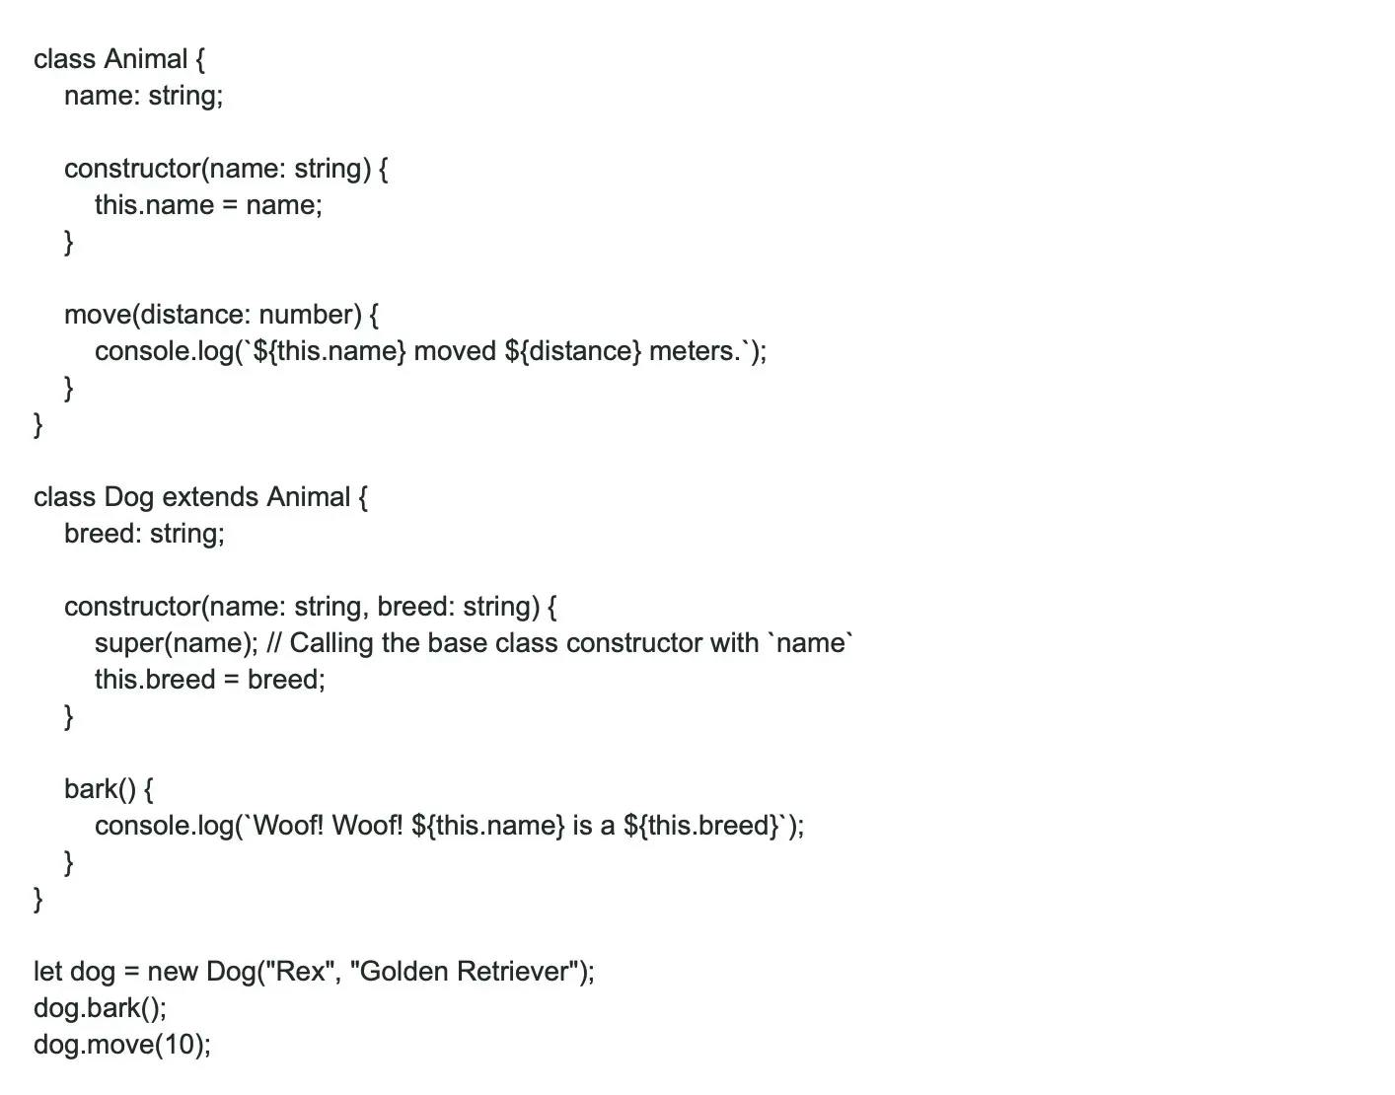

In this example, the Dog class extends the Animal class. When you create a new Dog instance, the Dog constructor calls the Animal constructor using super(name). This ensures that the parent class's properties are properly initialized before initializing the child class's properties.

### 9.What is the difference between TypeScript and a statically typed language?

TypeScript is optionally statically typed, which means you can tell the compiler to ignore a variable's type. We can assign any type of value to the variable using any data type. During compilation, TypeScript will not perform any error checking.

### 10.Is string interpolation possible in TypeScript?

Yes, string interpolation is possible in TypeScript, and it is also known as template literals or template strings. It allows you to embed expressions within string literals, using backticks (`) instead of single or double quotes. To include a variable or expression within the string, use the ${expression} syntax. This feature makes it easier to create more readable and concise strings without resorting to string concatenation.

Here's an example of string interpolation in TypeScript:

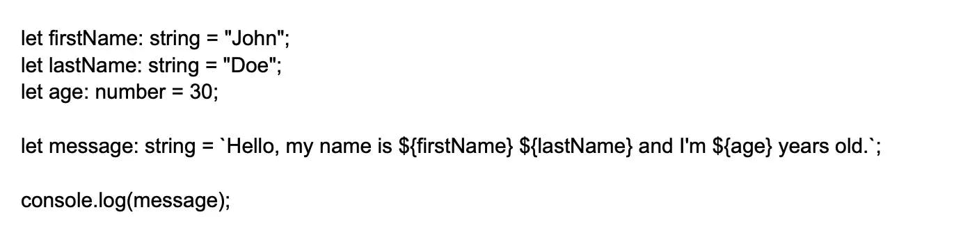

In this example, the message variable uses a template literal to construct a complete string with interpolated variables firstName, lastName, and age. The output will be:  
Hello, my name is John Doe and I'm 30 years old.

### 11.How do the extensions .ts and .tsx differ in TypeScript?

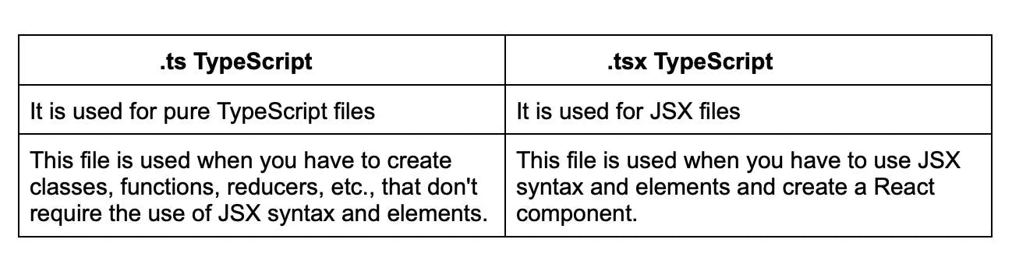

### 12.Differentiate between Classes and Interfaces in TypeScript?

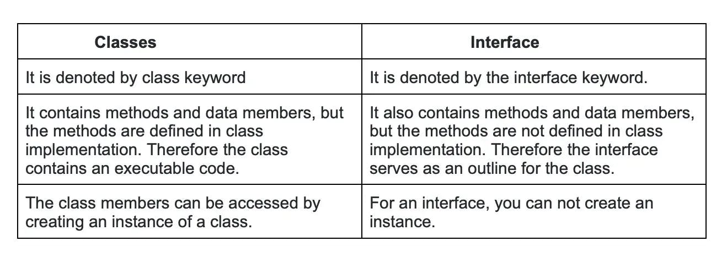

### 13.Explain the Interface in TypeScript?

In TypeScript, an interface is a fundamental concept that allows you to define the shape, structure, and contract of an object or a class without implementing its actual functionality. Interfaces let you define custom types by specifying the properties and their respective types that an object should have, and the class that implements the interface must adhere to these specifications. Interfaces can also be used with functions to define specific parameters and return types.

Interfaces can have optional properties, read-only properties, and method signatures as well as support extending and implementing multiple interfaces.

### 14.Explain Decorators in TypeScript.

Decorators in TypeScript are a special kind of declarative syntax used to add metadata or modify the behavior of classes, methods, properties, or parameters. They provide a convenient way to apply reusable logic or behavior across multiple parts of your code without having to manually modify each target element. Decorators are built using higher-order functions, which receive the target element (such as a class or property) as an argument and return a modified version of it or perform specific actions on it.

### 15.When should you use interfaces or classes in TypeScript?

In TypeScript, both interfaces and classes are used to define custom types and structures. However, you should choose between interfaces and classes based on your specific requirements:

Use Interfaces when:

* You want to define the shape, structure, and contract for how an object or a class should look, without implementing its actual functionality.
* You want to enforce specific properties, methods, or their types on an object or a class.
* You need a lightweight approach that only focuses on the type-checking aspect during development.
* You want to describe the structure and requirements for function parameters.

Use Classes when:

* You want to encapsulate methods and properties within a single entity, including providing a concrete implementation for them.
* You want to use object-oriented concepts like inheritance, abstraction, and encapsulation.
* You need to create instances of the class to interact with.
* You want to use instance-specific state and methods based on concrete implementations.

### 16.How can you use class constants in TypeScript?

You can declare class constants in TypeScript using the keywords " readonly ", const and readonly static. The readonly keyword marks a property as unchangeable; you cannot change the value of the property once it is set. Const keyword declares a constant outside the class and uses it inside the class. But if you want it to be accessible only inside the class, declare it privately.

### 17.In TypeScript, what can you do to check null and undefined?

In TypeScript, null and undefined are separate but related types representing the absence or uninitialized state of a value. To check for null or undefined, you can use various language constructs and techniques:

* Equality checks Use the equality operator == or inequality operator != to check for both null and undefined at the same time. You can also use the strict equality === or strict inequality !== operators followed by explicit checks for null and undefined.

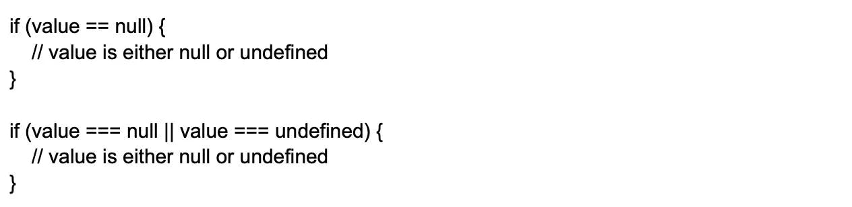

* Optional Chaining Operator The optional chaining operator ?. can be used to access properties and methods on an object that may be null or undefined. If the object is null or undefined, the result of the expression will be undefined.  
  const result = obj?.property; // result will be undefined if obj is null or undefined

### 18.Are all object-oriented principles supported by TypeScript?

Yes, it supports the [OOP principles](https://www.turing.com/kb/object-oriented-programming-help-the-developers-to-code-better) such as,

* Inheritance
* Abstraction
* Polymorphism
* Encapsulation

### 19.Also, tell me some OOP terms supported by TypeScript.

TypeScript, being a statically-typed superset of JavaScript, supports many Object-Oriented Programming (OOP) concepts to help you build more structured, maintainable, and reusable code. Some of the important OOP terms supported by TypeScript include:

Classes: Classes in TypeScript serve as blueprints for creating objects that share similar properties and methods. They consist of a constructor, properties, and member functions.

Inheritance: TypeScript allows you to inherit properties and behaviors from a parent (base) class to a child (derived) class through the extends keyword, which enables code reusability and simplifies complex code structures.

Interfaces: Interfaces are used to define the shape, structure, and contract for objects, classes, and functions, specifying properties and methods that should be implemented by classes that adopt the interface.

Abstraction: TypeScript supports the creation of abstract classes, which serve as base classes that cannot be instantiated directly and often include unimplemented methods and properties.

Encapsulation: TypeScript provides access modifiers (public, private, and protected) to control the visibility and accessibility of class properties and methods, ensuring only intended parts of an object or a class are exposed.

### 20.Explain Getters/Setters in TypeScript.

In TypeScript, getters and setters are special class methods used to control the access and modification of object properties. They provide a flexible and encapsulated way to work with properties while giving you the ability to add additional logic around retrieval and assignment.

Getters are accessor methods used to retrieve the value of a property. They are defined using the get keyword followed by the method name, and they have no parameters. Getters are accessed like regular properties, but they invoke the getter function internally to compute the result.

Setters are accessor methods used to update the value of a property. They are defined using the set keyword followed by the method name, and they contain a single parameter representing the new value. Setters are assigned values like regular properties, but they invoke the setter function internally to perform additional logic.

### 21.Can TypeScript be used on the back-end and how?

Apart from the front-end or browser, TypeScript can also be used for the back-end. TypeScript can be used on the back-end for building server-side applications and services. One popular approach for using TypeScript on the back-end is with Node.js. With TypeScript and Node.js, you can create scalable and maintainable server-side applications while enjoying the benefits of static typing and other TypeScript features.

### 22.Explain TypeScript Map file?

A TypeScript Map file, also known as a Source Map, is a JSON file generated during the compilation process of TypeScript to JavaScript. It serves as a bridge between the original TypeScript source code and the compiled JavaScript code, allowing developers to easily debug and trace back to the TypeScript code while working directly in a browser's developer console.

A Map file essentially maps the compiled JavaScript code back to its corresponding TypeScript code, enabling support for features like breakpoints, code stepping, variable inspection, and call stacks in the TypeScript code during debugging. This is particularly useful when using minified, obfuscated, or transpiled code because it preserves the original structure and naming, making it more comprehensible for developers.

### 23.Can you explain the difference between String and string in TypeScript?

In TypeScript, String and string both represent textual data, but they have different meanings and use cases:

string: This is the simplest, preferred, and most commonly used type for representing textual data in TypeScript. It's a primitive type that is automatically assigned to string literals. When you use the string type, TypeScript performs type checking and ensures that all operations and assignments are valid for strings.

let text: string = 'Hello, TypeScript!';

String: This is a built-in global object of JavaScript and wraps around the simple string type to provide additional methods and functionalities. The String object acts as a constructor for creating new strings and as a namespace for various utility methods to manipulate or inspect strings. However, in most scenarios, it is not necessary to use the String object, as TypeScript and JavaScript automatically convert primitive strings to String objects when required.

let wrappedText: String = new String('Wrapped TypeScript!');

In practice, you should generally use the string type for working with textual data in TypeScript, as it provides type checking and simpler, more efficient code. In contrast, avoid using the String object unless you have a specific use case that requires the additional functionality it provides.

### 24.Explain Type Erasure in TypeScript?

Type erasure in TypeScript refers to the process in which TypeScript's type information is removed during the transpilation (compilation) to JavaScript. Since JavaScript doesn't have a native type system like TypeScript, TypeScript compiler (tsc) eliminates all type annotations and corresponding type-checks when generating the resulting JavaScript code.

Type erasure has the following consequences and implications:

Runtime type information: TypeScript's type system only exists at compile-time for static type checking. Once compiled to JavaScript, there’s no information about types at runtime, which means you cannot perform type-checks or type-related operations during the execution of the code.

Compatibility: Type erasure ensures that the generated JavaScript code remains compatible with existing JavaScript libraries, frameworks, and codebases. TypeScript aims to be a strict superset of JavaScript, and type erasure helps maintain that compatibility.

Performance impact: Type erasure causes TypeScript's static type checking to have no overhead at runtime. The generated JavaScript code doesn't include any additional constructs related to type-checking, which means there is no impact on the overall runtime performance of the application.

### 25.How can you create an enum with string values?

In TypeScript, you can create an enum with string values by assigning a string to each enum member. Unlike numeric enums, string enums don't have auto-incrementing behavior. You need to define string values manually for each member. Here's an example of creating an enum with string values:

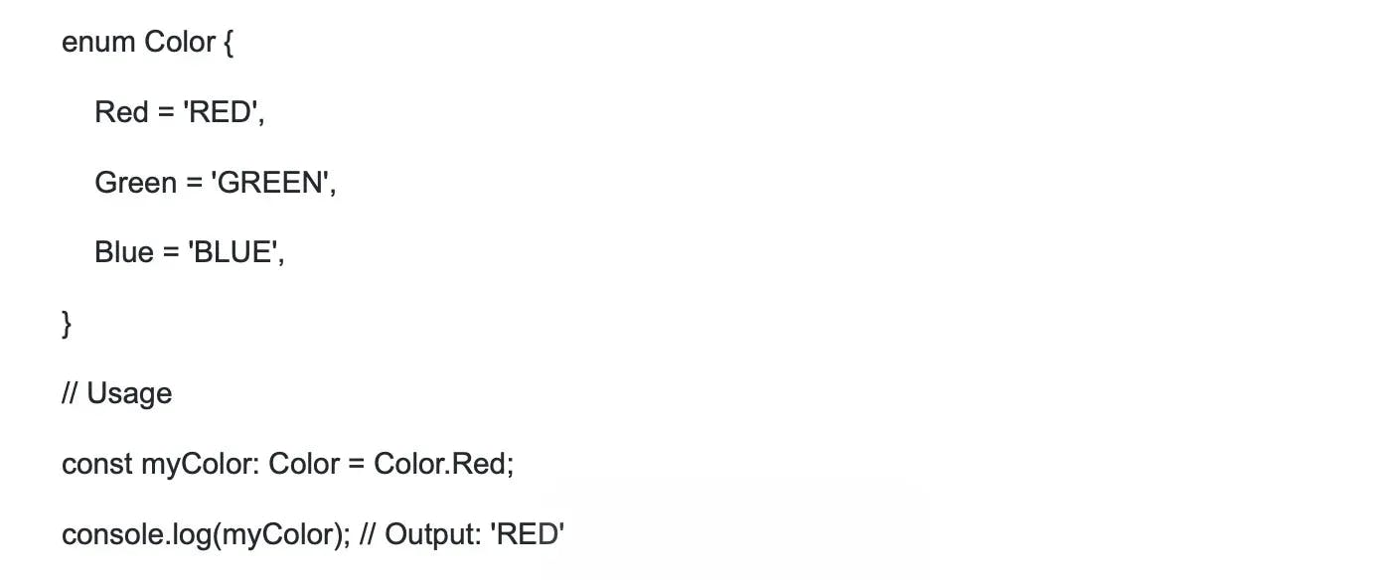

In this example, we define a Color enum with string values for each member. When using the Color enum, the TypeScript compiler will enforce the string values for type safety, ensuring that you can't accidentally assign an incorrect string value.

### 26.List some features of TypeScript.

TypeScript brings several powerful features to JavaScript development, which help in creating safer, more maintainable, and scalable code. Here are some key features of TypeScript:

Static Typing: TypeScript introduces static typing, providing type checking during the development stage rather than at runtime. This leads to early detection of errors and better developer tooling.

Interfaces: Interfaces define the shape, structure, and contract of objects or classes, allowing for custom types and enforcing a consistent structure across your codebase.

Classes: TypeScript supports object-oriented programming concepts like inheritance, encapsulation, and abstraction through classes and their related features, such as constructors, access modifiers, and abstract classes.

Generics: Generics enable you to create highly reusable and flexible components that work with a variety of types without sacrificing type safety.

Type Inference: TypeScript automatically infers types of variables and expressions when they are not explicitly specified.

### 27.Tell me the Components of TypeScript?

TypeScript consists of several components that work together to provide powerful features for developers building JavaScript applications:

Language− TypeScript extends JavaScript by adding optional static typing, interfaces, classes, decorators, namespaces, and many other features that JavaScript doesn't have natively.

Compiler − TypeScript has a dedicated transpiler (tsc) that compiles TypeScript code into plain JavaScript. The TypeScript compiler ensures type safety, checks for errors, and transpiles TypeScript into JavaScript, which can run across different browsers and platforms.

Language Service: The TypeScript Language Service provides editor support, such as IntelliSense, code completion, syntax highlighting, and refactoring, for modern development environments like Visual Studio, VSCode, WebStorm, etc. These advanced editing features enable developers to write code efficiently and productively.

Type Definitions: TypeScript uses type definition files (.d.ts) to provide type information about external libraries or JavaScript code. Type definitions help TypeScript developers access type information for third-party libraries like jQuery, React, or Express that are written in JavaScript. The DefinitelyTyped repository is a popular source of type definitions for various JavaScript libraries.

Tooling: TypeScript has robust integration with popular build tools, test runners, task runners, and bundlers, such as Webpack, Rollup, Gulp, Grunt, Babel, and Jest. These integrations ensure a smooth development, testing, and build process for TypeScript developers.

### 28.How will you install TypeScript?

To install TypeScript, you need to have Node.js and npm (Node Package Manager) installed on your machine. With Node.js and npm installed, you can follow these steps to install TypeScript:

Open up your terminal or command prompt.

Run the following command to install TypeScript globally:

npm install -g typescript

This command will install the latest version of TypeScript as a global package, making it available on your entire system for use in multiple projects. The -g flag ensures that the package is installed globally.

After the installation is complete, you can check the installed version of TypeScript by running:

tsc --version

This command will display the TypeScript version on your system, confirming that the installation was successful.

Now, you have TypeScript installed and ready to use. To compile a TypeScript file, you can use the tsc command followed by the filename, like this:

tsc myFile.ts

This command will compile your TypeScript file (myFile.ts) into a JavaScript file with the same name (myFile.js).

### 29.List the steps you will use to compile TypeScript files?

To compile TypeScript files, follow these steps:

Install TypeScript: First, install TypeScript globally on your system using npm (Node.js package manager) by running npm install -g typescript. If you don't have Node.js installed, you can download it from <https://nodejs.org/en/download>.

Write TypeScript code: Create a TypeScript file (.ts extension) and write your TypeScript code in it. For example, create a file called app.ts and add the following code:const message: string = 'Hello, TypeScript!'; console.log(message);.

Compile TypeScript code: Run the TypeScript compiler (tsc) on your TypeScript file by executing tsc app.ts. This command will compile the app.ts file and generate a corresponding JavaScript file, app.js, in the same directory.

Execute compiled JavaScript: Once the TypeScript files have been successfully compiled into JavaScript, you can execute the .js files using Node.js or include them in your HTML files for use in a browser environment. To run the compiled JavaScript file using Node.js, execute node app.js (or node ./dist/app.js if you are using a tsconfig.json file with outDir).

### 30.Explain Variables in TypeScript and how to create them?

In TypeScript, variables are memory locations that store values of various data types. To declare and initialize a variable in TypeScript, you use the let or const keyword followed by the variable name, an optional type annotation, and the assignment operator (=) to provide an initial value.

Creating Variables:

Using let keyword: The let keyword is used to create mutable variables that can be reassigned later in your code. It follows block-scoping rules, making the variable available only within the scope in which it is defined.



Using const keyword: The const keyword creates constant, immutable variables that must be initialized at the time of declaration and cannot be reassigned afterwards. This enforces the value remains constant throughout the execution of the program.



Type annotations:

In TypeScript, you can explicitly set a type for a variable using type annotations, which are written after the variable name followed by a colon. This helps catch type-related errors at compile-time.



If you do not explicitly set a type for a variable, TypeScript will infer the type based on the initial assigned value, which is known as "type inference".



### 31.List the ways you can declare a variable?

var [identifier] : [type-annotation] = value; //Here we declare type and value in a single statement

var [identifier] : [type-annotation]; // Here we declare type without value

var [identifier] = value; //declare without type

var [identifier]; //Here we declare without value and type

### 32.Can we compile .ts automatically with real-time changes in the .ts file?

Yes, you can automatically compile a TypeScript file (.ts) whenever there are real-time changes by using the TypeScript compiler's --watch option. The tsc (TypeScript Compiler) will watch for modifications in the .ts file(s) and automatically recompile them whenever changes are detected.

To use the --watch option, open your terminal or command prompt, navigate to the directory containing the .ts file(s), and run the following command:

tsc --watch your-file.ts

Replace your-file.ts with the name of your TypeScript file.

If you want to watch and compile multiple .ts files or an entire project, you can also specify the --watch option in your project's tsconfig.json settings file. Set up a tsconfig.json file in the root directory of your TypeScript project (if you don't already have one) and include the following:

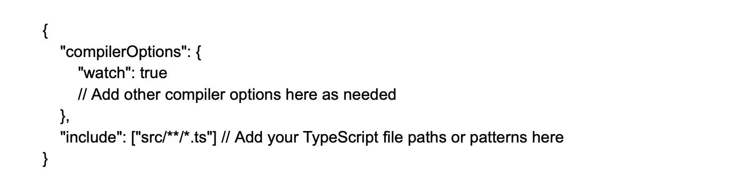

After setting up the tsconfig.json file, you can run the TypeScript compiler with just:

tsc

This will start the compiler in watch mode, and it will recompile the specified TypeScript files automatically whenever changes are detected.

### 33.List the access modifiers that TypeScript supports.

Public: members of the class including child classes and the instances of the class have access to it.

Protected: Here, the members of the class including the child classes can access except the instances of the class.

Private: accessible only to the members of the class.

## Intermediate TypeScript interview questions and answers

### 1.Why do we say that TypeScript is an optionally statically typed language?

TypeScript is referred to as an "optionally statically typed language" because it allows developers to mix both static and dynamic typing within the same codebase. TypeScript provides static type-checking through type annotations, interfaces, and generics, enabling safer and more efficient code development. However, it doesn't enforce static typing for every variable or function, as it's not a requirement for all TypeScript code.

The language offers a great deal of flexibility, making it easy for developers to migrate from JavaScript and incrementally add static types to their existing JavaScript projects. TypeScript gracefully handles dynamic typing with the built-in any type, which effectively bypasses static type-checking. By using the any type, developers can tell the compiler to treat a particular variable or object as dynamically-typed, retaining JavaScript's dynamic nature when necessary.

Thus, TypeScript's ability to balance static and dynamic typing, where developers can choose to use one or the other as per their requirements, is what makes it "optionally statically typed."

### 2.Explain modules in TypeScript?

In TypeScript, modules are a way to organize and encapsulate related code, making it easier to reason about, maintain, and manage. They allow developers to split code into separate files, with each module exporting and importing specific components, such as classes, functions, variables, or interfaces. By using modules, you can avoid naming collisions and control the visibility of your code parts.

Modules in TypeScript can adhere to one of the two popular module systems: CommonJS (used mainly in Node.js applications) or ES Modules (used in modern JavaScript running in browsers).

Exporting Components: To export a component (class, function, variable, or interface) from a module, you use the export keyword:



Importing Components: To import and use a component from another module, you use the import statement:



Aside from the CommonJS and ES Modules systems, TypeScript supports other module systems, such as AMD, SystemJS, and UMD, enabling compatibility with various runtime environments.

### 3.Differentiate between the internal module and the external module?

In TypeScript, the concepts of internal and external modules have evolved over time. The terms have been mostly replaced with "namespaces" and "modules", respectively. Here's a brief comparison between the two:

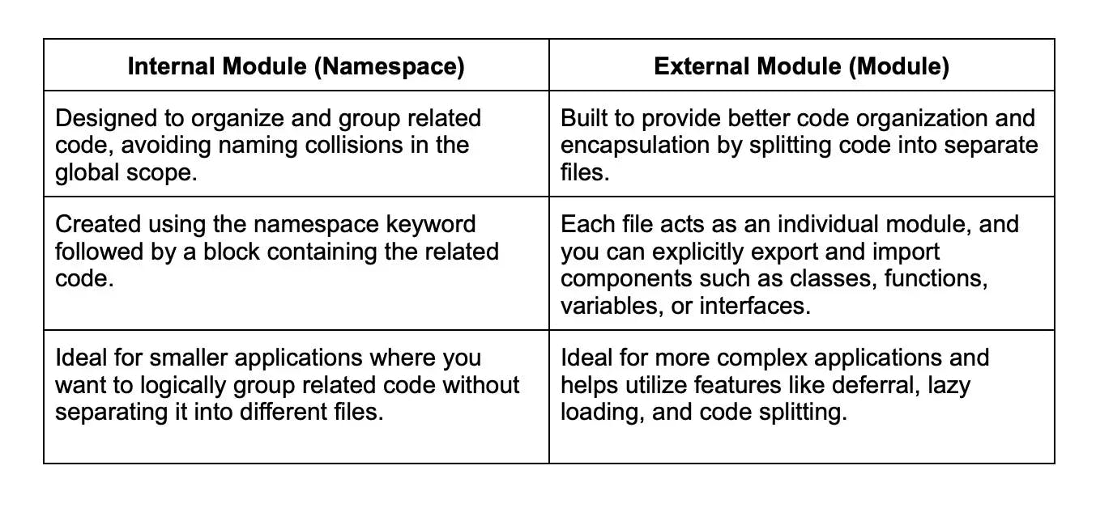

### 4.Explain namespace in TypeScript and its declaration

Also, known as internal modules, Namespace group functionalities in a logical manner. Also, it encapsulates the features and objects that have common relationships. Also, a namespace can include interfaces, classes, functions, and variables to support some other functionalities.

Syntax

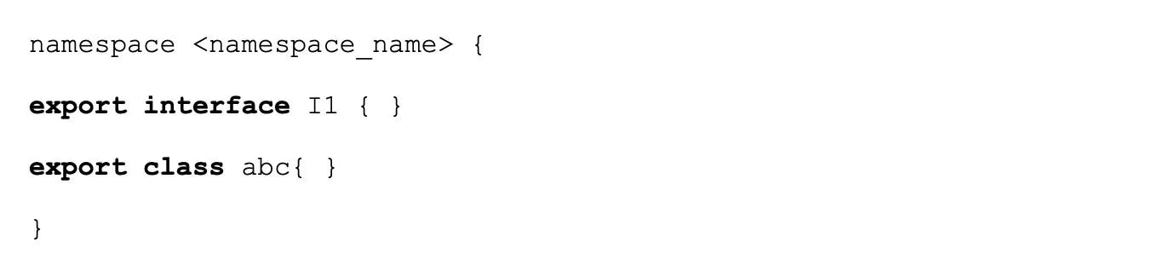

### 5.Is function overloading supported in TypeScript?

Yes, TypeScript supports function overloading, allowing you to define multiple function signatures with the same function name but differing parameters. Function overloading enables you to have several ways to call the same function with different argument types and combinations while maintaining type checking capabilities.

To implement function overloading in TypeScript, you need to define the different overloaded function signatures without their implementation, followed by the actual function implementation with a more generic signature. The implementation must be flexible enough to handle all supported overloads, and TypeScript will enforce the implementation to be compatible with the provided overloaded signatures.

### 6.Explain Mixins?

Mixins are a way of creating classes from components that can be reused. Basically, they are built up by combining simpler partial classes. So this means instead of class A extending class B to take its functionality, B takes class A and reuters a new class with additional functionality, And, thus function B is a mixin here.

7.TypeScript supports optional parameters in function, can you explain how?

In the TypeScript compiler, an error is thrown if the function is invoked without giving the exact number and types of parameters as are given in the function signature. To declare an optional parameter, use the ? symbol after the parameter name in the function signature.

Example:



### 8.Explain the Scope variable?

In TypeScript, the scope of a variable refers to the context or region of code in which the variable is accessible and can be used. Proper scoping is essential for managing variables effectively, preventing naming conflicts and keeping code maintainable.

TypeScript has three types of variable scopes:

Global scope: Variables declared outside any function, class, or module are considered global. They can be accessed from any part of the code in the same script file or other script files included in the same application. Global variables should be used sparingly, as they can lead to naming conflicts and difficulty in managing code.



Local scope: Variables declared within a function are limited to the function's scope, meaning they can only be accessed within the function in which they are declared. These scopes are also known as local scopes.

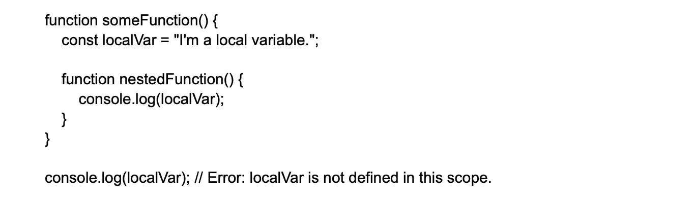

Block scope: Variables declared with let and const keywords are bound to the block in which they are declared (within curly braces {}). These variables are only accessible within the block and any nested blocks enclosed by that block.



### 9.Explain to me the debugging process for a TypeScript file.

First of all, for the debugging process, you will need .js source map file. Then you compile the .ts file with the – sourcemap flag to generate a source map file.

$ tsc -sourcemap file 11.ts

After this we get file11.js and file11.js.map. And the last line of file11.js would be a reference of the source map file.

//# sourceMappingURL=file1.js.map

### 10.Explain TypeScript Definition Manager and its use.

In the TypeScript ecosystem, the TypeScript Definition Manager (TSD) was a popular command-line tool used to manage TypeScript declaration files (.d.ts) which contain type definitions for external JavaScript libraries and frameworks. Providing accurate type information for external libraries allows TypeScript developers to leverage the advantages of static typing and catch potential type-related errors during compilation.

However, TypeScript Definition Manager (TSD) has been deprecated, and it is now replaced by DefinitelyTyped and @types scoped packages alongside the npm package manager.

DefinitelyTyped is a large repository containing high-quality TypeScript declaration files for numerous JavaScript libraries and frameworks. The @types scoped packages refer to individual type declaration packages generated from DefinitelyTyped, which can be easily installed using the regular npm package manager.

### 11.Tell me the steps to include a Type Definition File.

First, install TSD

$ npm install tsd -g

Go to TypeScript directory and launch new TypeScript project

$ tsd init

Now install the definition file for jquery

tsd query jquery --action install

Now, update the TypeScript file to include the definition file to point to the jQuery definition.



Now, compile again.

### 12.Explain TypeScript Declare Keyword?

The declare keyword in TypeScript is used to inform the TypeScript compiler about the existence of a variable, function, class, or module that is defined externally, usually in some external JavaScript code or a library. This allows TypeScript to provide type checking and intellisense for those elements without actually implementing their behavior within your TypeScript code.

When defining TypeScript declaration files (commonly with the .d.ts extension), the declare keyword is often used to provide type information about external JavaScript code, allowing you to use it safely and efficiently in your TypeScript projects. These declaration files act as a bridge between the external JavaScript library and TypeScript, enabling proper type checking and code completion.

### 13.Explain tsconfig.json file?

The tsconfig.json file is a configuration file used in TypeScript projects to specify various compiler options and settings. It enables developers to control options like specifying the output folder for the generated JavaScript code, module resolution strategy, strict type checking, source mapping, and features specific to various ECMAScript versions. The TypeScript compiler uses this configuration file to understand how to compile and transpile TypeScript code into JavaScript.

### 14.Tell me about Generics in TypeScript?

Generics is a tool that provides a way of creating reusable components. It provides components that can work with varied data types instead of a single data type. Besides all this, Generics also provides type safety without affecting performance or productivity. Generics also allow the creation of generic classes, generic functions, generic methods, and generic interfaces.

### 15.Differentiate between interface and type statements?

In TypeScript, both interface and type statements can be used to define custom types, and sometimes their use can overlap. However, there are key differences between the two, which make them suitable for different situations.

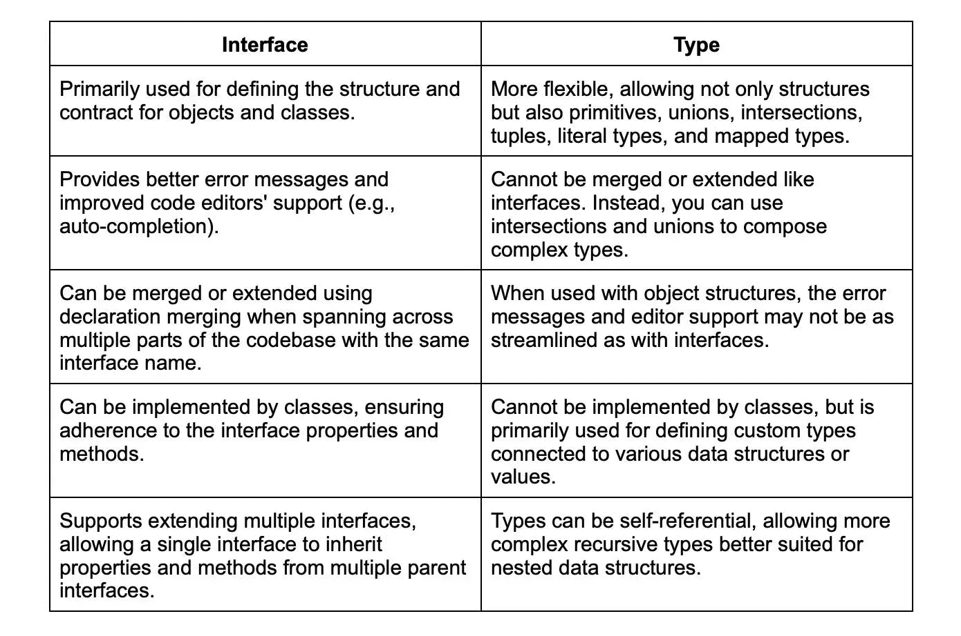

### 16.Tell me about JSX in TypeScript.

JSX (JavaScript XML) is a syntax extension for JavaScript, primarily used with React, that allows you to write HTML-like code within your JavaScript or TypeScript code. TypeScript supports JSX and provides a seamless way to use JSX syntax alongside TypeScript's type checking and other features.

To use JSX in TypeScript, you need to configure your tsconfig.json file to specify some options, like:

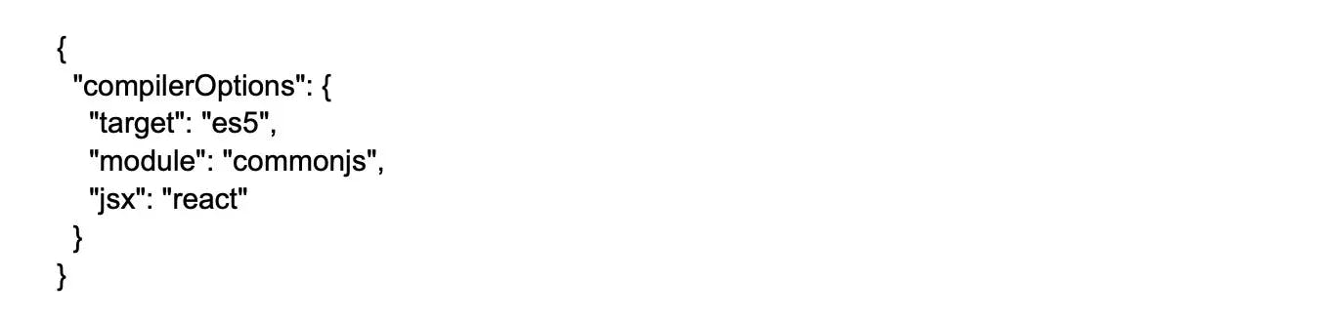

Here, the "jsx" option is set to "react", which transpiles JSX content into React.createElement() calls, compatible with the React library.

TypeScript also allows you to leverage its type system in your JSX code to ensure type safety when using React components:

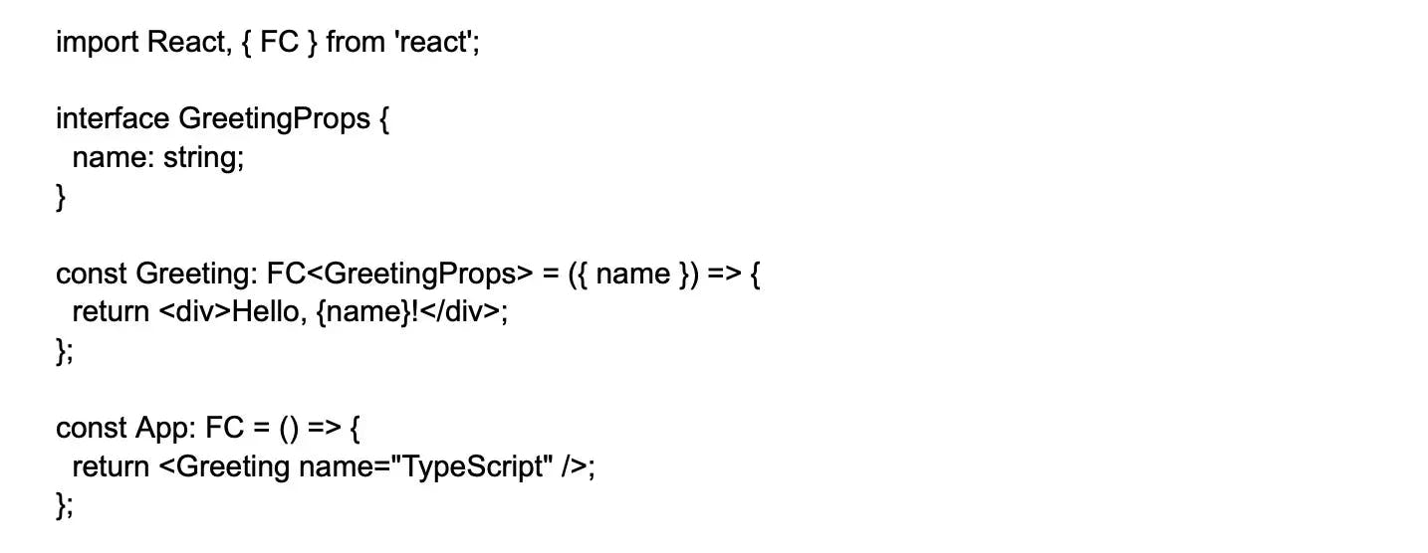

In this example, we define a Greeting functional component with a strongly-typed prop using the GreetingProps interface. The FC (Functional Component) generic type is imported from the react library and used to specify the type of our components.

Using TypeScript with JSX ensures safer, maintainable, and more efficient React code, since the TypeScript compiler checks for correct component usage, valid properties, and accurate types during development.

### 17.List some JSX modes in TypeScript?

In TypeScript, JSX is a syntax extension for JavaScript that resembles XML, commonly used in UI frameworks like React. TypeScript supports various JSX modes, which determine how JSX expressions are compiled and emitted, as specified by the jsx option in the tsconfig.json file or as a command-line flag.

Below are some of the supported JSX modes in TypeScript:

preserve: Keeps the JSX syntax intact in the output files, with the file extension changed to .jsx or .tsx. Mostly used with tools like Babel for further transpilation.

react: Transforms JSX syntax into JavaScript calls, specifically to React.createElement(). This is the commonly used mode for React applications.

react-jsx: Convert JSX syntax to JavaScript calls using the jsx imported-from or local factory function with the React version 17 or higher. Creates more optimized and compact code.

react-jsxdev: Similar to react-jsx, but with additional checks to enable React development mode features during development. Should only be used in development builds.

react-native: Identical to the preserve mode, but does not change the file extension, leaving it as .js. Used for building React Native applications.

When using TypeScript with JSX, make sure to set the specific JSX mode you're using in the tsconfig.json file based on the target platform/framework.

### 18.Explain Ambients in TypeScripts and their use?

These declarations inform the compiler about the actual source code that exists elsewhere. If these codes do not exist at runtime and one tries to use them, it will break and not give a warning either.

These declaration files are similar to doc files.here if the source changes, the docs need to keep updated. However, if the ambient declaration file is not updated, you get a compilation error.

### 19.Explain Type assertions in TypeScript?

Type assertions in TypeScript are a way to explicitly inform the compiler that you, as a developer, are certain about the type of a specific variable or expression. By asserting the type, you essentially override TypeScript's inferred type, giving you more control over how the compiler treats that variable or expression. Type assertions do not change the value or runtime behavior of the variable, but they can affect the type information during compile-time, allowing additional functionality or avoiding compile-time errors

### 20.Explain Rest parameters?

In TypeScript, Rest parameters provide a clean and concise way to handle an indefinite number of function arguments as an array. By using the rest parameter syntax, denoted by three dots ... preceding the parameter name, you can represent any remaining arguments in a function as an array of elements. Rest parameters offer an alternative to the arguments object in JavaScript, allowing you to capture all extra arguments while maintaining type safety and providing better code readability.

Here's an example of Rest parameters in TypeScript:



In this example, the ...names rest parameter captures the remaining arguments and treats them as an array of strings (string[]). The displayGreeting function outputs a greeting message and a list of names separated by a comma.

It's important to note that rest parameters should always be defined at the end of the parameters list, and only one rest parameter is allowed per function.

### 21.List the rules to follow for declaring Rest parameters? Give an example

Here are some rules to be followed for declaring Rest parameters

* In a function, only 1 rest parameter is allowed.
* Its type should be an array.
* Should be the last parameter in the parameter list.

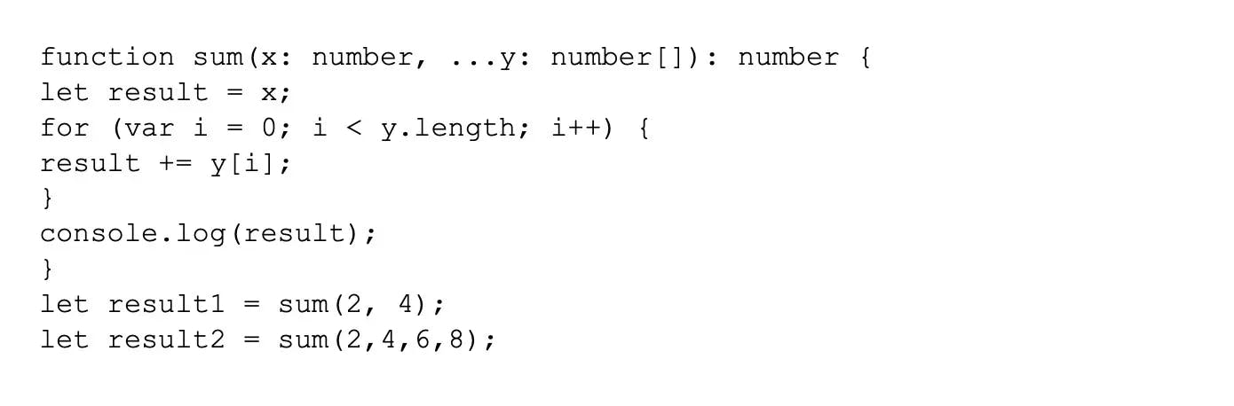

### 22.Explain “as” syntax in TypeScript.

The "as" syntax in TypeScript is used to create a type assertion, which is a way to explicitly inform the compiler that you know the actual type of a value and want to treat it as a specific type. This can be useful when the TypeScript compiler cannot automatically infer the correct type or when you need to perform a type conversion during development.  
Type assertions with as syntax do not change the runtime behavior of the underlying value, but they provide compile-time type information that can help catch type-related errors.

Here's an example of using the as syntax for a type assertion:



In this example, someValue has an unknown type, which means the type of the value is unknown during development but can be any type during runtime. We use the as syntax to cast someValue to a string and then access the length property.

### 23.What do you know about Enum in TypeScript?

In TypeScript, an Enum (short for enumeration) is a custom data type that allows you to define a set of named numeric constants, making your code more self-explanatory and easier to maintain. Enums provide a robust and expressive way to handle sets of values that represent specific categories, states, or options in your program.

Here's an example of an Enum in TypeScript:



### 24.Differentiate between Relative and Non-relative module imports.

In TypeScript, module imports can be either relative or non-relative, based on how the import path is specified. Here's a comparison between the two:

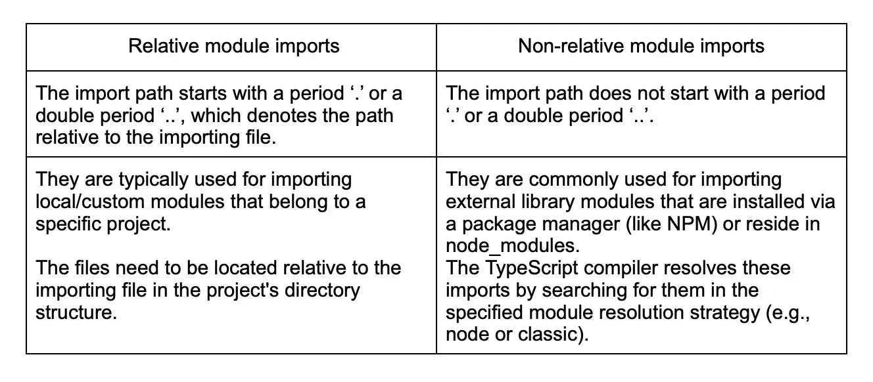

### 25.Explain the anonymous function?

An anonymous function is a function without a name, typically defined using a lightweight syntax and commonly used as a one-time-use function or for passing as an argument to other functions. In JavaScript and TypeScript, anonymous functions can be used as callback functions, event listeners, or in scenarios where a simple function is required with no need to declare or reference it afterwards.

### 26.Explain the method overriding in TypeScript?

Method overriding in TypeScript is an object-oriented programming concept that allows a derived (subclass) to provide a new implementation for a method inherited from its base class (superclass), effectively replacing or customizing the behavior of the inherited method. This is useful when a derived class needs to maintain the same method signature as its base class but requires different logic or functionality.

Some rules for method overriding are as follows:

* Method must have the same name as the parent class
* Also, it must have the same parameter as in the parent class
* IS-A relationship or inheritance should be present.

### 27.Explain Lambda/Arrow function?

Lambda, or arrow functions, are a more concise way to define functions in JavaScript and TypeScript. Introduced in ECMAScript 6 (ES2015), arrow functions simplify function expressions and provide a more compact syntax by using the fat arrow => to define the function. Arrow functions have two key features:

Concise Syntax: Arrow functions are shorter and more elegant compared to traditional function expressions.

Lexical this: Arrow functions do not have their own this binding, which means they inherit the this value from their enclosing scope. This behavior is particularly useful when dealing with callback functions or event listeners.

### 28.Explain conditional types in TypeScript.

Conditional types in TypeScript are a powerful feature introduced in TypeScript 2.8 to help model complex logic for the type system. They enable developers to define a type based on a condition, usually expressed using generic type parameters. A conditional type takes the form T extends U ? X : Y, where T and U are type variables, and X and Y represent the types that will be used depending on whether the condition is true or false, respectively.

Syntax:

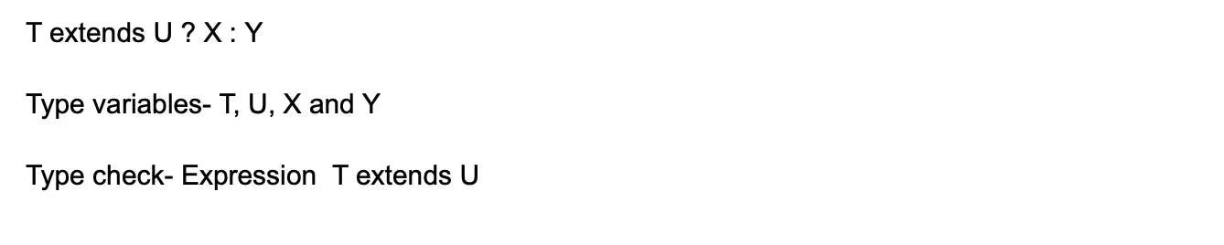

Here if T is a subtype of U, the conditional evaluates to X , else to Y.

### 29.How can you make read-only Arrays in TypeScript?

Using ReadonlyArray type, we can define Arrays to be read only. Thus any variable with reference to ReadonlyArray won't alter any element of the array.



### 30.Explain Nullish Coalescing operator?

The nullish coalescing operator (introduced in TypeScript 3.7) is a logical operator that returns the right-hand side operand when the left-hand side operand is either null or undefined. Otherwise, it returns the left-hand side operand. In TypeScript and JavaScript, it is denoted by ‘??’. The nullish coalescing operator is useful for providing default values for variables or expressions that might be null or undefined, making your code more robust and less prone to errors.

Here's a simple example illustrating the use of the nullish coalescing operator:

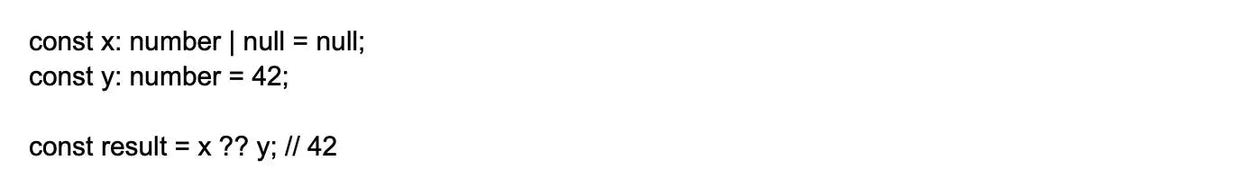

In this example, the result will be assigned the value of y (42) because x is null. If x had a non-null value, the result would be assigned the value of x.

### 31.Explain assertion functions?

In TypeScript, assertion functions are user-defined type guards that perform runtime checks and assertions to narrow down the types of variables further. They help ensure the correctness of data by checking the values' constraints and throwing errors when those constraints are not met. Assertion functions can help detect and prevent unexpected behavior or bugs early during runtime.

Here's an example of an assertion function:

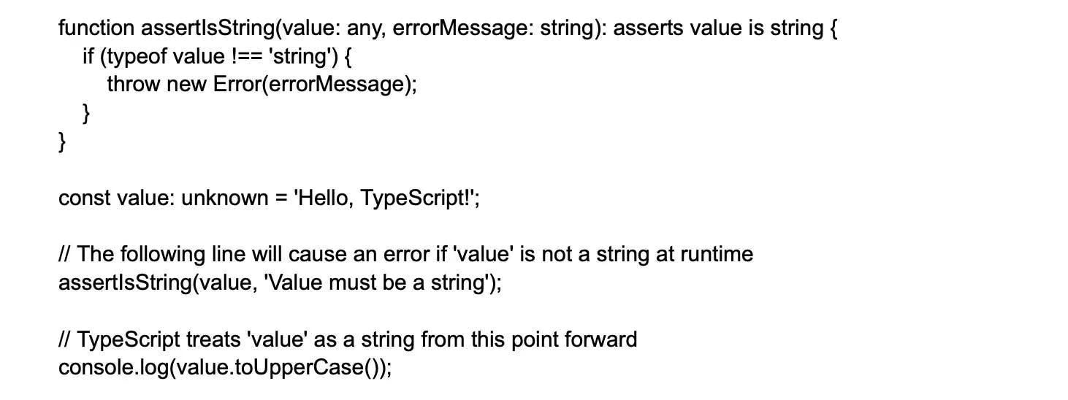

In this example, the assertIsString function takes two arguments: value, which is the variable to check, and errorMessage, which is the message to include in the error thrown if the provided value is not a string. The function uses the asserts keyword with the is keyword to specify the type that the value will be narrowed down to if the assertion succeeds.

### 32.Explain Triple-Slash Directives. List some of the triple-slash directives.

They are single line comments containing an XML tag to serve as compiler directives. Every directive indicates what to load at the time of the compilation process.

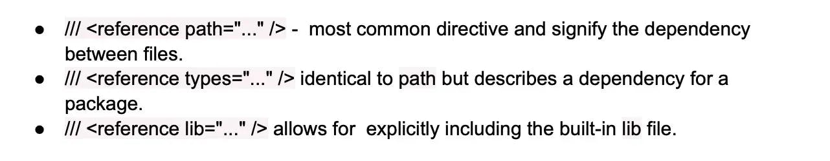

### 33.Explain the Omit type ?

In TypeScript, the Omit utility type is used to create a new type from an existing type by excluding specific properties from it. It takes two type arguments: the first is the type you want to modify, and the second is a union of properties you want to omit from the original type. The Omit type helps create more specific types based on existing data structures without manually changing their properties.

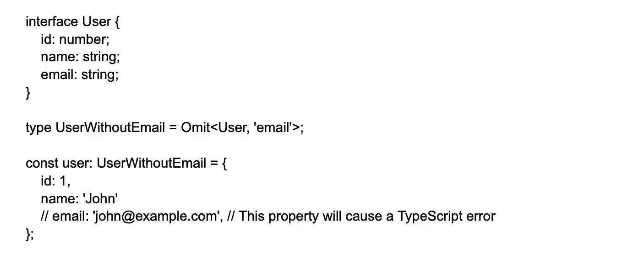

In this example, we have an User interface with three properties. By using the Omit type, we create a new UserWithoutEmail type that excludes the 'email' property from the original User interface. Now when you create the user object using the UserWithoutEmail type, you cannot include the 'email' property; doing so will cause a TypeScript error.

### 34.How can you compile TypeScript through Visual Studio Code?

* In Visual Studio Code, you will find the TypeScript language support but not the TypeScript compiler.
* For that, you need to install the TypeScript compiler to transpile the TypeScript source code to JavaScript.
* You can install this through npm, the Node.js Package Manager
* Further you can test your installation through version or help.

### 35.Can TypeScript files be supported from Node Modules? If yes, then how?

Yes, TypeScript files can be supported from Node Modules. To achieve this, you should follow these steps:

Step 1: Install TypeScript and the necessary declarations: You need to have TypeScript installed in your project. You can install it using npm or yarn:

npm install --save typescript

If you're using packages with TypeScript definitions in your project, add their respective '@types/' declarations using npm or yarn. For example, to add declarations for Node.js and Express:

npm install --save @types/node @types/express

Step 2: Configure your tsconfig.json: Create a tsconfig.json file in your project's root directory or modify an existing one, and set up the necessary configurations for your project.

Here's an example of a typical tsconfig.json configuration:

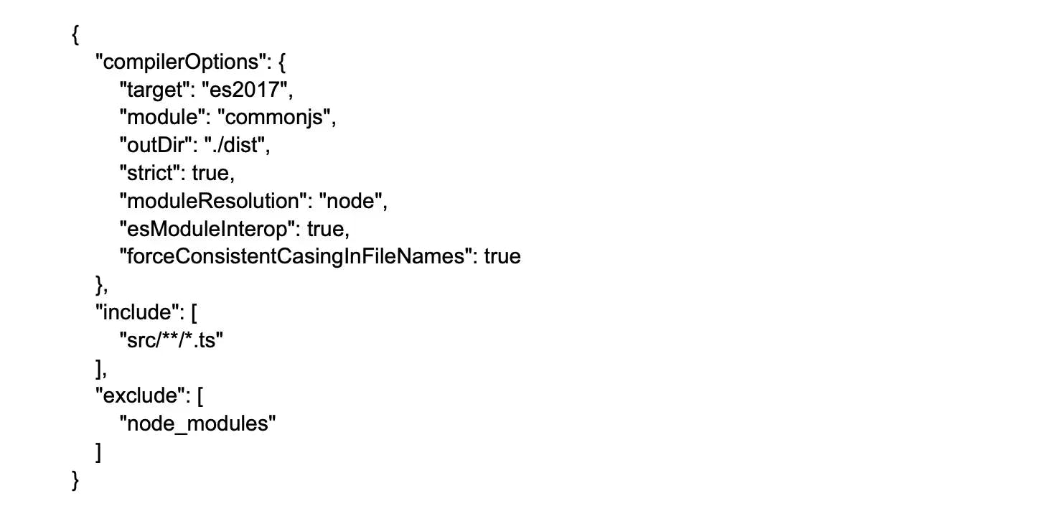

This configuration sets the target ECMAScript version, module system, output directory for compiled files, and more.

Step 3: Run TypeScript with Node.js: To execute TypeScript files with Node.js, you need to compile them to JavaScript first. You can use the tsc command to do this:

tsc

This command will generate JavaScript files from your TypeScript files as specified in the tsconfig.json.

To automatically compile and run TypeScript files when changes are made, you can use tools like ts-node or nodemon with ts-node. First, install them in your project:

npm install --save ts-node nodemon

Next, modify your package.json file to add scripts for running your app with ts-node and nodemon:



Now you can run your TypeScript Node.js app using npm start or npm run dev for auto-compilation and restart during development.

### 36.Explain Recursive Type Aliases?

Recursive type aliases are a feature in TypeScript that allows creating a type alias that refers to itself in its definition. This can be particularly useful when working with complex, hierarchical, or nested structures, which often arise when dealing with JSON data, tree-like structures or linked lists.

### 37.Explain “any” in TypeScript?

In TypeScript, any is a special type that represents any possible JavaScript value without constraints. It is used when you either don't know the type of a value, or you want to explicitly bypass the type-checking system.

When a variable is assigned the any type, TypeScript disables certain type-checking and allows the variable to store a value of any type. This means that you can assign, access, or use its properties and methods without TypeScript raising any type-related errors or warnings. However, this flexibility comes with a loss of type safety, making it easier to introduce runtime errors.

Here's an example using the any type in TypeScript:

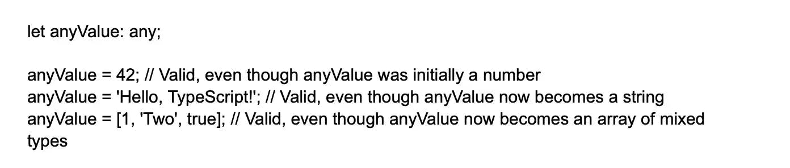

It's generally recommended to use the any type sparingly, and only when absolutely necessary, to maintain the benefits of TypeScript's type-checking system.

38.How are ‘let’, ‘var’, and ‘const’ different?

In TypeScript and JavaScript, let, var, and const are used to declare variables, but they have different scoping rules and behaviors:

var: Variables declared with var are function-scoped, meaning they are accessible throughout the entire function in which they are declared. If declared outside any function, they become globally-scoped. var also suffers from hoisting, which means that the variable declaration is moved to the top of the containing scope, causing uninitialized variables to be accessible (with the value undefined) before their actual declaration. This can lead to unexpected bugs and errors.

let: In contrast, let creates block-scoped variables, limiting their accessibility to the block, statement, or expression in which they are declared. This helps prevent unintentional access to variables outside their relevant scope. Variables declared with let are not hoisted, so you must declare them before trying to access them. Attempting to access a let-declared variable before its declaration results in a ReferenceError.

const: Similar to let, const is also block-scoped and isn't hoisted. However, variables declared using const must be assigned a value during their declaration and cannot be reassigned afterward. This makes const suitable for declaring constants or values that shouldn't be changed during program execution. Note that declaring an object with const does not make its properties immutable - only the reference to the object itself is constant.

To sum up, let and const are generally preferred over var due to their clearer, more predictable scoping and behavior. Use let for variables that may change over time and const for values that must remain constant throughout the program's execution.

## Advanced TypeScript interview questions and answers

### 1. Tell me about the ‘tsconfig.json’ file?

The tsconfig.json file is a configuration file used by TypeScript to control various aspects of the TypeScript compiler behavior when building (transpiling) TypeScript files into JavaScript. This file provides a way to define the options and settings that the TypeScript compiler (typically tsc CLI) should use during the compilation process.

Some of the settings you can configure in tsconfig.json are:

compilerOptions: This property is an object containing the configuration options for the TypeScript compiler, such as:

1. target: Specifies the output language level, e.g., ES5, ES6, or a higher ECMAScript version.
2. module: Sets the module system used in the output, e.g., CommonJS, AMD, UMD, or ES2015.
3. outDir: Indicates the output directory for the compiled JavaScript files.
4. sourceMap: Generates source map files for debugging purposes.
5. strict: Enables stricter type checking and other compiler checks to ensure more robust code.
6. watch: Enables watch mode, where the compiler will automatically recompile when there are changes in the TypeScript files.

exclude: An array that lists file patterns to be excluded from the compilation, usually for files that are dependencies or not required for the build process.

extends: Allows you to inherit settings from another configuration file, which promotes reuse and decreases duplication in multi-project scenarios.

files: An array that explicitly lists TypeScript files to be included in the compilation, typically used in smaller projects that have few source files.

These settings help to customize the TypeScript build process based on your project's requirements and conventions, resulting in consistent and maintainable code output. By configuring tsconfig.json, you can tailor the compilation process to cater to multiple environments, outputs, and module systems.

### 2.Tell me about “never” in TypeScript?

The never type in TypeScript represents a value that should never occur or be reached within the code. It is often used to narrow down the types of variables in specific control flow paths or to indicate that a function should always throw an error and never return a value. The never type is different from void, which represents the absence of a type, typically used for functions that do not explicitly return a value.

Here are a few use cases for the never type in TypeScript:

Function return type: When a function should always throw an exception and never return a value, you can use the never type as its return type.



Unreachable states: In a control flow path where it is never possible to reach a certain state, the never type can be used for better type safety.

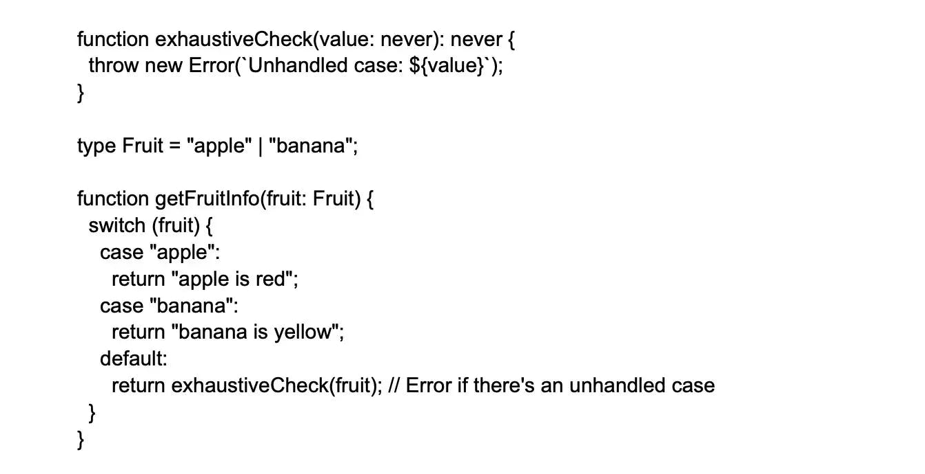

In this example, exhaustiveCheck function expects the value parameter to be of type never. If we add more cases to the Fruit type but forget to handle one of them within the getFruitInfo function, TypeScript will raise a type error for incorrect handling of an unhandled case.

### 3.What are design patterns?

Design patterns are reusable, general-purpose solutions to common problems that arise during software design and development. They represent best practices formulated by experienced software developers to guide the software design process. Design patterns improve code structure, enhance maintainability, and ensure reliable functionality. They also help facilitate communication among developers by providing a shared vocabulary for discussing coding challenges and solutions.

Design patterns are categorized into three groups:

Creational Patterns: These patterns deal with the process of object creation, abstracting the object instantiation process and ensuring a more efficient and maintainable way to create objects. Examples include Singleton, Factory Method, Abstract Factory, Builder, and Prototype.

Structural Patterns: These patterns focus on building a flexible and efficient structure for combining objects or classes to form larger systems or subsystems while maintaining the ability to change or extend the composition. Examples include Proxy, Bridge, Decorator, Flyweight, among others.

Behavioral Patterns: These patterns define the ways in which objects interact and communicate, guiding how responsibilities are distributed among objects and ensuring flexibility and extensibility in the communication process. Examples include Interpreter, Iterator, Command, Observer, State, Mediator, Template Method, among others.

### 4.What is the Singleton Design Pattern?

The Singleton Design Pattern is a creational design pattern that ensures a class has only one instance throughout the lifetime of a program, and provides a global point of access to that instance. Singleton is particularly useful when a class must coordinate its behavior across multiple parts of an application, and it's essential to have a single, shared instance to maintain a centralized state or control resources.

The main principle behind the Singleton pattern is to make the constructor of the class private to restrict instantiation by external code, and instead provide a static method or property that manages the unique instance creation internally.

### 5.Explain Facade Design Pattern?

The Facade Design Pattern is a structural design pattern that provides a simplified interface for a complex subsystem or group of interfaces, making it easier for clients to interact with the subsystem. It involves creating a higher-level class (facade) that encapsulates the complexity and exposes simpler methods to the clients. The objective is to improve the usability of a system by masking internal complexities, reducing dependencies, and enhancing modularity.

A common analogy for the Facade Pattern is the use of a home theater system, which typically includes several components such as a TV, audio system, media player, and game console. Instead of manually configuring and managing each component independently, a user can use a remote control (facade) that provides a straightforward interface for controlling the entire system.

### 6.Explain “promise” in TypeScript.

A Promise in TypeScript represents an asynchronous operation that eventually produces a value. It is an ES6 feature which TypeScript fully supports, allowing developers to write concise and easily maintainable code when dealing with asynchronous processes like network requests, timers, or file operations.

A Promise can have three states:

pending: The initial state, where the promise neither has a resulting value nor represents a reason for rejection.

fulfilled: The successful completion state, where the promise has resulted in a value.

rejected: The failure state, where the promise has a reason for not completing successfully.

### 7.Explain how you can manage default parameters in a function in TypeScript?

In TypeScript, you can manage default parameters in a function by assigning a default value in the function signature. When a parameter is not provided explicitly by the caller, the default value will be used instead. Default parameters help improve the function's flexibility and ensure that it behaves predictably even when some parameters are not supplied by the caller. Here's a simple example to illustrate the concept:

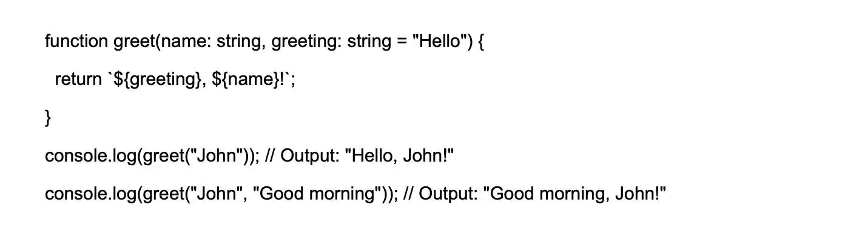

In this example, the greeting parameter has a default value set to "Hello". When the greet function is called without a second argument, the default value of "Hello" is used for the greeting parameter.

### 8.Explain the distributive conditional type in TypeScript and its usage?

In TypeScript, Distributive Conditional Types are a powerful feature that allows you to conditionally apply different types based on the input type. They work by applying conditionals at the individual union member level, effectively distributing the conditional across the input union type members. The syntax used for creating a distributive conditional type is:

T extends U ? X : Y

Here, if T extends U (i.e., T is a subtype of U), the type of expression is X; otherwise, it's Y. Now let's dive into an example to better understand distributive conditional types:

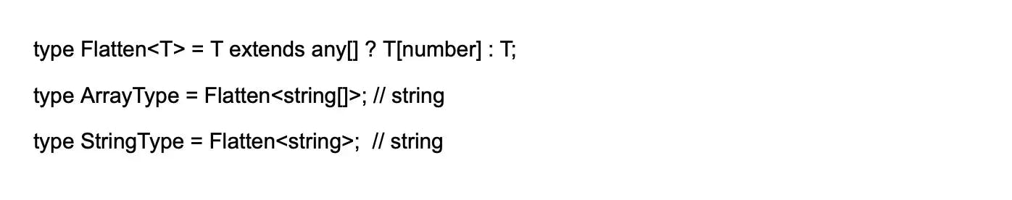

In this example, we define a Flatten type, which takes an input type T. If T is an array type, it evaluates to the element type of the array; otherwise, it returns the original type T. When we use Flatten<string[]>, it matches the condition T extends any[], and TypeScript determines the type of ArrayType to be string, since string[] is an array type.

Distributive conditional types are commonly used for type manipulation, tailor-made typings for specific data structures, and to create more precise types in various scenarios, improving type safety, maintainability, and the overall quality of the code.

### 9.Explain the "type" keyword in TypeScript and its usage?

In TypeScript, the type keyword is used to define custom, reusable type aliases that can represent complex types or provide a more meaningful name for an existing type. A type alias can refer to primitive types, union types, intersection types, object types, function types, arrays, or any other valid TypeScript type. Type aliases improve code readability, maintainability, and allow developers to create more expressive type annotations over time.

Here's an example illustrating how to use the type keyword:

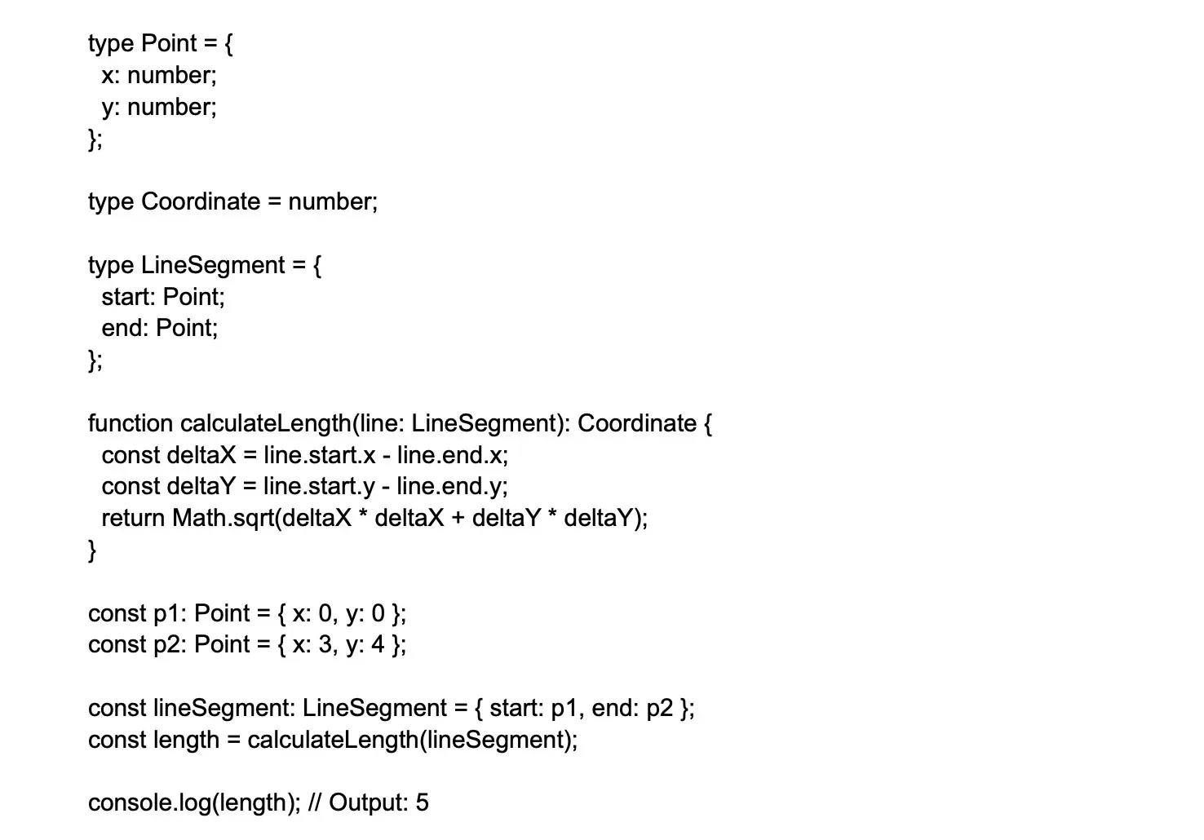

In this example, we define three type aliases (Point, Coordinate, and LineSegment) to represent the structure and required data for geometric shapes. We then use these aliases to create a function that calculates the length of a given line segment. The type keyword enhances the readability of our code, making it easier to understand and maintain.

### 10.Explain the "import type" statement in TypeScript?

In TypeScript, the import type statement is used to import only the type information from a module, without importing the actual values or side-effects associated with the module. This feature is beneficial when working with type-only imports, as it helps clarify the intent of the import, prevents accidental value imports, and can have some performance improvements in certain bundlers.

When using import type, the imported types will be erased during the compilation process, as TypeScript only uses them for checking types and does not include them in the emitted JavaScript code. This ensures that no runtime overhead is introduced as a result of importing types.

### 11.List some disadvantages of TypeScript.

While TypeScript offers many advantages, such as improved scalability, better code organization, and strong typing, there are some disadvantages to consider:

Learning curve: Developers familiar with JavaScript may need to invest time in learning TypeScript's concepts, syntax, and tools before becoming proficient. This learning curve might feel more significant for those who are new to typed languages in general.

Compilation step: TypeScript needs to be compiled to JavaScript before running in a browser or other JavaScript environments. This additional step can add time to the development process, impact build times, and introduce the need for build automation tools like Grunt or Gulp.

Potential inconsistencies: When using third-party JavaScript libraries, TypeScript relies on accurate typing declaration files (.d.ts) to infer the types and properties correctly. Not all libraries have these files or keep them up to date, which can lead to inconsistencies and potential type errors. Developers may need to create or update the typings manually to fix discrepancies.

Limited backward compatibility: TypeScript usually attempts to align with the latest ECMAScript features. However, some advanced TypeScript features may not have equivalent support in older browsers or JavaScript engines. Transpilers like Babel can help mitigate this by compiling TypeScript code into a compatible JavaScript version, but this adds an extra layer of complexity to the process.

Verbosity: Writing TypeScript code can become verbose due to the necessity of type annotations and interfaces. This extra typing might be considered as additional boilerplate code by some developers, but it's essential to achieve the benefits of static typing.

Not applicable everywhere: TypeScript mainly targets the JavaScript ecosystem, making it less suitable for contexts where JavaScript itself is unsuitable. For example, it might not be the ideal choice for low-level or performance-critical projects where languages like Rust, C++, or WebAssembly are better options.

Despite these downsides, TypeScript's benefits often outweigh the drawbacks, especially in large-scale projects that demand robust, maintainable, and scalable codebases.

### 12.What rules to follow when declaring a variable in TypeScript?

When declaring a variable in TypeScript, you should follow these rules and best practices:

Use keywords: Declare variables using the const, let, or var keywords. Prefer const for immutable values and let for mutable values; avoid using var as it has less predictable scoping rules.

const PI = 3.14159;

let counter = 0;

Type annotation: Provide type information for variables by adding a type annotation to ensure type safety and catch potential errors during compile-time.

let message: string = "Hello, TypeScript!";

Initialize: Always initialize variables during declaration to avoid issues with uninitialized or undefined variables.

let userName: string = "John"; // Initialization with value

Use descriptive names: Choose meaningful and descriptive variable names that indicate the purpose or value they hold.

let userName: string = "Alice";

Follow naming conventions: Stick with common naming conventions, like camelCase for variable names and PascalCase for types and interfaces.

const defaultGreeting: string = "Hello";

type UserProfile = { name: string; age: number };

Use union types: For a variable that should accept multiple types, use union types.

let id: number | string = 42;

id = "abc123";

By adhering to these rules and best practices, you can create robust, type-safe, and maintainable TypeScript code.

### 13.When is an unknown type used?

In TypeScript, the unknown type is used when a value can potentially have any type but still requires type-checking before performing any operations on it. It is a safer alternative to the any type, which disables type-checking completely. By using the unknown type, you are signaling that a value's type is not predetermined, yet you still want to enforce type-checking before using it.

Using unknown is particularly useful when dealing with user input, values from external libraries or APIs, deserialized data, or any situation where the exact type of a value cannot be determined beforehand. When a value is of type unknown, TypeScript enforces a type guard or a type assertion to narrow down its type before using it in the code, making it a more type-safe approach.

Here's an example:

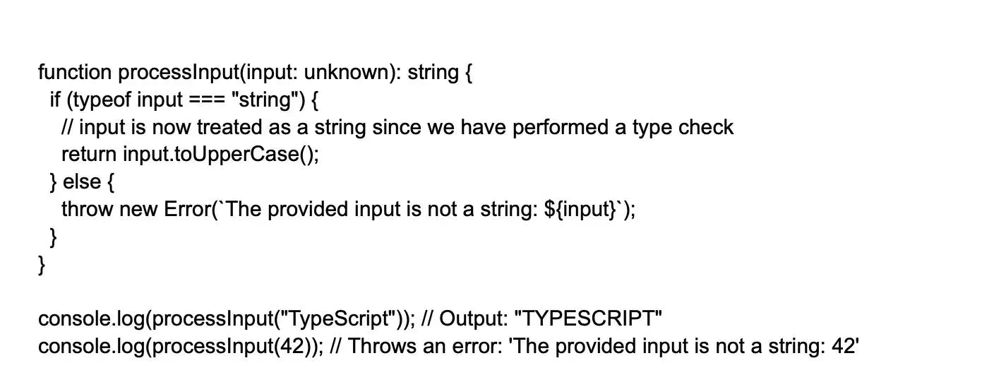

In this example, the processInput function accepts a parameter of type unknown, and it uses a type check (typeof input === "string") to narrow down the type to string before operating on it. This ensures that the code is type-safe and any potential issues are caught during compile time.

### 14.Explain noImplicitAny?

noImplicitAny is a property available with the TypeScript project configuration file ( tsconfig.json). This file alters how the compiler manages the project’s implicit “any” types. One can also set the noImplicitAny flag for either true or false. While deciding on the flag value, it is necessary to see the changes when it is turned on or off.

When set to false, noImplicitAny, the compiler defaults the type to “any”. However, when the noImplicitAny flag is true, the compiler tries to decipher the type giving a compile-time error if it isn't able to infer the type.

### 15.Differentiate union and intersection types?

Union types and intersection types in TypeScript are used to combine multiple types; however, they serve different purposes and represent different relationships.

Union Types (A | B): Union types represent a type that can be any one of several types. If a value is a union type, it means that the value can be of any type included in the union. When using a union type, you can only access members common to all types in the union.

Example:

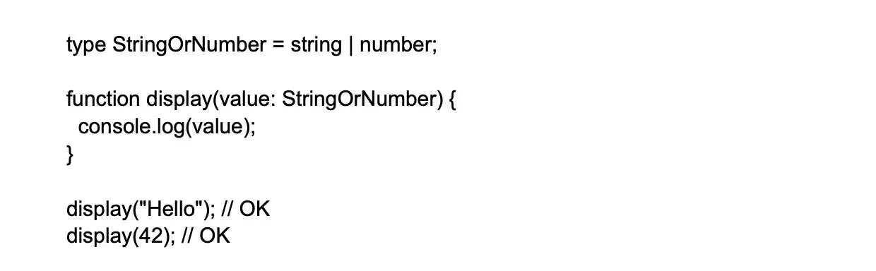

Intersection Types (A & B): Intersection types represent a type that combines multiple types into one. If a value is an intersection type, it means that the value must have properties and behaviors consistent with all types included in the intersection. In other words, a value of an intersection type must satisfy all the types combined.

Example:

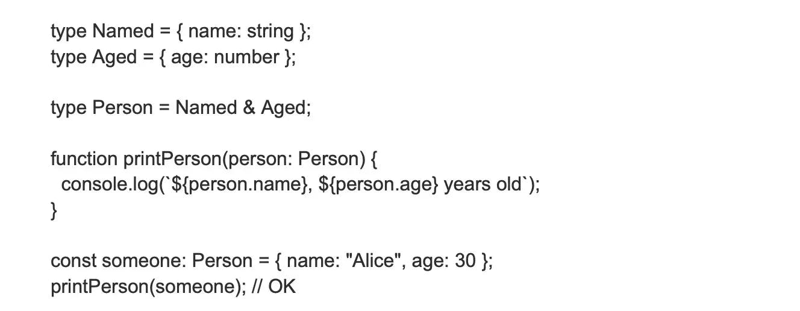

### 16.Differentiate between extends and implements in TypeScript?

In TypeScript, extends and implements are used to establish relationships between classes and interfaces. They serve different purposes in terms of inheritance and structural contract enforcement:

extends: The extends keyword is used to establish a subclass relationship between classes and also between interfaces. When a class or interface extends another class or interface, it inherits all properties and methods from the parent entity.

Class extending a class: Child class inherits properties and methods from the parent class. A class can only extend one class (single inheritance).

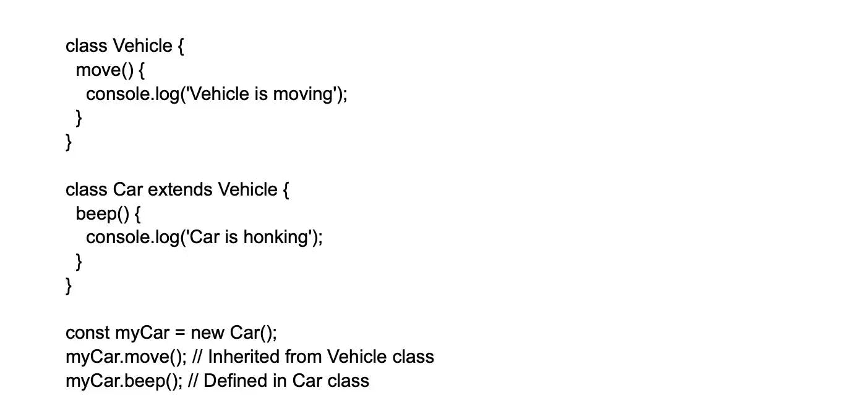

Interface extending an interface: Child interface inherits properties and methods from the parent interface. An interface can extend multiple interfaces.

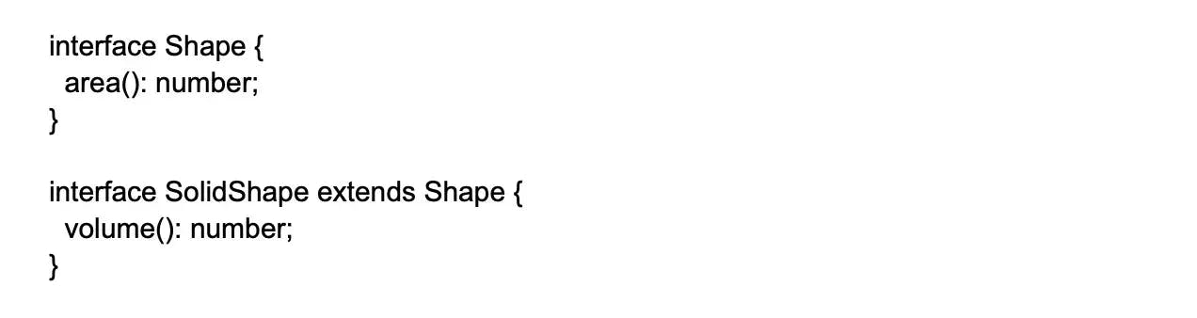

implements: The implements keyword is used to enforce that a class adheres to the structural contract defined by one or more interfaces. When a class implements an interface, it must provide definitions for all properties and methods declared in the implemented interface(s). A class can implement multiple interfaces.

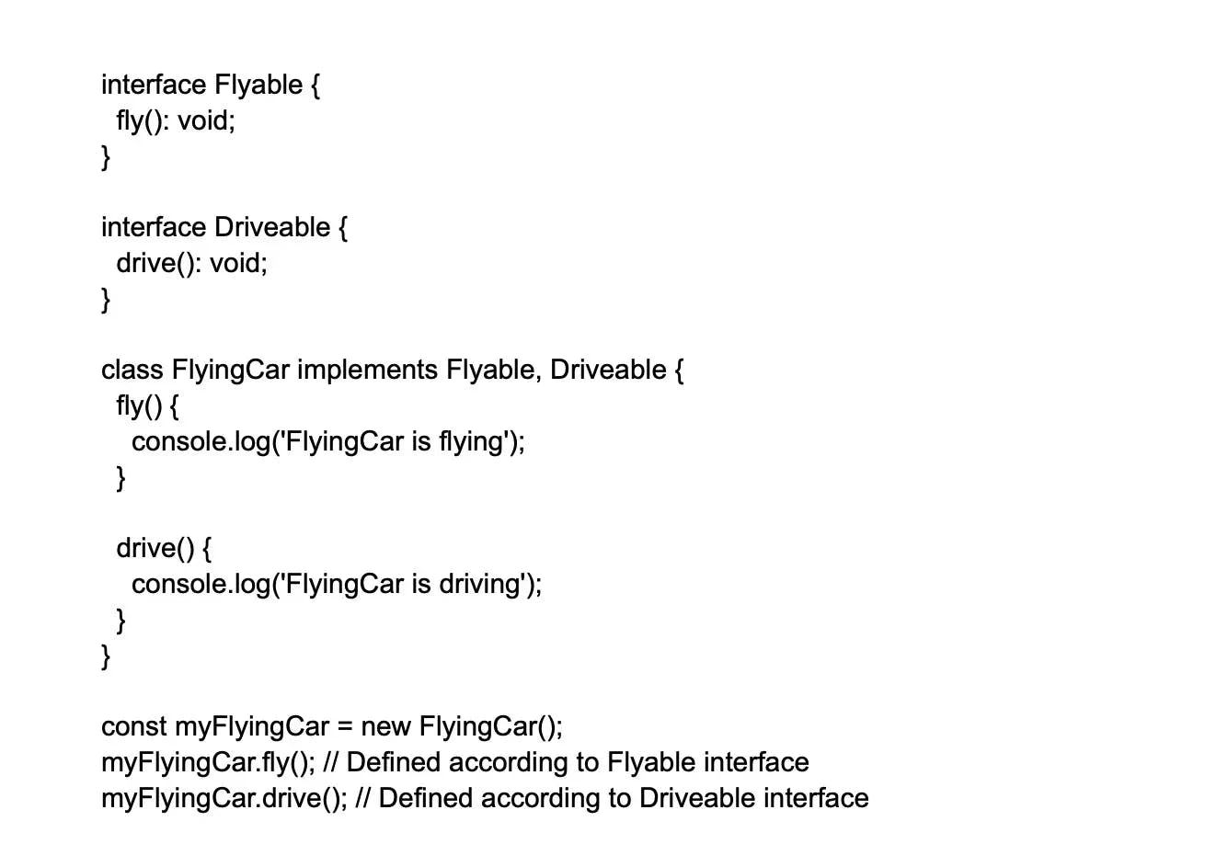

In summary, extends is used for inheritance between classes and interfaces. A class or interface can extend another class or interface, respectively, to inherit properties and methods. On the other hand, implements is used by a class to ensure it adheres to the contract(s) defined by one or more interfaces. A class must provide definitions for all properties and methods declared in the implemented interface(s).

### 17.Explain how optional chaining works in TypeScript.

It allows access to properties and methods within an object without the need to check the validity of every reference in the chain. It uses the question mark with a period as follows (?.). It analyzes each reference in the chain and does a null or undefined check before making an access to its children.

### 18.What are abstract classes?

Abstract classes in TypeScript are specialized classes that cannot be instantiated directly but serve as a base for other classes to extend. They are used to define common properties, methods, or a basic structure that must be shared among child classes.

Abstract classes can include a mix of fully implemented methods, empty methods (without any implementation), and properties. Methods and properties marked as abstract in an abstract class must be implemented by the child classes that extend the abstract class.

Here's an example to illustrate the concept of abstract classes in TypeScript:

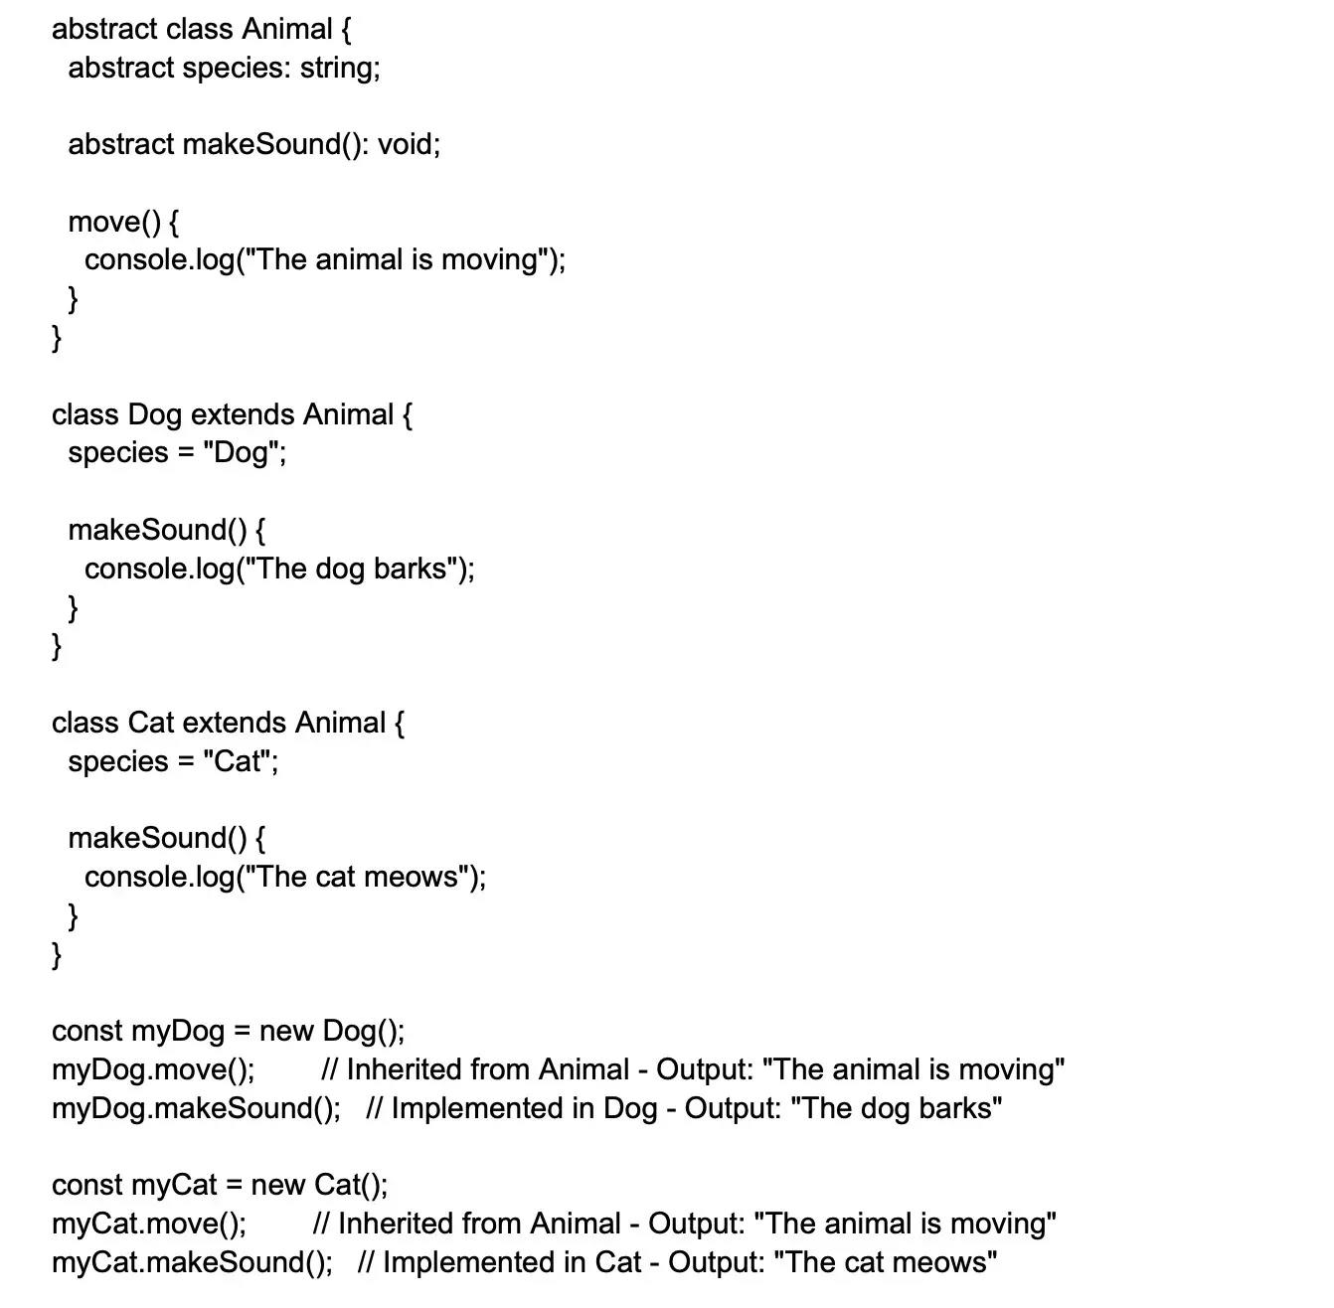

In this example, Animal is an abstract class with an abstract species property and an abstract makeSound() method. It also includes a non-abstract move() method. The Dog and Cat classes extend Animal and provide implementations for the abstract members (property species and method makeSound).

### 19.What are the two syntaxes for type assertions in TypeScript?

In typeScript, type assertions are used to inform the compiler of the intended type when the inferred type might be too general, or when converting a more general type to a more specific one. It's important to note that type assertions do not perform type conversion or runtime checks; they act as a hint to the compiler during static type checking. There are two syntaxes for type assertions:

Angle-bracket syntax:



as syntax:



Both syntaxes have the same effect from a type-checking perspective, but certain environments, like in JSX code in React projects, only support the as syntax due to the conflict of angle brackets with JSX elements. It's recommended to be consistent with your choice across a project to maintain code readability.

### 20.Differentiate between type inference and contextual typing?

In TypeScript, both type inference and contextual typing are mechanisms used to determine the types of variables or expressions without explicit type annotations. While they share a common purpose, they are used in different scenarios:

Type Inference is the process by which TypeScript automatically deduces the type of a variable or expression based on the value it is assigned or initialized with. If you don't provide an explicit type annotation, TypeScript attempts to infer the type from the context. Type inference usually occurs when you declare and initialize a variable, assign a value to a variable, or set a function's return value.

Contextual Typing is the mechanism by which TypeScript deduces the type of an expression based on its location in the code or the context in which it is used. Contextual typing occurs when an expression is part of a larger expression, and the type can be inferred by analyzing the surrounding code. TypeScript uses contextual typing in situations like event handlers, function parameter types, or type guards.

### 21.Tell me about the process to declare a constant in TypeScript?

In TypeScript, declaring a constant is similar to declaring variables, but with a crucial difference: the value of a constant can't change once it's initialized. This immutable nature ensures that the value remains consistent throughout the application, increasing code safety and enabling easy reasoning about the behavior.

To declare a constant in TypeScript, use the const keyword followed by an identifier, an optional type annotation, an equal sign, and the constant's initial value. Here's an example:

const PI: number = 3.14159;

const WELCOME_MESSAGE: string = "Hello, World!";

In this example, two constants are declared: PI and WELCOME_MESSAGE. The PI constant is declared with a type annotation indicating it's a number, while WELCOME_MESSAGE is declared as a string. Note that the type annotations are optional, as TypeScript can often infer the correct type based on the initial value. However, providing an explicit type annotation can improve code readability and catch potential errors during compilation.

Remember that once a constant has been initialized, its value cannot be changed:

PI = 3.14; // Compilation error: Cannot assign to 'PI' because it is a constant.

### 22.How do you implement Mixins in TypeScript?

Mixins are a way of combining multiple classes or interfaces into a single class. TypeScript supports mixing classes through function-based implementation.

Example:

### Image 15-06-23 at 2.53 PM.webp

23.How can you implement async/await in TypeScript?

The async/await feature can be used to simplify handling asynchronous operations in TypeScript. Functions with the async keyword return a Promise that can be awaited.

Example:

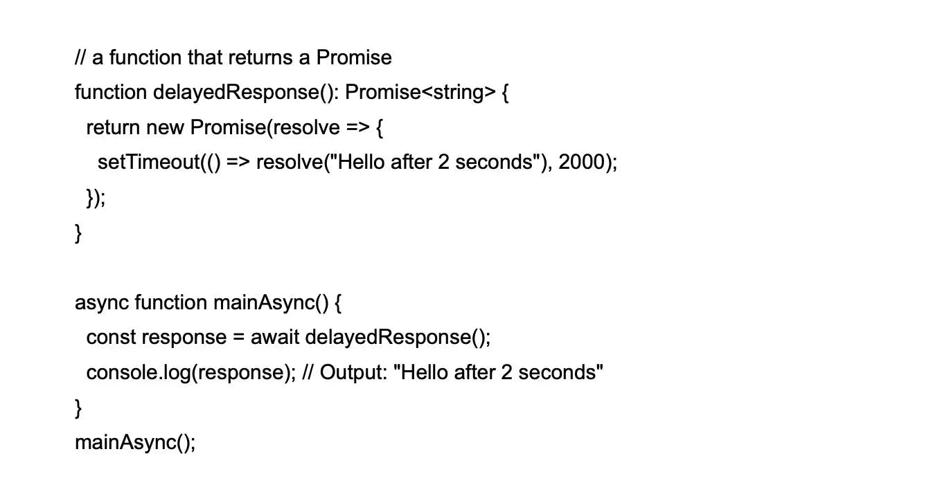

### 24.How can you use mapped types in TypeScript?

Mapped Types allow you to create new types based on existing ones by iterating over their properties and modifying them.

Example:

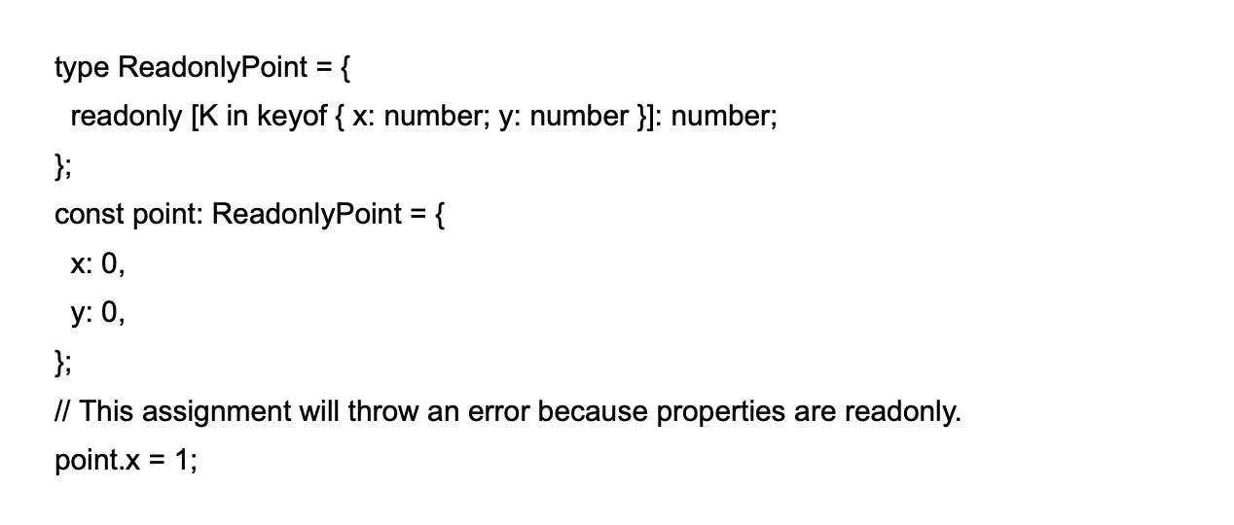

### 25.What is the keyof type operator in TypeScript?

The keyof type operator is used to create a new type that contains a set of keys of the provided type.

Example:

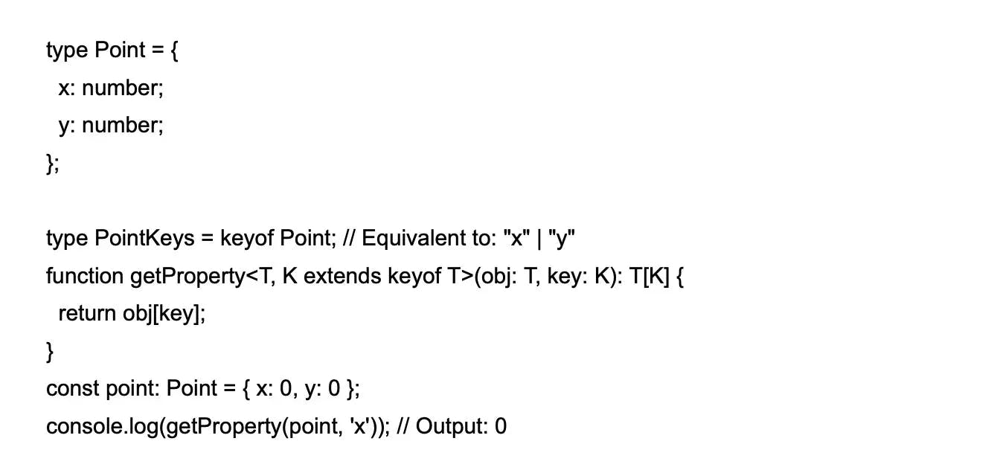

### 26.How to use accessors (getters and setters) in TypeScript?

TypeScript allows the creation of getter and setter methods using get and set keywords.

Example:

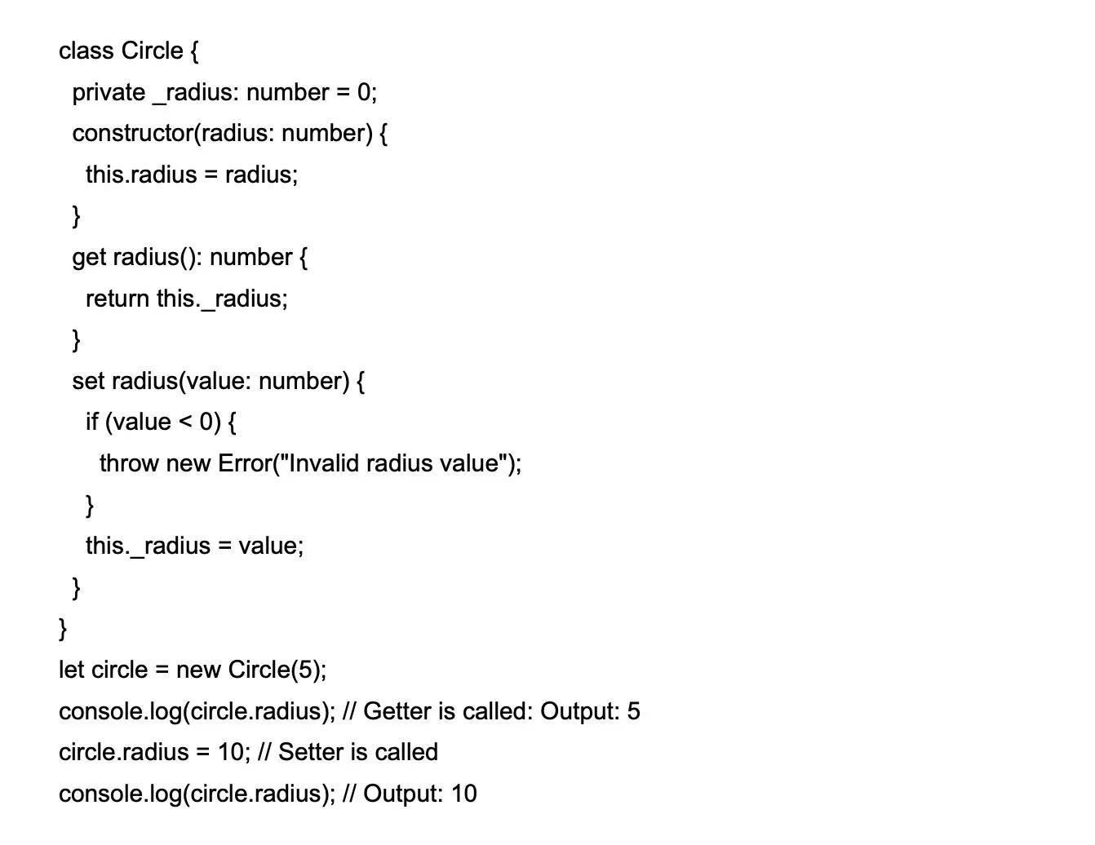

### 27.How can you create a custom decorator in TypeScript?

Decorator is a special type of declaration that can be attached to a class, method, or property to extend or modify its behavior. To create a custom decorator, define a function with the corresponding parameters.

Example:

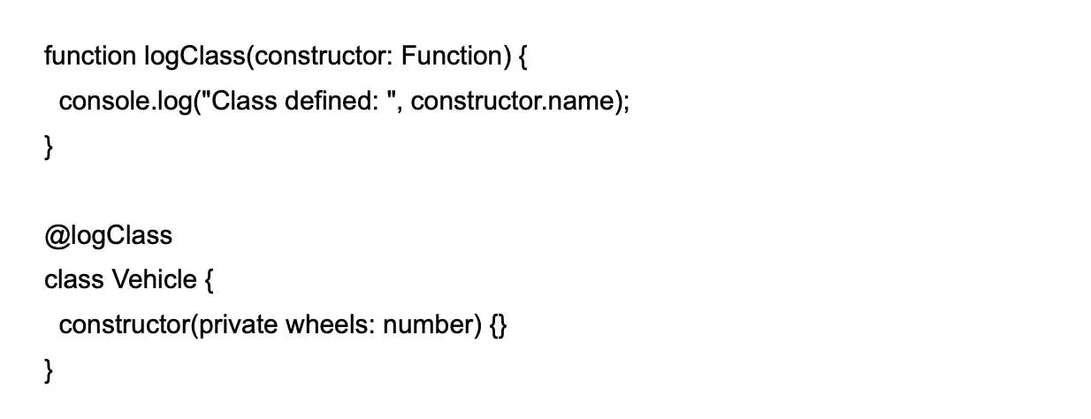

### 28.How can you handle enums in TypeScript?

Conditional types enable you to create types that are based on other types and can be refined based on some condition.

Example:

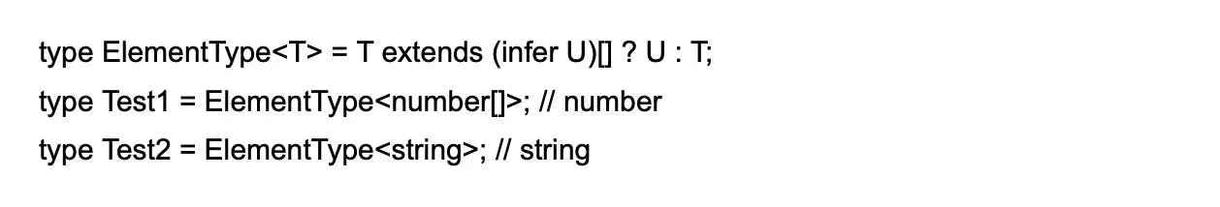

### 29.How can you use mapped types with conditional types in TypeScript?

You can combine mapped and conditional types by using a mapped type as the extends clause of a conditional type.

Example:

